
SCSP1513-06
TECHNOLOGY AND INFORMATION SYSTEM



3RD INDUSTRY VISIT REPORT
INDUSTRY VISIT 2
ONEMAKER, ISKANDAR PUTERI

SUBMIT TO: DR.NOR BAHIAH BINTI HJ. AHMAD

SUBMIT BY: GROUP 4
NAME | MATRIX NO
NANDA AZKA MULIA | A18CS0316
TAUFIIQ BIN NOOR AZMAN | A18CS0240
WILBERT HARIANTO | A18CS5138
RAZIELA BINTI ROSLI | A18CS0240
NURUL ZAHFIAH BINTI MOHD HAMZAH | A18CS0228

Nowadays, the current generation has a variety of interesting ideas about Artificial intelligence. A visit to The OneMaker Medini Makerspace on 24th November help to open our eyes on quality technologies that can advance the industry in our country such as drone flying, code with colours,3D modelling challenge, AI head and the best part is doodle 3D with printing. This program has been accompanied by all the students who take the course of software engineering. According to the speaker (Mr Tee), OneMaker is a company from Singapore which has been set up about 5 years ago, actually this company moderate to create intelligent machines and indirectly people have a job opportunities if they join this company. These visit helps to motivate us so that we can create a better and convenience technology for the future. Artificial intelligence have a lot of usage which is machines unlike humans, do not require frequent breaks and also they are programmed for long hours as well as can continuously perform without getting distracted or even tired. As we are moving toward 21st century, the new generation are need to use internet access to communicate with others, unconsciously they have used the latest technology which is computed methods for automated reasoning and learning have become a common phenomenon in our everyday lives for example Siri or Cortana. Besides, this visit also help us to be more determine of our dream toward achieving a world of AI for our country so that we don’t need other country’s skill to perform certain task involve to create a quality technology and as we know our country are lack of artificial intelligence and need support from other country such as China and United Stated. Besides that, we also visited the Forest City. It is a place where they place the future prototype of Malaysia. Forest city is said to be one of a big plan towards the future. Forest city does not own by Malaysia, however, it is own by China. Actually this development is without question a city designed for the future and to spur the economy of the country. Though most units at Forest City have been sold to international buyers, it shouldn’t stop you or any other Malaysian from buying a home there and settling down, where education, healthcare, leisure, and transportation make it a liveable city, while also being an investment for the future

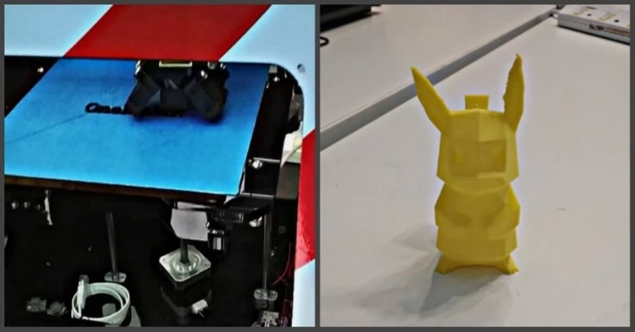

Figure 1:3D printing at OneMaker group and their replica

OneMaker Organisation

According to OneMaker websites, the team consist of 10 important people.

   Quartermaster: Bob Mischief Maker: William Finance: Lydia Operation: Jan


Engineering: Tee Designer: Robin Builder: Mark Builder: Sheila


Maker Coach: Hasan Maker Coach: Sathi

Resources: https://www.onemakergroup.com/

Services Provided by OneMaker

There are many services offered by OneMaker nowadays, one of it is known as Makerspace Development. OneMaker offer customer to have a session of consultation with their Makerspace specialist. They also supply customer with tools, machines and material to customize their own makerspace.

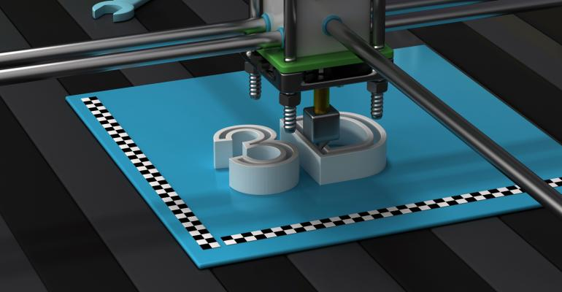
Next, OneMaker also provided some prototyping and consulting service based on 3D printing. Besides, customer may be able to get some printing services and able to rent some of their 3D FDM and SLA printer. According to the speakers during the visit, customer also can seek for their help in case customers are having problem to use the printer or want to repair the printer.

Somehow, OneMaker provided some event consultancy and management that allow customers to customize the content of the events. They will organise and conduct some events such as craft classes that enable students to learn sewing, leather crafting, water coloring, cosmology and maths in art, and many more.
The service provided are also easy to obtain, customer can access their websites and contact the company by the email provided.
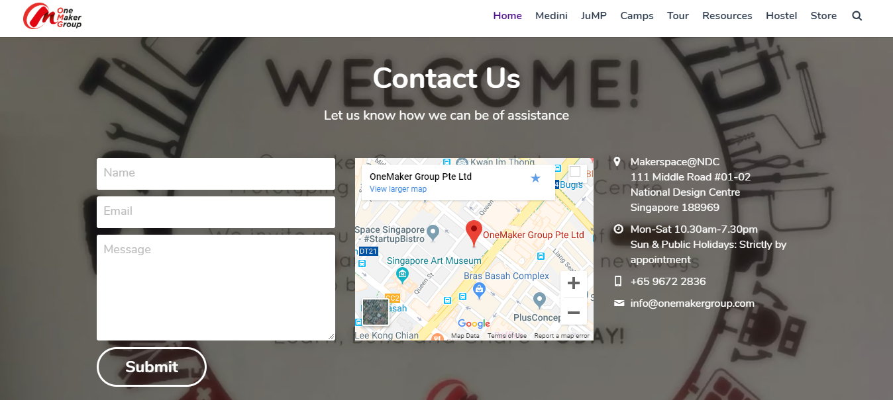
Resources: https://www.onemakergroup.com/
Achievement of OneMaker

- Won Principal’s Award for being very Conscientious in his approach to work (2013 Grade 6, Overseas Family School)

- Participated in Model United Nations as Delegate of Japan, Overseas Family School (Nov 2014)

- GEO HACKATHON 2015, project shortlisted for the final round on the 5th and 6th of December in 2015.

- Won 1st RUNNER-UP position in secondary category at Science Buskers Festival 2015, organized by A*STAR and The Science Center, Singapore.

- 3D printing

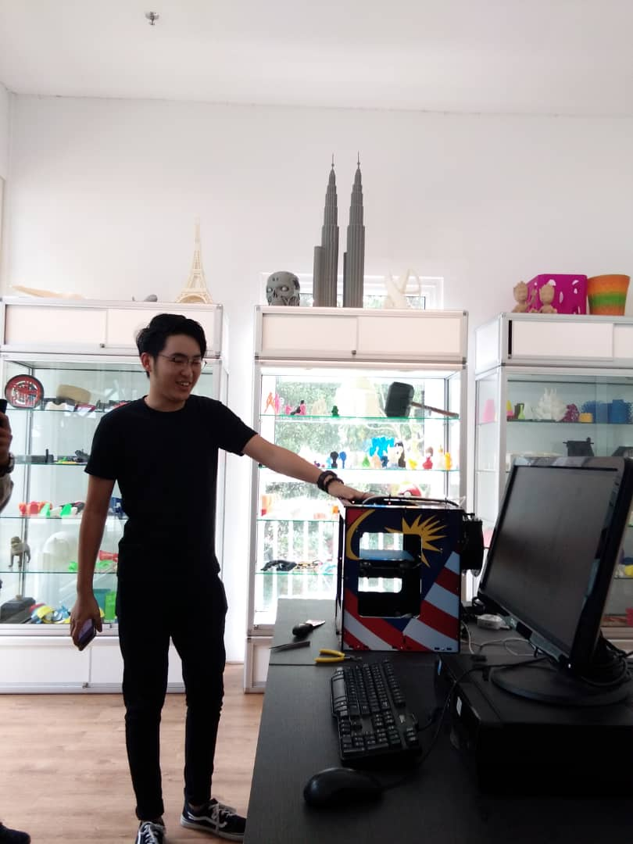
In this section my group get the first time to try 3D printing and use the application called doodle 3D to make our own names and such of things. 3D printing is such as an additive manufacturing creates physical products from a digital design file. There are several steps to produce the design which are design, file processing and production.

- Google Assistant
Google assistant is a big revolution in this era where humankind can really talk to a virtual human from a digital form. In this section of sharing session One Maker they show us how this google assistant works. First of all, we call “hey google” and the sensor will attract when there is a person calling. Second we can ask any question to the google assistant not only that we can also request for help. In this case the most amazing thing is when you ask a question your question will be transferred to the cloud computing where every data is there, so any question you ask will get the answer. Furthermore, google assistant also can help you on a booking schedule for saloon by just telling the google assistant “please set a meeting schedule for saloon this Monday” and it will work by its own self.
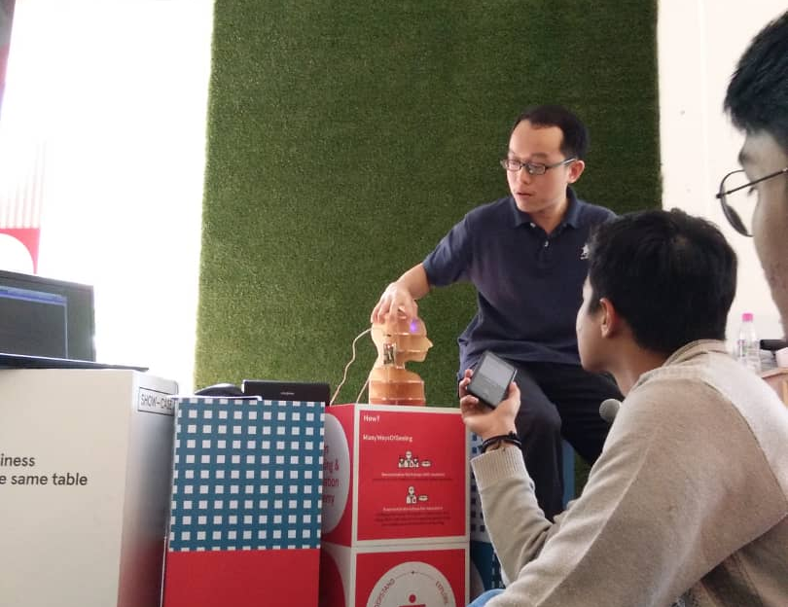

- Color Following Robot
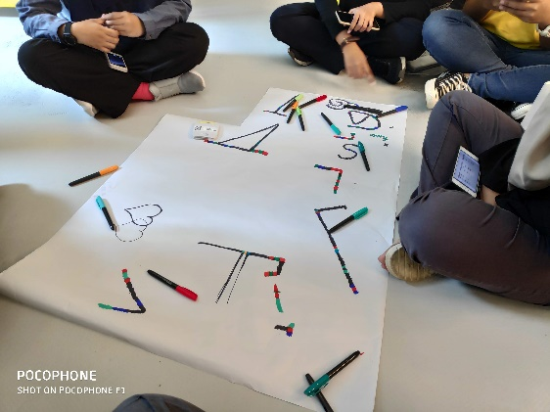
In this session, we can learn how to implement our coding knowledge into our daily activities. This robot is programmed and designed by a basic computer language. We can learn how to design a system by only using simple language. We might use the color line to decide where our robot will go. Our robot will follow the color line depends on color that we have drawn. By using this method, all of us can understand and learn easily how to encode a computer language in simple method. We can use any pen or marker to make the color line. But, make sure your color drawing is clear, so the robot can detect easily the color line.

- Drone
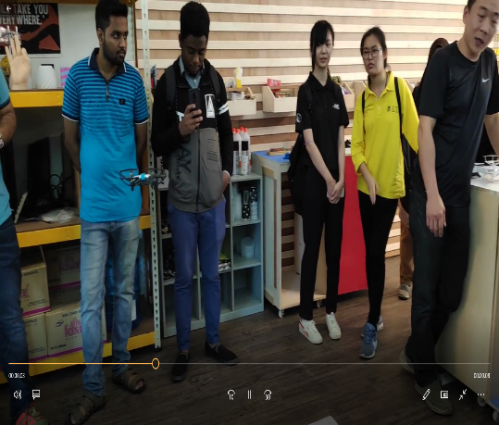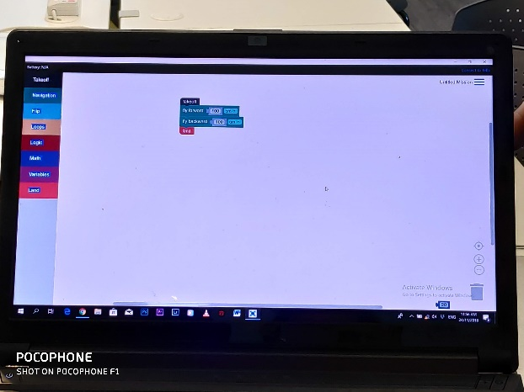
Basically, the concept is similar with color following robot. We need to manage our movement in the computer software that we will use. Then, we may use the software to control our drone movement. In this session, we can also know the usage and advantages of using drone in our daily life. We can use drone to ensure our home safety and to spy another people’s activity (For good purpose only).

- Design Sketch

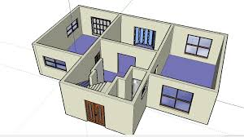
SketchUp is one of the software that we can use to design 3D Project/Prototype. In this session, we need to use a software that has been installed in our computer to make a design for a project that we want to make. In this session, we can learn and improve our knowledge in making a 3D project by using computer software. We can use any pattern that we want to use in our 3D Prototype.

- QuirkyBot Battle Robot
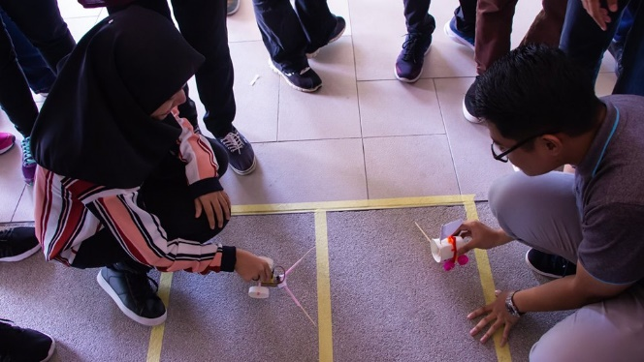
QuirkyBot Session is very interesting session for all of us. Firstly, all of us divided into a group of 2. All of us need to make an innovative and strong robot by using used plastic bottle. We must ensure the robot that we made is the strongest one. Why? Because in the end of the session, one representative in the group need to challenge their robot with another group’s robot in battle arena. The latest robot which stays in arena will become the winner.

Self reflection

Taufiiq bin Noor Azman
- OneMaker company has attracted me to artificial intelligence because this machine that have the ability to think indirectly make the lives of humans more easier.
- My ideal is to become a programmer who can create a multifunction software that can help a lot of people in this world, with the existence of artificial intelligence I can improve my system and cooperate with them.

Raziela binti Rosli
- In the modern world, we human depend too much from robot and the speaker as OneMaker said left me in thought what I can be in future as he said now robot can do programming.
- I think I need to learn hard to achieve my dream in future. I think it a necessary to always learn something new along a journey especially a skill.
Wilbert Harianto
- I feel encouraged to be more innovative and creative in finding a new benefical innovation.
- I need to be open-minded and up-to-date person by following the newest technology and trying to develop it by implementing my knowledge in Technology System.

Nurul Zahfiah binti Mohd Hamzah
- These activities make me realize that we, the humankind need to be more creative to compete with Artificial intelligence.
- AI does give us pro and cons, but as we are living in this modern technology era, we need to blend well with the new technology diversity itself instead of blaming the creation of AI.

Azka Nanda Mulia
- I got motivated by the One Maker I want to always make a new idea for the future where human can still work not controlled by the robots.
- I remember when they said “human intellect getting smarter but machine getting smarter much faster”
- I want to always create a great idea solve this kind thing when human being can still control machine and not dependent to the robot’s machine.

