

TITLE: INDUSTRIAL TALK 2 – (NALI UTM 2018)
DATE: 25th-26th SEPTEMBER 2018
VENUE: DEWAN SULTAN ISKANDAR, UTM
COURSE: SCSJ – SOFTWARE ENGINEERING
SUBJECT: TECHNOLOGY AND INFORMATION SYSTEM (SCSP1513)
SECTION: 05
TEAM MEMBERS:
NO. | NAME | MATRIC. NUMBER
1 | MUHAMMAD AFIQ BIN ZAIDIN | A18CS0118
2 | MUHAMMAD AIDIEL BIN JAMALLULLAIL | A18CS0120
3 | NUR ANIS HANANI BINTI ROBIDAN | A18CS0185
4 | NUR AKMA NADIA BINTI SUHAIMI | A18CS0183

LECTURER’S NAME: DR NOR AZIZAH SA’ADON

TABLE OF CONTENTS

TITLE PAGE
1. INTRODUCTION (TRENDS IN NALI)………………………….……...........1
2. GO GREEN SCHOOL-…………………………………………………........2-3
COMMUNITY SERVICE LEARNING (BOOTH 42)
3. EDUTAINMENT MOBILE APPLICATION-…………………….……......4-5
KEMBARA NOMBOR (BOOTH 29)
4. ADAPTATION GUIDELINE FOR DIFFERENT TYPE OF. …….………6-7
LEARNERS IN ONLINE LEARNING SYSTEM (BOOTH 65)
5. MRMD DIGITAL BOARD (BOOTH 11) …………………………….…....8-9
6. REFLECTION………………………………………………………………...10

1. INTRODUCTION (TRENDS IN NALI)

UTM’s NALI (New Academia Learning Innovation) Framework was introduced in 2013 to transform the learning and teaching landscape in a university to be future-ready in an era of 21st Century Learning. Over the years, many initiative have been introduced under NALI. And important step forward would be to provide and avenue for the sharing of NALI’s best practices in an ambience that embraces innovation and transformation in learning & teaching and this has led to the organization of NALI 2018. NALI 2018 was organized to provide a platform to showcase and celebrate innovative and transformative practice, research and products in learning & teaching in line with Education 4.0 and the promotion of STEM Education. They also aims to recognize excellence in innovative learning & teaching through the NALI.

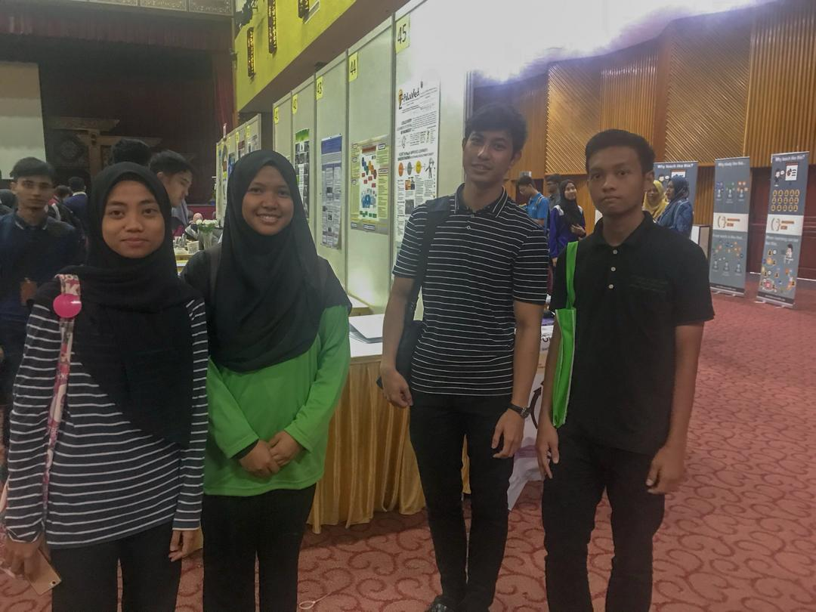

2. GO GREEN SCHOOL-COMMUNITY SERVICE LEARNING (BOOTH24)

The go green school is a project that include UTM students and form 3 students and the teacher of SMK Infant Jesus Convent in Johor Bahru. The project aim to develop the social community engagement between student and community through greening the environment.

2.1-OBJECTIVES
The objectives are to inculcate the awareness on the importance of protecting our nature, to create more planting areas at the school in promoting oxygen production, to create beautiful school areas, creating botanical garden and harvest the crop eventually, to develop a relationship between university and schools community and nevertheless promoting our university’s programme.

2.1-SIGNIFICANT
The significant of this project includes creating awareness among students and school communities on the importance of protecting our nature with the inculcation of herbs and trees planting. The herbs we choose are chili, tumeric, lime trees, curry trees and cabbages.

2.2-METHOD
Students are assigned to take care of the plant and they come to monitor the growth progress fortnightly throughout the semester. The school pupils are assigned according to classes of which planting area to be taken care of the sense of responsibility of the condition of the plants. Furthermore, the research method like a simple survey was concluded among the form 3 students involved after a month of the project and they are satisfied with the project. The school principal would like them to conduct more similar programs to encourage the students’ awareness and involvement with such activities. It has been called student to student edutainment, the process of the product meaningful and interactive activities with many materials.

3. EDUTAINMENT MOBILE APPLICATION – KEMBARA NOMBOR (BOOTH 29)

Kembara Nombor is a mobile application of game for children on age between 4 to 5 years. Basically this application is just to educate and expose them with number system from 0 to 9.The speaker said that, normally the children will confused with some number. For example number 2 and 5.

3.1-THE APPLICATION
This application is invented to help the children to recognize number system. There will be no mathematical operation such as addition, subtraction, multiplication or division. So when launch this application the user will input their name and their gender to create an avatar. The inventor thought that the children will be more interested to this application if they have an avatar. After created the avatar, the screen will display 3 activities in which the level of difficulty increase from 1 to 3. So the user need to choose by tap the screen. For the first activity, it requires the user to rearrange the number that has been scatter around into a sequence whether increasing or decreasing. Next, the user will be given 30 seconds to search for number and tap it in increasing order which is from 0 to 9. The third activity is quite challenging, where some graphic will be display and user need to count it. Maybe it seems easy for us, but to the children on that age, it is quite tough. For that reason the inventor created this application.

3.2-PUBLISHMENT AND ACHIEVEMENT
Unfortunately, this application still not available on the Playstore or Appstore. This is because there is some problem with the copyright. The application has been published in 2016 and it also has achieved award in a competition in Melaka.

3.3-ADAPTATIONS
The mobile application was developed using Adobe Flash, Adobe Photoshop as well as AIR programming. First the developer analyze the target user so the finished program will attracted them and after the analyzing it is found the avatar are needed in this program. Although the application has been published, implementation and evaluation are still in planning.

4. ADAPTATION GUIDELINE FOR DIFFERENT TYPE OF LEARNERS IN ONLINE LEARNING SYSTEM (BOOTH 65)

In developing online learning system, the different type of learners must be taken into account to ensure learner are totally engaged in the online learning process. Most of the current online learning systems failed to satisfy different types of learner and not considering their differences in learning, thus they are not adaptive in the actual sense. Therefore, there is a need to propose a guideline for an online learning system that will accommodate for all learners regardless of their differences.

4.1-OBJECTIVE
The objective of this project is actually to propose an adaptation guideline for online learning system that accommodate all types of learners through individualize content and adaptive presentation.

4.2-SIGNIFICANT
The significant of this research are mainly focus into difference types of users which are learners and educator. Learner with different learning styles may view the different presentation of the same Educational Module (EM) on the online learning system. The concept of this process is to provide all learners with the same knowledge, however the method of the presentation is adapted differently based on learners type. Thus, learners accomplish their learning goal. While for educator, it help them to prepare and develop most appropriate learning environment that support the different type of learners. It can be used as a medium of learning platform using technologies to adapt educational content, presentation, navigation support and education services.

4.3-APPLICABILITY

The applicability for learner through this project is that different learner can view the different presentation of the same educational material based on their learning style. While for educator they can prepare educational material that support the different types of learners. The impact from this program is different type of learners gain same knowledge through different presentation of educational materials. Hence, learner will engage in the learning process.

5. MRMD DIGITAL BOARD: A NEW WAY ENGAGING WITH STUDENTS

The founder of MRMD Digital Board is the Faculty of Accountancy, UiTM. MRMD Digital Board represents new era of teaching and learning technology which transform the style of teaching of the lectures and change the learning style of students into a better and more creative way using digital platform. This platform enable students and lecturers to share information by using QR (Quick Response) code.

5.1- OBJECTIVES
MRMD digital board offers digital platform with the objective of enriching and enhancing the classroom experience by using QR code. This platform helps students to learn better and help lecturers to teach through better engagement.

5.2-INNOVATION
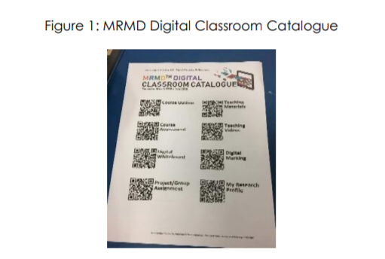
The materials for teaching need to be uploaded on the PADLET once. When new or updated material uploaded for the existing material, the PADLET application will be automatically updated without the need to create new QR codes. All QR codes for each element is placed together on a piece of paper called MRMD Digital Classroom Catalogue (Figure 1). Lecturers can share information with students more effectively by sharing this catalogue. (Figure 1)

5.3-APPLICABILITY AND IMPACTS
By using QR codes for all teaching materials provides more venue for the lecturers to be more creative in providing knowledge to their students. Students will be more attracted to gain knowledge in more creative way. MRMD Digital Board also provides students to be more prepared for the workplace as the students are made familiar with emerging technologies by using this platform as part of their learning process.

REFLECTION

Education, being a social institution serving the need of society is indispensable for society to survive and thrive. It should be not only comprehensive, sustainable and superb but most continuously evolve to meet the challenges of the fast-changing and unpredictable globalized world. This evolution must be systemic, consistent and scalable, therefore educator are expected to innovate the theory and practice the teaching and learning as well as all other aspects of this complex organization to ensure quality preparation for all students

