

FACULTY OF COMPUTING
UNIVERSITI TEKNOLOGI MALAYSIA, 81310 UTM JOHOR BAHRU, JOHOR MALAYSIA.

NAME: JEAWAN NAAYAGAR A/L KANAKASABAI
MATRICS NO. : A18CS0084
TOPIC: IOT OPEN DAY 2018 (PREDECTIVE MAINTENANCE TALK)
DATE: 18 NOVEMBER 2018
TIME: 11.00 AM – 12.00 PM
VENUE: FACULTY OF ELECTRICAL ENGINEERING, P03-221

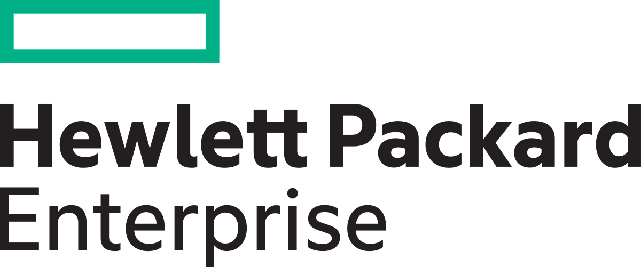

What is Hewlett Packard Enterprise?
Hewlett Packard Enterprise or also known as HPE is a developing information technology company. This company are the origin of Hewlett Packard Company and HP Inc. This company was spilt into two sections where servers, storage, networking, consulting and support, and Financial Services.
Now days, this company had been updated their service from printing device and computers services to Hybrid Cloud Data Protection. This is due too data loss from device failure, physical data protection and data breaching.
Cloud service helping us now days to access to our data anywhere and anytime. But do you think is it secure? This is where HPE providing their service to secure our data. No more worries about network error or corrupted data.
The main objective of HPE is to implement the application of Artificial Intelligence. HPE main focus are on the industry field. By having this type of program could help them to do work efficiently.

What is Artificial Intelligence?

Artificial Intelligence or else known as A.I is a type of intelligence that is to use in decision making system. Besides, that A.I also labelled as machine intelligence. Usually it is used in choice choosing system to work and react as human. At the beginning, it always been used in problem solving.

Where do Artificial Intelligence is used?

HPE had been using the AI in their Data Center. By having this, they might secure and user could save their data from hackers get their information. Even the greatest Web Browser also using AI in their Data Center now days. This is due to, AI could help others to take their duties such as monitoring and storing data.

Application of Artificial Intelligence in Oil and Gas Industry

.

Based on HPE, by using AI in this field could save up cost. For example, an employer needs to pay a high cost for the employee that work at the oil drilling section due to higher risk. The most important thing is, AI could update the data as soon as possible and accurately without while drilling without waiting for the lab test. The virtual assistant could process general inquiries

The Enterprise Consultant Commercial and Public Sector of HPE, Mr. Syahrul Hafidz Suid told that this talk is mainly focused on final year and third year students. This is because, if they scored high mark on their final year project, HPE authorities would like to select the best two from UTM to give RM 500. 00 as reward and offer to work at Hewlett Packard Enterprise Malaysia.

