
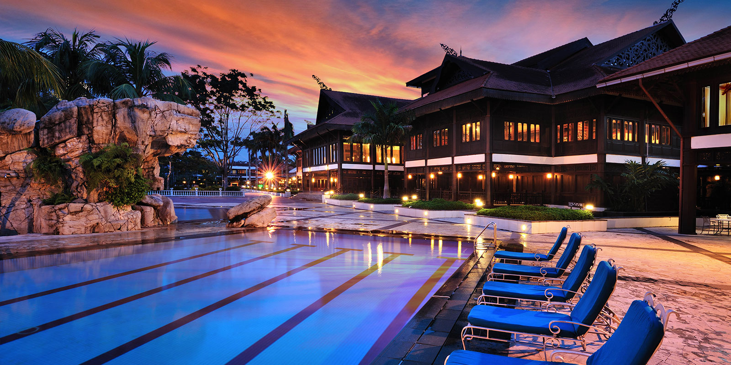
Welcome To Pulai Spring Resort






Looking for place to stay near Skudai ?
Come to us here Pulai Spring Resort!!! Only for RM 250 per nite…
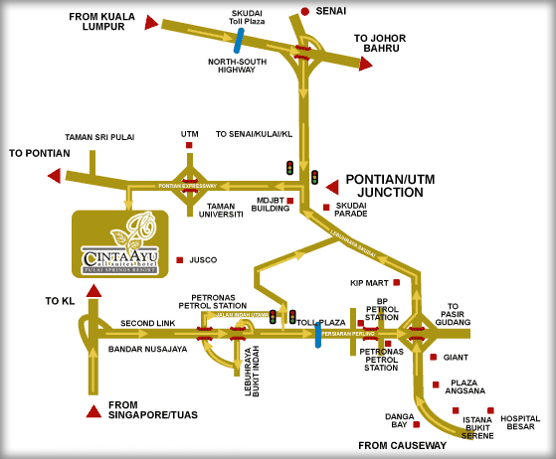
You could enjoy :
- Swimming Pool
- Playing Golf
- Spa Services

For contact :
Azura – 012 – 785 6650

