

SCSP 1513
TECHNOLOGY AND INFORMATION SYSTEM

INDUSTRIAL TALK 3:
IOT – PREDICTIVE MAINTENANCE GETS AN EXTREME MAKEOVER

LECTURER:
Dr Azurah Abd Samah

SUBMITTED BY:
Tang Kuan Yew (A18CS0261)

Semester 1 2018/2019

IOT – PREDICTIVE MAINTENANCE GETS AN EXTREME MAKEOVER
- INTRODUCTION

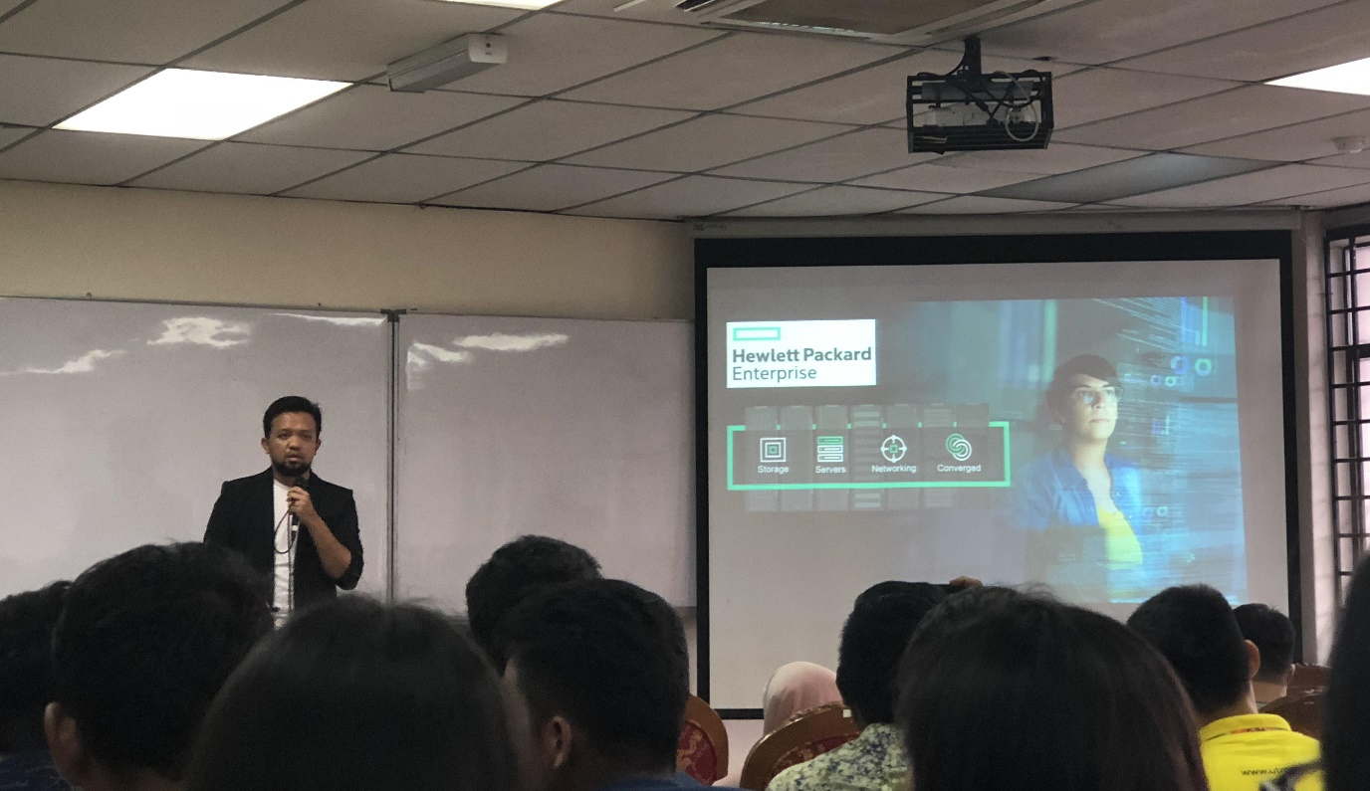
(Figure 1: Mr Syahrul Hafidz Suid)

On 18TH November 2018, all students from Technology and Information System (Section 8) attended a talk organized in P03-221 at 11AM. The talk was brought to us by Hewlett Packard Enterprise (HPE) and was presented by an experienced speaker, Mr Syahrul Hafidz Suid, who currently working as the enterprise consultant. From the talk, we got to know that the concept of IOT, how artificial intelligence plays role in industry and how we can contribute and get ourselves prepared for the industry. The talk was conducted in English and lasted for 1 hour including Question & Answer session.

- WHAT IS HPE?


(Figure 2: Hewlett Packard Enterprise (HPE))

Hewlett Packard Enterprise (HPE) is an American multinational enterprise information technology company that offers worldwide IT, technology & enterprise products, solutions and services. HPE provides technology that fuels transformation, delivers high-quality, high-value products, consulting and support services in a single package, and has been in the innovation business for more than 75 years. HPE is accelerating our digital transformation agenda by involving the three most important components: people, technology and economics.

(Figure 3: HPE in Digital Transformation Agenda)

- WORLDWIDE CIO AGENDA 2019 PREDICTIONS by IDC
The speaker first introduced us CIO, Chief Information Officer, where they create business value via technology. IDC (International Data Corporation) is a premier global provider of advisory services, market intelligence, and events for the information technology, consumer technology markets and telecommunications. IDC FutureScape has recently released 10 predictions on worldwide CIO Agenda.
10 Predictions by IDC FutureScape on worldwide CIO Agenda:
- By 2021, driven by LOB needs, 70% of CIOs will deliver "agile connectivity" via APIs and architectures that interconnect digital solutions from cloud vendors, system developers, start-ups, and others.

- Compelled to curtail IT spending, improve enterprise IT agility, and accelerate innovation, 70% of CIOs will aggressively apply data and AI to IT operations, tools, and processes by 2021.

- By 2022, 65% of enterprises will task CIOs to transform and modernize governance policies to seize the opportunities and confront new risks posed by AI, ML, and data privacy and ethics.

- Through 2022, 75% of successful digital strategies will be built by a transformed IT organization, with modernized and rationalized infrastructure, applications, and data architectures.

- By 2020, 80% of IT executive leadership will be compensated based on business KPIs and metrics that measure IT's effectiveness in driving business performance and growth, not IT operational measures.

- By 2020, 60% of CIOs will initiate a digital trust framework that goes beyond preventing cyberattacks and enables organizations to resiliently rebound from adverse situations, events, and effects.

- By 2022, 75% of CIOs who do not shift their organizations to empowered IT product teams to enable digital innovation, disruption, and scale will fail in their roles.

- Through 2022, the talent pool for emerging technologies will be inadequate to fill at least 30% of global demand and effective skills development and retention will become differentiating strategies.

- By 2021, 65% of CIOs will expand agile/DevOps practices into the wider business to achieve the velocity necessary for innovation, execution, and change.

- By 2023, 70% of CIOs who cannot manage the IT governance, strategy, and operations divides between LOB-dominated edge computing, operational technology, and IT will fail professionally.

Among these 10 predictions, Mr Syahrul stressed on Prediction 2: Compelled to curtail IT spending, improve enterprise IT agility, and accelerate innovation, 70% of CIOs will aggressively apply data and AI to IT operations, tools, and processes by 2021. He told us about how important AI (Artificial Intelligence) plays its role in today industry especially when it comes to data interpreting, data organisation and predictive maintenance. Based on the research done by Computerworld Tech Forecast, 30 % organisations agreed that big data / analytics is one of the disruptive technologies that most likely to have an impact on them over the next three to five years. From this research, we knew that a massive development in AI and implementation of AI in operations of industry are highly demanded in order to solve these problems.

(Figure 4)
(Source: Computerworld Tech Forecast 2017)

- INDUSTRY REVOLUTION
For better understanding towards nowadays trend in industry, Mr Syahrul explained about the industry revolution. In Industry 1.0, which is around 17th and 18th Century, water and steam power to run mechanical production facilities were mainly used in the industry. At the early of 20th Century where it began Industry 2.0, the use of electrical power had replaced water and steam to enable work-sharing mass production. Industry 3.0 started in early 1970s, it was the time where electronics and IT were gaining popularity in industry. In today’s Industry 4.0, cyber-physical systems had been invented to monitor, analyse and automate business.
There are several technology trends in Industry 4.0, namely Big Data, Augmented Reality, Additive Manufacturing, Cloud Computing, Cyber Security, Internet of Things, System Integration, Simulation and Autonomous Robots.

Big Data | - Collection and comprehensive evaluation of data from many different sources  - Data from production equipment, systems, enterprise and customer management system  - Standard to support real-time decision making
Augmented Reality | - Provide workers with real-time information to improve decision making and work procedures
Additive Manufacturing | - To produce small batches of customized products
Cloud Computing | - Machine data and functionality  - Enable more data-driven services to production systems
Cyber Security | - Joining forces from industrial-equipment vendors
Internet of Things | - Devices connected in 2015: 4.9 million  - Forecast: 20.8 billion in 2020
System Integration | - Companies, departments, function and capabilities  - More connected and cohesive
Simulation | - Leverage real-time data  - To mirror the physical world in virtual model
Autonomous Robots | - Evolving for greater utility

- PREDICTIVE MAINTENANCE
Mr Syahrul then explained about predictive maintenance and how it actually contributed a lot in nowadays industry. He introduced us a real life example created by Flowserve, a company that captures sensor data from heavy-machinery, performs analytics, and then uses machine learning by comparing this data with information from other equipment to predict failures before they occur.
He showed us a video on how predictive maintenance was implemented in a heavy machine. Data of the heavy machine was captured and displayed using Augmented Reality and Simulation. When the engineer made a slightly adjustment on the machine, the frequency of vibration increased and sensor data was sent to be analysed. It then displayed the probabilities of all outcomes including when will the machine stop operating, when to service the machine and so on.

- IOT CARNIVAL EXHIBITION
After the talk, we then visited the exhibition of IOT Carnival 2018 to get more information.
6.1 SMART LOGISTICS: RFID TRACKING SYSTEM
RFID is the use of wireless signals to transfer data between microchips. The chips can be inserted in tags, cards, or even living being such as pets. Nowadays, RFID has been widely used global wide. In Malaysia, it is commonly used in delivery services, logistics industry and transportation.
RFID is more precise compared to barcode as it allows people to track the location by using the reader. With this system, the whole package delivery process including classifation of packages, vehicle scheduling, path planning, transportation monitoring can be managed more effectively.
RFID has brought beneficial and convenience in the logistics industry as we could easily track the inventory. However, it is expensive due to high cost of microchips and might get influenced by interference occurred around the microchips.

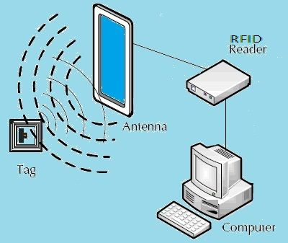
(Figure 5: RFID)

6.2 IOT SMART RETAIL (AMAZON GO)
Amazon Go is a mobile application used by retailers to connect with their customers by providing targeted information to enables consumers to make better informed decisions about which products or services to consume. Currently, it is launched in 3 cities, Chicago, San Francisco and Washington.
Customers have to register their bank cards into this apps and they can go cash free in shops that support this system. Once they have picked their products, they have to scan it with their phone. The microchips inside price tag will send information to their phone and let them know how much to pay.
This technology has brought lots of advantages including time saving, technical job opportunities, easy price tagging and global technology competition. Meanwhile, it also causes disadvantages such us limited service level, elimination of human interaction and vulnerable to hackers.


(Figure 6: Amazon Go)

6.3 IOT IN CUSTOMER SERVICE (E-RESTAURANT)
To cope with the problem of managing customers’ order during peaks hour, E-restaurant management system is implemented in lots of restaurants. This system helps to reduce the mistakes in taking orders compared to manually done.
This system implement the idea of Iot and technology from Zigbee to make the operation in restaurants more efficient. Zigbee is a low cost, low data rate and low power consumption advancing global standard in wireless IoT networks.
The system works in a very straight forward way. Customers place their orders using smart devices set up by restaurants and the order will be organised and interpreted by Zigbee and will then be sent directly to the chefs. If the order is not available, alert can be given by chefs directly to the customers to avoid miscommunication.
This system has reduced mistakes in taking orders and labour costs. At the same time, it shortens the order time taken and can attract more customers. However, the system is non-friendly UI and might have input errors sometimes. The transmission line is also limited as it uses infrared.

(Figure 7: ZigBee)

- REFLECTION
After the talk and exhibitions, I was amazed by how the use of the Internet of Things (IoT) technology can promote the intelligent level of the whole industry, may it be the manufacturing industry, logistic industry, information industry, business industry and so many more.
The implementation of technology in industry especially Artificial Intelligence has extended the life of assets, improved safety and reduced costs. Many of us might worry that AI will eliminate and cut down workforce. However, it does not. It actually gives an opportunity for the industry to expand and create more job opportunities such as data scientists to support the system.
As what Mr Shaiful has said, as students, we are the future assets of the industry. We must know what can we contribute to this industry and must get ourselves well-prepared within our study times. Mr Shaiful’s encouragement has motivated me to work harder to adapt myself in this latest Industry 4.0.

