

SCSP 1513
TECHNOLOGY AND INFORMATION SYSTEM

INDUSTRIAL TALK 1: GLOBAL ONLINE WORKFORCE (GLOW)

LECTURER:
Dr Azurah Abd Samah

SUBMITTED BY:
Tang Kuan Yew (A18CS0261)

Semester 1 2018/2019
INDUSTRIAL TALK: GLOW (GLOBAL ONLINE WORKFORCE)
1.0 INTRODUCTION
On 24th September 2018, all students from Technology and Information System (Section 8) attended a talk organized in School of Computing Seminar Hall at 4pm. The talk was brought to us by MDEC and was presented by an experienced speaker from Global Online Workforce (GLOW), Miss Nor Ashikin Binti Halil, who currently working as a freelancer and at the same time a master trainer for GLOW. From the talk, we got to know that the concept of crowdsourcing, working experiences of freelancers, how trainers of GLOW played roles to encourage people generating a stable digital income and how the program makes impact on country’s economy. The talk was conducted in English and lasted for 2 hours.

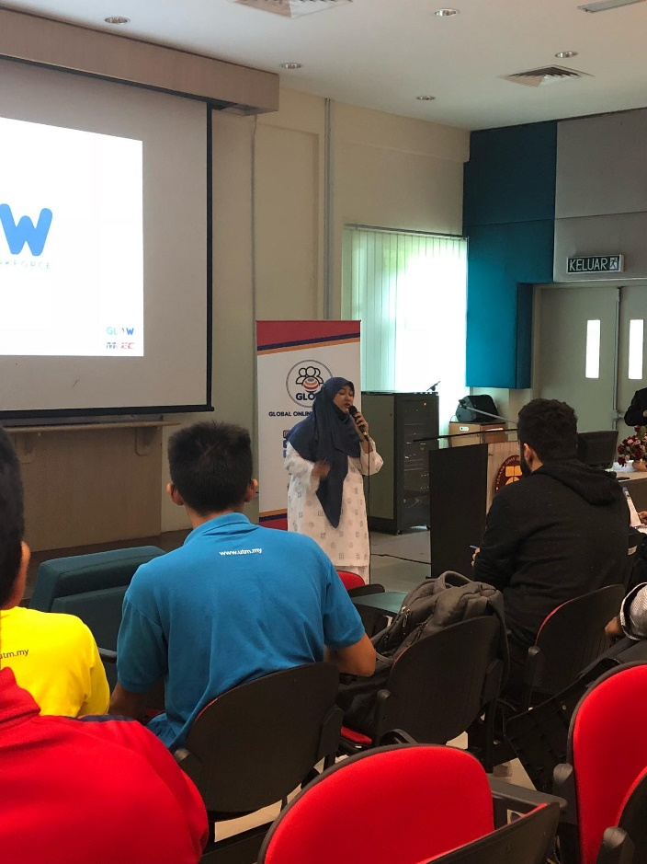
Figure 1: Miss Nor Ashikin Binti Halil was introducing GLOW

2.0 WHAT IS GLOW?
Global Online Workforce (GLOW) is one of the programmes under Malaysia Digital Economy Corporation Sdn. Bhd. (MDEC) to catalyse the transformation of Malaysia’s economy towards digital economy. GLOW aspires to nurture and coach crowd workers who are able to generate income of not less than RM 2000 per month consistently through digital platform. Besides GLOW, MDEC also launches programmes such as E-Usahawan to help local entrepreneurs by promoting their products digitally and E-Rezeki for easier jobs and tasks in digital platform.

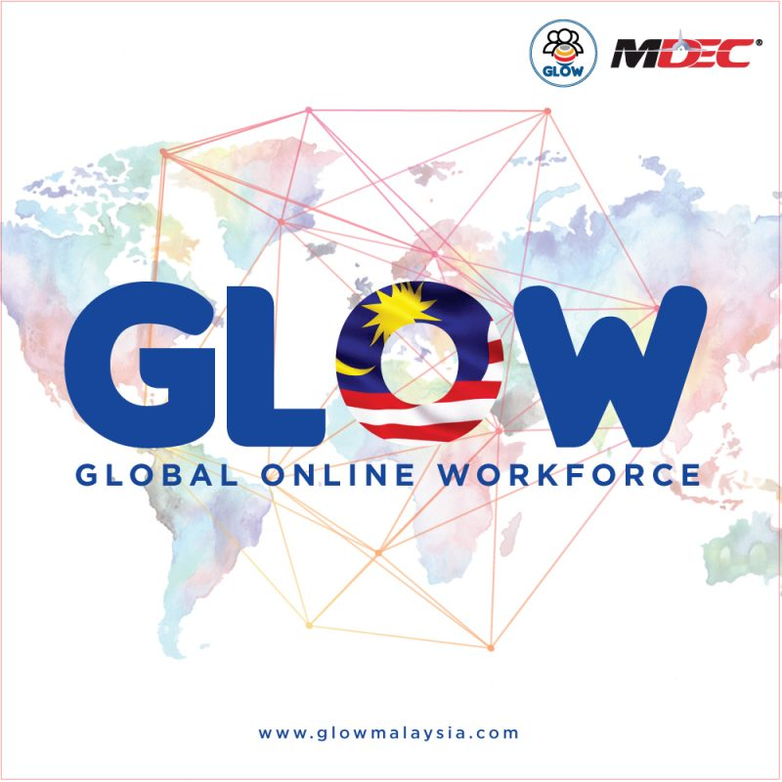
Figure 2: GLOW

3.0 BENEFITS OF THE PROGRAM
Knowing that crowdsourcing is the future trend, GLOW gives training to Malaysians to generate stable and fixed digital income under sharing economy. Based on fastcompany.com, sharing economy is an economic model based on sharing under-utilized assets from spaces, stuffs, to skills for monetary or non-monetary benefits. Currently, GLOW collaborates with some of the world’s largest crowdsourcing platform such as Upwork.com and Freelancer.com and also local-based platform such as Kerja Digital and Supahands Dotcom Sdn. Bhd. Through these collaborations, GLOW trains public to become a competitive and successful freelancer in not only local platform but also global platform. Under the engagement with these strategic partners, GLOW manages to establish a sustainable model to support and motivate all freelancers. GLOW also helps participants to be more disciplined by having to finish the job given independently within limited time constraint. Participants are no longer limited to certain amount of income as they could generate digital income based on their own capabilities. Various incentives offered to qualified participants, too.

Figure 3: Example of Sharing Economy

4.0 JOINING GLOW
4.1 How GLOW Gets People to Join Them
GLOW provides an alternative way for Malaysian to earn, not by selling products nor earning from internet, but by selling skills that we have. In fact, there are lots of fields in crowdsourcing platform that require professional hard skills. For example, programming, digital marketing, virtual assistant, data entry, graphic design, search engine optimisation (SEO), translation, web developer and writer. Experts from GLOW Training Centre provides free full time intensive training for 3 months to qualified participants. All apprentices are given hands-on exercises and monitored by experienced mentors. From the activity calendar of GLOW, we can tell that GLOW are organising free programs at all around Malaysia such as Fast Track and Higher Learning Institution. All we have to do is to register under specified category including public, students, retrenched workers, senior pensioners, unemployed individuals and underemployed individuals. GLOW also offers incentives to qualified participants to encourage and attract more people to join this program.
4.2 Who Can Join the Program?
Although intensives are given in different forms, but hard skills training is not included. Hence, participants should possess specialised skills sets to fulfil selection criteria. Regardless of educational background, participants are selected based on their commitment, passion and determination to work as an active freelancer.

Figure 4: Selection Criteria for Program Participants (Source: glowmalaysia.com)
The program is open to B40 group, however, is prioritised to experienced crowd worker in local or global crowdsourcing platform, experienced offline and face-to-face freelancer, registered individuals in employment programs, unemployed graduates or retrenched workers and also committed individuals aspiring to be freelancer with qualifications in certain fields such as IT, translation, designing, marketing, etcetera.

5.0 FREELANCER.COM
To work as a freelancer, there are basically two platforms to choose: international platform such as Freelancer.com, Upwork.com, Shutterstock.com or domestic platform such as Kerja Digital, Freetimeworkz.com and 123RF. However, Freelancer.com is featured by our speaker in the talk as it is easy to access and more suitable for new freelancer for the huge varieties of job types available. Freelancer.com allows employers and employees from all around the world to find and connect with each other. It is a marketplace that allows employers to post jobs while global freelancers compete with each other through bidding process. Employers and freelancers set up profiles on the site and they will receive reviews of people they work with or for after every completed work.


Figure 5: Freelancer.com
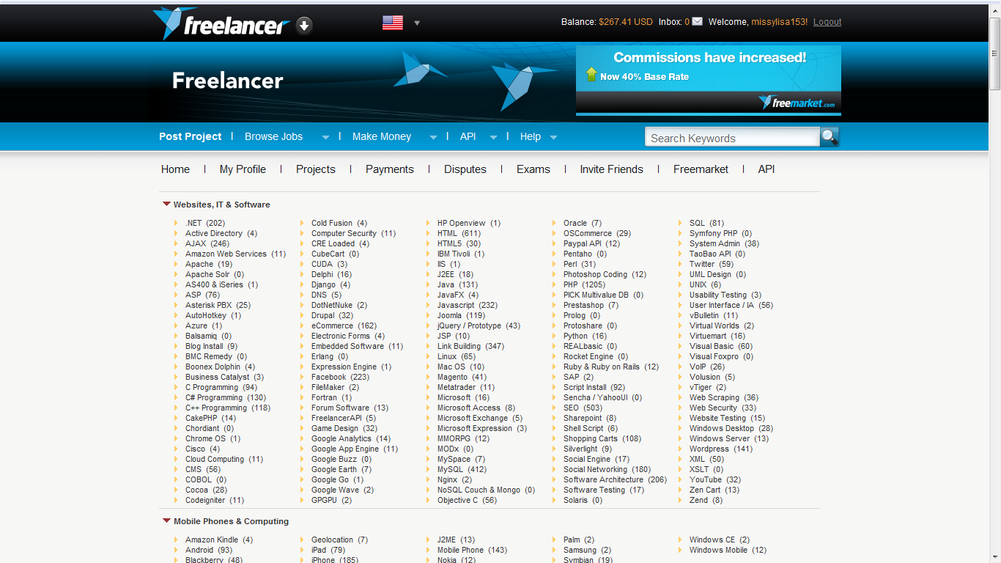
Figure 6: Example of Job Variety Available in Freelancer.com

6.0 IMPACT OF PROGRAM TO MALAYSIA
Through these years, digital economy in Malaysia has shown significant growth. The greatest challenges in digital economy of all time are the lack of digitally skilled workforce, no prioritised budget and the perception of digital income is not stable. However, MDEC provides all Malaysians a structured approach to digital transformation by implementing GLOW. Apart from generating extra income, GLOW gives opportunity to everyone to start their “own business” for digital work. GLOW contributes a lot to the development of Malaysia’s economy as many unemployed graduates and retrenched workers manage to generate a fulltime stable income via this program. Digital Economy has great potential to enhance new job opportunities as well as increasing employment opportunities in some existing occupations in both government and private sector. In this way, the unemployed rate of country is bound to decrease. Furthermore, one can maximise their earnings through freelancing, which in turn will make great impact to the development of local economy. Nevertheless, the rise of freelancing may be an indicator of the future of work, notably in terms of global collaboration practices. Currently, freelancers are already facilitating clients or firms from other countries to manage their projects. Soon enough, they will also be communicating and collaborating with society at large whereby it acts as a catalyst towards globalisation of our country.

7.0 REFLECTION
After listening to the talk, I am motivated and impressed by the concept of crowdsourcing and freelance working. Global well-known entrepreneurs such as Jeff Bezos (founder of Amazon), Jack Ma (co-founder of Alibaba.com), Mark Zuckerberg (co-founder of Facebook), Garrett Camp (co-founder of UBER) and Brian Chesky (co-founder of Airbnb) have well-used the crowdsourcing platform and make such a great transformation of digital economy. They are such a great inspiration for all of us especially for those who are about to kick start their freelancing career.

Figure 7: Well-known Entrepreneurs on Crowdsourcing Platform

Furthermore, I get to know that being a freelancer not only allows me to work flexibly, it also motivates me to sharpen my hard skills and keep it up to date to be a competitive freelancer in global platform. As a student, I can also generate extra income whenever I’m free to reduce parents’ burden. It is also a great chance for me to get myself involved in global platform to widen my vision before I graduate and step into the real society. Working as a freelancer will also sharpen my soft skills including communication skill, problem solving skill, strong work ethic, time management ability and others as I might need to deal with clients from other country and at the same time to take care of my study.
In a nutshell, I strongly agree that GLOW is really a good platform for all of us, especially for non-experienced freelancers as they give training and guidance from basic to advance. From joining this program, it gives us an alternative way to make a living as well as make contribution to our country’s economy.

