Technology and Information Systems (SCSP1513)
Industrial Talk Report – MDEC GLOW

BY:
MUHAMMAD AMIR SYAFIQ BIN MUSTAFA KAMAL

LECTURER’S NAME:
DR. NOR AZIZAH SA’ADON

DUE DATE:
07 OCTOBER 2018

2018

  - Recently, School of Computing for Faculty of Engineering with the collaboration of Malaysia Digital Economy Corporation (MDEC) had organized an event which is a talk about their program, Global Online Workforce (GLOW). The talk was held on 24 September 2018, from 4 p.m. to 5 p.m. at Seminar Hall, N28a Building, School of Computing for Faculty of Engineering. The main point about the talk is to give a briefing about their program, Global Online Workforce (GLOW) and what the initiative that this program give to all of us. The speaker of this talk was Nur Ashikin Binti Halil. She is from GLOW and she also one of the master trainer for GLOW. She was born in Skudai, Johor. She grows up in so many places but currently she live at Kangkar Pulai, Johor. She’s graduated from Universiti Teknologi MARA (UiTM), Melaka in Office Management and Technology. She was also serving as personal assistant and her last station is as executive personal assistant to the high level of IKEA. However, now she’s currently working as a freelancer for almost 3 year’s already since 2015 that she had never plan to be before. Surprisingly, she was being taught about free lancing at this faculty, which is in this school of computing. Her father was from Yemen while her mother was from China. The amazing things about her that impressed me a lot was the capability of her to be fluent and master in seven(7) different languages which is Malay, English, Mandarin, Hangul (Korean), Hindi, France and Spanish language. That’s a bit information and biography about her.
  - Based on what the speaker have said during the talk, Global Online Workforce (GLOW) program is basically one of the programs organized by Malaysia Digital Economy Corporation (MDEC), a government agency under the Ministry of Communications and Multimedia Malaysia (KKMM), other than e-Usahawan program. The program generates a consistent and full-time digital income for Malaysians through the “crowdsourcing” method. “Crowdsourcing” method is a digital income method where work is offered and implemented digitally on global platforms such as “Freelancer.com” and “Upwork.com”. In other words, we can simply say that this program helps us to earn income only through an internet. People tend to have a misunderstanding about this program which is most of them thought that this program was selling a product. However, actually this program does not selling any product instead, it’s help us selling our skills and talent. Skills or talent that will be very useful for us to earn income in this program such as programming, translation, digital marketing, graphic design, web developer, virtual assistant, data entry, writer and much more depends on that person’s skills. Global Online Workforce trains, mentors and cultivates trainees into full-time digital workers & generates monthly income with a stable and consistent minimum of RM2, 000.
  - There are several reasons on why this GLOW program was being organized. First and foremost, this program was implemented to establish a community of capable digital workers in full-time. Besides, it is also to develop a sustainable model for high impact digital worker programs with the involvement of MDEC's strategic partners. Other than that, this program also being as a platform in introducing an alternative source of income for Malaysians through a global digital revenue platform. Moreover, GLOW also provides support programs for digital workers to remain motivated and committed to generating digital income. Furthermore, it’s also help in marketing Malaysia services and skills to the global market. This program is open to anyone who is interested and has a skill that can be very useful to others. However, there are certain people who are recommended and encouraged to join this program such as an experienced digital workers. Besides, those who has the qualification and talented also are encouraged to join this program. Examples of skills that are useful and being recommended to join this program are those who have a skill in the field of IT or ICT such as programming, websites, mobile application and others. Design and creative field also can be very useful skills such as graphic design, multimedia and others. Linguistic and foreign languages also one of the recommended field of skills that people have to join this program because of the skills that are very required and popular nowadays such as translation, transcription, and others in foreign language such as Mandarin, Arabic, French, Spanish, Hangul, and much more other language. Other than that, those who are a freelancers either an offline or face-to-face freelancers also are being recommended to join this program. Furthermore, those who are recommended to join this program also includes a IPTA or IPTS students who are qualified and skilled, unemployed private workers whose qualified and skilled as a digital worker, a pensioner that who are skilled to be a digital workers, a housewife whose have a skills to be a digital worker, as well as a young professional who has a two or three years working experience that wants to generate a higher side income with the skills they have.
  - Actually, in order to attract people to join GLOW, there are other programs that being organized by the GLOW itself that being offered to any people who are interested to join GLOW. One of the programs that being organized under GLOW is “GLOW@HLI’s” program. Future graduates from the Faculty of Computer Science, Information System, Communication, and Multimedia, Faculty of Language and Linguistic, Faculty of Business Administration, as well as Faculty of Education are recommended to join this program. The duration of the training for this program is one semester which is around six months. The advantages for those who are joining this course are individual mentoring sessions and online monitoring throughout the semester. The participants also will automatically become a member of Malaysia Freelancer Association (MAFA) as well as able to join all activities organized by MAFA. Besides that, another program that being offered under GLOW is “Fast Track” program. This program is recommended to a freelancer, a qualified graduate, or a private sector worker to join. It is also recommended to a pensioner and a housewife who are skilled to be a digital worker, as well as a young professional who has around two or three years working experience that interested to gain a higher side income. For this program, the duration of the training is just for two days. There will be an individual mentoring session in those two days. After that, there will be a online monitoring for around 10 days. The advantages for this program are still the same like the other program. Moreover, both of those programs are just for free. The will be no fees that need to be paid for anyone who want to join those program. Those are the examples of what the initiatives that GLOW do to get people to join GLOW.
  - There are a lot of examples of a success story from the participants who have join GLOW and now they become more and more success. One of the examples is the speaker itself. After she joins GLOW, she already gains a total income around RM177, 980.00. The profiles being listed below are the examples of the success story for those who have joining GLOW.
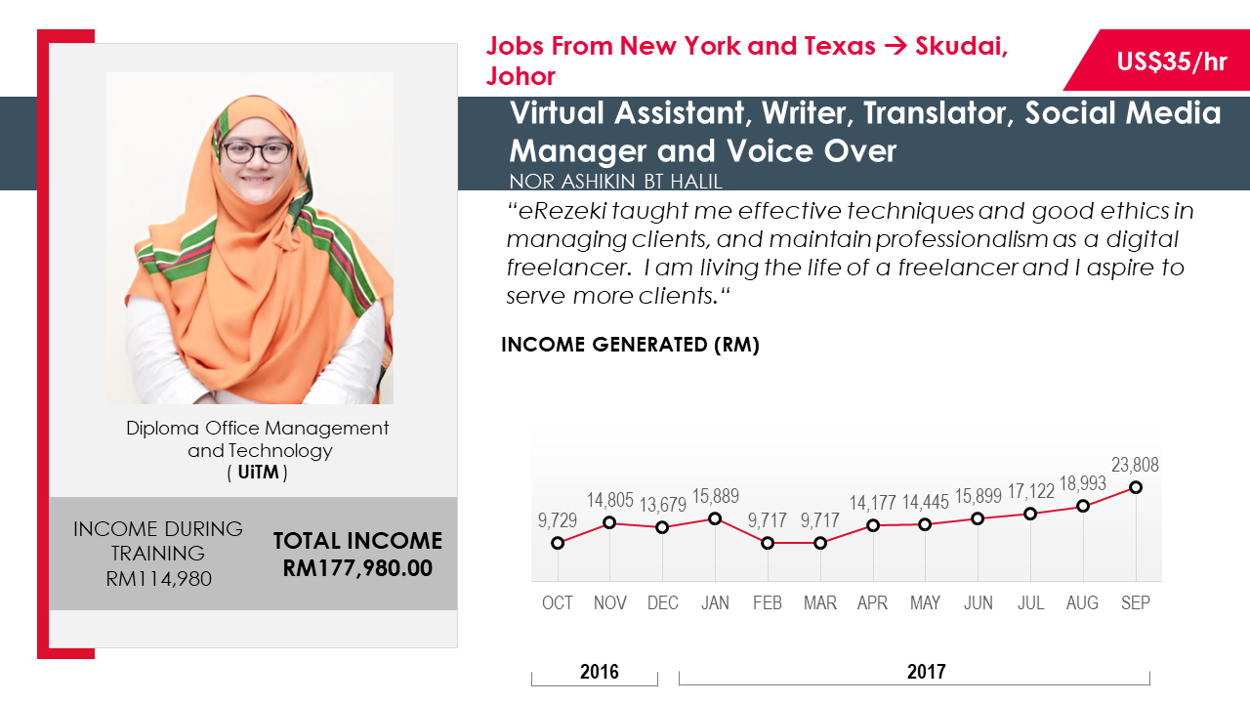
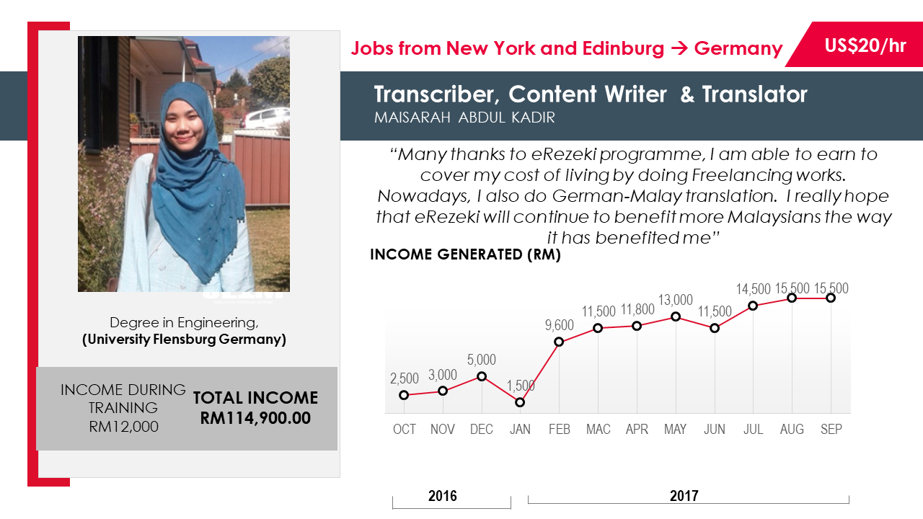
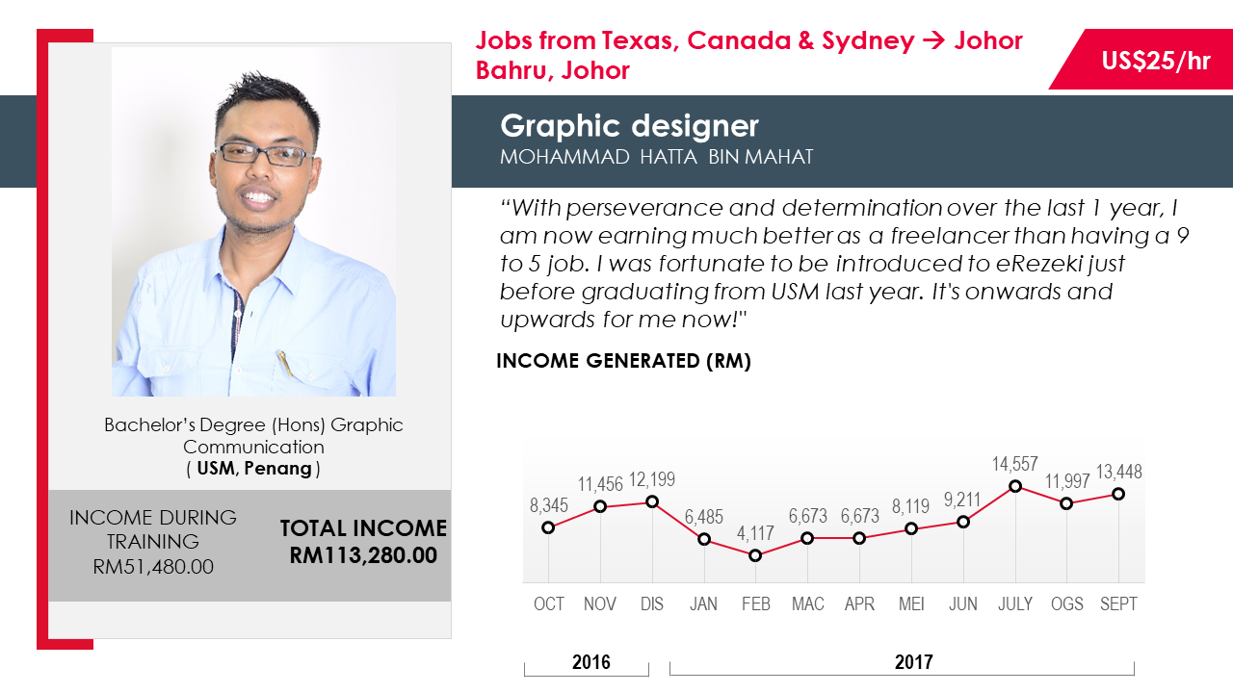
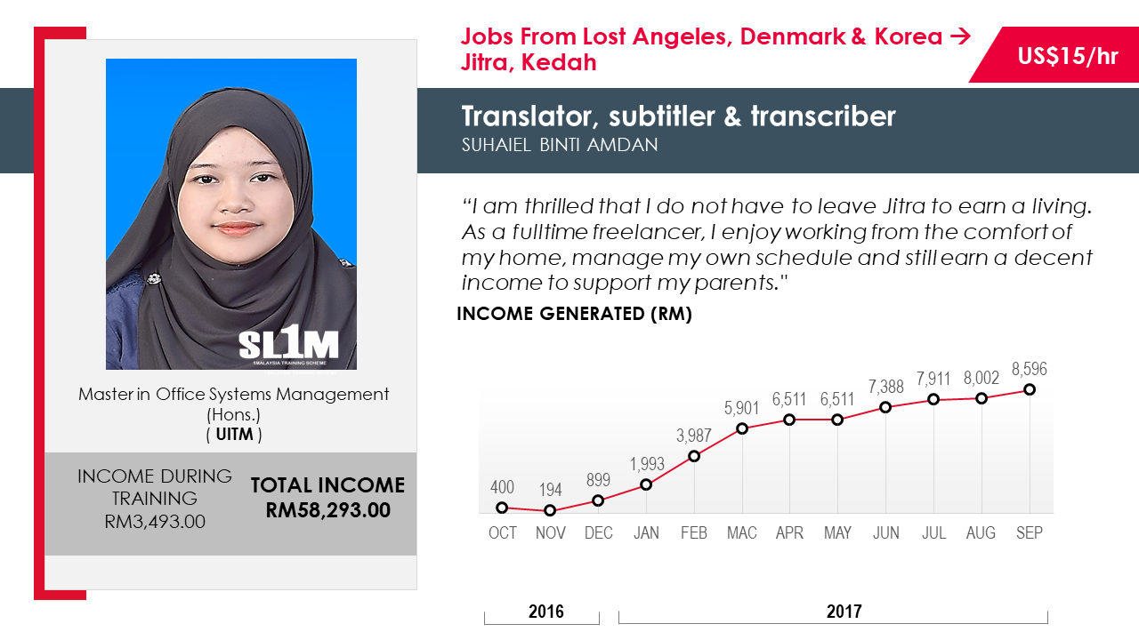

  - Why people should join GLOW? The speaker briefly stated that people should involve and join GLOW because it is a platform that gives a chance for us to generate digital income monthly. Besides that, it is flexible for those who joined GLOW to do their digital work at anytime and anywhere. Other than that, GLOW also generates digital income according to our individual ability and needs. Furthermore, GLOW also gives a big chance to the participants to open a digital employment agency business. Actually, there’s a lot of impact of this program to Malaysia. First and foremost, one of the impacts of this program to Malaysia is reducing the unemployment statistics. It is because with GLOW, it provides a lot of chance to our society to get a job especially to the new graduate students that still doesn’t has a job. So with GLOW, there will be more jobs available and a higher chance for our society especially for new graduate students to get their job and automatically the number of unemployment will decrease. Aside from that, another impact of this program is increasing Malaysia’s economy as well as make Malaysia become more popular in digital work sector.

  - In conclusion, from the industrial talk, my reflection that I have gain through the talk is there are actually a lot of chance and various kind of job in digital world that I didn’t realize before. As long as we have a skill in certain things, we can actually make it worth for ourselves. In fact, even though we not a higher educated person, but still we can become success and also more success than those whom are higher educated than us. Last but not least, GLOW gives a lot of advantages to us either we realized it or not and I believes there will always has a chance for us to become successful in our life as long as we brave to try something new.

