Industry talk
Who is the is the speaker of the talk ? she is Nor ashikin halil born in Skudai graduate from uitm : Universiti Teknologi MARA System faculty of office management and technology and she is a freelancer for almost 3 years her father is from Yemen and her mother from Malaysia she has two bosses in new York and she is a CEO in Malaysia and she earns about 500 dollars a week and she speak 7 language and she worked as a voiceover
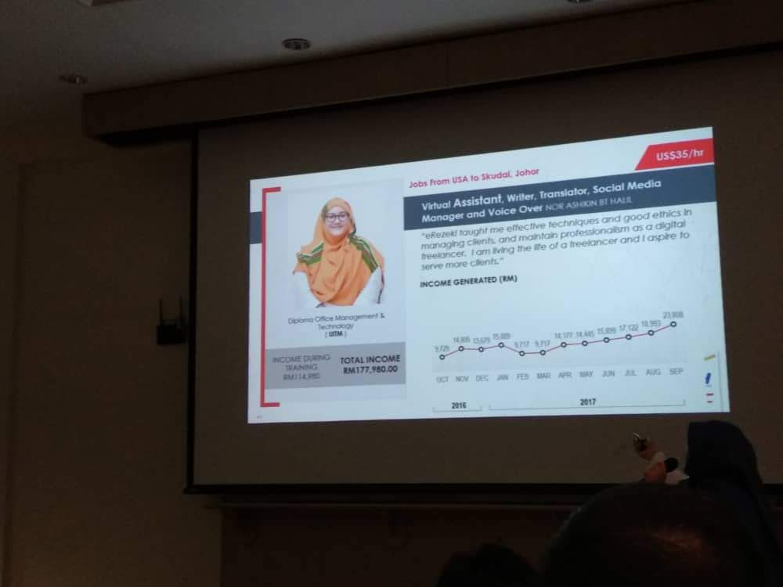
What is glow and what are the benefiets of glow? Global Online Workforce (GLOW) is an initiative by MDEC, which aims to create a community of competitive digital workers among Malaysians who can earn jobs or projects from global crowdsourcing platforms, in order to generate alternative incomes and is the understanding of freelancer glow train you to be freelancer credits for http://www.ums.edu.my/v5/en/banner-link/6971-training-of-trainers-global-online-workforce glow doesn’t sell product they sell skill
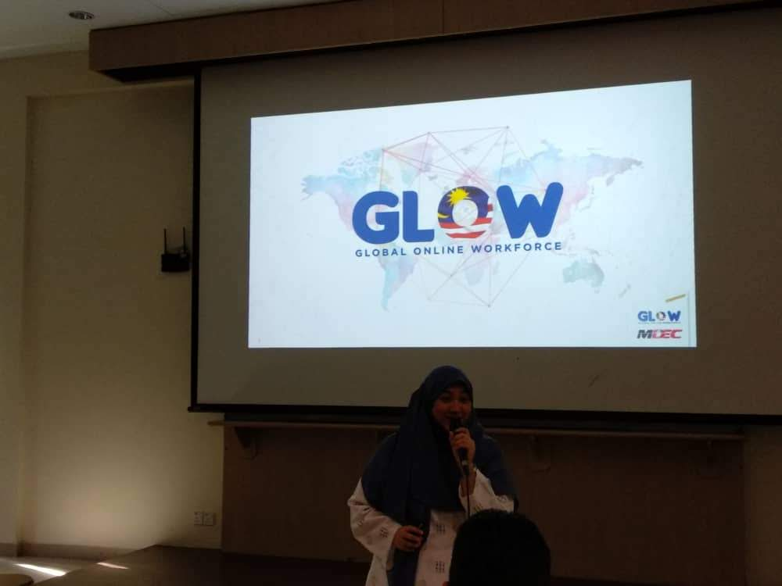
And she talked about sharing economy like Facebook , Airbnb , amazon and many more application for example like man who made Airbnb doesn’t have many house and hotel he only deal with other people that have hotel or a house to rent and he take a small percentage from the money and amazon he doesn’t have store the make a deal with other store and sell from other store and also take percentage and Facebook you can communicate with other people.
And doctor nor ashikin halil she talked about freelancing What is freelancing ? freelancing is a person who is self-employed and is not necessarily committed to a particular employer long-term and she gave examples of some people in the college who are freelancing 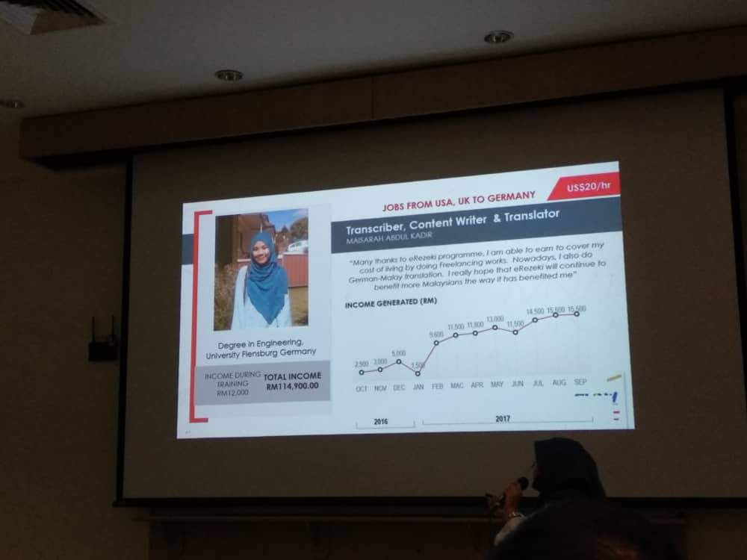
For example this girl name is maisarah abdul kadir she has a degree in engineering and she is freelancing as a transcriber , content writer and a translator in October in 2016 she earned 2500 rm and at September 2017 she earned about 15000 RM this like a year form where she started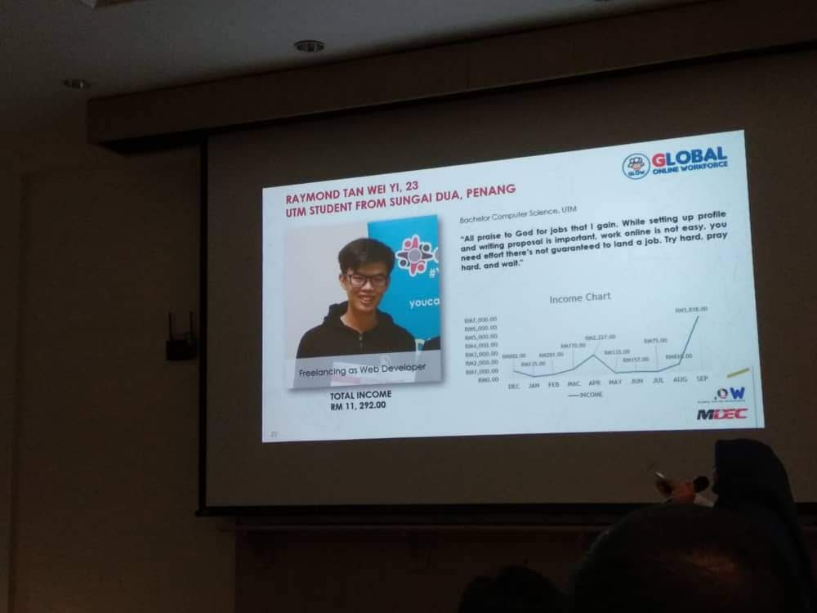
This young man also is a freelancer too his name is Raymond tan wei he is 23 and his a student in utm university bachelor degree in computer science and freelancing as a web developer what the meaning of developer web developer is a developer that design a website for example some need a website a store for electronic or a webstore for merchandise and his total income is 11292 annual in his first year is a freelancer he didn’t made that much money as he now his ffirst year is a freelancer he earned about 2000 per year now he earn about 11292 see the difference and he is only a student there are a lot of student who are freelancing because they can ease the university bills on there parent and can help there parents to live a better live

In glow you work digitally like for example you open a website and in this website you will people who needs for to be made for them like you entered the website you will see people to make and advertisement about a restaurant a new meal has been released so you do coy writing or some one need you to make a voice over in a movie so he tells you to send a voice massage to him screaming and see if he liked your job or not if he liked it he will pay you check if he doesn’t he go for another one or someone give you a task to make a PowerPoint about the how diabetes can be deadly and you can earn a 20 dollar per slide if made 20 slides you earn only for these slide like 400 dollar for only a slide

Anyone can join glow you need only a good education and a English language to communicate with other people
The impact of global online workforce for Malaysia it will give people for chances to make more what if he or she have a good degree but can’t make more money in glow they can they join and chose a progame they what to work on and see if the people will like or not and if they like they can buy it from you
My reflection on the industrial talk it will give people more chances to make more many as they want and also college student can start their freelancing too be must do what they love to do like me example I like to do advertisement copywriting , copywriting is a way to advertise in commercial like for example of “you can get your dream car right only for 1000000 RM and you will have your dream car’’ for other people to gain more money but I’m not working as a freelancing but if I worked as a freelancer I will I like there are a lot of student who are freelancing because they can ease the university bills on there parent and can help there parents to live a better life
My reflection to this event that I have learned for glow is that you can chose your own schedule and your own work and I learned to learn how to freelance and the event gave the confidence to work alone glow is a good freelancer trainer you could train in glow and be a good freelance you could be your own work no bosses to tell what to do and you do is right or wrong
Thanks for reading this report

