INDUSTRIAL VISIT 2
24th November, OneMaker Medini, Iskandar Puteri
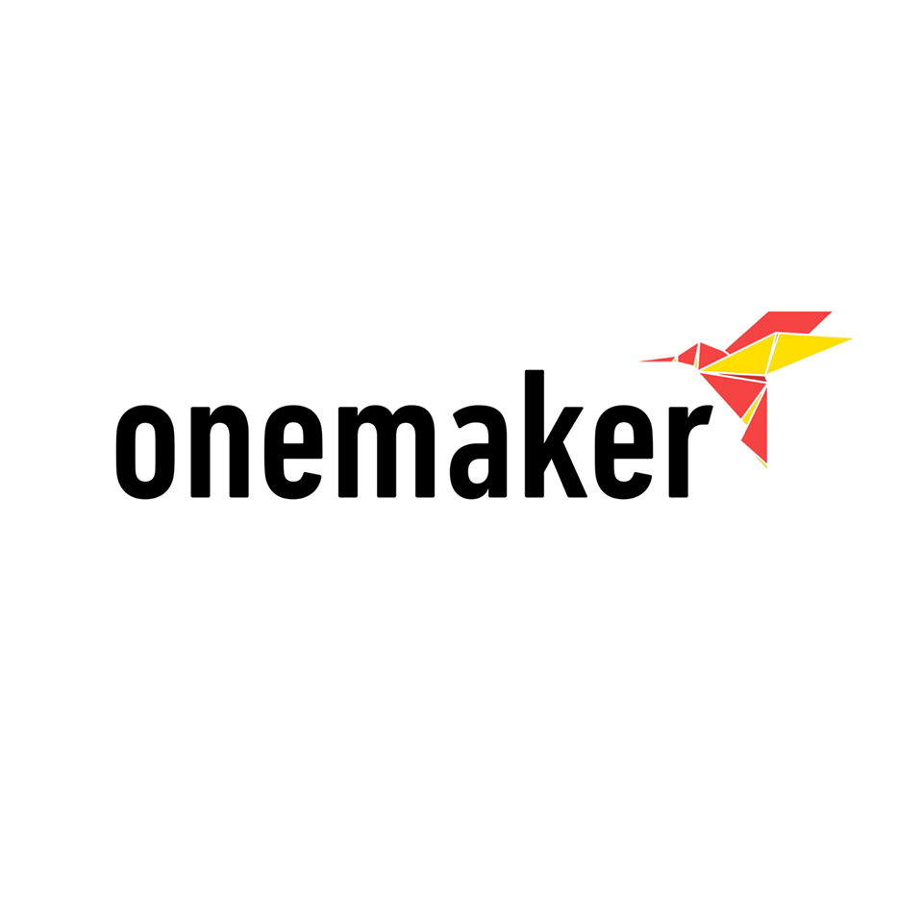

Post-event Report
Prepared by: Group 8 (Octagon)

1. Nurul Adila Binti Mohamad Kamil
2. Thilak A/L Sundaram
3. Ong Shi Bing
4. Raihan Muhammad Wilinio
5. Syed Sanzid Hasan
Introduction
On 24th November 2018, the students of the course SCSP 1513 visited One Maker Group (OMG) at Mall of Medini, Iskandar, Johor Bahru. The purpose of the trip was to visit and learn more about OMG, their services and facilities that they provide. The students were first taken to Forest City. Forest City is an island residence surrounded by green plants which created a forest-like environment which can fit up to hundred thousand residents. Using the latest technology, Forest City is an example of a modern residential area. They provide complete facilities such as recreation areas, hospitals, restaurants, grocery stores and even a huge golf resort. After a short tour the students were taken to the Mall of Medini, where One Maker Group have their offices. Students were then engaged in a series of activities prepared by the members of One Maker Group.

One Maker Group (OMG)
OMG is a group that is a maker-centric group that provide services such as making a prototype, having educational programmes and many more. They believe that thinking very important before making a certain prototype. Therefore, design thinking must be implemented when they are making a prototype.

Virtual Reality (VR)
The first talk we attended was about virtual reality (VR). The talk was hosted by UTM alumni Mr. Syukry Radzi. He is the co-founder of Gini Tech, a start-up which was established with help from OMG. He told us about the basic concept about VR and the history of it. He talked about how these technologies would affect the future and how we interact with computers.
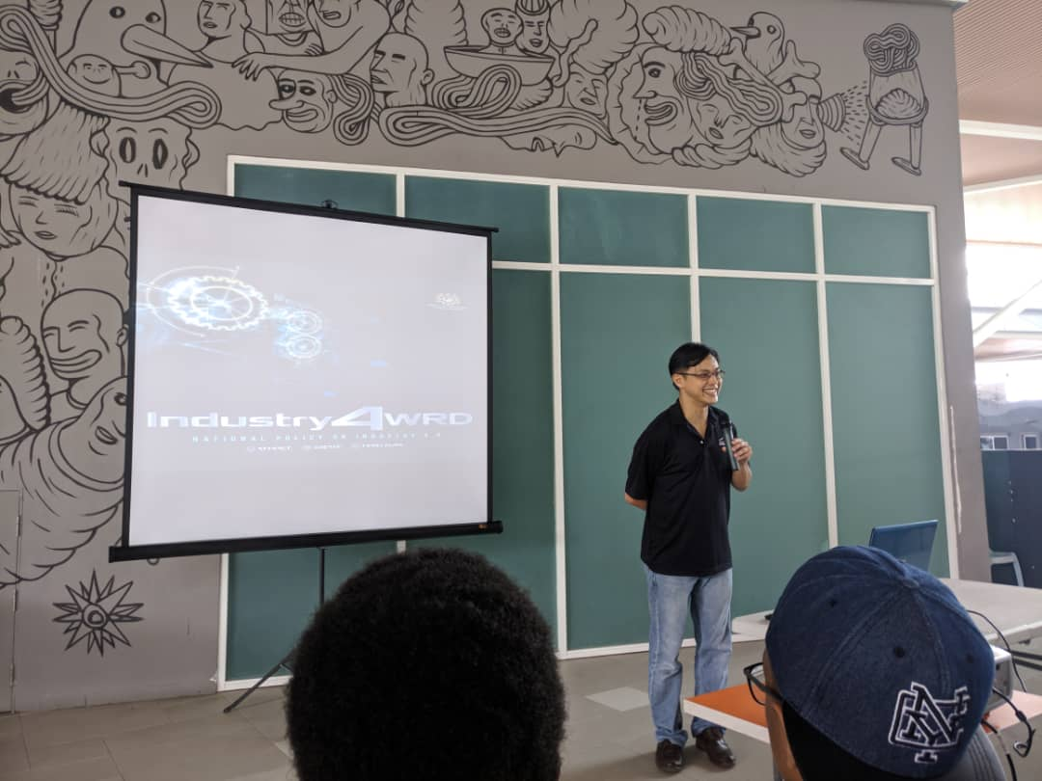
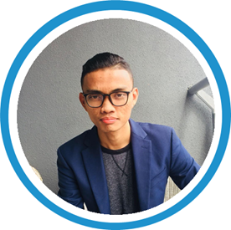
Shukri Radzi
Co-Founder Gini Technologies Sdn Bhd

Quirky Robot Competition
After the talk about VR, another member of OMG took over. He introduced us to Quirky Robots. These are small robots made using simple components just to teach basic robotics concepts. The students were given a motor and access to reused wastes. After that they arranged a tournament to test the robots. The objective was to be the last robot left in the arena. He told us that this type of competition was first held in Japan and now people from all over the world take part in this annual tournament. Students were grouped into pairs and each pair made their robots and compete.

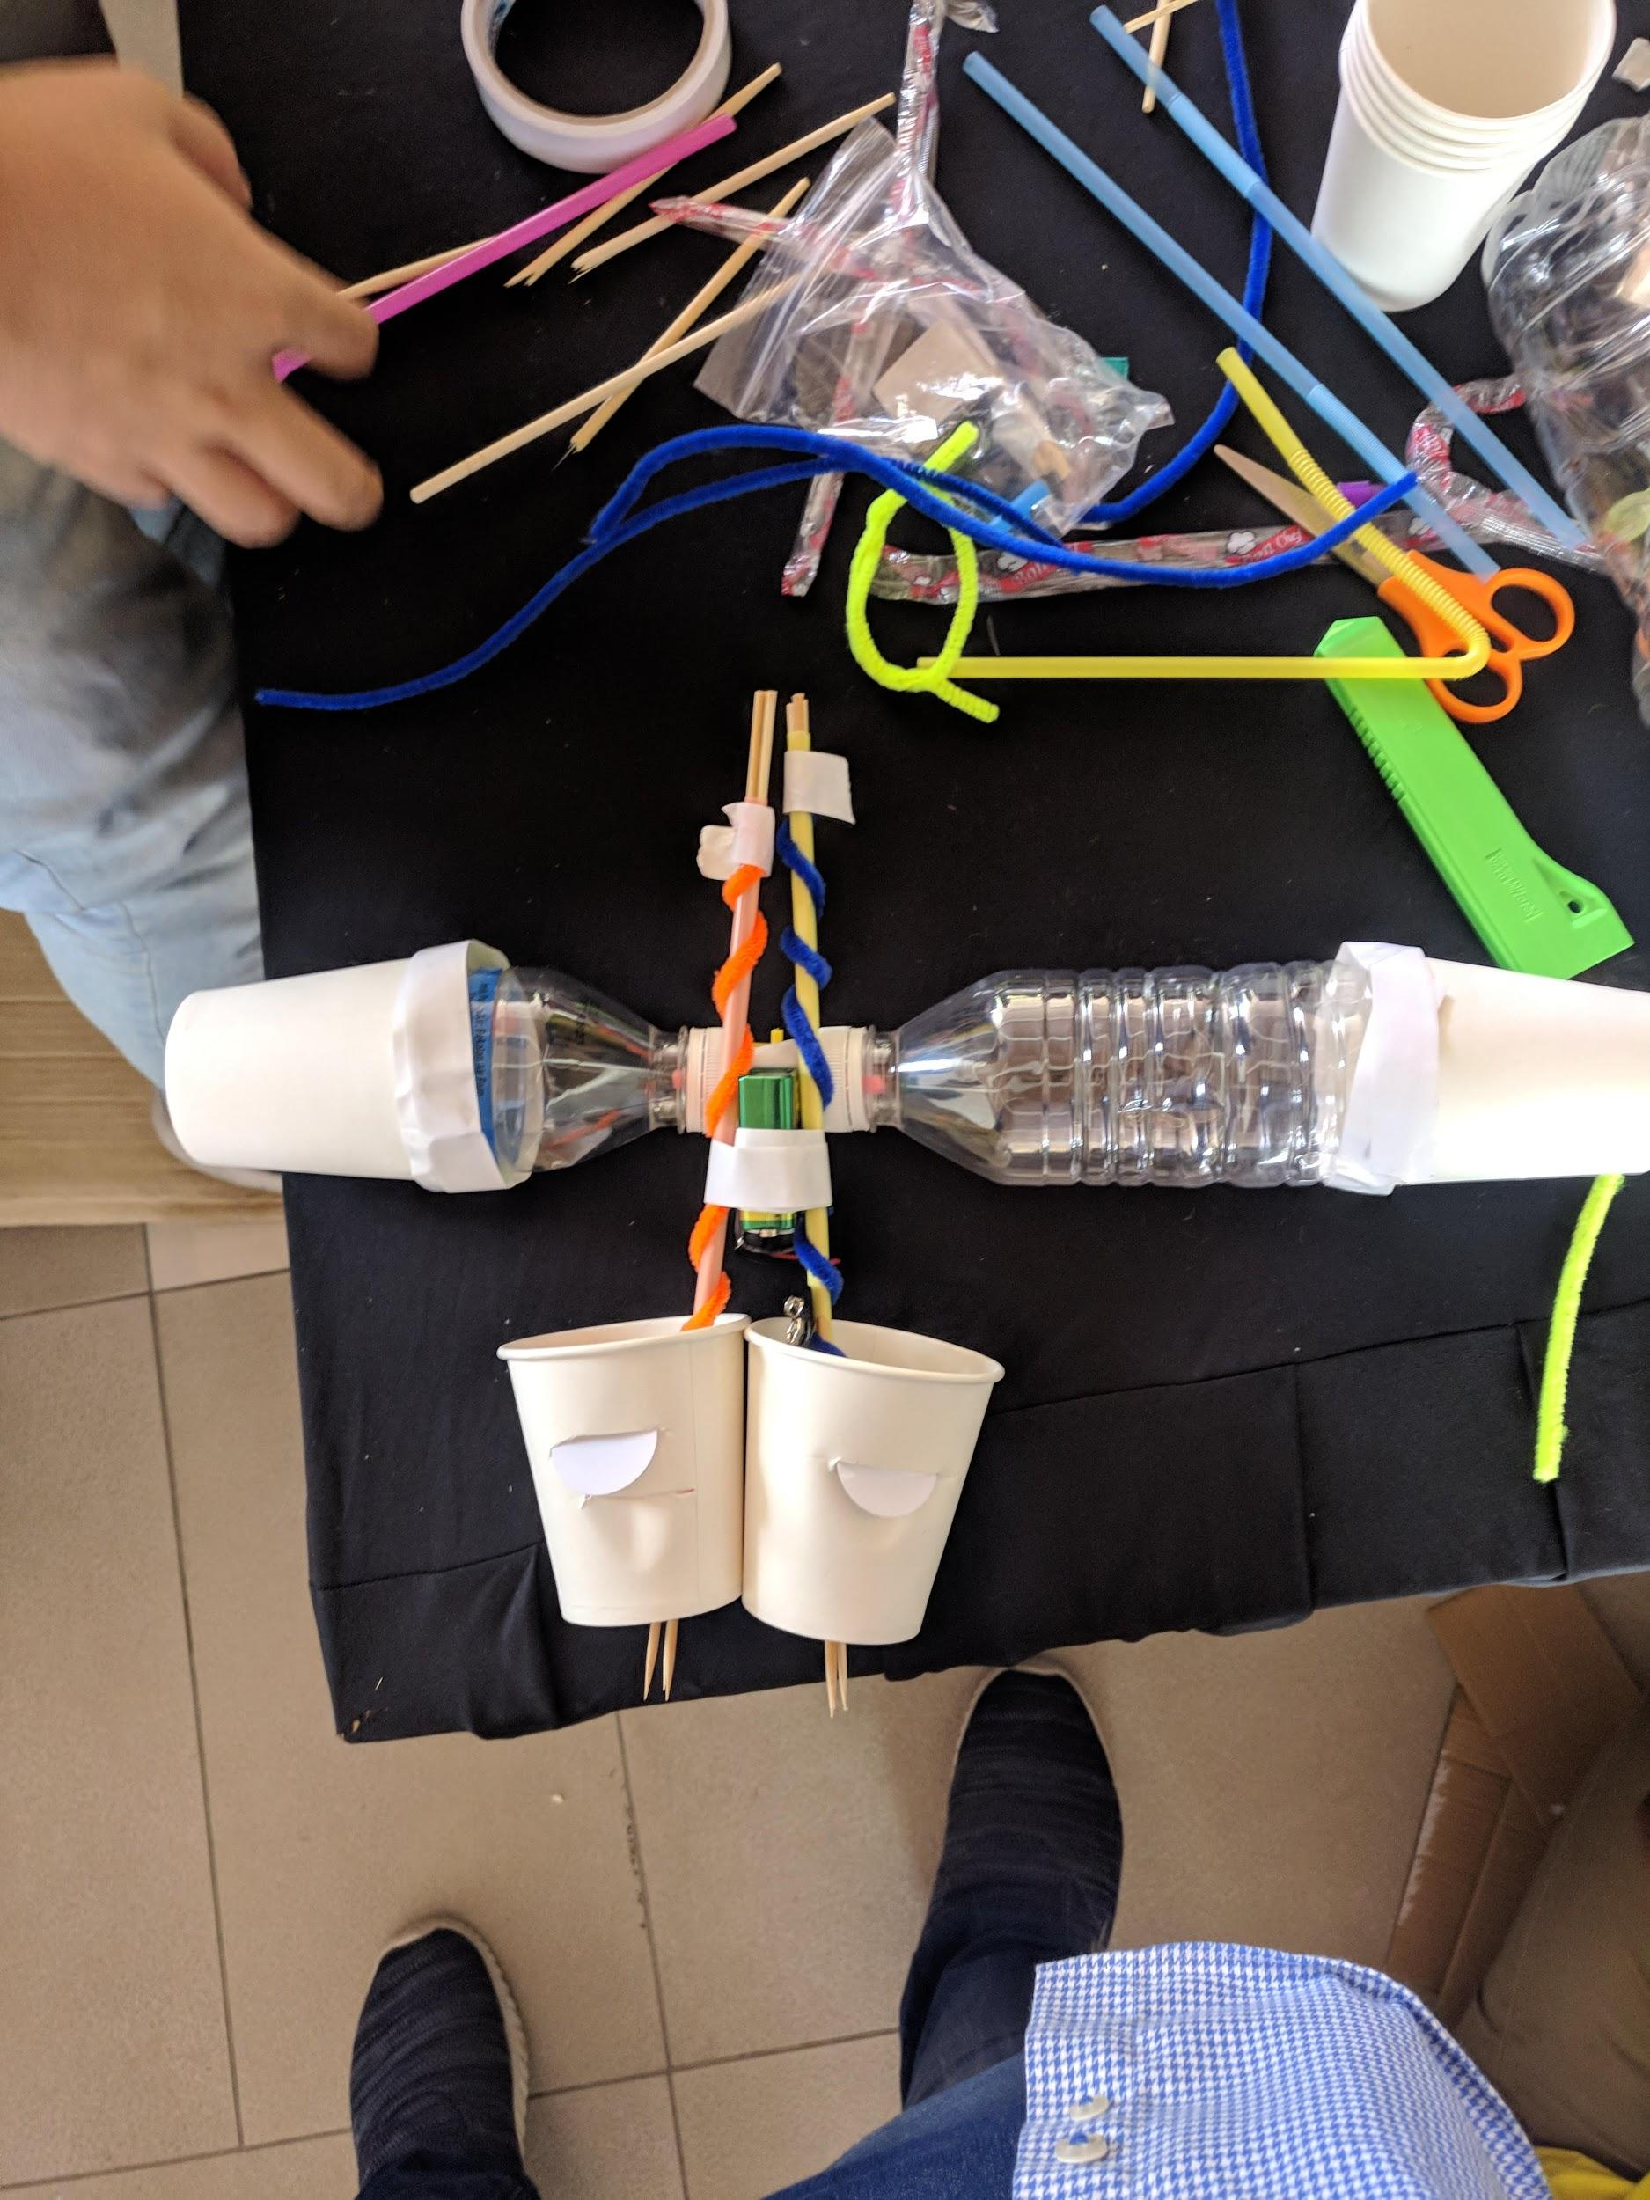
The Quirky robot we made.

3D Printer
During this session, a member of OMG showed the students a 3D printer. He introduced students the printer and told us some history behind it. After that, he gave the students a demo and allowed them to 3D print something by using a basic software and a 3D printer. Then, he showed us 3D printed models with different kind of shapes, colours and sizes. He told us 3D printers are widely used by many companies nowadays.

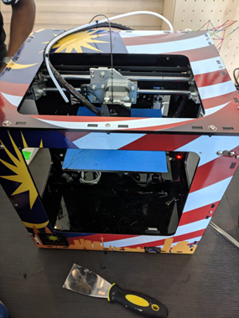 A 3D Printer

Voice Assistant Head
During this session, one of the members of OMG showed us a model head that was installed with a mini computer running a virtual voice assistant which is Google Assistant. He demonstrated to the students how it works by talking to the model head and asking it some questions and making it do some tasks. The speaker emphasized the growing role assistants like this will play in our daily lives and how it may help people in their regular tasks.

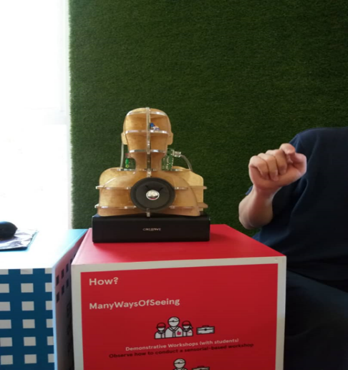

The voice assistant head

Colour Sensing Robot
In this session, students were shown a colour sensing robot. The robot follows a line and responds with different movements depending the colour codes that it sees. It can do movements like spin, speed up and reverse according to the colours it senses. The students were then allowed to make up their own circuits and loops for the robot to follow.

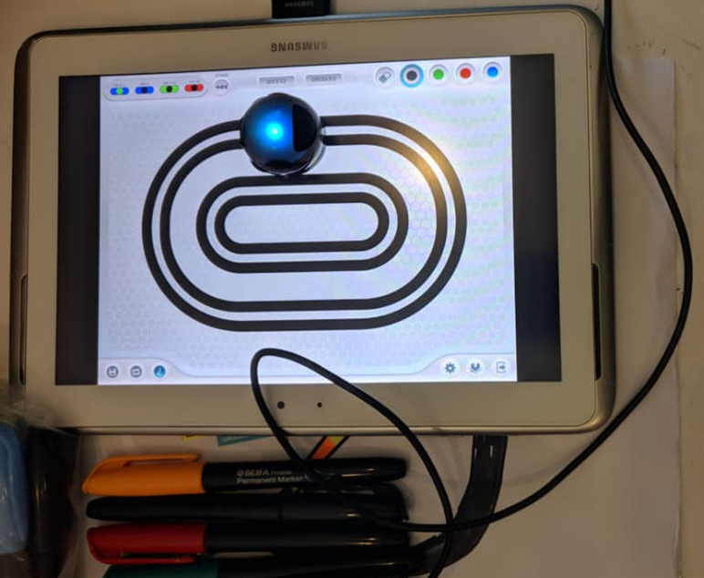 The colour sensing robot

SketchUp
In this session, students learned how to create a 3D model using the Computer Aided Design software SketchUp. Students were asked to create a digital model of an object given to them by using the software. The instructors described how this was the exact process used by engineers to model their project inside a computer. She told the students that usually the next step after this is to use a 3D printer to make real life prototypes.

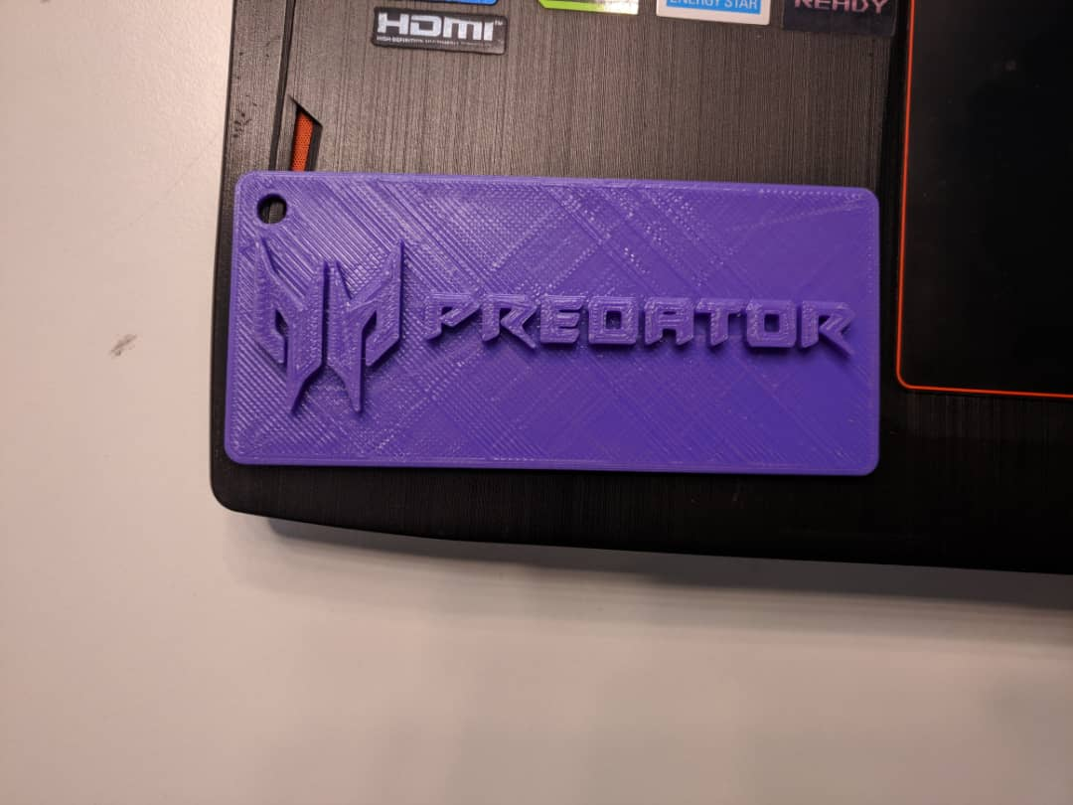 Object given to be modelled.
Drone Flying
During this session, students were able to fly the drone by using a software in a laptop. By using the software, students can give command to the drone to make it takeoff, land and other movements to perform in the air.

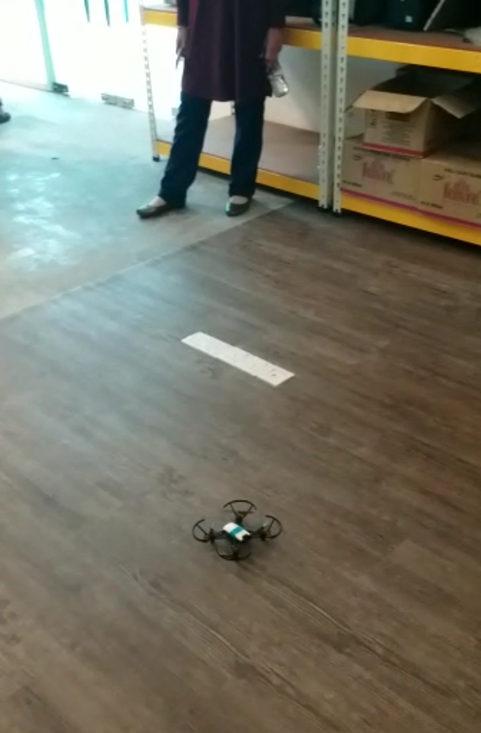

The drone.

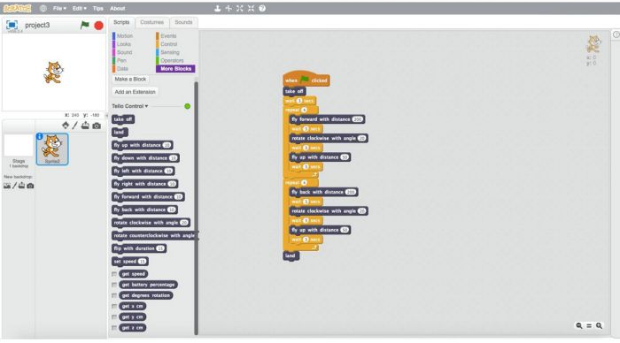
The software used to fly the drone.

Individual Reflection

Ong Shi Bing

a) From the visit, I know that technologies are so important that it is almost required in many fields nowadays. I learned more about how the new technologies can be implemented in company to simplify the tasks. This is so important because it is related to my future career as a software developer to constantly improve the technologies we are having now. I will study hard and get good academic results to adapt my working environment in the future.
b) Moreover, I should learn some extra knowledges other than the syllabus my course. I learn C++ programming language in my class and I should also learn Python and Java so that I am more capable of programming with various programming languages. Besides, I can do more researches regarding the technologies that are developed by man so that I am not getting behind in everything.

Nurul Adila

From this visit, I realized that technology provides many job opportunities. We do not have to venture into medical or engineering field. I used to be interested in technology, especially about 3D printing, so this visit it gave me some experience about using a 3D printer. From this visit I learned that now we can programme drones by using programming language. I really want to be able to programme my own drone. If I have the opportunity to work as the one who programmed thousand drone that can used as launching tool. I will work hard to make sure that all my dreams comes true. I will graduated in Software Engineering soon and after that I will chasing towards my dream.

Thilak Sundaram

1) This visit has given me a hands-on opportunity to experience physical contacts with modern equipments such as the 3D-printer and drones. Besides, one can also learn how does 3D-printing can reduce one’s effort and cost on buying materials from factories. 3D-printing can also be a state of art whereby anyone come up with an unique design and be used for aesthetic purposes. I’ve also learnt that VR & AR can be used for education purposes as well as gaming and entertainment.

2) There are several improvements can be made which are the number of equipments can be increased such as the drones and 3D-printers. Besides, there should have been VR & AR equipments to try so we get to experience it physically instead of theoretically listening to the talk.

Raihan Muhammad Wilinio

1) The visit has opened my mind on the potential of IT in the future. I love the idea of VR, and how the concept of reality can be transferred into a certain medium. The visit has given me some insights on how VR can be implemented in the real world, and I would love to learn more on VR.
2) I believe learning how to program better and efficiently is a very important skill that i need to develop, because programming is everything. I need to learn on how to utilize the 3D Printer, because in the future, many industry will be utilizing it. I need to learn more on the current trends of people around the world. I believe this will help me better in knowing on what kind of technological advances are people looking forward to and create something based on people’s needs.

Syed Sanzid Hasan

1. This visit allowed me to have some first hand experience with technologies that the industry is going towards using 3D printers, VR. As a future worker in the 4th industrial revolution, we need to be familiar with all developments so that we are not left behind. This visit allowed me to realise that I need to focus more on these technologies to reach my academic and career goals.
2. After this visit, I must learn to adapt to changing technologies. I need to be exposed to more and more new technologies so that I can fit in properly into the workforce. I plan to keep myself immersed in the emerging technologies and keep myself up to date on the changes coming to the industry I work in. I need to ensure my skills are on par with what my industry wants so that I can excel in it.

