Report on an Industrial Talk About Technology and Information System

Executive Summary
The talk that I had attended on 24th September 2018 was organized by Malaysia Digital Economy Corporation (MDEC). The purpose of the talk was to share the information about eRezeki or freelancing to the newcomers of University of Technology Malaysia (UTM). The name of the speaker for the talk is Mr. Mohd Ihsanuddin Jamhari. eRezeki is a program for Malaysian to sell their skills online so that they can earn extra income through the Internet. A freelancer is a person who do not have a fixed career, self-employed and recruited by a certain employer to work temporarily. Freelancer can live a healthier lifestyle because they can control their own workload, better time management and free from stresses. MDEC are going to organize a program named Program Fast Track GLOW on 28th and 29th September 2018 for those who are interested in freelancing. Students who like freelancing must good in computing, English and some other criterion. Freelancing provides an alternative job for Malaysian. I think that the increasing of freelancing in Malaysia will develop the country as freelancers provide better quality of work compare to ordinary employers.

Introduction
On 24th September 2018, I was asked to attend an industrial talk regarding eRezeki from MDEC. There were two sections for the talk which were 11am-1pm and 4pm-6pm. I attended the industrial talk with my friends at 11am located at Seminar Hall, N28A, School of Computing. Although my friends and I are from software engineering, there are many students from other courses such as data engineering and bioinformatic join the talk as well.
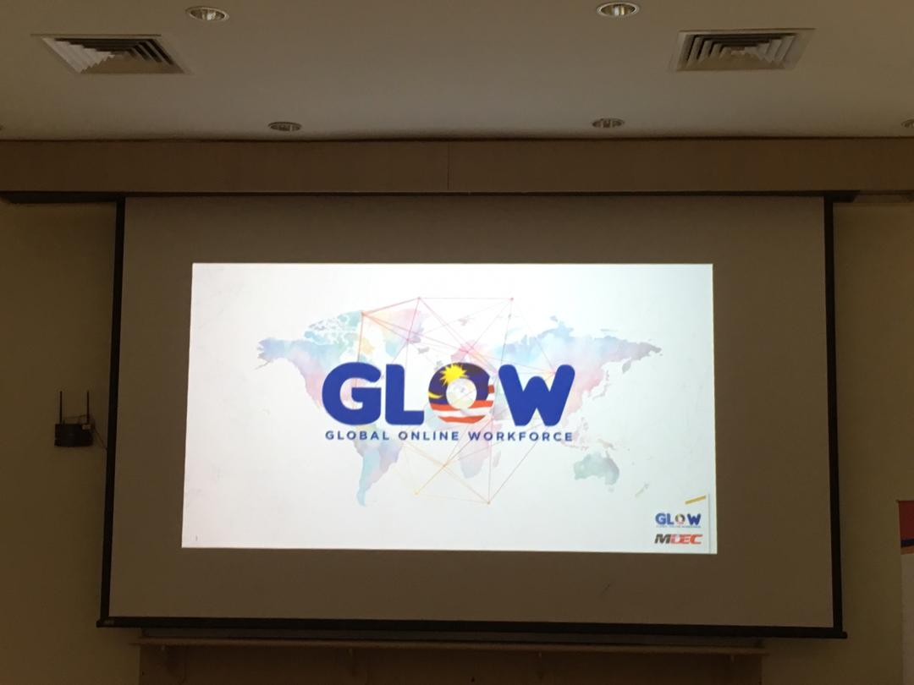
Picture 1: Main title of the slide of the industrial talk.

Content
The talk was presented by Mr. Mohd Ihsanuddin Jamhari, the master trainer of a program called Global Online Workforce (GLOW). He is one of the master trainers of GLOW and give industrial talk as well at many other universities around the southern part of Peninsular Malaysia such as Johor, Negeri Sembilan and Melaka. Mr. Mohd Ihsanuddin Jamhari was once studied electrical engineering at Technical University of Malaysia Malacca (UTeM). After that, he finished his postgraduate program at University of Technology Malaysia (UTM). Now, he is a full time Freelancer, project manager and involve in photography, information and communications technology (ICT) service and consultant, education and graphic design.
MDEC is a government agency formed in 1996 to digitize Malaysia economy to achieve the Vision 2020, which is to develop Malaysia into a fully-developed country (MDEC, 2017). He explained that digital economy is so important that business can be carried out through the Internet but not only physically. From his talk, he explained to us that MDEC provides three main programs, which are eUsahawan, eRezeki and GLOW. From his talk, I knew that eUsahawan is a program that teach people on how to sell their goods online. For example, we can sell our products or goods through application such as Amazon, Lazada, Zalora, Shopee, Taobao and so on. Through eUsahawan, we can learn on how to do website marketing, email marketing, social media marketing, copywriting, Whatsapp close sales and learn to identify digital business potential through research on market and competitors (eUsahawan, 2018).
Furthermore, I knew that GLOW is a program that help people in Malaysia to leverage the usage of crowdsourcing platform to gain income or work it on a full-time basis (GLOW, 2018). I also knew that eRezeki is a program for Malaysians, especially low-income groups, to earn extra income through digital assignments via online crowdsourcing platform (eRezeki, 2018). The participants of eRezeki will be matched with digital work according to their own skills. For example, companies such as Foodpanda, Grab and Uber offer people temporary jobs for everyone. Through eRezeiki and GLOW, people can become a freelancer. Freelancer is people who don’t have a permanent job and is self-employed. Mr. Mohd Ihsanuddin Jamhari explained that freelancers sell their skills and promote themselves through the Internet and wait for a certain company to be recruited temporarily.
I had also known the meaning of sharing economy from the talk. Basically, sharing economy is a type of business that owners rent out their cars, bicycles or even houses to a total stranger by using these peer-to-peer services (Yellen, n.d.). There are several benefits of becoming a freelancer. First and the foremost, a freelancer can control his or her own workload so that he or her can live a healthier lifestyle and will not get sick easily. Besides, a freelancer has better time management compare to normal employer because a freelancer never leave home for work. Moreover, a freelancer is less stressful than a normal employer because a freelancer is self-employed so he or she is free from stresses that come from colleagues or employers (Muhammed, 2016).
Mr. Mohd Ihsanuddin Jamhari told us that MDEC had organized a program named Program Fast Track GLOW MDEC for UTM students who are interested in eRezeki. The program is held on 28th and 29th September from 8.45am until 5.00pm at the School of Computing, N28. Students who are good in programming, web developing, graphic designing or even translation can join the program. Besides, students who have commitment on becoming a digital entrepreneur can join the program as well. Not only that, students must good in English as a freelancer may be work or interact with a foreign employer. Another criterion of becoming a freelancer is to own an email account, local bank account, PayPal account for global transaction and a virtual communication platform as well.
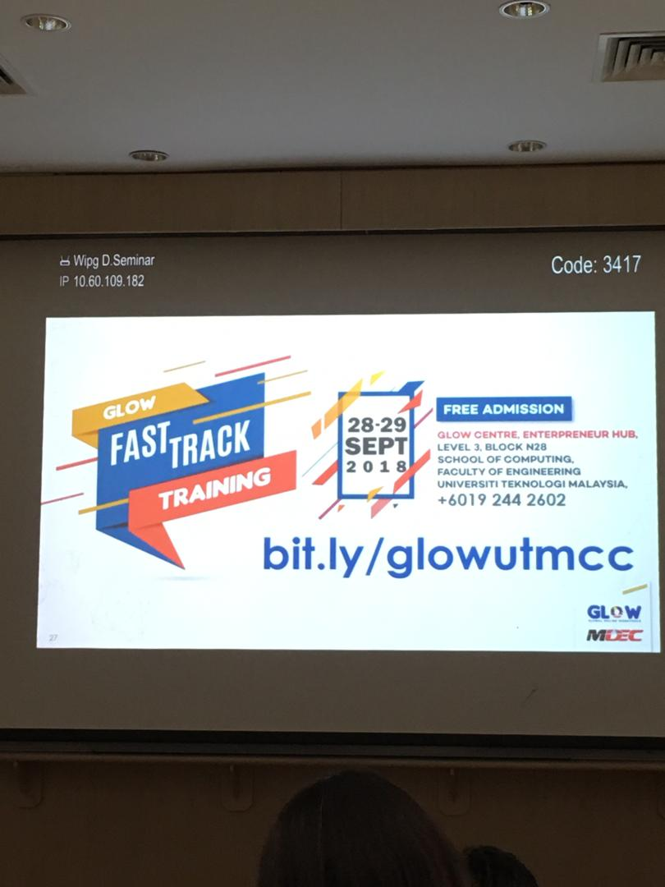
Picture 2: Slide about the program organized by MDEC
According to Mr. Mohd Ihsanuddin Jamhari, freelancing provides alternative job opportunities for Malaysian with certain skills. He shared us an article that 50.9% of the United States population will be freelancing in 10 years if a current uptick in freelancing continues at its current pace. In my opinion, this issue might happen in Malaysia as well if more and more people know about freelancing. If there are more people freelancing, this means that more people have flexible working hours. Because of having flexible working hours, people can manage their time more easily and have a better and healthier lifestyle. Moreover, companies in Malaysia can save more cost as they no need to have a big working environment because most freelancers only work in their home. Furthermore, freelancing can also improve the quality of the work because freelancers have good time management and a very good working environment which is their own house. Thus, more freelancers can also trigger the development for the country so that Malaysia can be fully developed as soon as possible.
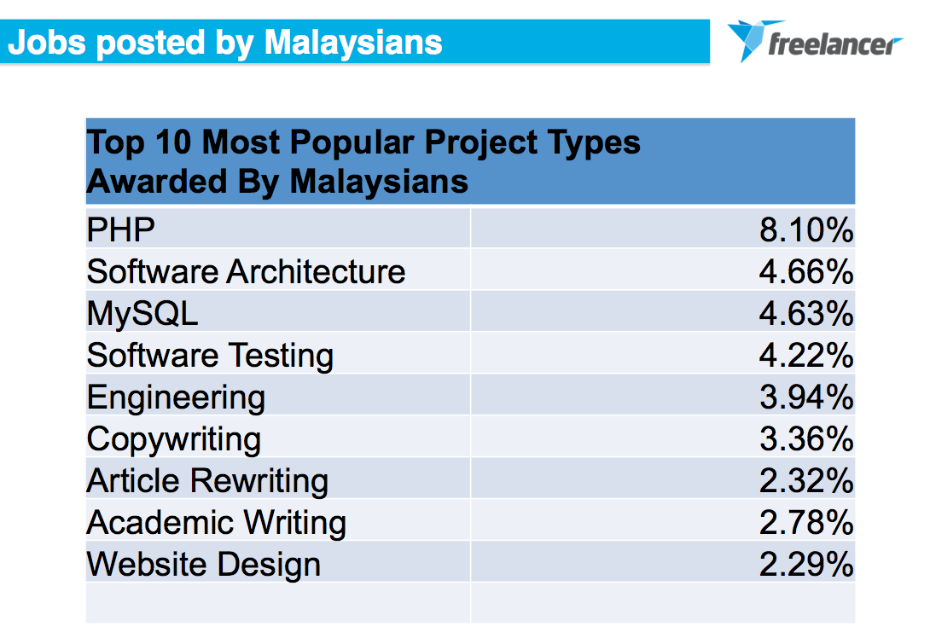
Picture 3: Statistics of top 10 most popular freelance project types awarded by Malaysians

Reflection
In my opinion, I think that the industrial talk is applicable to my studies and my future. There are many things I had learnt from the industrial talk. Firstly, I had known that technology and information system has become more n more important in our lives. Using technology wisely can bring a lot of benefits to us and make our lives better. For example, I was amazed by the talk as I never knew that business or economy can be carried out in such an effective and useful way with the use of the technology advancement. As we are approaching the 4th Industrial Revolution, we must fully utilize the use of the modern technology especially the Internet so that we can survive in the new era and will not fall behind the trend. Besides, I was told that we need to accept and adapt something that is new to us nowadays. We need to be the innovators who try new idea at certain risk instead of being lagging adopters who bounded by tradition and reluctant to make any changes. At the beginning of the talk, I felt that freelancer might not be as successful as an ordinary employer. After Mr. Mohd Ihsanuddin Jamhari showed us the annual incomes of some students from freelancing, I was impressed by their surprisingly big amount of incomes and the benefits derived from this job in comparison with fixed-income employees. Freelancer is not only an interesting job but also a worthwhile career to invest, Hence, freelancer would be my consideration in my future career. Last but not least, I would like to take this great opportunity to thank my lecturer, Dr. Nor Bahiah binti Haji Ahmad, for asking us to attend this meaningful and useful industrial talk. I really enjoyed myself and learnt a lot from the talk that I attended. I hope to attend more talks like this next time so that I can learn more about technology and information system.

References
eRezeki. (2018). Now everyone can benefit from the digital economy. Retrieved from https://erezeki.my/about
eUsahawan. (2018). Program eUsahawan. Retrieved from https://eusahawan.mdec.my/en/
Gabey. (2013). Freelancer.com makes Malaysian debut with eye on SMEs
https://www.digitalnewsasia.com/digital-economy/freelancer-makes-malaysian-debut-with-eye-on-smes
GLOW. (2018). Program background. Retrieved from
https://glowmalaysia.com/what-is-global-online-workforce-freelancer/?lang=en
MDEC. (2017). Building Malaysia’s digital future. Retrieved from
https://www.mdec.my/about-mdec
Muhammed, (2016). 7 benefits of freelancing you don’t get with a desk job. Forbes. Retrieved from https://www.forbes.com/sites/abdullahimuhammed/2016/08/11/7-benefits-of-freelancing-you-dont-get-with-a-desk-job/#5cf5e5b13135
Yellen, D. (n.d.). Airbnb, Snapgoods and 12 more pioneers of the 'Share Economy'. Forbes. Retrieved from https://www.forbes.com/pictures/eeji45emgkh/airbnb-snapgoods-and-12-more-pioneers-of-the-share-economy/#5c22321452cf

