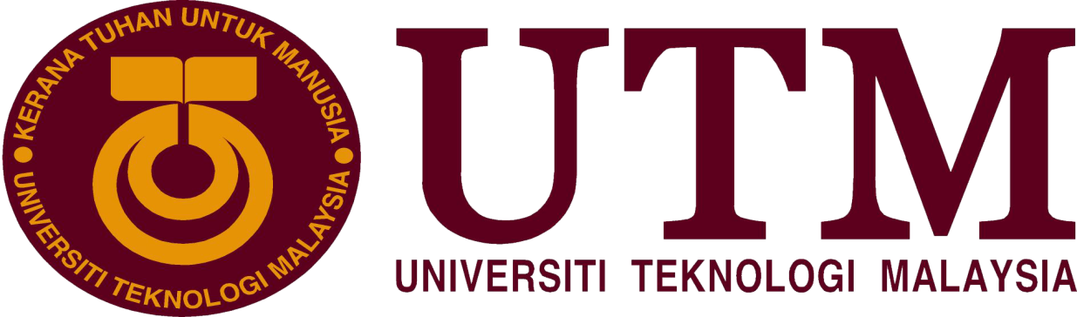

Center for Information and Communication Technology (CICT)

NAME:
AIMAN HAZIM BIN MOHD ARSYAT(A18CS0020)
CHUA HUN HO (A18CS0050)
HAFSYAHIRA BT. OTHMAN (A18CS0068)

SUBJECT: SCSP 1513 (SEC 02)

LECTURER’S NAME: DR. ARYATI BINTI BAKRI

Table of Contents
Introduction 2
Detail of journey 4
Detailed Description 4
Organization Structure 4
Services 5
Achievements 6
Information Systems Developed/Maintained by CICT 7
Reflection 8
Conclusion 9
References 9

Introduction
CICT
Pusat Teknologi Maklumat dan Komunikasi CICT UTM

Historically, CICT was built in 1975 as Pusat Komputer(Computer Centre). Then in 1981, Computer Centre was combined with the Department of Computer Science into a Computer Science Division under the Faculty of Science. It then was upgraded to become Institute of Computer Science at 1984, becoming UTM Computer Centre or PKUTM. At 004, the name change to Pusat Teknologi Maklumat dan Komunikasi (CICT) and it was become the center of ICT from 016 until now.

The early services of CICT (1985-1995) was as follows:-
- The mainframe system is enhanced with the use of IBM 3090-1J
- Improve the network system’s capabilities
- The main computer network connectin is connected through the System Network Architecture

Vision(Visi) – Visi kami untuk UTM menjadi “ Universiti Digital peneraji penyampaian perkhidmatan berpaksikan academia.

Mission(Misi) – Meneraju pembangunan ekosistem digital bersifat entrepreneurial dengan memupuk professional digital berinovasi dan menggalakkan kerjasama dalam perkhidmatan digital.
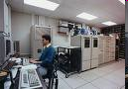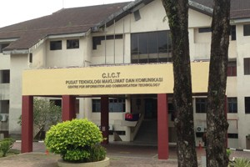

Detail of journey
On 1st October 2018, we attended the industrial talk of Center for Information and Communication Technology (CICT). The speaker of the talk is PPTM En. Zahari bin Zainal. He gave a briefly talk about the organization of CICT, the ICT management, the security of ICT, customer management and also future achievements and administrations. We have visited the PPICTP and also the gallerium CICT. He took us to visit the different kinds of the hardware of computer which are arranged there and explained the function of those hardware. We know more about the career, responsibility and also function of CICT in UTM. We also learn a lot about the component of CPU and also the revolution of the computer.

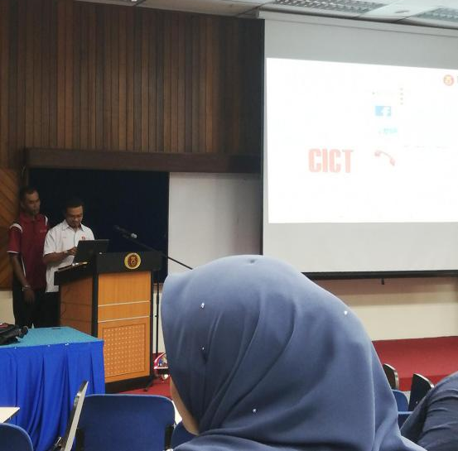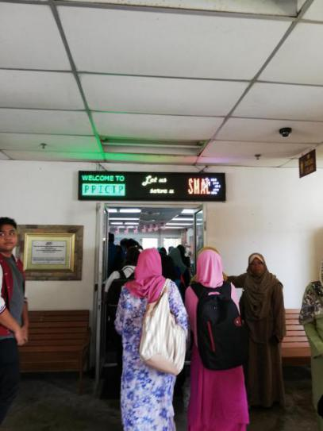
Figure 1(left): The speaker gave a talk about CICT.
Figure 2(right): Visit the PPICTP.

Detailed Description
Organization Structure
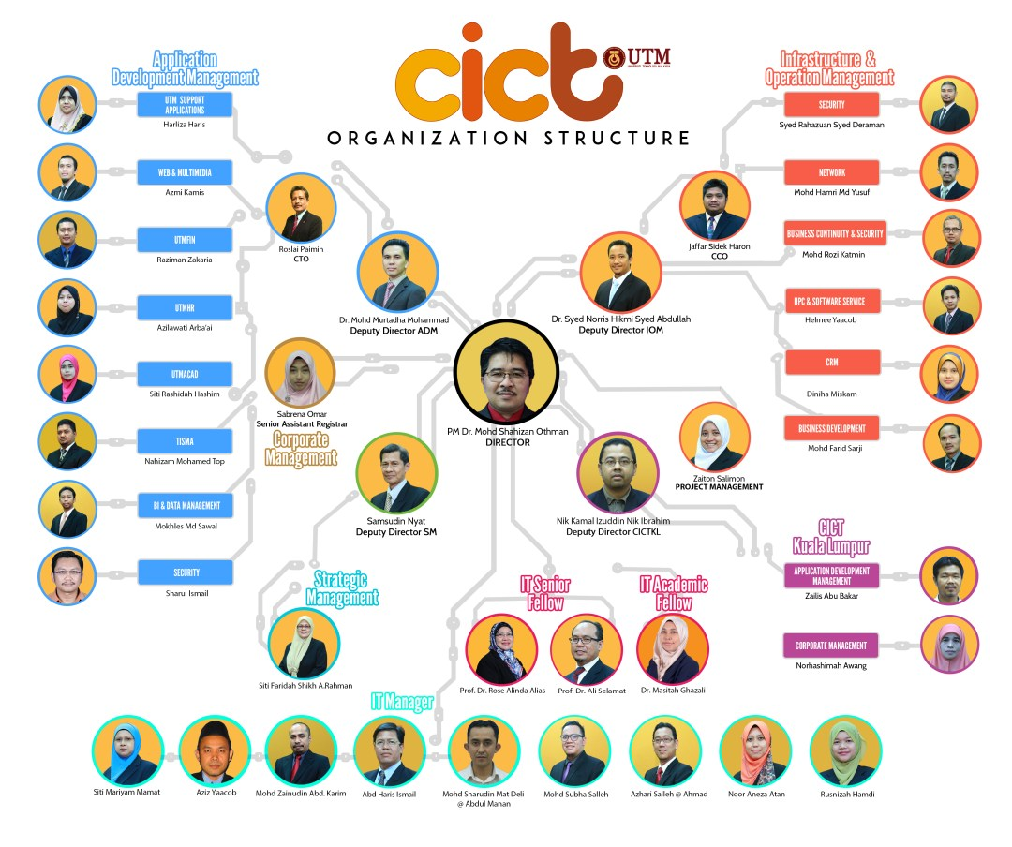
Figure 3: The organization structure of CICT

The director of CICT is PM. Dr. Mohd Shahizan Othman and there are 6 subordinates under director which are Dr. Mohd. Murtadha Mohamad(Deputy Director ADM), Dr. Syed Norris Hikmi Syed Abdullah(Deputy Director IOM), Siti Mariyam Mamat(Business Development), Nik Kamal Izuddin Nik Ibrahim(Deputy Director CICTKL), Samsudin Nyat(Deputy Director SM) and Sabrena Omar(Senior Assistant Registrar). There also have IT officers and technicians to support the team.

Services

CICT not only as the WiFi controller of UTM, CICT also provides services such as Internet, Infrastructure & security, Application development, Web management, Software and ICT support.
CICT provides students an ID account and also email address. CICT also has High Performance Computing, Virtual Private Network(VPN), UTM Hosting and also video conferencing &Streaming which can save more cost instead of flying to the specify places to hold a meeting.
CICT provides some free download software for students and staffs such as Antivirus, Microsoft Product, Microsoft Office, Wifi hotspot@utm extention and others.

Achievements

One of the biggest achievement of CICT is link myutm.my where in this link the student and staffs of UTM can use anytime anywhere where the lecturers can post the assignments,notes or announcement throught that links without the lecturers need to meet the students first. Next, Academic Computing ID (ACID) is one of the part of computer service where the user's unique ID through authentication from the server for the use of the login of the academic computing system. All students have their own user ID after registering the program through their respective faculties. Meanwhile, staff need to have an official UTM mail account first before applying for an ACID account. ACID can be used to log in the Eportfolio, UTMotion, UTM library online databases, Elearning UTM and other systems. After that, internet network of UTM also can be access from the outside of the UTM even someone want to access internet in overseas where its does not become trouble anyone to get wifi. Next, CICT of UTM skudai is the biggest network that can compile a lot of data such as information of each student and staffs UTM every year. Its also can compile data of student in UTM Kuala Lumpur.
UTM digital infractructure has three benefit such as wifi college service,internet gateway and server and storage. In wifi colleges service,the access point covering all colleges and the access point for hotspot in admin center.increasing amount of wifi will be increasing from 2017 to 2020.Internet gateway involve UTMJB with internet and Telekom Malaysia(TM). Then between college with internet and YTL. After that UTMJB with UTMKL and TM.The internet gateway will be same from 2 GB in 2017 to 2020. For server and storage,there will be increasing in server virtualizatoin from 300 units in 2017 to 1000 units in 2020.its also increasing in HPC CPU core from 208 core in 2017 to 500 core in 2020. Next, the other achievement of CICT is contribution to rating and research university in managing university data. CIICT behave got many awards such as become 5 stars overall rating in 2017,ranked 100 in “The Brics and Emerging Economies Ragkings”, rangked 253 in “World University Rangking”. Then CICT also has award in highest joint rank in Malaysia at 121-130 in category “The World University Rankings 2017 Top 200”. CICT also get award UTM in SAGA Compliance(AG) in 22 November 2017.

Information Systems Developed/Maintained by CICT

CICT developed many information systems by themselves. The following are several examples of website or applications that CICT have made:-
- UTM Portal
An online portal built by the CICT special for the UTM students and lecturers uses. UTM portal provide many services for the users and the users can get to know the current information in the UTM.
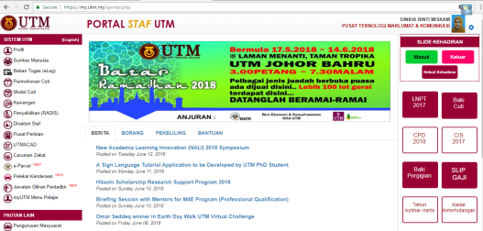
- UTMID / ACID
What is Academis Computering ID or ACID? ACID is the special unique ID given to the UTM students, and staffs whereas the purpose is to access the several services or application in the UTM such as e-Learning Portal, MyUTM, wireless or HotspotUTM etc.
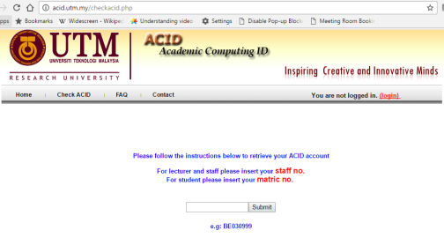

- BusUTM
This apps help the students to find or track the UTM bus and identify the buses that boarding to their respective locations.
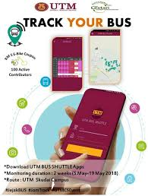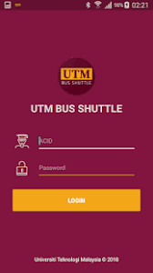

Reflection
GOAL REGARD PROGRAMME
The programme had given a lot of information in using wifi in the UTM. We are taken to the ICT room where at there the student can access the internet freely and we were told that ICT rooms can accommodate up to 100 users at a time. The programme is also to announce for students that internet usage not limit in UTM`s area only but can be used anywhere.

IMPACT ON GOAL
We all know where the main source of wifi formaly and we can directly refer to CICT if we had a problem of ACID or we want to complaints about the internet. Then we know about the conveniences of the computer from the first establishment of CICT until the modern one. After that CICT not only for UTM`s student but also for staff of UTM. CICT become the center for UTM getting the information and update the news

ACTION/IMPROVEMENT
After a time to time, the use of computer tools is increasingly sophisticated up to the modern tools. Previously, internet usage was limited where it could only be used in some areas or hotspot places such as lecture hall or the students can access the internet if they go to the CICT,but bowadays UTM member can access the internet anywhere. Then CICT also has relationship with outside country like with Singapore where Malaysia can ask for kuota internet from the Singapore and vice versa. For the next steps , CICT plan to produce digital@lifestyle in industrial revolution 4.0, ICT innovation likes big data and cloud searching. Then, to produce eco-system to drive KFA PGU3's achievement and UTM smart campus.

Conclusion
As a conclusion, CICT give a huge good effect to the entire of the UTM in terms of ICT. The Information Systems developed by the CICT have help the learning process between the students and the lecturers become smoothly. As example, the wireless Internet around UTM give the students a free connection to the Internet, with that they can do the work easily. Also the UTM Portal make the students easy to get and submit their assignment and easy for the lecturers to put the assignment or homework in the portal.
Not forgetting too the very neat organization among the CICT Staffs. Because of them, CICT are very progressing and the ICT work goes smoothly and sequentially. Many services provided them. Such as the students that have problem with their ACID can go to CICT to solve that issues.
As the world become progressing day by day without stop, we hope that CICT will become more sophisticated and greater ICT center in many aspect especially the services provided and the facilities in the CICT and also becoming well-known in the entire the country and international.

References
- UTM CICT
https://cict.utm.my

- En Mohd Zahari bin Zainal Abidin PPTM
The speaker of the CICT Talk

- UTM CICT
Lingkaran Ilmu, Universiti Teknologi Malaysia, 80990 Johor Bahru, Johor

