Industrial Visit 2
Iskandar Puteri Report

Topic: Industrial Visit 2 – Iskandar Puteri
Date: 24th November 2018
Time: 8.00am – 8.00pm
Venue: Forest City & OneMaker Medini, Mall of Medini, Medini
Iskandar Malaysia.
Section: Section 06
Lecturer: DR NOR BAHIAH AHMAD
Prepared by: Nurfa Hadirah binti Tabri
Yeoh Kai Xiang
Tan Chong Lim
Md Belal Hossain Santo
Md Mostafizur Rahman Masud

Table Of Content

No | Content | Pages
1. | Cover page | 1
2. | Table Of Content | 2
3. | Introduction | 3
4. | Details Of Journey | 4
5. | Detailed Description of OneMaker | 5-7
6. | Detailed Descriptions of Sessions | 8-12
7. | Reflections | 13-15
8. | References | 16

- INTRODUCTION

On 24th November 2018, an industrial visit to Forest City and OneMaker Medini, Mall of Medini, Medini Iskandar Malaysia, Johor Bahru was organized with 150 students of Software Engineering, School of Computing, Faculty of Engineering of Universiti Teknologi Malaysia were involved in this industrial visit. OneMaker Group Pte Ltd (OMG) is a leading Maker-centric service provider that have been supporting the Maker movement since their establishment in 2014. Their business circulates around Maker education, digital prototyping services and corporate professional development.

- DETAILS OF JOURNEY

8.00 a.m. | Registration and gathered in front of N24, UTM
8.30 - 9.30 a.m. | Started the journey to Forest City (sight tour) by bus
9.30 - 10.00 a.m | Journey to OneMaker Medini, Medini Iskandar Puteri
10.00 a.m | Arrived at OneMaker Medini
10.30 - 1.00 p.m | Virtual Reality Talk & QuirkyBot Making Session
1.00 - 2.00 p.m | Lunch Break and Zuhur prayer
2.00 - 4.30 p.m | Disruption of Technologies Learning Journey Session
4.30 - 5.00 p.m | Break and Asar prayer
5.00 - 7.00 p.m | Design Thinking & Making Session
7.00 - 8.00 p.m | End session and Maghrib prayer
8.00 p.m. | Back to UTM

- DETAILED DESCRIPTIONS OF ONEMAKER

  - Organization Structure

  - Services

- Makerspace Development:
Makerspace Specialist: They offer consultation & building services to customize the makerspace consumers wish to set up.

- Prototyping & Consulting Services:
(i) 3D Printing: They offer 3D printing consultancy, printing services or rental of 3D FDM and SLA printer for consumer’s design and model.
(ii) Laser Cutting: They offer digital fabrication using laser machine for consumer’s design and model. Engraving is possible.
Materials: acrylic, cardboard, fabric, foam, lather, wood
(iii) Computer Numerical Control (CNC) Routing: They also offer digital fabrication using CNC routing machine for consumer’s design and model. Engraving is possible.
Material: acrylic, aluminum, cardboard, copper plate, fiberglass, hardwood, high density foam, marble, stone, wood

- Flexi Access Pass: They offer a flexible access pass to the space where a wide range of tools and equipment are available. They also offer induction courses for new users before they start working in our space.

- Event consultancy & management: They offer curetted, customized, and highly engaging content for events. They organize and conduct:
(i) Craft classes (sewing, leather crafting, water coloring, cosmology & math in art, and many more)
(ii) Digital Creative learning journeys & workshops (3D printing, augmented reality, design thinking, digital fabrication, drones, Internet of Things, physical computing & embedded systems, virtual reality, and many more)
(iii) Innovation & Product Development Programs
(iv) Creative Technology Innovation & Team Building
(v) Hackathons

- Official Certification:
Arduino Creative Technology in the Classroom (Arduino CTC 101)
CTC is Arduino’s one-of-a-kind STEAM (Science, Technology, Engineering, Arts, and Mathematics) program for upper secondary education*. Students are introduced to the foundations of

  - Achievements

From 19th until 23rd November, the recent glorious achievement of OneMaker was organising Junior Makers Programme (JuMP), Make-Vember camp. Mainly this camp was organised for children activities. Trinkrer trak and maker track activites were available for different types of ages childrens. They explored a paper mechanisms and helped to give the direction how to build a machine, chain reaction, straw-botics, plastic tech, and circuit games activities are done there. Participants of activity maker track, need to take a challenge to build an interactive machine. To build this one they were using power tools and digital equipment like 3D printer and laser cutter. They also organised designethon, where students, social worker, designer, and health expertise were participated. They designed and created a solution of frenzy and caregivers. On 22nd July, Bedok square, they have arranged a workshop to encourage creativity. A workshop which helps its participants to increase their merit skills.
Actually OneMaker group have organised many other events like Makervilla 2.0, Sky Camp and so on.

- DETAILED DESCRIPTIONS OF SESSIONS

  - Virtual Reality Talk & QuirkyBot Making Session
    - Virtual Reality Talk
The talk was conducted by Shukry Radzi, the Co-Founder Gini Technologies Sdn Bhd, who was graduated from Universiti Teknologi Malaysia and holder of Bachelor's degree, Real Estate. He also involves in sales and marketing in both primary and secondary property market.
What is virtual reality? Virtual reality is a term used to describe a three-dimensional, computer-generated environment which can be explored and interacted with by a person. The example given in the talk was the movie "Ready Player One" It is a simulated world in a computer, and with certain equipment, human is able to see the simulated world as if it is in the real world.

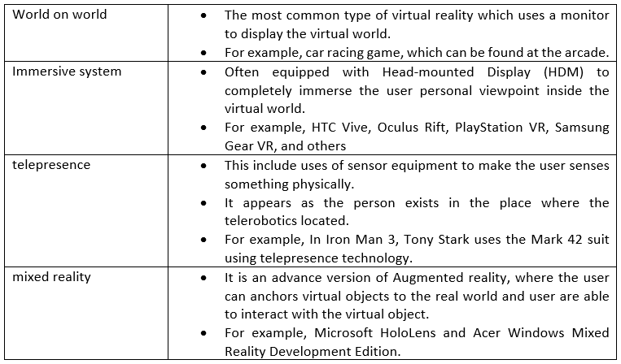
Virtual reality was first introduced by Sensorama in 1956. Later, the first VR head-mounted display was created by computer scientist Ivan Sutherland in 1968. With the surge of technology, lots of parties getting involved in this technology including Google, Sega, HTC, Oculus, just to name a few. The use of the term “virtual reality,” was used in the mid-1980s by Jaron Lanier. There are several types of virtual reality such as world on world, immersive system, telepresence, and mixed reality.
As a leading technology, virtual reality has great possibilities in the future. The application of this technology involved but not limited to education, commercial, medical, gaming, and entertainment. Virtual reality is indeed a great start for the fourth industrial revolution.

    - QuirkyBot Making
One of the activities we conducted was quirkybot maker. We are provided with materials such as engine, battery, empty bottles, cardboard and other recycled materials. We were grouped in pairs and build our own quirkybot using the provided materials with our creativities. A short period of around 30 minutes was limited for us to design and build our quirkybot. After that, a small competition between groups was conducted. The quirkybot that maintain inside that limited area is considered winning the game. It was indeed a challenging and exciting game.
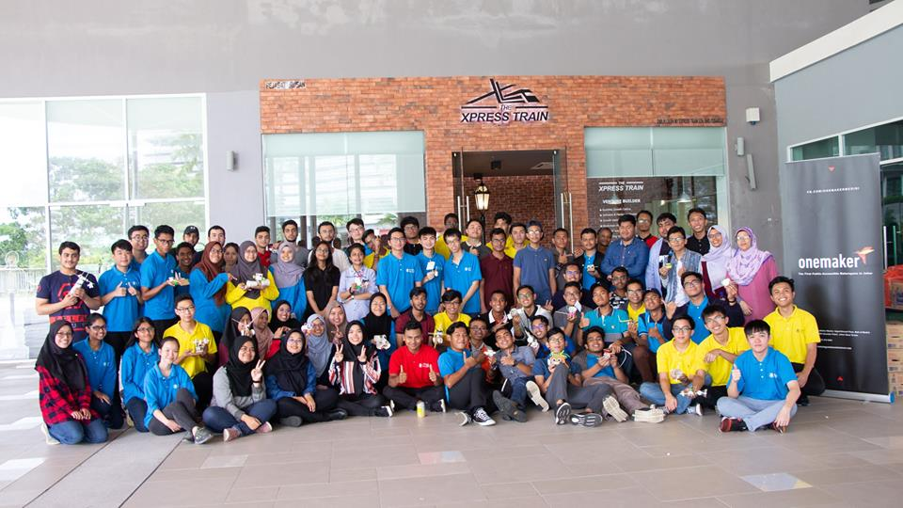

  - Disruption of Technologies Learning Journey Session

There are five stations in the Disruption of Technology Learning Journey, which are Introduction to Artificial Intelligence, Drone Programming and Flying Experience, 3D Printing Experience, Computer- Aided Design Challenge and Colour/Line Following Robot Demo.

In the 3D Printing station, we are shown a variety of objects which are 3D printed. Then, the people in charge shows us how to operate the 3D printer. The 3D printer is connected to the computer and they are using Doodle3D as an interface to operate it. We are told that all the products from 3D printing are all produced in one-shot and we have the opportunity to have a touch on the products of 3D printing.
In the Introduction to Artificial Intelligence part, we are introduced to an Artificial Intelligence Google product, which is Google Assistant. Google Assistant can be toggled on by saying "Ok, Google". Then, we can ask any question we want to like the weather today, the time and so on. Besides, we can chit chat with her too. We are then given the opportunity to talk with Google Assistant too.

In the Drone Programming and Flying Experience station, we use a computer program to fly a drone rather than using a remote control. They are using a program which allows users to pick a list of commands and after that the drone will fly in the direction and distance as commanded. We are able to control the flying direction and flying distance of the drone, and it can even do some tricks like fliping in the air and fly in curves. After a demonstration by the people in charge, we are given chance to have a try.

In the Colour/Line Following Robot Demo, we are introduced to Ozobot, which is a small robot which can move following the colours of the path. The moving of the Ozobot is demonstrate on a tablet. They have a program which is used to create colour paths for the Ozobot. A few paths with different colours are displayed on the screen and the Ozobot will determine which path to be taken. Then, we are given the chance to create a path for the Ozobot using marker pens on a big piece of paper too.

For the Computer-Aided Design Challenge, we are informed to download and install SketchUp program earlier. It is a software for users to do 3D modelling. First, we are shown a 3D printed plastic piece with a Predator logo and word on it. The logo and word are raised and not in 2D but 3D. We are requested to do the modelling of the plastic piece using SketchUp.

  - Design Thinking & Making Session

This Masterclass aims to address how participants can understand design making as key in value creation and to teach participants how to solve real-world problems by using several steps. From the talk, it is known that there are five steps of design thinking, from empathize, define, ideate, prototype to the final step, test. There are two types of solution for solving problems. The first solution is known as vision-first product solution, where visualizing a future state is the first step, followed by validating that with inventions. The problem is first addressed, follow by experiment, and getting feedback from the audience and tester, and the final state is the outcome. User-Centric solution if the second solution which the problem needs to be stated clearly in advance before finding the solution. Then, the prototype is created to get feedback from the tester, only to identify the vision in the last step.
There are a variety of tools and tricks used by the company in making of prototype and designing. The most common one is 3D ideation pen. It is a prototyping tool that helps us to create objects easily and quickly. The concept is similar to 3D printer except 3D ideation pen is easy to carry and cheaper. Besides, a non-toxic, biodegradable polyester called polymorph is also widely used to create a prototype. It has a low melting point and is easy to be molded. The alternative of making prototype is by using a cotemporary art call Tapigami. Variety of art can be formed using masking tape by taking advantage of its properties such as versatile, accessible, and malleable.
After the talk, we were given a chance to build our own prototype with the theme of the future school. We were grouped into 10 and were given materials and tools for building prototype. During the process, we were given chances to try out their 3D ideation pen. It can be used to build a small 3D building. Besides, we also experimented with polymorph and understood how it works. After a short 40 minutes of designing and building our prototype, the prototypes of every group were combined to form a complete prototype of the future school.

- REFLECTIONS

From the one day trip to OneMaker Medini, I have learned that the rapid growth of technology produces infinite possibilities for the future. The uses of Artificial Intelligence indeed provide ease in our life. Everything can be automated using technology from opening a door, making coffee, driving a car, and even exploring the space using an AI robot. The application of technology in various field such as education, and industrial helps a country to improve itself. Therefore, one of the keys to success is technology. Everything that seems impossible at the current time is possible in the near future. It is only a matter of time. – Tan Chong Lim

From this industrial visit, I realise that the technologies in ICT field is improving drastically. We now are able to use AI to do a lot of others job such as programming. Besides, they are efficient and they seldom make mistake too.
This makes me think a lot. If the technologies can do all the programming and coding, will there be a job for graduates from computer science in the future? The competition in the working environment is becoming more intense because graduates have to compete with the robots too. Therefore, it is a very powerful reason for us to keep improving in order not to get eliminated.
Therefore, self-discipline and determination are very important qualities that we should possess. We should learn more and practise more. Only people with strong determination would be able to resist others temptation and keep improving. – Yeoh Kai Xiang

From this industrial visit, I have learned that Technology and Information System are growing rapidly. There are a lot of technologies that have been developed to solve the problems that we faced in our life such as virtual reality, artificial intelligence and so much more. This progress made me realized that as a Software Engineer, I can create more technologies that could contribute to our society and explore more about new technologies such as Artificial Intelligence and expand its potential. This visit helped me to see my visions clearer to strive for a better future after I graduate. To improve myself, I have to be more creative and always ready to learn something new. I also have to learn to empathize with the problems, so that I will be able to create a solution that will helps the user. Therefore, I have to imply determination and resilient so that I will be able to improve myself in the future. – Nurfa Hadirah binti Tabri

Throughout the industrial visit I’ve learned lot of things. But truly, it was all about technology. I realized the constant changing & advancing of technology in this modern era. As time passes on, we use & rely on technology more & more but less on old or traditional methods. It taught me, world needs talent & effective people more than just the number of people. As a student of Computer Science it really inspired me to be a part of this wind of change. It also inspired me to have much knowledge on artificial intelligence, virtual reality & other things which are technology based.
To cope with this modern technology based world, it’s very important to make ourselves prepared specially for this industry. Knowledge, Discipline, punctuality, hard working, self confidence & determination would be the key to any massive success. - Md Belal Hossain Santo

A lot of experience were gathered from this industrial visit. We know that how much of modern technology improved day by day and what can be the future of modern technology. By using artificial intelligence, machine learning, and data science, now we can do anything that may be we did not think before. Even the coding was also made by artificial intelligence. When we are writing or speaking the machine automatically converted into code by artificial intelligence. The virtual world is expanding with the technology. It is realizing, if all of this coding and other virtual work is done by the artificial intelligence so what should we have to do as a computer science student.
So we have to do hard working in our sector, be confident and patient in yourself. Because the next competitor is machine, we follow strategy to learn. I believe a machine cannot to know more than a man. Because a machine is created by man, man is not created by machine. – Md Mostafizur Rahman Masud
- REFERENCES

https://www.onemakergroup.com/
https://www.facebook.com/OneMakerMedini/

