
SEMESTER 1 2018/2019

SUBJECT: TECHNOLOGY AND INFORMATION SYSTEM
SCSP (1513)

TITLE: DESIGN THINKING

GROUP MEBERS:

NAME | MATRIC NO
MUHAMMAD AKMAL BIN HISHAM | A18CS0122
MUHAMMAD HILMAN BIN HASHIM | A18CS0148
AMIR FIRDAUS BIN KHORUDIN | A18CS0027
GOVIND RAJ A/L GNANASEGARAN | A18CS0066
MOHAMMAD IRFAN ISKANDAR BIN ZAINUDDIN | A18CS0111

INTRODUCTION

In this modern era, the need to develop the creative and innovative way of thinking among
The society, especially the youth is very important. This is because, the society now days
Prefer take simple and easy approach in completing certain task and just rely on the materials
That have been provided or through internet as their main source. There is no effort from
Themselves to think creative and innovatively to produce an outcome to be more realistic
And interesting. There are few approach been taken to overcome this issue and one of it
Is to develop Design Thinking.

Design Thinking helps students to have a better understanding when executing problem
Solving situation. With the application of Design Thinking, students will be able to apply
Different dimension and enhance the level of their thinking skills. Furthermore, Design
Thinking helps students producing a coherent vision out of messy problems and it helps
Students in term of organization.

Last but not least, Design Thinking give students the opportunity to embrace their
Experiment by building a prototype. Prototyping is not a simply to validate your idea
but it is an integral part of your process.

Design thinking process can be divided into 6 major steps:

Empathize Define Ideate Prototype Process

STEPS AND DESCRIPTION

- EMPATHIZE

Basically Empathize can categorized into 3 different parts which is:

OBSERVE
We note that, most of the computer science students now days having many types of problem
In programming. In fact, some are starting to lose interest in programming as they can’t
Really figure out the problem they are facing when solving programming questions.
Furthermore, In University context, the lectures only teaches the students according to
Syllabus in general and it will be hard for them to find out every student’s problem in the
Subject. It all starts with the student’s initiative and willing to self-taught to discover
New programming skills and enhance their foundation in programming skills and knowledge
From time to time. Therefore, we carried a research to have a better view of student’s
Thought and perception of programming followed by other few questions.

ENGAGE
We have carried out the research by creating a google form where we highlighted few
Questions regarding programming such as what programming language majority
Is familiar with, what is their platform of learning programming, what do they think
Is hard about programming and many more. We spread and share the google form via
Link and we received a lot of responses from UTM”s students. The responses have been
Recorded for our next step of Design Thinking.

IMMERSE

From the responses, we are able to see the pattern of people’s thought and their problem in
Dealing with programming problem solving. From there we will brainstorm on solutions
To overcome most of the problem faced by the users.

- DEFINE

From the questions we have draft through the google form, we have received a lot of
Feedback from the students. There are some who are familiar with only one language
And there are some who familiar with more than one programming language. After
We analyzed the responses, our goal is to design a prototype on how to improve
Programming skills among students and make it more interesting and fun.

From the responses, we can see that majority is having problem with syntax and logic
Specialization. From the responses, we have decided to help overcome these problems
By understanding the problem so that we can have the best solution that will be result
As our prototype.

- IDEATE

This is the phase where we had the brainstorm session. Each of us had given the idea
To overcome the issue most people faced. We list down all the ideas we have and we will
Choose the best one based on this criteria:

- Rational choice
- The most likely to delight
- The long shot
- Idea with the most food will be chosen.

- PROTOTYPE

This is the phase where we deliver our idea publically. From there we can see the response
From the student’s. We will briefly explain how the prototype works in term of helping
Majority of the problem faced by students from the data we observed from our research.
Basically our prototype is about to help students to have a better interface experienced
That have a better organization. Each topic are organized systematically and make the
End user to have a better experience of learning programming. Besides, we also
Created a simple game for the user to have some fun while learning process. We manage
To gather more ideas when constructing the prototype together as a group.

- TEST

By reaching this state only then we will know if our prototype works or not. From
There we will evaluated according to our effort and idea to produce the prototype.

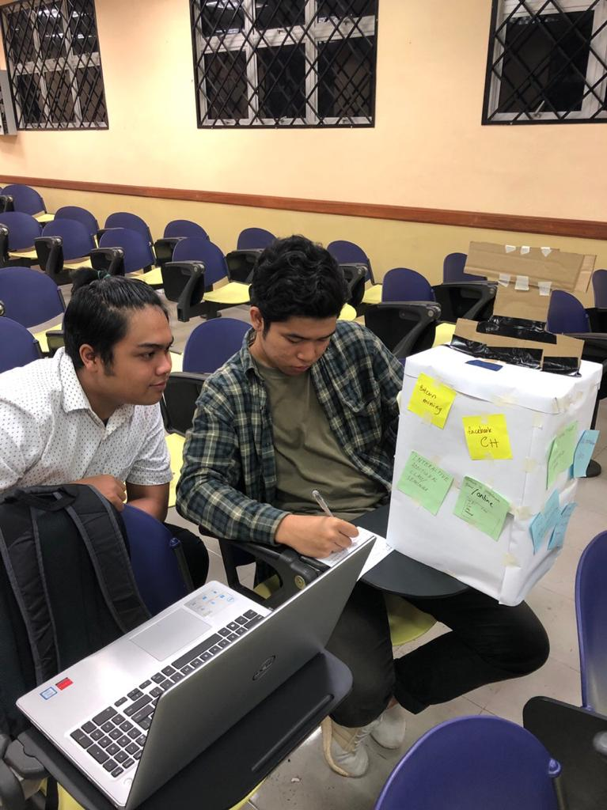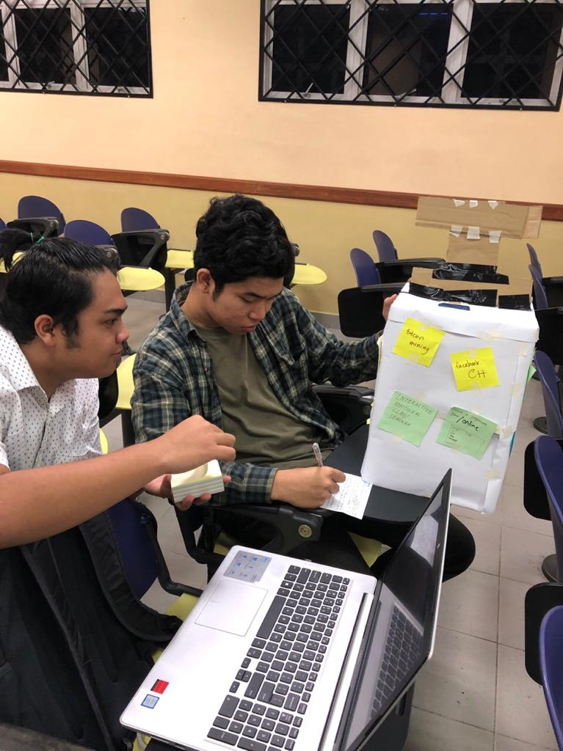
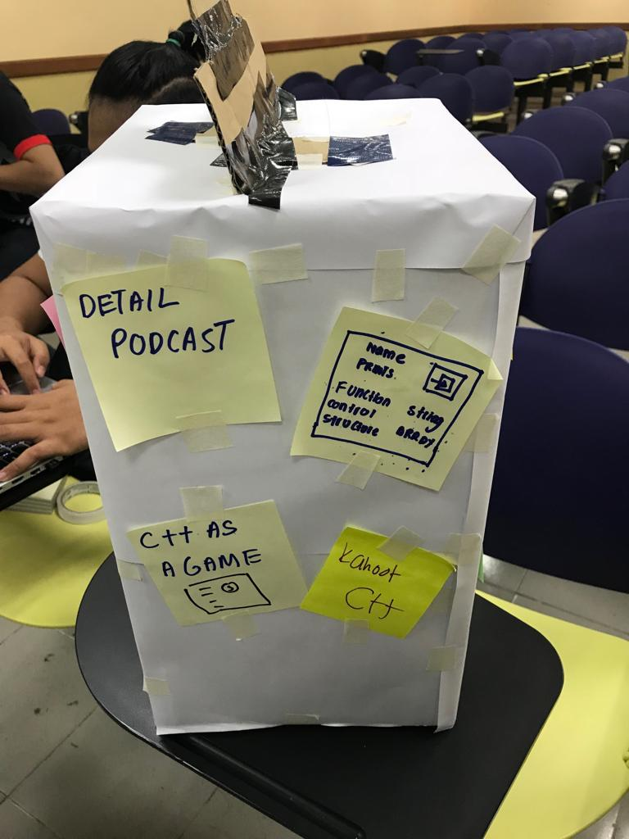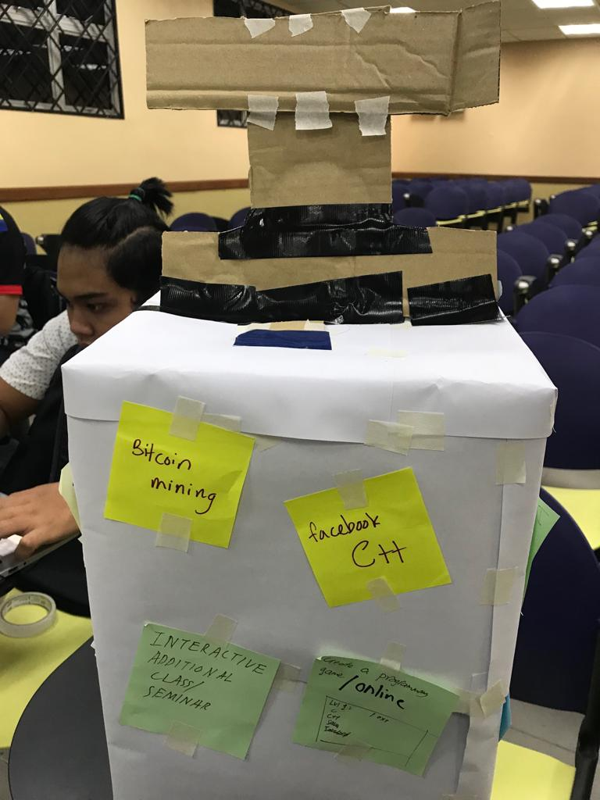

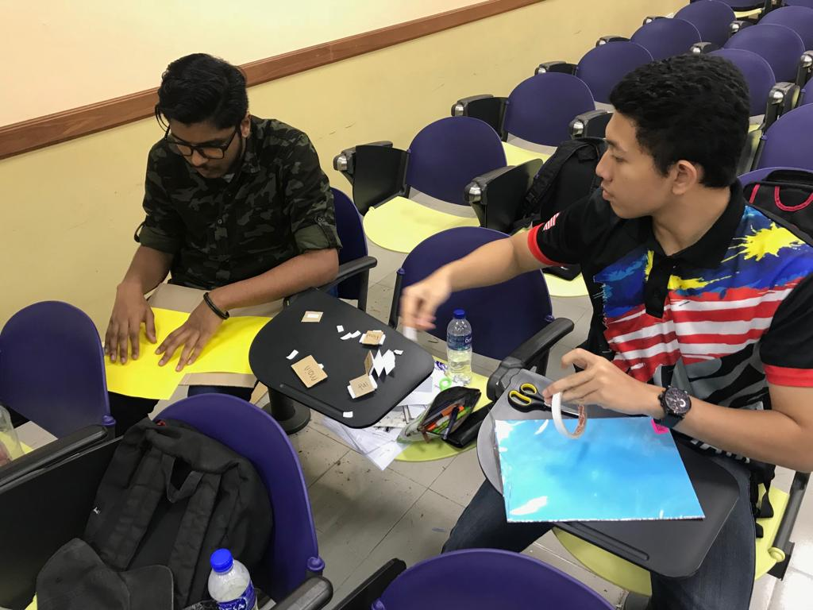

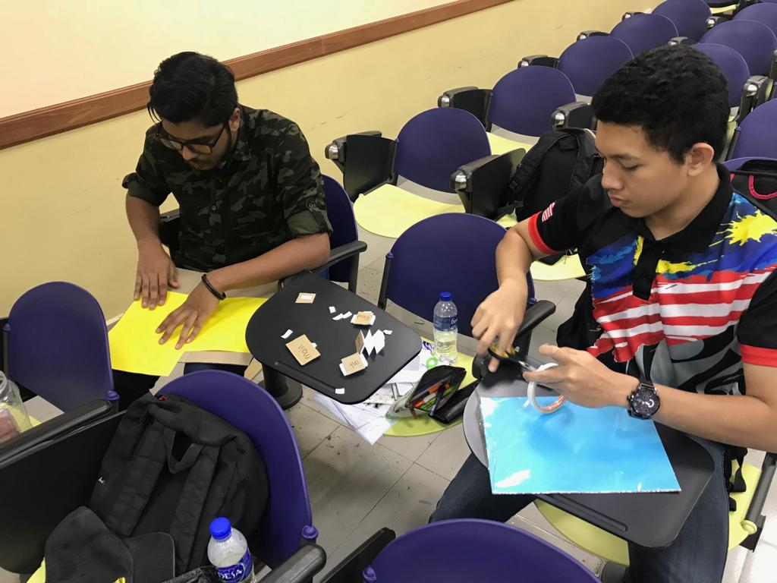
DETAILED DESCRIPTION

The problems we faced during the process was clash between ideas of team member and time management. If we just focus on giving our ideas, we will mostly crash into issues. So what we did was we let every team members to give their point of view personally. After we listen to all of the point given, we most likely to decide and making decision for next step. We worked in group throughout the whole process to prevent from errors.

DESIGN THINKING ASSESMENT

After the end of project, we found that our project prototype receives a lot of support
as most of the audience from our class including our lecturer as they understand the points
that we presented on how our prototype works. Some improvement could be made for
example making our product more interactive, colourful and easier for students to use and
engage as our main target audience is the students who is taking programming subject. Based
on the feedback gained by testers, this product is very user-friendly and easy to use. This
product was mainly focused on C++ language, but it could also be modified to be used on
more advanced language such as R, Python and Swift. The drag and connect method like the
jigsaw puzzle are really fun and easy to use by the user and also solve the problem that were
pointed out from the survey conducted which is problem solving, logic understanding and
also rules of programming.
During the define phase, we managed to detect our target audience and the subject
that we want to emphasize on. After that, information was collected from the survey form we
distributed to the students all across computing faculty in UTM. Empathy was gain as we
know their problems, and how they hope to improve it. From that information, we try to
create idea by brainstorming which brings us to ideate phase. With the ideas, we come up
with the product which focuses on how to help students to understand more about
programming and the easy way of doing it.

DESIGN THINKING EVIDENCE

The evidence and detail of our research is in google doc form. To open
The form just click.

PROTOTYPE

The idea of the prototype came during our brainstorming session. We were able to have a
A good understanding and clear picture on how roughly our prototype will look like.
Furthermore, the idea just keep coming to us while we were in the process of building the
Prototype to make it look more realistic and user friendly.

TEST
We tested our prototype to few students before we present it in front of the lecturer.
.We received good feedbacks from them as they also share the same thought as us that
The prototype is very user friendly and fun to use while learning programming.

REFLECTIONS

Design thinking is an effective way to solve problems surrounding us. The designing thinking method makes it very easy for a group of people to work together and to brainstorm ideas to overcome the given or intended problem that occur around us. Our goals of us is to work for a good IT company. In the environment, there is bound to be work that does only involves us but it has to be done by a team of workers. Therefore this method is very effective and a good way to get the best possible outcome because it creates a platform for all the team members to give their opinion. However, we all believe that we each need to improve some criteria to improve our potential in the industry. The main improvement that is needed is communication. When working in a team, communication is key because all opinion are very crucial. This is so that all the members on the team are on the same page and does not argue among them. Therefore, we all believe that we need to improve more of our communications skills in working as a team.

