
Industrial Talk 3

Name : Muhammad Syukran Syahiran Bin Mohd Shaifullizan - A18CS0162
Siti Nurkhayrina Binti Mohd Azizan - A18CS0247
Yap Xin Yin - A18CS0276
Course : SCSP1513-09 Technology and Information System
Lecturer : Dr Aryati Bakri

Table of Contents
1 Introduction 3
2 Content 4
2.1 IOT- Predictive Maintenance Gets An Extreme Makeover 4
2.1.1 Predictive maintenance 4
2.1.2 Predictive IDC future scope worldwide 10 agenda 4
2.1.3 Industry Revolution 5
2.1.4 Industry 4.0 Technology Trends 6
2.1.5 Computing at the edge 7
2.1.6 AI for data center 8
2.2 Internet 2.0 9
2.2.1 Man - Computer Symbiosis 9
2.2.2 Internet 2.0 History/Trend 9
2.2.3 Blockchain vs Centralized database 10
2.2.4 Strength, weaknesses, opportunity & threat 12
2.2.5 Use case – Blockchain of technology 13
3 Summary 14
4 Bibliography 15

Table of figures
Figure 2: The speaker for Internet 2.0 talk 3
Figure 1: The speaker for IOT talk 3
Figure 3: Industry Revolution 6
Figure 4: Industry 4.0 7
Figure 5: Computing at the edge 7
Figure 6: Blockchain 11
Figure 7: Centralized database 11
Figure 8: Blockchain SWOT 12

Introduction
On 18th November 2018, an industrial talk about HP and Maxis was held at Faculty of Electrical Engineer, UTM. The talk given was about internet of Things (IoT) and Internet 2.0. From 11:00 A.M to 12:00 P.M, the first talk was given by Mr. Syahrul Hafidz Suid, Enterprise Consultant with the topic IoT. Next talk was given by Mr. M Nazrul Hazeri Nazirmuddin, Solution Design Architect from Maxis Berhad Cisco Service Provider with topic Internet 2.0.
IoT which known as Internet of Things is a system of interrelated computing devices, mechanical and digital machines, objects, animals or people that provided with unique identifiers (UIDs) and the ability to transfer data over a network without requiring human-to-human or human-to-computer interaction. A thing in the internet of things can be a person with a heart monitor implant, an automobile that has built-in sensor to alert the driver when tire pressure is low or any other natural or man-made object that can be assigned an IP address and is able to transfer data over a network.
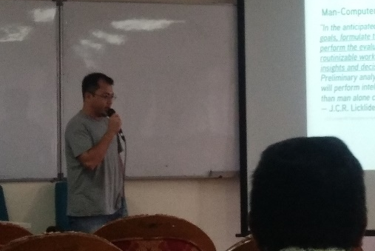
Figure 2: The speaker for Internet 2.0 talk
Internet 2.0 or Web 2.0 is the current state of online technology as it compares to the early days in Web, characterized by greater user interactivity and collaboration, more pervasive network connectivity and enhanced communication channels. One of the most significant differences between Web 2.0 and the traditional World Wide Web is greater collaboration among the internet users, content providers and enterprise. Originally, data was posted on Web sites, and users simply viewed or downloaded the content.
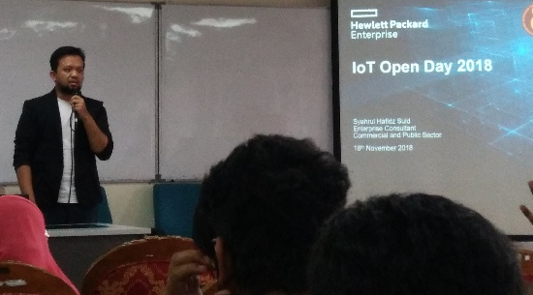
Figure 1: The speaker for IOT talk

Content

IOT- Predictive Maintenance Gets An Extreme Makeover

Predictive maintenance
The objective of having predictive maintenance is to improving production efficiency and improving maintenance efficiency. Prediction can be made by analyzing data that been taken from device or running predictive algorithms. According to the McKinsey report, IoT-based predictive maintenance extends equipment’s life, helps to eliminate as much as 30 percent of the time-based maintenance routine, and reduces equipment downtime by 50 percent. There are many industries that using predictive maintenance such as discrete manufacturing, process manufacturing upstream oil and gas, electric power industry, railways, construction. As seen that most industries needed IoT to predict possible outcomes or damage, thus it will reduce cost and time. This shows how important IoT to the industries in order to manage all the system.

Predictive IDC future scope worldwide 10 agenda
- By 2021, driven by LOB needs, 70 percent of CIOs will deliver "agile connectivity" via APIs and architectures that interconnect digital solutions from cloud vendors, system developers, start-ups, and others.
- Compelled to curtail IT spending, improve enterprise IT agility, and accelerate innovation, 70 percent of CIOs will aggressively apply data and AI to IT operations, tools, and processes by 2021.
- By 2022, 65 percent of enterprises will task CIOs to transform and modernize governance policies to seize the opportunities and confront new risks posed by AI, ML, and data privacy and ethics.
- Through 2022, 75 percent of successful digital strategies will be built by a transformed IT organization, with modernized and rationalized infrastructure, applications, and data architectures.
- By 2020, 80 percent of IT executive leadership will be compensated based on business KPIs and metrics that measure IT's effectiveness in driving business performance and growth, not IT operational measures.
- By 2020, 60 percent of CIOs will initiate a digital trust framework that goes beyond preventing cyber-attacks and enables organizations to resiliently rebound from adverse situations, events, and effects.
- By 2022, 75 percent of CIOs who do not shift their organizations to empowered IT product teams to enable digital innovation, disruption, and scale will fail in their roles.
- Through 2022, the talent pool for emerging technologies will be inadequate to fill at least 30 percent of global demand and effective skills development and retention will become differentiating strategies.
- By 2021, 65 percent of CIOs will expand agile/DevOps practices into the wider business to achieve the velocity necessary for innovation, execution, and change.
- By 2023, 70 percent of CIOs who cannot manage the IT governance, strategy, and operations divides between LOB-dominated edge computing, operational technology, and IT will fail professionally

Industry Revolution
At 17th and 18th century, the First Industrial Revolution began. Use of water and stream power to run mechanical production facilities. These facilities are to increase the human productivity. The human and good can move in great distances in a few hours with the use of steamship.
At beginning of 20th century, the Second Industrial Revolution bagan. Use of electrical power to enable work- sharing mass production. The idea of mass production is from the pigs hang from conveyor belts and each butcher perform only a part of the task to butcher the pigs. The aim of mass production is significantly faster and at lower cost.
Industry 3.0 began at the early 1970, electronic and IT are used to automate the production for example computer. With the invention of these technologies, we able to automate production without human assistance.
The industry revolution today is Fourth Industrial Revolution. To monitor, analyse and automate business, cyber- physical systems are used. In Industry 4.0, we able to communicate easier via a network and production.
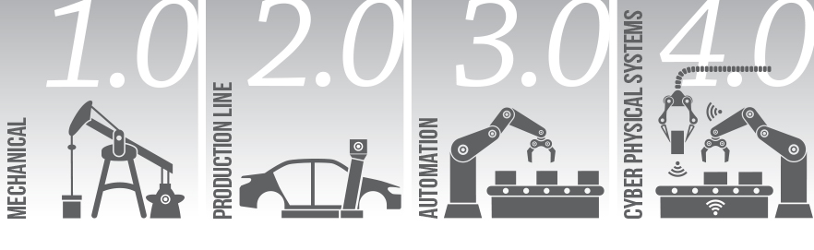
Figure 3: Industry Revolution
Source: https://www.utilitywise.com/2016/08/03/manufacturing-4-0/

Industry 4.0 Technology Trends
Nowadays, robot became more flexible, autonomous and cooperative. The robot that had been invented which have the ability to interact with each other and greater range of capability. Besides, the robots able to work with human, communicate with human and it is convenience to us. Robots increase the productivity and reduce the human resources. Besides, the computer simulation now is a tool to evaluate and model for complex system. This technology trend improve the designs for complex system. Growth in computing power made simulation can be feasible to use to optimize the designs. Next, the system integration such as Cyber- Physical System (CPSs) which improve the interaction between physical and virtual system. The system integration connected the smart object and world to exchange data and opinion with each other. Furthermore, growth of technology nowadays caused a lot of threat and risk to technology. Cybersecurity companies joined with industrial equipment through partnerships. For cloud computing, machine data and functionally will increasingly be displayed to the cloud, enabling more data-driven services for production system. Besides, additive manufacturing method is widely used for increase the productivity and reduce the productivity period. Additive manufacturing method often used in produce small batches of customized product. In Industry 4.0, the augmented reality are developed to improve the productiveness and to enhance the user experience. Companies will make much broader use of augmented reality to provide workers with real- time information to improve decision making and work procedures. Last but not least, the collection and comprehension evaluation of data from many different sources for example production equipment, systems, enterprise and customer management system which will become standard to support real-time decision making.

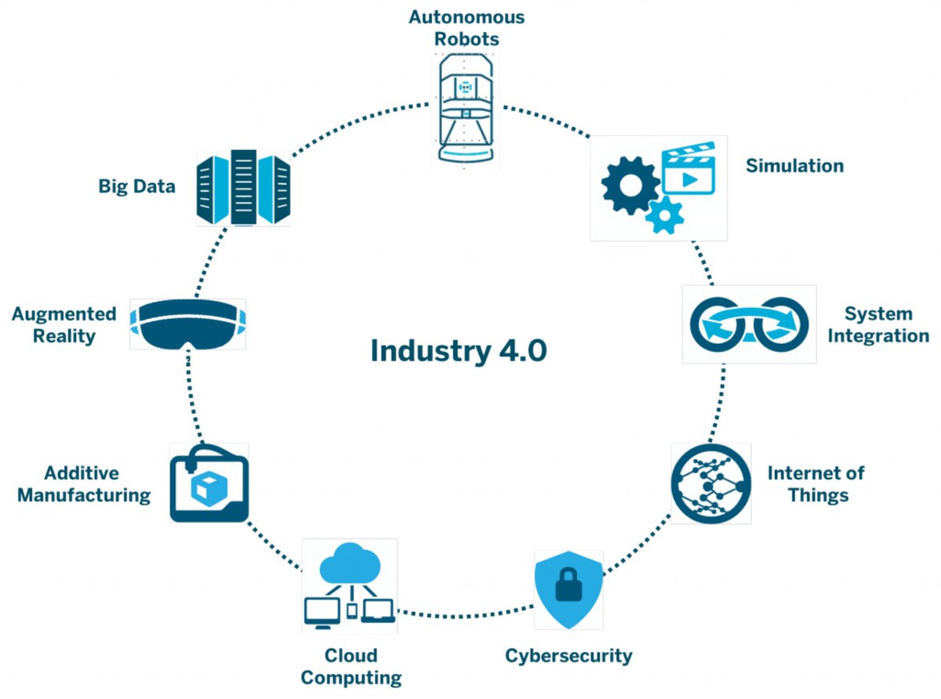
Figure 4: Industry 4.0
Source: https://twitter.com/ipfconline1/status/826278924716036099

Computing at the edge
Networks play an important role around the world and edge computing devices and edge infrastructure development hold a key role. Computing at the edge method is to improve data processing in cloud-based system. There are a lot of advantages of edge computing in our life. Local devices transmitted less data through a network to a data cloud, it will reduce the network traffic. Besides, it improved application performance because the app can achieve lower latency level since the app that don’t tolerate latency.

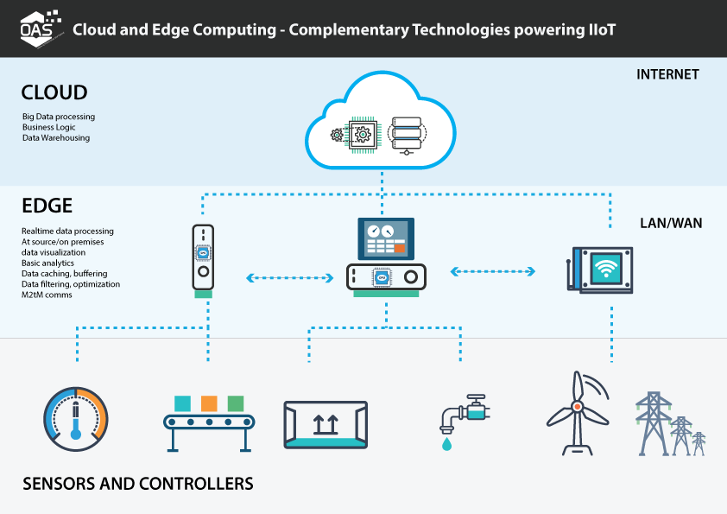
Figure 5: Computing at the edge
Source: https://hackernoon.com/edge-computing-a-beginners-guide-8976b6886481

AI for data center

These days, AI are consider popular and common among this generation with all the robotics and voice recognition, example like SIRI from APPLE company and Alexa from Amazon. However the use of AI are spread not just for searching or something but also use in data center. It not yet to apply on many company but there are some of big company try to achieve the use of AI in managing their data center because of the lots of data consume nowadays.
Along the rapid change of technology and the data continue to grow, AI are needed manage all aspect in data center. AI are chosen because it has potential help with the workload, security and optimize the decision and process in the data center. AI are also to consume the data with more faster, less cost and less energy. For example, Google has reported that it was able to cut down its energy usage by 40% using deep learning. Its deep mind AI controls about 120 variables of the data center, like fans, cooling system, windows, and more. Google used 4,402,836 MWh of power in 2014. So, a power savings of 40% could result in millions of dollars saved down the line. In short AI bring big impacts for one company within considerable amount of time.

Internet 2.0

Man - Computer Symbiosis
As a concept, man-computer symbiosis is different in an important way. In the man-machine systems of the past, the human operator supplied the initiative, the direction, the integration, and the criterion. The mechanical parts of the systems were mere extensions, first of the human arm, then of the human eye. These systems certainly did not consist of "dissimilar organisms living together". There was only one kind of organism-man-and the rest was there only to help him.
In one sense of course, any man-made system is intended to help man, to help a man or men outside the system. If we focus upon the human operator within the system, however, we see that, in some areas of technology, a fantastic change has taken place during the last few years.In some instances, particularly in large computer-centered information and control systems, the human operators are responsible mainly for functions that it proved infeasible to automate.They are "semi-automatic" systems, systems that started out to be fully automatic but fell short of the goal.
Man-computer symbiosis is a subclass of man-machine systems. There are many man-machine systems. At present, however, there are no man-computer symbioses. The purposes of this paper are to present the concept and, hopefully, to foster the development of man-computer symbiosis by analyzing some problems of interaction between men and computing machines, calling attention to applicable principles of man-machine engineering, and pointing out a few questions to which research answers are needed. The hope is that, in not too many years, human brains and computing machines will be coupled together very tightly, and that the resulting partnership will think as no human brain has ever thought and process data in a way not approached by the information-handling machines we know today.

Internet 2.0 History/Trend
The term, Web 2.0, first gained currency after the 2001 “dot.bomb” when the IT bubble that had lasted a good 5 years burst. While some commentators suggested that the Internet had been over-hyped, other folks maintained that the crash signaled the end of the first phase of the Internet and suggested that the more exciting stuff was yet to come. They called this new phase or era “Web 2.0.” A number of people affiliated with O’Reilly Media (which publishes some of the best programming books I’ve encountered) began using “Web 2.0” first at a conference brainstorming session and then at a Web 2.0 Summit. By 2005, usage of the term had spread well beyond a small circle of people. Currently, the term has become ubiquitous in the IT world.
One of the most influential concepts of democratization was due to Chris Anderson, editor in chief of Wired. In “The Long Tail,” an article from the October 2004 Wired, Anderson expounded on the new economics of marketing to the periphery rather than to the median. In the past, viable business models required marketing to the largest possible demographic. For example, when there were few television networks, none could afford to run programs that appealed to a limited audience, which led to the characteristic phenomena of programming aimed at the lowest common denominator. With the proliferation of satellite and cable networks, however, mass marketing began to splinter into highly refined submarkets that cater better to individual tastes.

Blockchain vs Centralized database
Blockchain is a block which linked growing list of records by using cryptography. The function of blockchain is to modify the data that had been set. A blockchain which is decentralized, distributed and public digital ledger. Distributed ledger database can locate at multiple physical locations. The record involving in all subsequent blocks in computer cannot be altered retroactively since blockchain is used to record transactions through many computers. The participants enable to verify and audit transaction by themselves and it is affordable. The peer-to-peer network is used to manage the database of blockchain. The data security is quick strong in blockchain. Besides, the long standing problem of double spending are able to solve by using blockchain. The blockchain is cheaper, safety and quickly compared to traditional system.
Centralized database is the database which only maintains, stored in a single location. Centralized database enable the user access to the central CPU through a computer network. Centralized database more often used by company or university. Centralized database is highly dependent on the network connectivity. Compared to blockchain, centralized database is harder to retrieve back the data when the data lost accidentally. It is easier to retrieve back the data because it has a backup or copy in different location of database. Besides, centralized database is more safety since it only in a single location, so it only have one single place to stolen the data.

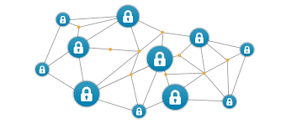
Figure 6: Blockchain

Source: https://www.draglet.com/blockchain-services/blockchain-technology/private-or-public-blockchain/
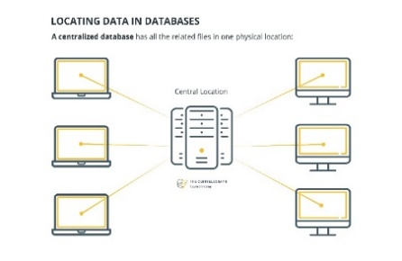
Figure 7: Centralized database

Source: https://cointelegraph.com/explained/decentralized-and-distributed-databases-explained

Strength, weaknesses, opportunity & threat
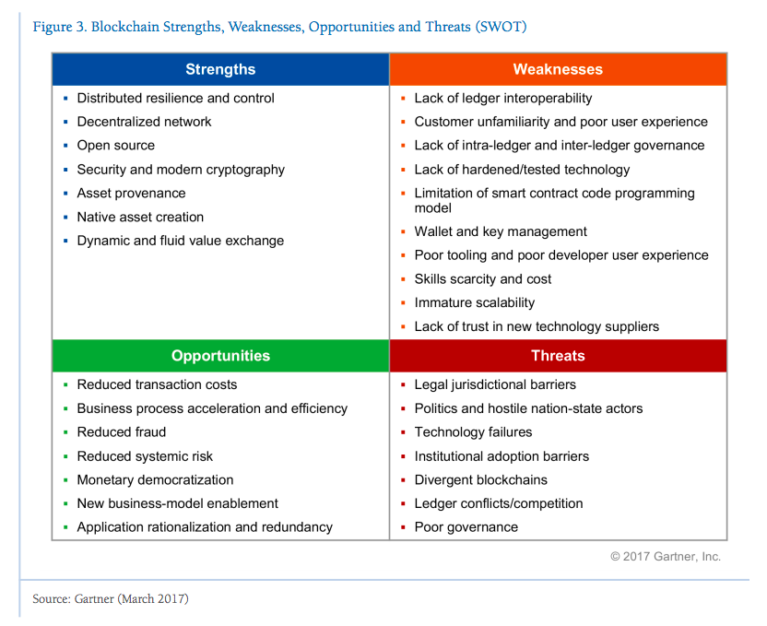
Figure 8: Blockchain SWOT
Source: https://blog.softwaremill.com/blockchain-business-applications-beyond-bitcoin-c9e6df0ba923
The strengths of Blockchain is not attackable, manipulation essentially ruled out. Blockchain is finality which cannot be retractable and unchangeable when the data is recorded. It is globally available, do not have the limit and it is open source which technology can be used or further developed. Like in the internet, Blockchain allows realtime access to the same data. Another strength of Blockchain is it enable digital transfer of values and assets.
The weaknesses of Blockchain is identification at the entry point not yet resolved by them. Besides, global scalability still questionable by Blockchain. The user unfamiliar and poor user experience in Blockchain caused they misuse it and the data security be a problem. Another weakness of Blockchain is Blockchain involves an entirely new vocabulary. Therefore, it is high complexity places enormous demands on users.
The opportunities of Blockchain in future is better security. Better security is important to protect the user’s record and prevent stolen. Besides, Blockchain reduces the transaction cost and processing cost thus the amount of user will increase. Blockchain has the opportunity to reduce fraud and systemic risk, so the user’s privacy are able to protect.
The threat of Blockchain is legal jurisdictional barriers and it brings a lot of risk to Blockchain. Technology failure is also a threat for Blockchain because technology play an important role in Blockchain to proceed the transaction. Another threat for Blockchain is ledger competition. There are many types of database for example centralized database which has bigger security. Poor governance in Blockchain is also the threat for Blockchain because the system cannot in well maintain condition and it will brings a lot of problem in Blockchain.

Use case – Blockchain of technology
Blockchain are basically a chain of block that block represent the information and chain is the public database. Moreover, have part which is to store information about a transactions, the person that involve in the transaction and the information from another blocks. Blockchain are used to store data from any type of transaction, stops in a supply chain and for voting. Lots of companies are using blockchain system and invest in blockchain.
There are many usage of blockchain like property records, smart contracts, privacy, decentralization, security, time and cost efficiency and fraud reduction. It can be apply in real life mostly in business as in banking industry blockchain benefit on reducing cost, shorter time consume to settle down the business, easier on auditing, secure and increase the quality and the performance of the work. Another great example of the blockchain applied to banking is the startup R3 CEV. The core idea of this startup is to build a platform and commercial applications for distributed ledger technology. By bringing together 80+ banks, technology partners, and regulators, R3 CEV aims to become a “new operating system” for financial markets. It really useful on managing finance data and problems.
However, there are also non-financial use case apply like in healthcare, law enforcement, human resources management and also education. In healthcare type of area, blockchain are used to solve the problems on recording and managing the medical records of the patients. So, it will be more efficient on tracking, collecting and to store data with more secure. A project named MedRec is using blockchain technology to solve issues with electronic medical records and provide a secure mechanism for recording and keeping them. MedRec is basically a decentralized CMS using smart contracts that’s tuned to help the entire community audit and share data.
In short, there are many benefit and usage of blockchain whether it involving finance management industry or non-finance management industry.

Summary
For IOT, there are countless use cases where IoT can be deployed, such as in manufacturing, vehicles and even future cases such as smart cities and energy. Manufacturing, as an example, has been operating shop floor equipment for decades with sensors that control machine processes, but these sensors have been relatively dumb, have not been IP enabled nor have they been able to communicate beyond their local process. This situation is changing; manufacturing equipment is now being produced with sensors that are IP-enabled, can communicate with each other, collect and disseminate data in real-time. IoT can play a role in health care with smart devices used for many cases. The elderly or disabled could live independently with fall detection devices and/or physical activity monitoring through body sensors; patient surveillance sensors for hospitals or care homes, smart sensors to control conditions in medical storage units and devices to monitor ultraviolet radiation on people.
For Internet 2.0, people are using internet 2.0 in daily lives to communicate, share information and collaborate with other people in community in virtual world. People around this world in various age updating their social media with pictures, videos and text without limitation. Mostly all user have the freedom to contribute everything which is sometimes bring negative impact to the community.aFrom all the outline and information that been obtain from the talk, internet 2.0 have many benefit to the community and develop things to help us managing daily life and solve complex solution. It depends on how user and developer using internet 2.0 and blockchain. Such as, blockchain really managing the role on optimizing the performance, secure the information and many more. Thus, even though blockchain have some weaknesses and threat it still give better solution for this certain of time. In the meantime, some of us can become the developer to improve the system one day.

Bibliography
1. Amy Shaw. (August 3). Manufacturing 4.0. Unknown. Retrieved from https://www.utilitywise.com/2016/08/03/manufacturing-4-0/
2. Ipfconline. (Jan 30, 2017). Industry 4.0 & Manufacturing Processes. Marseille, France. Retrieved from https://twitter.com/ipfconline1/status/826278924716036099
3. Justin Baker. (Nov 6, 2017). Edge Computing. Unknown. Retrieved from https://hackernoon.com/edge-computing-a-beginners-guide-8976b6886481
4. Draglet. (n.d). Public, Private and Consortium Blockchains. Unknown. Retrieved from https://www.draglet.com/blockchain-services/blockchain-technology/private-or-public-blockchain/
5. Andrew Tar. (DEC 02, 2017). Decentralized and Distributed Databases. Unknown. Retrieved from https://cointelegraph.com/explained/decentralized-and-distributed-databases-explained
6. Maria Wachal. (Mar 28). Blockchain business applications beyond bitcoin. Unknown. Retrieved from https://blog.softwaremill.com/blockchain-business-applications-beyond-bitcoin-c9e6df0ba923

