INTRODUCTION
On 26th October, Data Engineering students go to the main branch of CIMB Bank Berhad at Kuala Lumpur. We arrived around 3 p.m. We were greeted by 3 female workers and we were separate into 3 groups to make it easier for us to move around. We were taken to the 17th floor to see the exhibitions and work areas. After that, we were taken to 15th floor and they served us a late lunch before briefing started. There are 2 speakers in charge on the briefing. The first speaker is Mr. Speaker1 who is introduces us about CIMB and internship. The next speaker is Mr. Ahmad Affzan bin Mokhtar Anuar who is Director, Head of Production Support of CIMB. He explained more detailed about CIMB. The one who answered their question or ask question got a reward which is limited edition CIMB Touch’n Go card. The end of the briefing we took picture together with the speakers and person in charge to handle us. They also give us CIMB bag as souvenirs and the limited edition CIMB Touch’n Go card to the other who do not get it yet
CIMB is an abbreviation for Commerce International Merchant Bankers. CIMB Group is a leading KL-headquartered ASEAN universal bank, one of the largest investment banks in Asia and one of the largest Islamic banks in the world.
Vision:
To be the leading ASEAN company
Our Mission:
To provide universal banking services as a high performing, institutionalised and integrated company located in ASEAN and key markets beyond, and to champion the acceleration of ASEAN integration and the region’s links to the rest of the world.
Values:
Our values are the beliefs that guide our actions as we pursue our vision.
- Customer-centric:
We exist to serve our customers and we sell products and services that our customers understand and value.
- High performance:
We work hard and we work strategically for customers, staff and other stakeholders.
- Enabling People
We empower and align our people to innovate and deliver value in their workplace as well as for the community they serve.
- Strength in Diversity
We have respect for different cultures, we value varied perspectives and we recognise diversity as a source of strength.
- Integrity
We are honest, respectful and professional in everything we do because integrity is the founding value of CIMB
INFRASTRUCTURE
CIMB infrastructure was split by Technology Domains, Operate and Manage IT Infrastructure which includes hardware, software and IT environment.

Group Structure
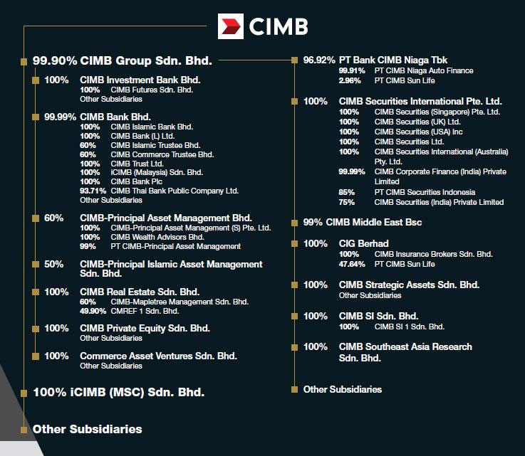
Figure 2 : CIMB Group structure

IT SECURITY

PRODUCT AND SERVICES
The services are wholesale banking for cooperate finance, equity capital markets, institutional broking, equity derivatives, securities borrowing and lending, corporate banking, trade finance, cash management securities services, global financial institutions, structured finance and syndication and research. Secondly, treasury which contains debt capital market and syndicate, cross markets trading and derivatives and government bond market making. CIMB also serve asset management which is includes retail and institutional funds (Islamic and Conventional), real estate funds, infrastructure funds management, private equity funds and real estate funds. Next, retail and commercial banking which contains deposits, private banking, loan and financing, mortgage, leasing, credit card, microcredit, ASBs, remittances, wealth management, self service terminal and digital banking. Last but not least, CIMB offered Islamic banking which contain ‘wadiah’,’ mudharabah’ and ‘sukuk’.
ACHIEVEMENTS
CIMB is the fifth largest banking group in ASEAN. They have around 37,000 staff in 15 countries across ASEAN and other countries. CIMB retail banking network have around 850 branches and serving more than 13.5 million customers. They have branches all over ASEAN countries and China, Hong Kong, India, Sri Lanka, Korea, United State and the United Kingdom. 30 June 2018, CIMB Group Corporate has RM 511.2 billion total assets, RM84.1 billion total funds under managements, 15 global markets and RM 46.9 billion total shareholders’ funds.
In 2018, Malaysia CIMB Bank earned numerous awards at Alpha Southeast Asia 12th Annual Best Financial Institution Awards 2018 such as best equity house, best Islamic finance retail bank, best Islamic finance commercial bank best Sukuk and Islamic finance investment bank. They also won best cooperate and investment bank and best bank for SMEs at Asiamoney Best Bank Awards 2018. Next, they won best Islamic investment bank at The Asset Triple A Islamic Finance Awards 2018. There are many more that CIMB got under the name of other countries branches.
For more award list, please refer to : https://www.cimb.com/en/who-we-are/overview/awards/2018.html#read

REFLECTION
In a nutshell, this CIMB visit gave us a huge benefit to our own goals. This is because, as a Data Scientist / Data Engineer to be, this visit gave us a brief of surface of what will us be facing for the future. Furthermore, the visit also shows us about how important to grab any opportunity especially in data management & IT related field which are one of the study requirement in our course, SCSP. Then, the visit also focused us about the internship, which one of the difference of our course than other. This is because with 2u2i, we need to prepare to do an internship for a whole year (2 semesters). CIMB management already gave us a brief of explanations about how to cop and secures an internship especially in CIMB.
In conjunction with that, there are various action need to be taken by ourselves to improve our potential in the industry. One of the actions that need to be taken generally, we need to focus on our study and try to score on it but we also need to maintain our curriculum such as joining any clubs in university. This is important because scoring in academic alone doesn’t give us the social networking and soft skill required in job environment. Next, we also need to improve our social interaction and soft skills. Social interactions, either casual communication or professional are very important for building a large social network for our future preferences. Soft skill such as presentation skills, interviews and many more also are important for us to improve to ease us in the future.
Finally, a few plans need to be construct as in to improve our potential in in this industry especially the growth and new wave of Industry Revolution 4.0. One of crucial plan need to be done is a set of frameworks of what specific industry or field that we want to join in the next 5/6 years ahead. With the vast moving world, Industry 4.0 will be any nearby. Therefore frameworks of future planning need to be done to help us prepare of any possibilities that might be happen .

REFERENCES
- https://www.cimb.com/en/index.html
- https://www.cimb.com/en/who-we-are/overview/awards/2018.html#read
- CIMB slide presentations

