
INDUSTRIAL REPORT

CICT

Group Members : Adiba Rusyda bt Mazri
Kennard Tan Jun Yuan
Govind Raj A/L Gnanasegaran

Lecturer’s Name: Dr. ARYATI BINTI BAKRI

Course : 1/SCSP Section 2

Contents
INTRODUCTION 3
Details of Journey 4
Organization Structure 6
REFLECTION 8
Kennard Tan 8
Conclusion 10
REFERENCE 11

INTRODUCTION
Centre for Information & Communication Technology (CICT) of UTM, the ex-building for Faculty of Computing.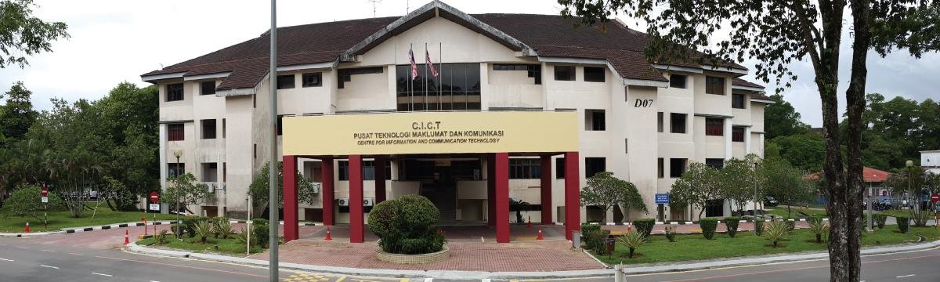
Figure 1: Centre for Information and Communication Technology
In its early days, around 1975 ~ 1985, it served as a staffs’ salary processor. It also used an old model mainframe – IBM 390. Then, it upgraded its system to handle staffs’ information system. Soon after, it also upgraded its ancient mainframe to IBM 1431 with a goal to handle all the increased users/usage and also using the Operating System – VM/SP 5. At the same time , it added a new function – which is Monetary System.
In 1975, CICT was only known as a “computer center”. As of 1981, “computer center” fused with the Department of Science Computer and thus its under Faculty of Science. By 1984, it upgraded into Institute of Science Computer, 1991 it became “Pusat Komputer UTM(PKUTM)”. 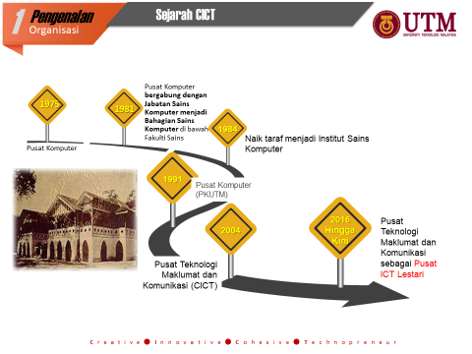

Details of Journey

On 31st of October 2018, we (SCSP & SCSB students) had a industrial visit to the Centre for Information and Communication Technology (CICT).
They gave us (SCSP and SCSB students) an amazing speech, by
Sir Mohd Zahari bin Zainal Abidin, figure 2 shows him.
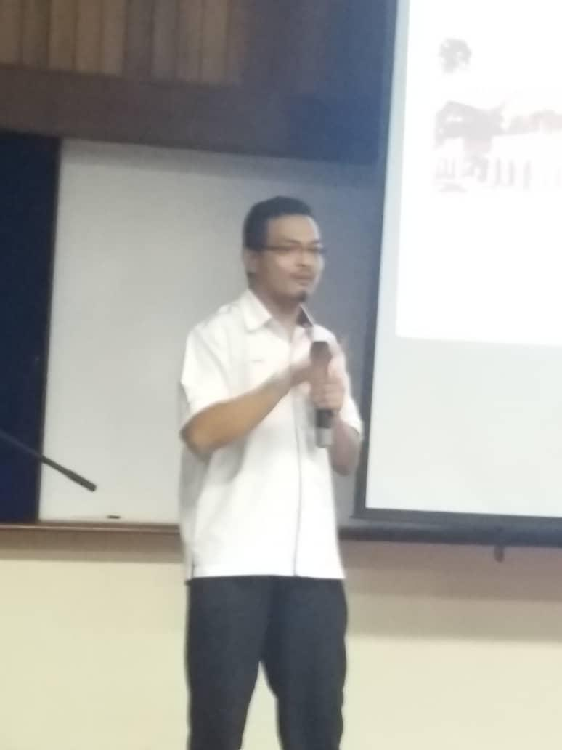,
the assistant officer of Technology Information of CICT.
Figure 2
The motto of CICT includes: -
C – Creative
I – Innovative
C – Cohesive
T – Technopreneur
In this talk, various things about CICT was presented by Sir Mohd Zahari things like the CICT’s organization structure, achievements of CICT and its security, etc. The talk lasted for around 2 hours, after the talk, we all visited the PPICIP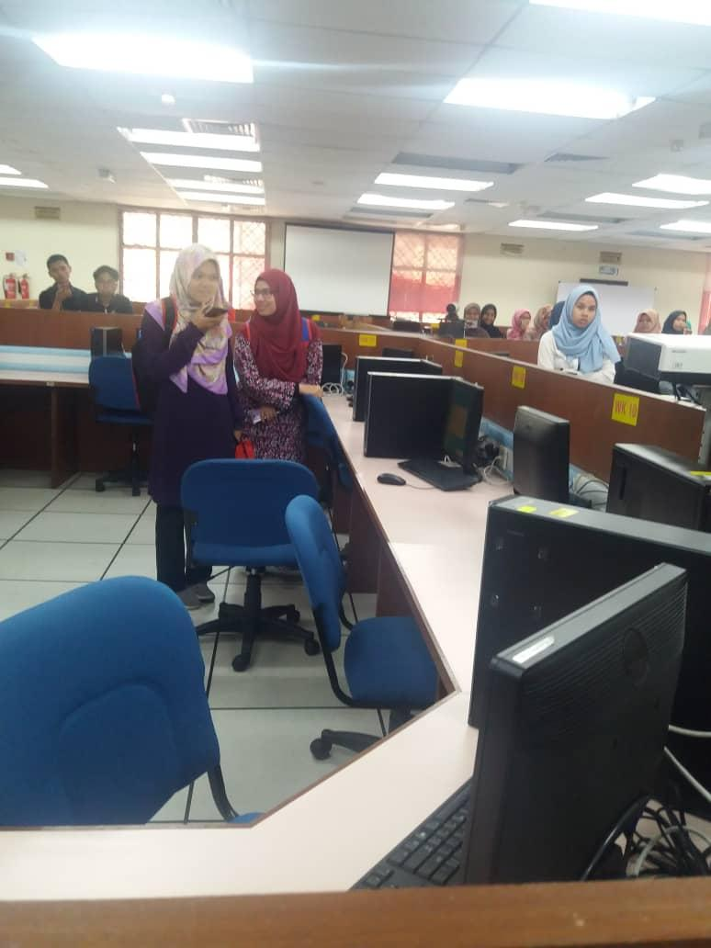
which is computer lab of CICT, which has around 70 computers with computers and also spaces with lan wires provided. After that, we also made a visit to the Gallerium too, where ancient technology lies. We were exposed to various technology long before we were even born to witness its usage.
Figure 3 : PPICIP , Computer Lab of CICT
Figure 3 : computer lab of CICT
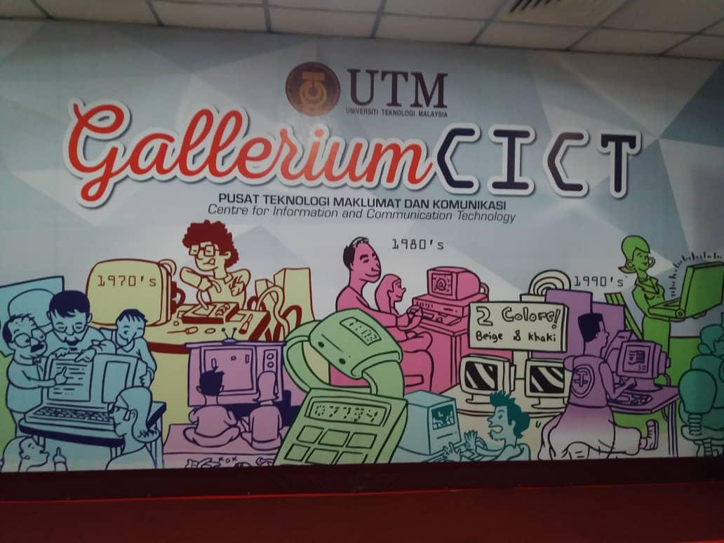
Figure 4 : Gallerium in CICT
The vision of CICT is to become a top digital university delivering academic-based service and its mission is to develop an entrepreneurial digital ecosystem by fostering innovative digital professionals and promoting collaboration in digital services. CICT’s main goal is to provide ICT services and also provide continuous improvement to increase customer satisfaction in conjunction with its vision and mission.

Organization Structure
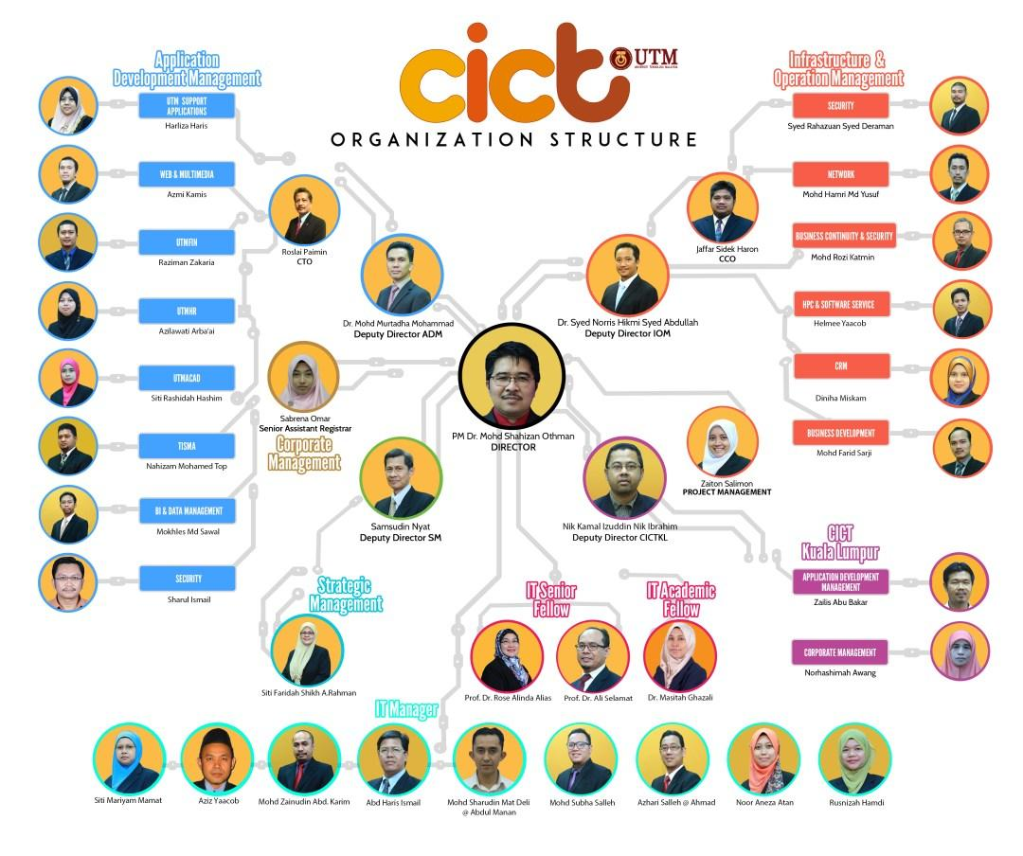
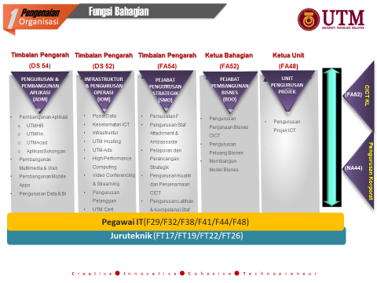
ACHIEVEMENTS CICT TOWARDS UTM
In addition, the CICT also has many achievements gained throughout their establishment. This is because, CICT at UTM is the largest data centre for the southern part of Malaysia because the system was developed from CICT own crew. Next, UTM is the first institute use green technology. Furthermore, we should be proud of their success, because without CICT, we will not be able to develop advanced facilities for students to enhance in studies. After that, we can see some of the latest achievements of CICT that have been uploaded on the CICT portal itself: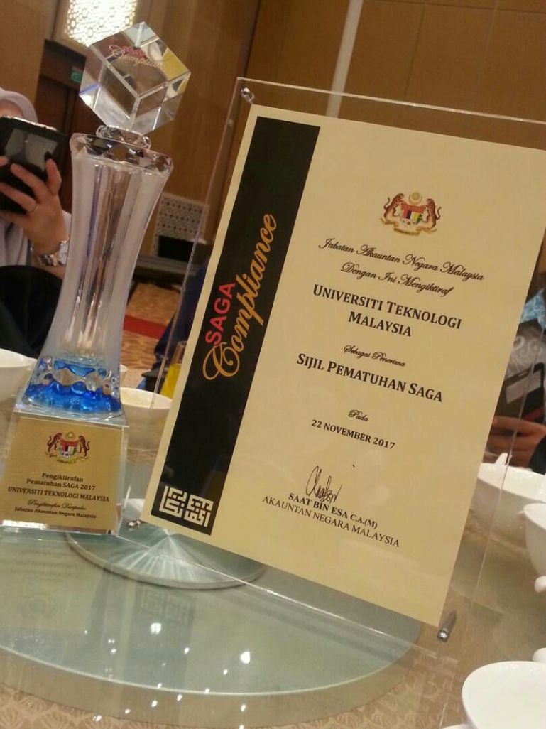
CICT receives recognition of the SAGA Compliance Certificate (which is Standard Accounting System For Government Agencies) amended by the Accountant General's Department on 22 November 2017.
Next, CICT also had organized first aerobic session at the Azman Hashim Stadium on February 27, 2017. There is 50 out of 123 CICT’s staff were present to enliven the program. Next, here we can see though they are busy with the work they do every day, they are also able to have a healthy lifestyle with this aerobics program. This is because they can have benefits by joining in this program, such as they can know others staff, make new friends and they can improve their social skills. Hence, we can conclude that even though they always busy organize or monitoring data system, they also can enjoy their free time with this kind of program.
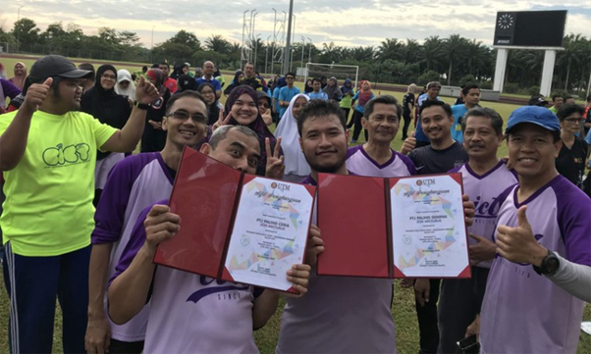

Additionally, CICT has received a data centre design award on December 1, 2017. Data centre with redundant infrastructure where maintenance on equipment can be implemented without disrupting other ICT services.
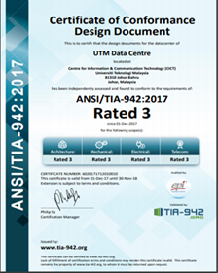

CICT SERVICES
There are quite a number of services that are provided by CICT UTM. The services that are provided are internet, infrastructure and security, application management, web management , software and ICT support. The following are the explanation of what the speaker said during his talk.
INTERNET
First of all the he explained about internet . He explained that the internet is the system of interconnected computer networks that use the Internet protocol suite to link billions of devices worldwide. It is a network of networks that consists of millions of private, public, academic, business, and government networks of local to global scope, linked by a broad array of electronic, wireless, and optical networking technologies.
Next he also talked about the internet service that is provided in UTM. He thought all of us how to access the internet in UTM. He also said that there is fix IP for Access Point, Printer, CCTV, Door Access. He also shared the amount allocation that is needed for that IP that is fixed. Moreover the internet bandwidth that is provided for the students and the staffs of UTM is only 1Gb . He said that that particular bandwidth is not enough for every people. The speed of the internet is 100Mbps which is fairly fast.
INFRASTRUCTURE AND SECURITY
Each and every staffs and students in UTM has an ID which is called the Acid ID. This ID is compulsory for every staffs and students in UTM. ACID can be defined as a unique ID of the user through the authentication server to use to log into the university’s systems . Every students have their own user ID after registering the program through their respective faculties . Meanwhile , the staff must have a official UTM email account first before applying ACID account .
Next, CICT UTM provides and manages ICT security using Next Generation Firewall with reducing complexity and lowering the total cost of ownership . In addition , CICT UTM also implements High Availability concept with active-avtice balancing to optimize the functionality and efficiency. CICT also implements the URL filtering concept to avoid explicit contents to be displayed and to avoid virus attack toward the users. Moreover there is also intruders prevention system which examines network traffic flows to detect and prevent vulnerability exploits.
SOFTWARES
The software in UTM has been operated by The Information and Communications Technology ( CICT ) . As a service center for licensed software to users in UTM , the CICT provides some rules that must be followed by the users . CICT has also been tasked to control the microsoft website for the use of all users at UTM . Microsoft ‘s software for FREE by MOE ( Ministry of Education ) is provided to staff and students of UTM . Moreover, the software is available in the Microsoft DreamSpark website where all the information to obtain the software can be found at staff email or students email.
SYSTEM DEVELOPMENT
CICT UTM builds and manages Multimedia, Administrative, Support, Learning Applications and Teaching to drastically improve the university’s service delivery efficiency and quality. CICT UTM also develop new web and mobile base application and maintain the current UTM application base on request by PTJ.

REFLECTION
Kennard Tan:
My goal/dreams with regard for my course (Data Engineering) is a simple one, yet hard to fulfill.
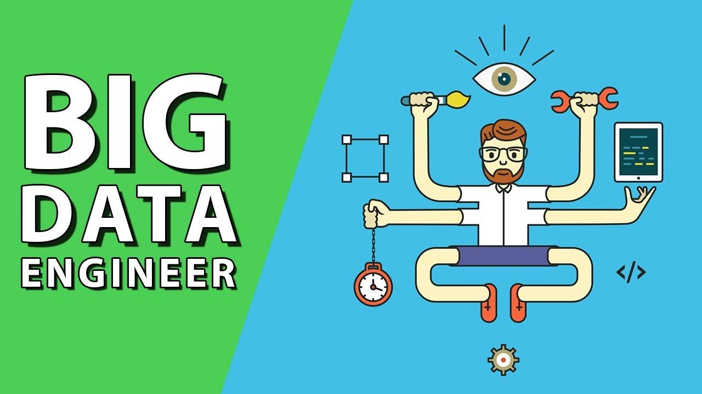
My dream is to be one of the pioneer Data Scientist Specialist in Malaysia and further improve Malaysian’s standard/skills in the IT department. In order to obtain that, first and foremost I have to prove myself worthy by attaining a first class degree here in UTM. I hope that this degree in UTM will be the perfect stepping stone for me to step into the wilderness, and potentially enable me to work overseas and gain more skills there. At the same time, earn an above average salary, and maybe in 10 years start my own start-up. As the current trend is towards the age of Big Data and Artificial Intelligence (AI), thus I believe that this goal of mine to have financial freedom should be reasonable and attainable.
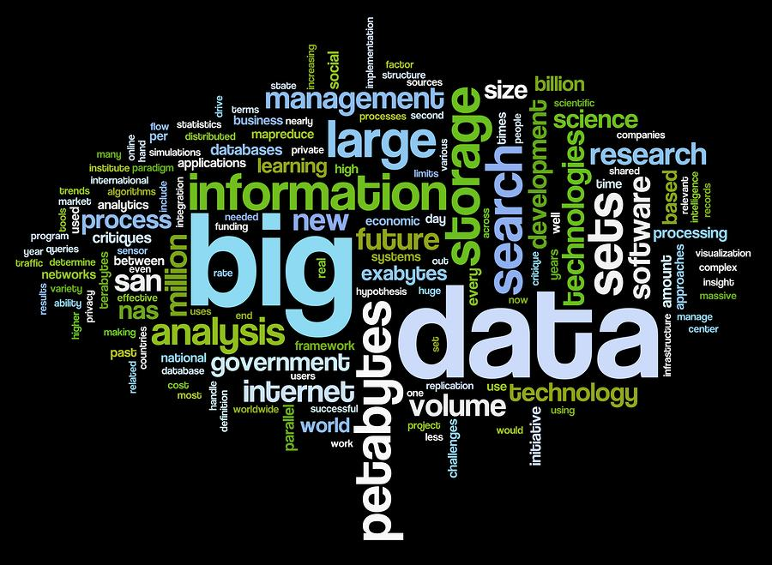

There are a few things that I’ve learnt through this visit to CICT. First of all, it taught me what kinds of system that an IT-based company/facility uses, and some of the problems it faced. This might give me a head start when I’m trying to start my own start-up, in which I hope it will prevent me from doing some of the silliest, simplest and common mistakes for start-ups. Next, it also showed me how does an IT company/department set up its hierarchy, in other words, its organization structure. In a company, its hierarchy is very important thus learning about CICT’s organization structure will prepare me for the future and help me with my journey.
CICT also gives free software such as Adobe Photoshop and Microsoft 360 to its workers and students. This act gave me an important lesson – give important software which is costs money to own to workers for free. As this act will be able to improve the workers’ performance and it will be under the cost of the company. Also, the free software given such as the antivirus given recently, will be able to aid me in my studies during this 4 years. Yes, this visit to CICT has given me a huge impact.
In my humble opinion, there are quite a few actions that I can take in order to improve my potential in the data sector in this industry. First of all, I believe that it is necessary for me to learn multiple coding language such as C++, C# and also Python, especially Python as it is becoming more and more in-demand. These can be learnt through online learning platforms such as SoloLearn and Coder Bytes and also through YouTube.
Next, I can also attend some seminars held in UTM related to data, especially seminars given by Malaysia Digital Economy Corporation (MDEC) as they are usually very beneficial. Adding on, I can also do freelance work at the same time earn some side income and thus relieving some of the financial burden on my parents.

Adiba Rusyda :
As a data engineering student , dreams or goals that i want to be apply regardless on seminar that I had attend is, I want to be data scientist or data analyst for sure. However, I have a dream more focused on business. One of my dreams is to open a company that sells all kinds of products. The dream to open this company is triggered when we rarely see businessmen in Malaysia using data scientists or data analysis as an important component in business.
Next, I know it is difficult for university graduates to get a job. My goal is, I want to open job opportunities to all students, especially data engineering leavers. I open this opportunity to help university graduates to work under the pursuit of my company. This is because, we strongly require university graduates in data fields to help my business grow more. For example, , if we want to promote our products to the public, we need data analyst to analyst what consumer in Malaysia needs.
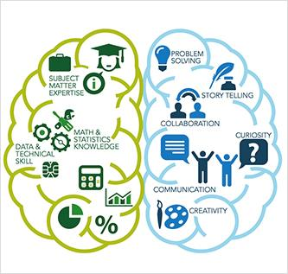
Besides that, we all know that online sales fraud is a cybercrime that we need to avoid. We can use data scientists to reduce risk and fraud this is because. data scientists are trained to identify outstanding data in several ways. They make large data statistics, networks, routes, and methodologies for predictive fraud preference models and use them to create alerts that help ensure timely response when extraordinary data is recognized. Therefore, we strongly require university graduates in data fields to help my business grow more. Additionally, I also dreamed that my business company was comparable to foreign companies such as Amazon, ebay and so on.

Govind Raj :
We as a data engineering student have a lot of dreams in us. First of all, our dream is to improve the IT world in the future, moreover we also expect to help the poor people by proving them quality software for free. Not only that our goal is also to bring Malaysia equal to other IT PRO countries where this can also stabilize our countries economic level.

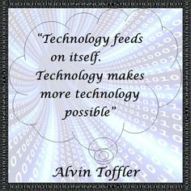

There are many ways this trip could help us to achieve our goals. First of all, by visiting CICT we got to know about the service they provide and how they provide it. In addition we also got to know how to run a user-friendly base. This is a big advantage in order to obtain user support.
Finally , there are many things that could be corrected in order to achieve our goals. First and foremost, first thing to be corrected is procrastination. This is because procrastination is the number one killer of our goals. Lastly , enough knowledge should be obtained in order to achieve what we aimed.

Conclusion

As a conclusion, we truly believe that this trip to CICT was a very advantageous one as it has brought us priceless life lessons and experience, even inspiring some of us to work harder to achieve our goals. It was a short few hours, but it might have changed our life. The services offered by CICT was wonderful and is very beneficial to the students as it can ease their workload and can help relief some of their financial burden as they do not have to buy any of the programs needed for their work/studies.

REFERENCE
- http://cict.utm.my/vision/
- http://cict.utm.my/organization-structure/
- http://cict.utm.my/ict-knowledge-repository-2/

