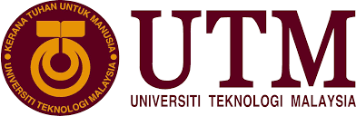

Industrial Visit 1

Name : Ishaq Sani Ishaq – A18CS0353
How Kah Hui – A18CS0074
Izzat Marzuqi Bin Ghali – A18CS0080
Course : SCSP 1513-09
Technology and Information System
Lecturer Name : Dr. Aryati Bakri

Table of content
1 Introduction 3
2 Details of the journey 3
3 Detailed Description 6
3.1 Organization Structure 6
3.2 Services at CICT 7
3.2.1 Basic ICT services for students: 7
3.2.2 Student management services: 8
3.2.3 ICT instructional services: 8
3.2.4 ICT social services: 8
3.2.5 Additional E-services: 9
3.3 Achievement 9
3.4 Information System 10
4 Reflection 10

Table of Figures
Figure 1 Entrance to PPICTP 4
Figure 2 Entrance to CICT 4
Figure 3 Collection of Old Laptops 5
Figure 4 IBM Mainframe CPU 5
Figure 5 Impact Printer 5
Figure 6 Organization Structure 7
Figure 7 Sijil Pematuhan Saga 9

Introduction
CICT is a support unit that offers and delivers ICT services for UTM especially in ICT infrastructure, system development and academic or administrative activities. It is located at block D07. The director of the CICT is Professor Madya Dr. Mohd Shahizan Bin Othman. The official website for CICT is cict.utm.my.
On 1 October 2018 (Monday), we had visited the Centre for Information and Communication Technology of UTM. First, Encik Mohd Zahari B Zainal Abidin, representative from the CICT briefed about the ICT services and regulations before conduct us to explore the Gallerium CICT and SMAL CICT (Student Multimedia and Content Authoring Production Lab).

Details of the journey
The trip was accompanied by Dr. Aryati Binti Bakri from faculty of computing UTM. The students gathered at the 4th floor of the CICT centre at Universiti Teknologi Malaysia by 1:30pm. We were accompanied by some lecturers to the seminar hall. Briefing began at 2:30pm by the head of the CICT about CICT. We were briefed about the services that CICT offers to students and lecturers such as PPICTP, WI-FI UTM, VPN, ACID, UTM LIVE@edu, AIMS, Student financial system, E-learning, MYLINE, E-PP, E-portfolio, UTM motion, UTM share. These are the main CICT services across UTM. We were then accompanied to the PPICTP where it contains 382 Computers, Mac OS - 52 Computers and Thin Client (Linux) - 20 Computers, Project discussion area ( 3 Areas), Printing, scanning and CD/DVD burning, Binding and Laminating, Specialize Multimedia & Content Authoring, Production Lab (SMAL). We were then escorted to GALLERIUM CICT where we were showed all the collections of computers or laptops, servers, monitors, chips and printers from the old ages such as mainframe computers, tower server, impact printer, etc. The visitation ended by 4:00pm.

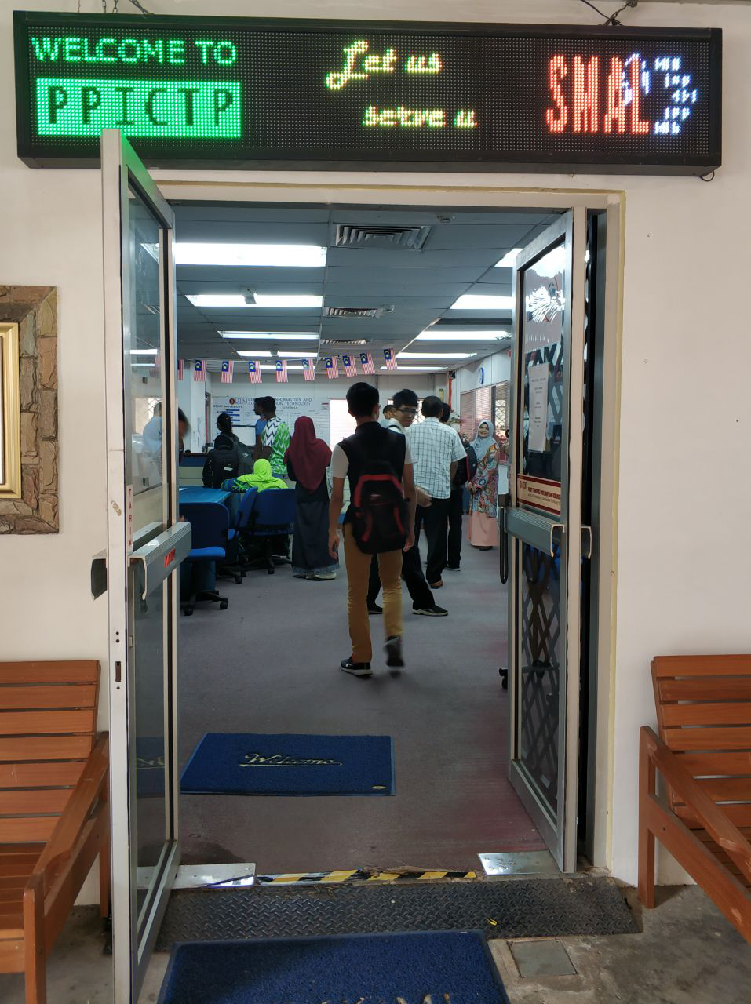
Figure 1 Entrance to PPICTP

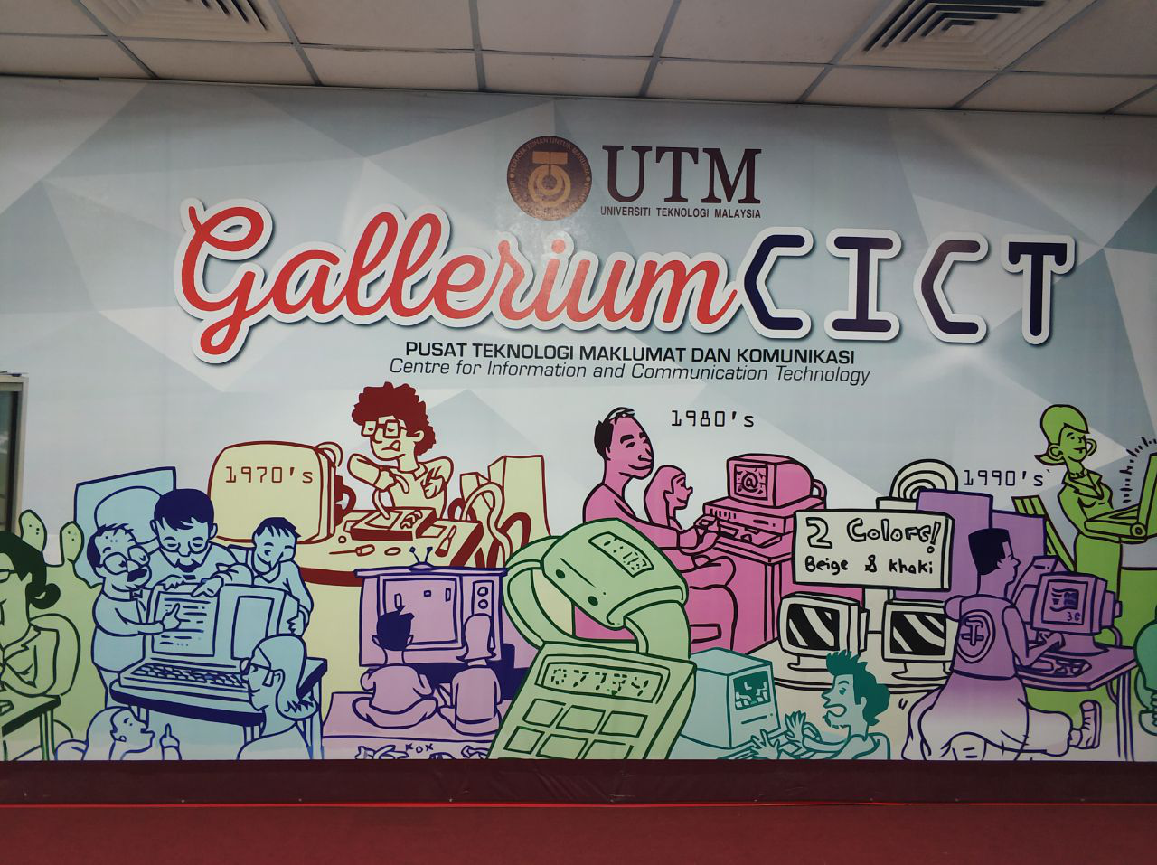
Figure 2 Entrance to CICT

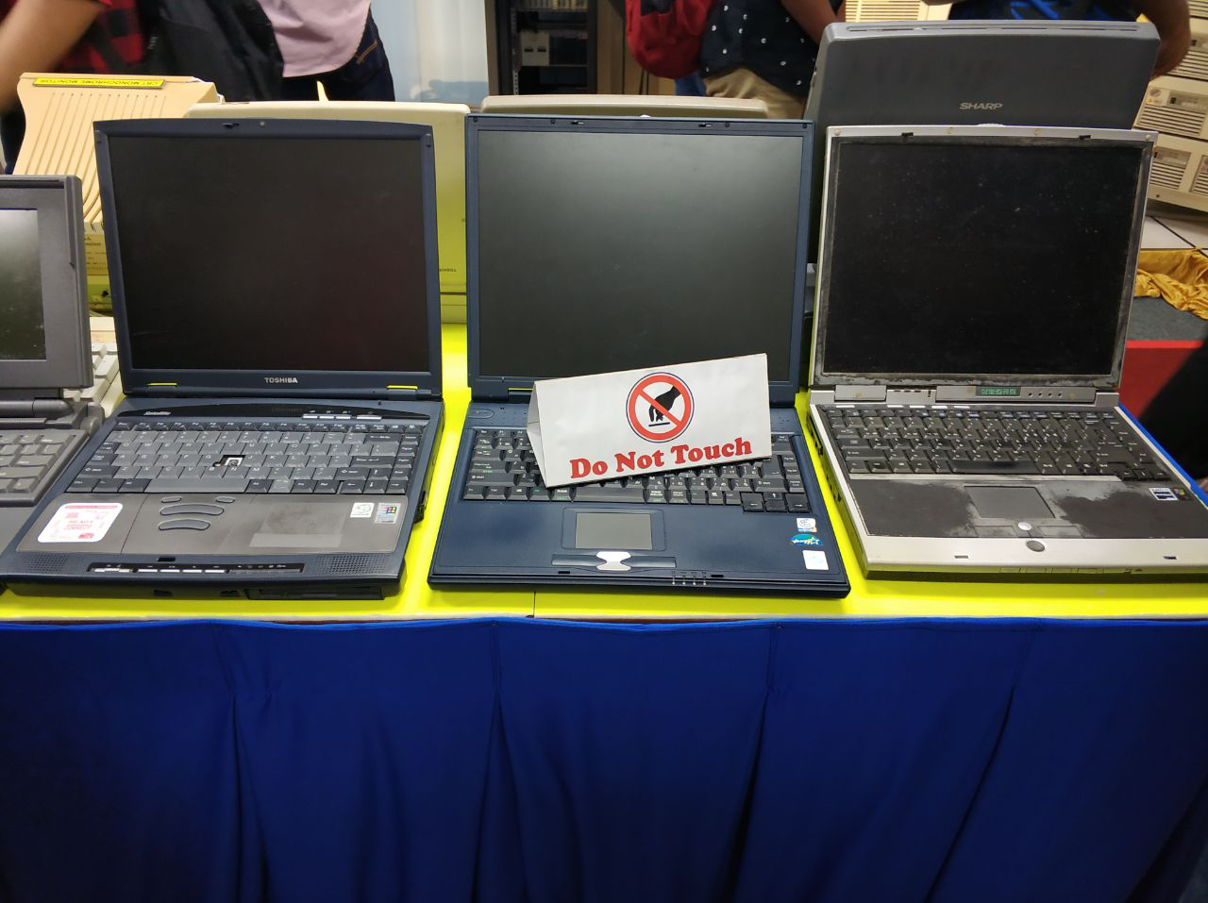
Figure 3 Collection of Old Laptops

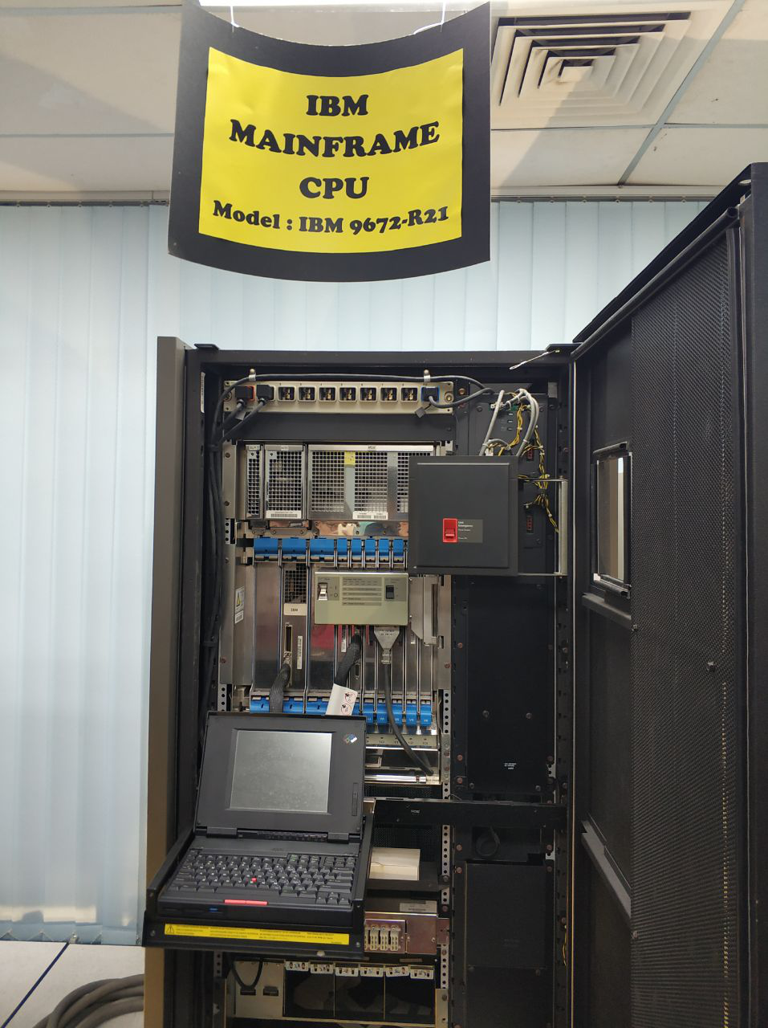  Figure 4 IBM Mainframe CPU | 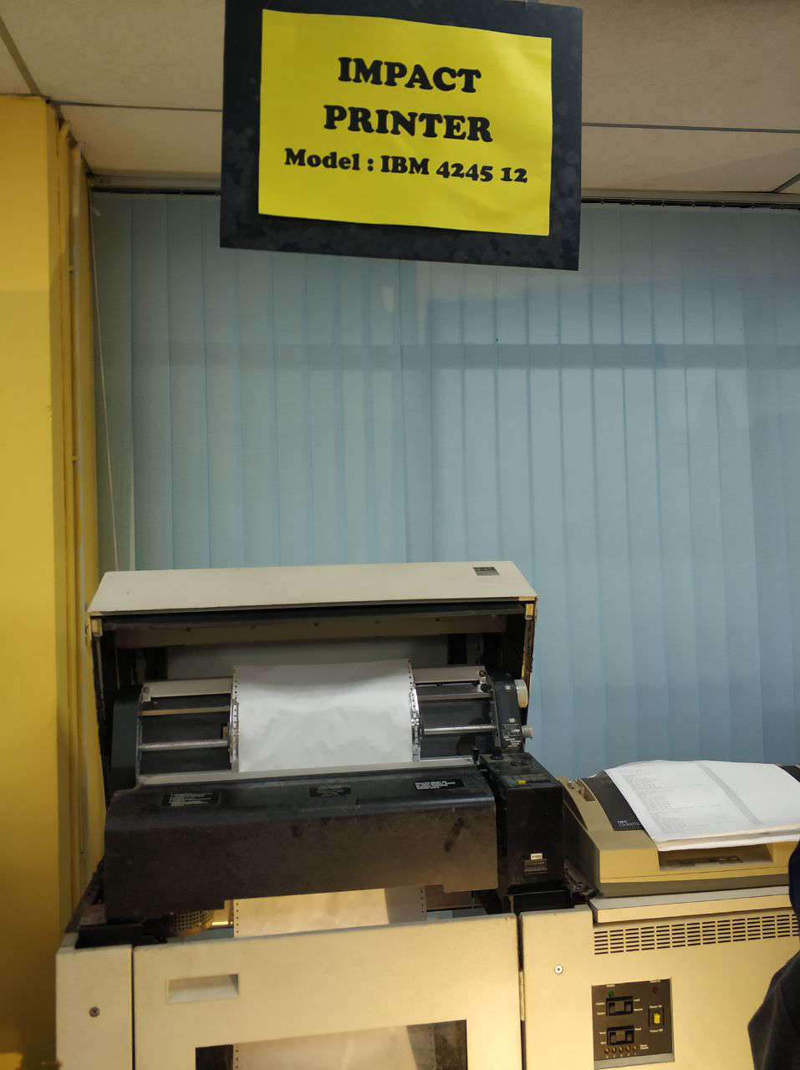  Figure 5 Impact Printer

Detailed Description

Organization Structure
The CICT is a support organization that offers and delivers ICT services for the university either staff or students especially in ICT, Infrastructure, system development and academic/administrative. CICT consist of 8 department, starting from the top management, Project Management Office (PMO), Strategic Management (SM), Infrastructure and Operation Management (IOM), Application Development Management (ADM), Business Development Office (BDO), Corporate Management (CM), IT Academy Fellow, CICT KL Campus.
Top management department are being led by, , followed by four deputy director which are deputy director of IOM department, SM department, deputy director of CICT KL and ADM department. Professor Madya Dr. Mohd Shahizan Bin Othman as the Chief Information Officer (CIO) also followed by 4 other staff which are Chief IT Officer in BDO unit, ADM department, Corporate Branding in SM and Senior Assistant Registrar in CM department.
For the PMO department the organization is led by, Professor Madya Dr. Mohd Shahizan Bin Othman also known as the Chief Information Officer of CICT, help by Puan Zaiton Salimon which is the IT senior. SM department is led by the deputy director and being assist by Puan Siti Faridah Shikh A. Rahman. In IT Senior Fellow it is been organized by Prof. Dr. Rose Alinda Alias which is a senior IT associate Fellow CICT, she is assist by Prof. Dr. Ali Selamat as a senior IT associate Fellow and Dr Masitah Ghazali as an academic IT (CICT UTM).
For the IOM department the organization are being led by the Deputy director and being assist by Encik Jaafar Sidek Haron as the Senior IT Officer, under IOM there are 6 small body which are more focus on specific part in (IOM), such as, the security management team, network activities, business continuity and security, High Performance Computer (HPC) and Software service team, Customer Relationship Management (CRM) and business development.
For ADM department, it is led by the deputy director and being assist with Encik Roslai Paimin as chief IT officer, under this department there consist of 8 small body which are help organize the department more efficiently, such as, UTM support applications, web multimedia, UTM FIN, UTM HR, UTMACAD, TISMA, BI & Data management and security.

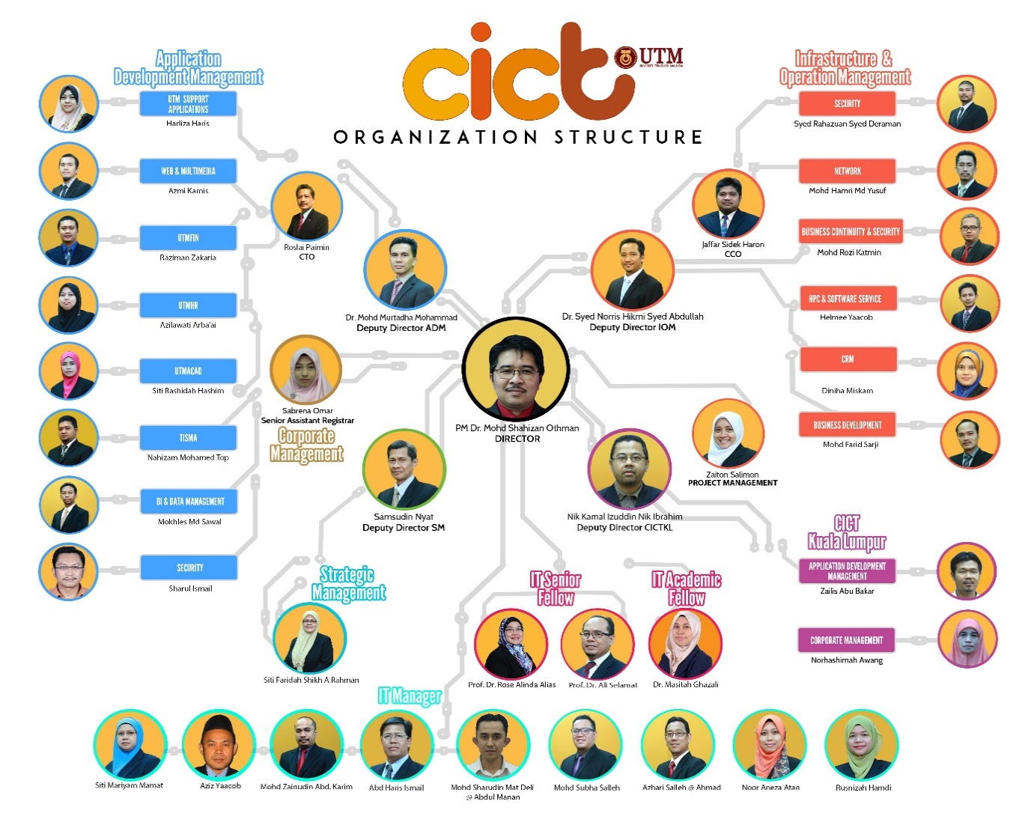
Figure 6 Organization Structure

Services at CICT
CICT offers a lot of services for UTM students and lecturers. The services are as follows:

Basic ICT services for students:
- PPICTP: it contains computers such as Windows Platform - 382 Computers, Mac OS - 52 Computers and Thin Client (Linux) - 20 Computers, Project discussion area (3 Areas), Printing, scanning and CD/DVD burning, Binding and Laminating, Specialize Multimedia & Content Authoring, Production Lab (SMAL). These computers have high end programs such as Final Cut Pro, DVD Studio Pro, Sound Track Pro, Color , Aperture, Motion, iWork, iLife , Adobe Suite, Roxio Toast and SDK.
- WI-FI UTM: internet can be accessed everywhere in UTM whether it is wireless or wired. CICIT provides WI-FI for all colleges and faculties across UTM. The UTM WIFI Uses the latest technology in WiFi for APs (803.11n) and it Provides 100% coverage to rooms to all kolej across UTM. The internet speed is 1Gps. The student is required to log into the WiFi using their ACID password and username.
- VPN: this is designed so that student can log into UTM intranet services outside UTM.
- ACID: This is a computing ID that gives access to UTM’s main application. Students can register their courses, check their grades, access e-learning and mail.
- UTM LIVE@edu: this is the students live email. Students can access Office 365, this offers free email, instant messaging, group video and voice chat, and online document viewing and editing.

Student management services:
- AIMS
- Student financial system: this is where students their debit and credit account. Students can see the fees due whether it is hostel fees or tuition fees.

ICT instructional services:
- E-learning: it is an educational program that allows lecturers and students to use, this assists the lecturers in the teaching process to be more effective and efficient. Lecturers can share slides, assignments E.T.C with the students.
- MYLINE: this is an online resource for learning English. This allows students to improve their English language communication skills. It allows students to make their learning flexible to when they are comfortable.
- E-PP: this is an online resource that allows students to grade the their lecturers on the way they teach and give comments.
- E-portfolio: An online compilation of documents that is flexible and is based on artifact evidences of which students write during their entire study at UTM. Plan their personal, academic and career development on the platform.

ICT social services:
- UTM motion: this is a platform that provides video sharing for teaching and learning purposes. It promotes UTM to the community and promotes more usage of e-learning.
- UTM share: this is platform that allows students to store data online. Each student has 7.15GB of storage.

Additional E-services:
Microsoft professional software/tools. Students get software programs such as Microsoft office, dream spark premium. Students can access this using their official UTM mail and their ACID username and password.

Achievement
CICT UTM had achieved the Anugerah Sijil Pematuhan Saga 2017- PTJ Paling Ceria & Gempak as they provided the best technical documents to the National Accounting Agency in 22 November 2017. UTM is one of the 59 among the 416 agencies to achieve the Sijil Pematuhan SAGA beside USM, UMP, UPNM, UNISZA, UTHM and UPM. Hopefully, it can encourage the other agencies in UTM to provide more comfortable and more professional services.
Moreover, CICT becomes the most active PTJ in Senamrobik Perdana in Zone Arcutus at 7 February 2017 at the Stadium Azman Hashim UTM Johor Bahru. They had a 40.7% of the overall staff in CICT which is 50 people of 123 staff in CICT. This shows that the staff in CICT not only dedicated in their work but they also active in the sport.
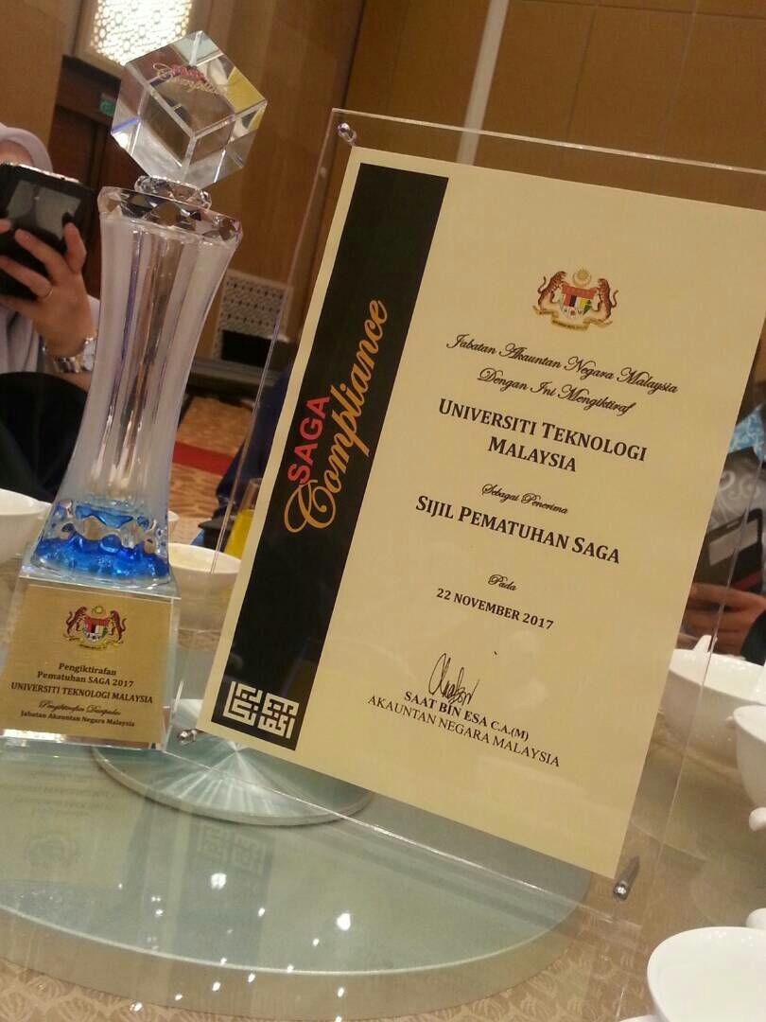
Figure 7 Sijil Pematuhan Saga

Information System
CICT mainly specialized to manage, supervise and maintain the UTM databases such as students and lectures information, UTM organization, academic database and more. Then, they also providing UTM’s IT infrastructure. They also manage the internet access of UTM like UTM Wifi. VPN also are handle by the CICT.
CICT have develop the official website of UTM and organize it. In this website, people can know about UTM well and apply for UTM. They also have developed the e-learning to ease the students and lectures. In the e-learning lectures can easily give assignment or notes for students. That make the learning process more efficient. CICT also have created ACID for every student that is academic computing ID to protect the student’s information. Moreover, UTM motion is created as a platform for video-sharing. This actually can promote UTM to the community.

Reflection
ISHAQ SANI ISHAQ (A18CS0353)
I started studying this program because of my love of computers. So I made a decision of studying them more. As a computer science student doing a major in graphic design, I want to be a very good programmer and graphic designer. I want to graduate with a good result and work for big computer companies like google, Microsoft, apple, Intel.
The visit to CICT has made me research more about my program, it showed us how computer makes a big impact in the life of a lot of people. The way computer programmers help people in their day to day activities. This gave me a new mindset of working towards my dream as a graphic designer.
I plan to study harder, ask my lecturers questions in during lecture. Listen to my lecturers and perform more tasks and submit on time. Performing tasks with people that are smarter than me or have a higher level of education more than me, by doing this I will learn from them and gain knowledge.

HOW KAH HUI (A18CS0074)
In my opinion, my goal according to the graphic and multimedia software course is to become a good graphic designer. This is because I love to design and involve in the multimedia sector. After visited the CICT, I realized that I can create a website and mobile application which is user-friendly same as the CICT websites which is friendly to the undergraduate students, the postgraduate students and all the UTM staff. At the same time, I think I can learn more designing and editing skills days by days from the events held or self-learning via MOOC or Youtube Video beside the knowledge learnt inside the classroom.

IZZAT MARZUQI BIN GHALI (A18CS0080)
As a computer science of graphic and multimedia student, I hope that I will master the programming and designing. I also hope that I have a good knowledge in IT to make sure that I have bigger opportunity in this course. My goal after graduate is get a good job with big companies local or abroad.
The visit help me a lot in how IT people work. It teaching me how important IT people in maintaining and improving the organization. Moreover, they also show us the early computer. There is big improvement of the modern computers than the early computer in just a short time. This means that IT are keep improving so fast.
Now, I am more confident that this course have a big opportunity in this era. After this, I will try to perform well in this course to ensure that I can work for big companies. I also will improve my skills in programming and designing.

