

Industrial Talk 3

Name : Ishaq Sani Ishaq – A18CS0353
How Kah Hui – A18CS0074
Izzat Marzuqi Bin Ghali – A18CS0080
Course : SCSP 1513-09
Technology and Information System
Lecturer Name : Dr. Aryati Bakri

Table of content
1 Introduction 3
2 Contents 4
2.1 IOT: Predictive Maintenance Gets an Extreme Makeover 4
2.1.1 What's in predictive maintenance? 4
2.1.2 IDC FutureScape: Worldwide CIO Agenda 2019 4
2.1.3 Industry Revolution 6
2.1.4 Industry 4.0 – Technology Trends 7
2.1.5 Computing at the Edge 9
2.1.6 Artificial Intelligence (AI) for the Data Centers 10
2.2 Internet 2.0: Transaction Based Networking 12
2.2.1 Man Computer Symbiosis 12
2.2.2 Blockchains 12
2.2.3 The Strengths, Weakness, Opportunity and Threat of Blockchains 13
2.2.4 Internet 14
3 Summary 16
4 Bibliography 17

Table of Figures
Figure 1 IOT OPEN DAY 2018 4
Figure 2 Industry Revolution 7
Figure 3 Technology Trends in Industry 4.0 9
Figure 4 Computing at the Edge 10
Figure 5 Artificial Intelligence 11
Figure 6 Cryptocurrency 12
Figure 7 Centralized Databases VS. Blockchain 13
Figure 8 Strengths, Weakness, Opportunities and Threats 14
Figure 9 History of Internet 16

Introduction
The Internet of things (IoT) is the network of devices, vehicles, and home appliances that contain electronics, software, actuators, and connectivity which allows these things to connect, interact and exchange data. IoT involves extending Internet connectivity beyond standard devices, such as desktops, laptops, smartphones and tablets, to any range of traditionally dumb or non-internet-enabled physical devices and everyday objects. Embedded with technology, these devices can communicate and interact over the Internet, and they can be remotely monitored and controlled. Hardware, software, and security solutions that put IoT into action in the connected world, providing valuable insights from devices and data at the Intelligent Edge.
On 18 November 2018 (Sunday), we had visited the IOT Open Day 2018 at P03-221 UTM for industrial talk 3. Mr. Syahrul Hafidz Suid who is the speaker for section 1 – IOT: Predictive Maintenance Gets an Extreme Makeover. He is the enterprise consultant of Hewlett Packard Enterprise. He was briefed about the worldwide CIO Agenda 2019 Predictions by IDC, Industry 4.0-Technology Trends, IOT- Predictive Maintenance and etc. Besides, Mr.M Nazrul who was given the second talk that quite interesting. The talk is about Internet 2.0: Transaction based networking. Actually, blockchains is Internet 2.0. Blockchain is essentially an open-source decentralized or distributed ledger or database that records every transaction in a block, which is link to other blocks which this is the basic concept of the Bitcoin. So, this will create a new kind of transaction for nowadays. This talk actually important to us because as a computer science student. Futhermore, Bitcoin will be famous and powerful in upcoming years. Mr.M Nazrul explained about Internet 2.0 to us to make sure that we undertstand this well.
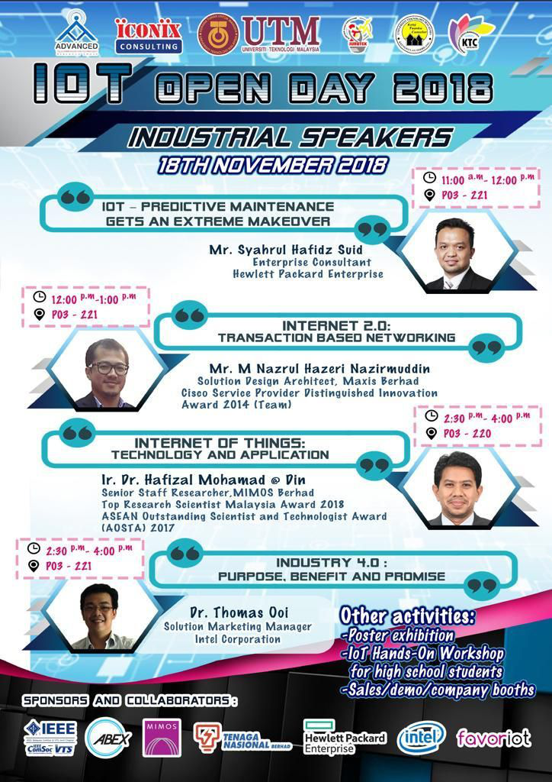
Figure 1 IOT OPEN DAY 2018

Contents

IOT: Predictive Maintenance Gets an Extreme Makeover

What's in predictive maintenance?
The concept of predictive maintenance may be as old as the first machine invented by humans. In the recent past, predictive maintenance solutions focused on complex machines, such as jet engines, whose failure would be catastrophic. Often, these systems involve the compilation of large amounts of historical data, the application of machine learning, and the creation of digital "twins", which are digital representations of physical machines that are actually similar to physical machines. Now, with the advent of the Internet of Things (IoT), reduced connection and storage costs, and the creation of large amounts of data, predictive maintenance is transforming industries and machines that were previously impossible.

IDC FutureScape: Worldwide CIO Agenda 2019
In the multiplied innovation economy, enterprises are racing to remodelling themselves as the pace of digital transformation (DX) becomes exponential. The most effective CIOs are remodelling IT from top to bottom and creating new digital platforms with agile connectivity while modernizing and rationalizing to jettison the ballast of obsolete systems. To support CIOs in their race to reinvention, IDC today unveiled the IDC FutureScape: Worldwide CIO Agenda 2019 Predictions. These predictions provide a strategic context that will enable CIOs to lead their organizations through a period of multiplied innovation and disruption over the next five years.
The predictions from the IDC FutureScape for Worldwide CIO Agenda are:
- Prediction 1: By 2021, driven by LOB needs, 70% of CIOs will deliver “agile connectivity” via APIs and architectures that interconnect digital solutions from cloud vendors, system developers, start-ups and others.

- Prediction 2: Compelled to curtail IT spending, improve enterprise IT agility and accelerate innovation, 70% of CIOs will aggressively apply data and AI to IT operations, tools and processes by 2021.

- Prediction 3: By 2022, 65% of enterprises will task CIOs to transform and modernize governance policies to seize the opportunities and confront new risks posed by AI, ML and data privacy and ethics.

- Prediction 4: Through 2022, 75% of successful digital strategies will be built by a transformed IT organization with modernized and rationalized infrastructure, applications and data architectures.

- Prediction 5: By 2020, 80% of IT executive leadership will be compensated based on business KPIs and metrics that measure IT’s effectiveness in driving business performance and growth, not IT operational measures.

- Prediction 6: By 2020, 60% of CIOs will initiate a digital trust framework that goes beyond preventing cyberattacks and enables organizations to resiliently rebound from adverse situations, events, and effects.

- Prediction 7: By 2022, 75% of CIOs who do not shift their organizations to empowered IT product teams to enable digital innovation, disruption, and scale will fail in their roles.

- Prediction 8: Through 2022, the talent pool for emerging technologies will be inadequate to fill at least 30% of global demand and effective skills development and retention will become differentiating strategies.

- Prediction 9: By 2021, 65% of CIOs will expand agile/DevOps practices into the wider business to achieve the velocity necessary for innovation, execution, and change.

- Prediction 10: By 2023, 70% of CIOs who cannot manage the IT governance, strategy, and operations divides between LOB-dominated edge computing, operational technology, and IT will fail professionally.

Industry Revolution
The industrial revolution has been changing since the middle of the last century. It is characterized by a technique that combines the boundaries between the physical, digital and biological domains. Today we are on the verge of a technological revolution that will revolutionize the way we live, work and connect with each other. In terms of its size, scope and complexity, the transformation will be different from anything humans have experienced before.
- Industry 1.0 – At ${17}^{th}$ & ${18}^{th}$ Century, the First industrial revolution use water and steam power to run mechanical production facilities.

- Industry 2.0 – At the beginning of ${20}^{th}$ Century, the Second industrial revolution use electrical power to enable work-sharing mass production.

- Industry 3.0 - At early 1970, the Third industrial revolution use electronics and information technology to automate production.
- Industry 4.0 – Today, the Fourth industrial revolution is building on the Third, use cyber-physical systems to monitor, analyse and automate business.

Today's changes do not directly extend the third industrial revolution, but the fourth and different changes. There are three reasons which are speed, range and system impact. There is no historical precedent for the speed of current breakthroughs. The fourth revolution in the industrial revolution was the speed of exponential and nonlinear. Moreover, it almost disrupts every industry in every country. The breadth and depth of these changes herald a shift in the entire production, management and governance system.
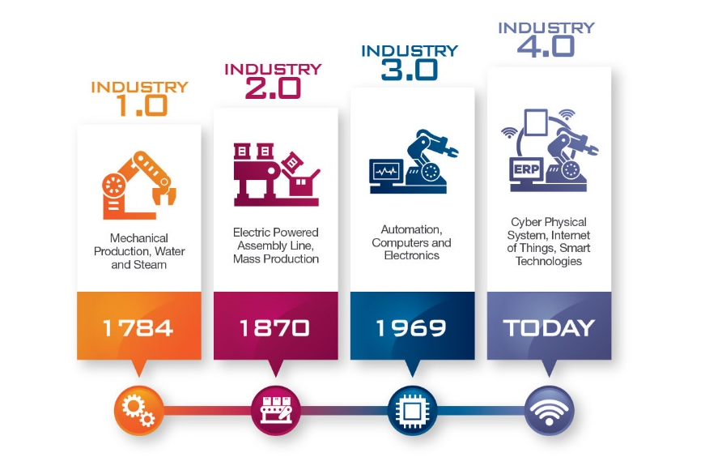
Figure 2 Industry Revolution
Source: https://www.metaltech.com.my/news/malaysia-and-industrial-4-0-in-the-spotlight-of-metaltech/

Industry 4.0 – Technology Trends
Industry 4.0 is the digital transformation of industrial markets (industrial transformation) with smart manufacturing currently on the forefront. Industry 4.0 represents the so-called fourth industrial revolution in discrete and process manufacturing, logistics and supply chain (Logistics 4.0), the chemical industry, energy (Energy 4.0), transportation, utilities, oil and gas, mining and metals and other segments, including resources industries, healthcare, pharma and even smart cities.

The Technology Trends in Industry 4.0 are:
- Autonomous Robots
Robots are evolving for even greater utility.

- Simulation
Simulations will beverage real-time data to mirror the physical world in a virtual model.

- System Integration
Companies, departments, functions and capabilities will become much more connected and cohesive.

- Internet of Things
Devices connected in 2015(4.9 million). Forecasts: 6.4 million in 2016 and 20.8 billion in 2020.

- Cybersecurity
Industrial equipment vendors are joining forces with cybersecurity companies through partnership or acquisitions.

- Cloud Computer
Machine data and functionality will increasingly be deployed to the cloud, enabling more data driven services for production systems.

- Additive Manufacturing
Additive manufacturing methods will be widely used to produce small batches of customized products.

- Augmented Reality
Companies will make much broader use of augmented reality to provide workers with real-time information to improve decision making and work procedures.

- Big Data
The collection and comprehensive evaluation of data from many different sources (i.e. production equipment systems, enterprise and customer management systems) will become standard to support real-time decision making.
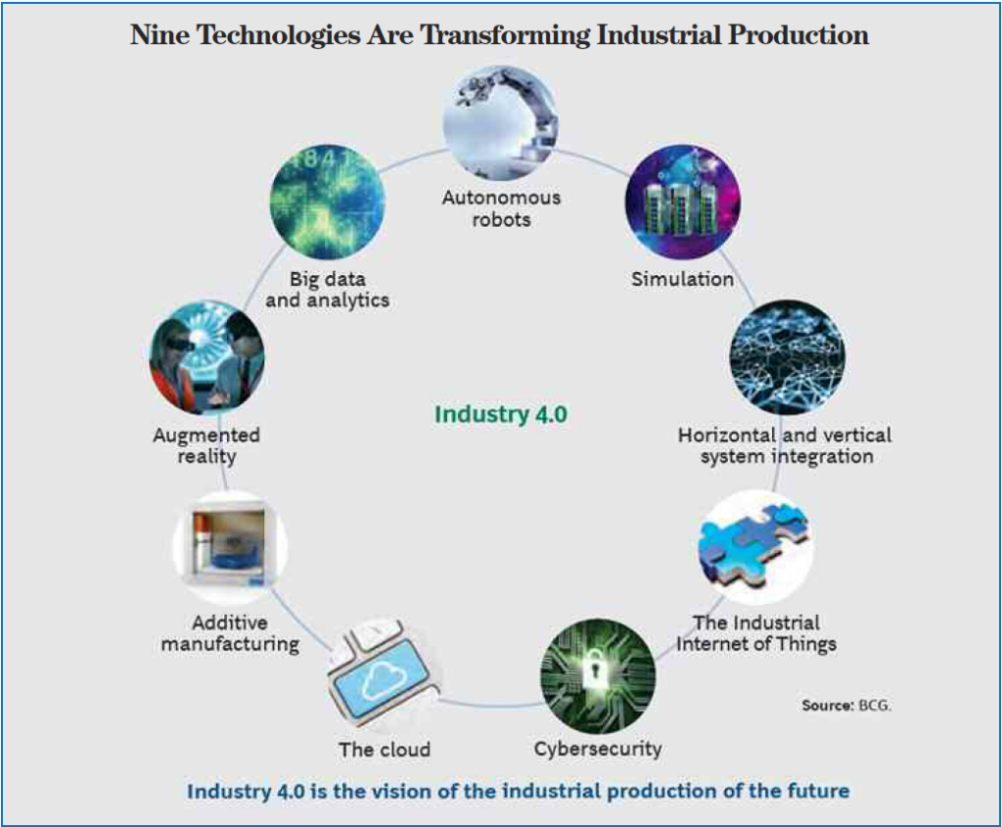
Figure 3 Technology Trends in Industry 4.0
Source: https://audiotech.com/trends-magazine/industry-4-0-and-the-u-s-manufacturing-renaissance/

Computing at the Edge
Edge computing is a mesh network of data centers which process and store data locally prior to being sent to a centralized storage center or cloud. It optimizes cloud computing systems to avoid disruptions or slowing in the sending and receiving of data. Rather than data being sent back to a cloud or data center, computing is instead conducted on the “edge,” or the periphery, of a network. Edge computing allows data produced by internet of things (IoT) devices to be processed closer to where it is created instead of sending it across long routes to data centers or clouds. Doing this computing closer to the edge of the network lets organizations analyze important data in near real-time – a need of organizations across many industries, including manufacturing, health care, telecommunications and finance.
Nowdays, the IoT edge has achieved celebrity status. In many instances, the IoT is a combination of OT and IT. When discussing the IoT, we must understand the four-stage IoT solutions architecture. "Things" are connected to sensors for data capture and actuators to control the things—either wired or wirelessly. These sensors and actuators connect to gateways, switches, and data acquisition systems in stage 2. Stage 3 is comprised of IT systems that are at the edge, and stage 4 is the remote data center or cloud. Not all IoT solutions include all four stages (e.g., some are sensor-to-cloud solutions), but a large portion of IoT solutions can be mapped into this architecture.
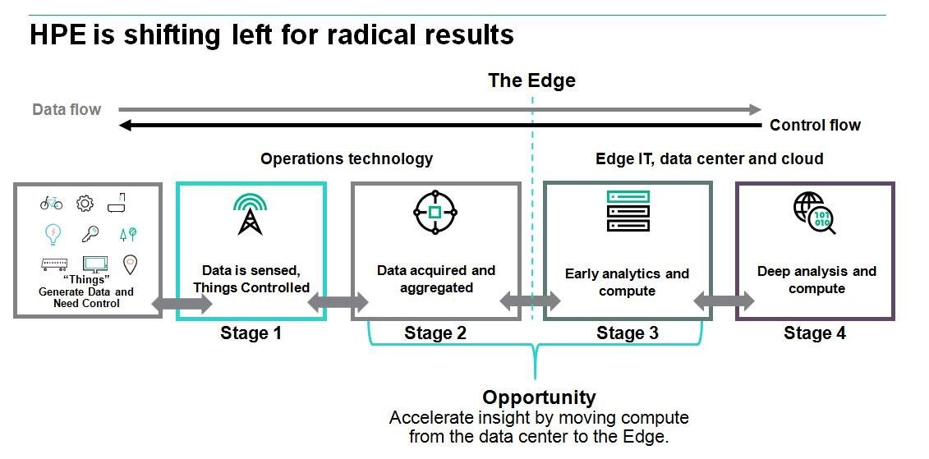
Figure 4 Computing at the Edge
Source: https://community.hpe.com/t5/Internet-of-Things-IoT/5-challenges-of-Industrial-IoT-Edge-computing-to-the-rescue/ba-p/6887829#.W_jm9o9OLIU

Artificial Intelligence (AI) for the Data Centers
The rise of artificial intelligence is affecting global data centers in two ways which are AI applications need the global data centers to provide the necessary computational power and AI applications are being developed to improve the data centers themselves. So, data centers are both serving and being served by artificial intelligence. Here are some important topics regarding the interaction between data centers and AI technologies.
The first is Artificial Intelligence to help the data center become energy efficient. Recent developments in AI can help significantly increase the energy efficiency of data center. According to reports, Google has reduced its energy use by 40% through deep learning. Its Deepmind AI controls approximately 120 variables in the data center, such as fans, cooling systems, windows, and more. Google used 4,402,836 MWh of electricity in 2014. Therefore, saving 40% of electricity can save millions of dollars. More data centers may start using similar AI-based solutions to save energy.
Next is using AI for data center security. Data centers must be prepared for cyber attacks and threats. But the pattern of cybersecurity is changing. It is difficult for humans to keep up-to-date on all the information. It requires a lot of work and labor time to monitor and manage network security issues. Machine learning and deep learning applications can help data centers adapt to changing needs more quickly. A British company Darktrace is using machine learning to define normal network behavior and then detect threats based on deviations from the specification. Often, data centers try to handle threats by restricting access and creating hard-to-penetrate walls. However, as users change, this method of restricting access has never been enough to ensure security. A more dynamic approach to AI-based systems can help data centers be more secure without imposing strict rules on users.
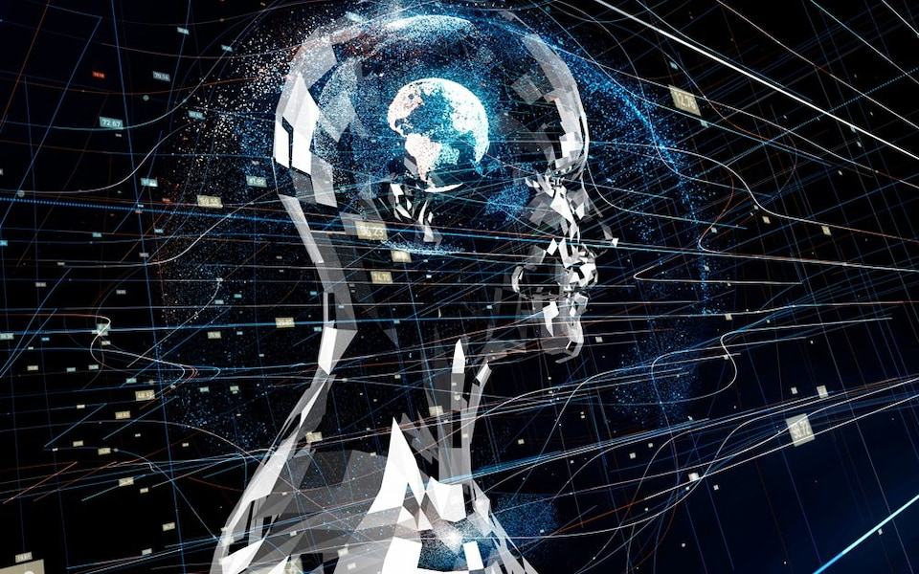
Figure 5 Artificial Intelligence
Source: https://www.telegraph.co.uk/science/2018/09/05/artificial-intelligence-greater-concern-climate-change-terrorism/

Internet 2.0: Transaction Based Networking

Man Computer Symbiosis
J.C.R Licklider had said that man will set goals, formulate hypothesis, determine the criteria and perform the evaluation. While, computer the routinizable work that can prepare the way for insight and decisions. It means that human interact with the computer to ease their work and this relation are keep developing. So, this symbiosis will be more effective and human can be productive.

Blockchains
Firstly, he explained to us about the blockchains. Blockchain is essentially an open-source decentralized or distributed ledger or database that records every transaction in a block, which is linked to other blocks. Blockchain allows you to share and store anything of value. There are two types of blockchains open public and permissioned enterprise. One of the example of blockchains is Bitcoin, one of the famous cryptocurrency.
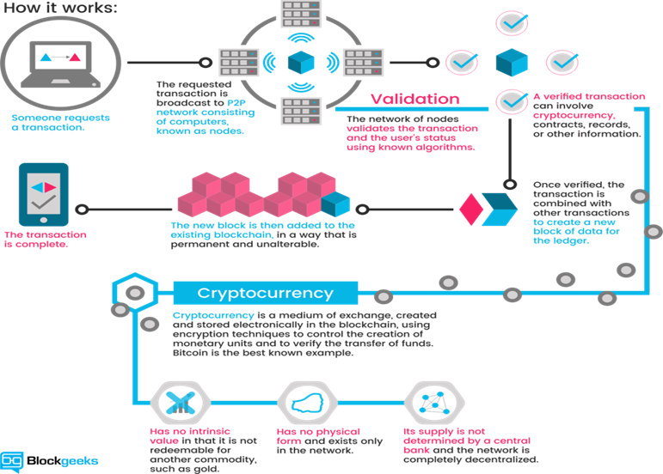
Figure 6 Cryptocurrency
Source: https://blockgeeks.com/guides/what-is-cryptocurrency/

Then, he tells us the different between centralized database and blockchains. The biggest difference is that in a distributed database scenario you trust all the machines (they are all in your control) and you expect them to not try to attack the integrity of the data (again you control all the machines). On the blockchain, you trust no machines but expect that over 51% of the computers connected to the network are honest and will not try to attack the data integrity. In terms of record keeping the blockchain is a lot more limiting that a distributed database.
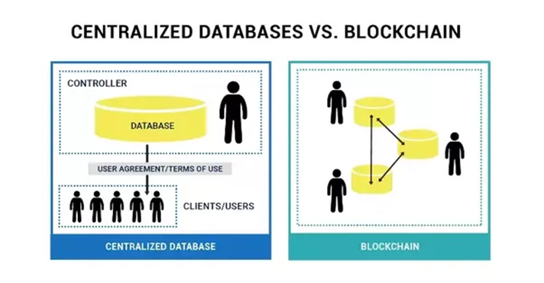
Figure 7 Centralized Databases VS. Blockchain
Source: https://www.quora.com/How-is-the-blockchain-different-from-distributed-databases-in-terms-of-record-keeping

He also explain the network architectures. Whether it’s server-based or P2P-network. also been explained by him. Four characteristic of the blockchains, first is smart contracts that consist digital rights, gambling, escrow. Then digital currency and fraud reduction that consist e-commerce, global payments, cThird, record keeping: loyalty programs, ownership, proof identity, intellectual program. Lastly, securities which is about debt, equity, private markets, crowdfunding and derivatives.

The Strengths, Weakness, Opportunity and Threat of Blockchains
The strengths of Blockchain is not attackable, manipulation essentially ruled out. Blockchain is finality which cannot be retractable and unchangeable when the data is recorded. It is globally available, do not have the limit and it is open source which technology can be used or further developed. Like in the internet, Blockchain allows realtime access to the same data. Another strength of Blockchain is it enable digital transfer of values and assets.
The weaknesses of Blockchain is identification at the entry point not yet resolved by them. Besides, global scalability still questionable by Blockchain. The user unfamiliar and poor user experience in Blockchain caused they misuse it and the data security be a problem. Another weakness of Blockchain is Blockchain involves an entirely new vocabulary. Therefore, it is high complexity places enormous demands on users.
The opportunities of Blockchain in future is better security. Better security is important to protect the user’s record and prevent stolen. Besides, Blockchain reduces the transaction cost and processing cost thus the amount of user will increase. Blockchain has the opportunity to reduce fraud and systemic risk, so the user’s privacy are able to protect.
The threat of Blockchain is legal jurisdictional barriers and it brings a lot of risk to Blockchain. Technology failure is also a threat for Blockchain because technology play an important role in Blockchain to proceed the transaction. Another threat for Blockchain is ledger competition. There are many types of database for example centralized database which has bigger security. Poor governance in Blockchain is also the threat for Blockchain because the system cannot in well maintain condition and it will brings a lot of problem in Blockchain.
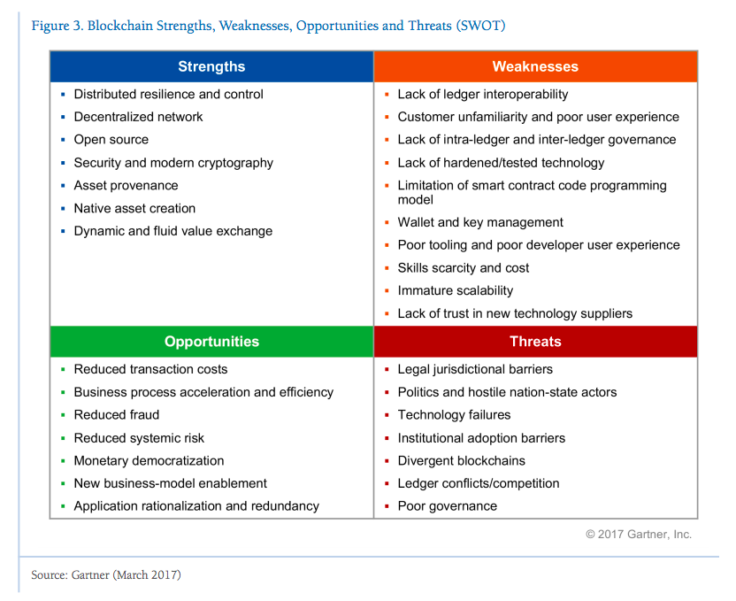
Figure 8 Strengths, Weakness, Opportunities and Threats
Source: https://blog.softwaremill.com/blockchain-business-applications-beyond-bitcoin-c9e6df0ba923

Internet
Internet is basically about sharing information in the form of content. Then, he explain the internet about it history briefly. The history of the Internet begins with the development of electronic computers in the 1950s. Initial concepts of wide area networking originated in several computer science laboratories in the United States, United Kingdom, and France. The US Department of Defense awarded contracts as early as the 1960s, including for the development of the ARPANET project. The first message was sent over the ARPANET in 1969 to the second network node at Stanford Research Institute (SRI).
Packet switching networks such as the NPL network, ARPANET, Tymnet, Merit Network, CYCLADES, and Telenet, were developed in the late 1960s and early 1970s using a variety of communications protocols. The ARPANET project led to the development of protocols for internetworking, in which multiple separate networks could be joined into a network of networks.
The Internet protocol suite (TCP/IP) was developed by Robert E. Kahn and Vint Cerf in the 1970s and became the standard networking protocol on the ARPANET. In the early 1980s the NSF funded the establishment for national supercomputing centers at several universities, and provided interconnectivity in 1986 with the NSFNET project, which also created network access to the supercomputer sites in the United States from research and education organizations. Commercial Internet service providers (ISPs) began to emerge in the very late 1980s. The ARPANET was decommissioned in 1990. Limited private connections to parts of the Internet by officially commercial entities emerged in several American cities by late 1989 and 1990, and the NSFNET was decommissioned in 1995, removing the last restrictions on the use of the Internet to carry commercial traffic.
In the 1980s, research at CERN in Switzerland by British computer scientist Tim Berners-Lee resulted in the World Wide Web, linking hypertext documents into an information system, accessible from any node on the network. Since the mid-1990s, the Internet has had a revolutionary impact on culture, commerce, and technology, including the rise of near-instant communication by electronic mail, instant messaging, voice over Internet Protocol (VoIP) telephone calls, two-way interactive video calls, and the World Wide Web with its discussion forums, blogs, social networking, and online shopping sites. Today the Internet continues to grow, driven by ever greater amounts of online information, commerce, entertainment, and social networking. However, the future of the global internet may be shaped by regional differences in the world.
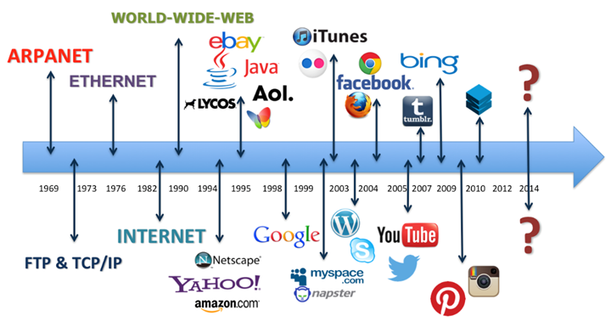
Figure 9 History of Internet
Source: https://www.tes.com/lessons/hMm6KQB3x9wzPw/web-the-history-of-the-internet
He also ellaborates the issues and problems of the internet that makes existence of Internet 2.0. One of problems is regarding surveillance and censorship. Comoditized user data also one of the aspect of the problems of the internet. Next, he explain to us about how from internet change to internet 2.0, the differences between this two and the trend.

Summary
In this talk, we realize that IoT offers a number of benefits to organizations, enabling them to improve the customer experience, monitor their overall business processes, save time and money and etc. IoT has finally started to get a pace. With so many developments for IoT to take place in the technology world, it’s reasonable to say IoT has begun to transform business landscape. We can also spot how IoT is transforming industries like automotive, energy, healthcare, transportation and manufacturing as well as various appliances like door well cam, air tracking, electricity plug, security system, oven, thermostat, and tens of others.
Technology disrupts technology. That has been fundamental to every innovation for improving our lives. But there comes a technology once in several decades that redefines innovation and allows new technologies to get built on that example is Internet 2.0 or blockchains. Internet 2.0 is a new kind of transaction based on online networking. The transaction will use cryptocurrencies or virtual currencies like Bitcoin. Bitcoin was invented by Satoshi Nakamoto. Cryptocurrencies is a growing asset class that shares some characteristics of traditional currencies, with verification based on cryptography. People all over the world buy Bitcoin to protect themselves against the devaluation of their national currency. So we as a user must always been updated with this kind of things to make sure that we can utilize it. We also must learn and understand about this kind of things. So, I thankful that we are been explained about this.

Bibliography
- Ms. Geonice Chong. (n.d). Industry Revolution. Subang Jaya, Selangor. Retrieved from https://www.metaltech.com.my/news/malaysia-and-industrial-4-0-in-the-spotlight-of-metaltech/

- Guest Edition. (23 Jun 2015). Technology Trends. Kensington Road, Oak Brook. Retrieved from https://audiotech.com/trends-magazine/industry-4-0-and-the-u-s-manufacturing-renaissance/

- EIC_IoT_Blog. (8 Nov 2016). Computing at the edge. California, United States. Retrieved from https://community.hpe.com/t5/Internet-of-Things-IoT/5-challenges-of-Industrial-IoT-Edge-computing-to-the-rescue/ba-p/6887829#.W_jm9o9OLIU

- Sarah Knapton. (6 Sept 2018). Artificial Intelligence. London. Retrieved from https://www.telegraph.co.uk/science/2018/09/05/artificial-intelligence-greater-concern-climate-change-terrorism/

- Blockgeeks. (13 Sept 2018). Cryptocurrency. Unknown. Retrieved from https://blockgeeks.com/guides/what-is-cryptocurrency/
- Cealicu, V. (6 Jan 2018). Centralized Databases VS. Blockchain. Unknown. Retrieved from https://www.quora.com/How-is-the-blockchain-different-from-distributed-databases-in-terms-of-record-keeping

- Maria Wachal. (Mar 28). Strengths, Weakness, Opportunities and Threats of Blockchain. Unknown. Retrieved from https://blog.softwaremill.com/blockchain-business-applications-beyond-bitcoin-c9e6df0ba923

- Soni, S. (5 Feb 2017). History of Internet. Unknown. Retrieved from https://www.tes.com/lessons/hMm6KQB3x9wzPw/web-the-history-of-the-internet

