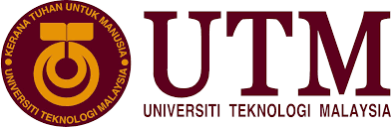

Industrial Talk 2

Name : Ishaq Sani Ishaq – A18CS0353
How Kah Hui – A18CS0074
Izzat Marzuqi Bin Ghali – A18CS0080
Course : SCSP 1513-09
Technology and Information System
Lecturer Name : Dr. Aryati Bakri

Table of content
1 Introduction 3
2 Exhibition Content 3
2.1 Booth 63 3
2.2 Booth 64 4
2.3 Booth 65 4
2.4 Booth 66 5
2.5 Booth 67 5
2.6 Booth 68 6
2.7 Booth 69 6
2.8 Task for each member 7
3 Reflection 8
4 Summary 8

Table of Figures
Figure 1 Example of Toy 1 4
Figure 2 Example of Toy 2 4

Introduction
For Industrial Talk 2, I had visited to the New Academia Learning Innovation (NALI) 2018 organized by the Center for Teaching and Learning (CTL), UTM. As we know, NALI is a framework comprising student-centered and mixed learning philosophy, multiple learning modes and materials towards achieving entrepreneurial academia. NALI is emphasized on improving the quality of teaching and learning with the implementation of student-centered teaching methods. In comparison to traditional teaching for example face to face learning, the concept of mixed learning is emphasized in NALI. Mixed learning is a combination of active and systematic strategy with the use of digital teaching materials in class. This will be a more meaningful learning experience.

Exhibition Content

Booth 63
Booth 63 is discuss about the Fun Learning Toy Library: Passage to Shape Future Scientists and Engineers which is led by Dr. Habibah @ Norehan Binti Haji Haron. The science, technology, engineering, arts and mathematics (STEAM) concept Fun Learning Toy Library (FLTL) provides a conductive, enjoyable and exciting learning environment at rural pre-schools for children to develop their interest and basic skills in science and technology at a very young age. With the facility in place these young children have increased motivation in STEAM education, useful for their future endeavour in fulfilling the national gap for holistic STEAM talents. The constructive learning by doing STEAM FLTL will help the learning of ‘challenging’ or ‘difficult’ subjects like sciences and mathematics. The aims for this project is to groom young children at rural pre-schools for children to become future scientists and engineers through STEAM FLTL. Commercialization potential of the project are measurement instruments for teaching and learning, training of educators and electronic format of innovation. FLTL focusing on STEAM, integrating Arts (soft skill components) in fulfilling the six thrust in the Ministry of Education pre-school curriculum. There are many implication of FLTL for teacher because the toy are a great tool that help teaching and learning process. Certain toys can be used for more than one themes and the FLTL has a very positive impact on students’ performance and motivations.
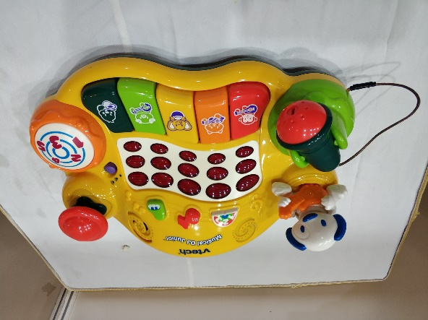
Figure 1 Example of Toy 1
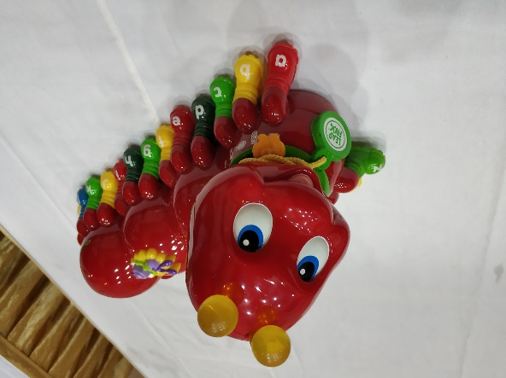
Figure 2 Example of Toy 2

Booth 64
This booth is talking about the Adaptation Guideline for Different Type of Learners in Online Learning System. Its objective is to propose an adaptation guideline for online learning system that accommodates all type of learners through individualized content and adaptive presentation. There are two types of adaptation guideline. First, individualized content will using process of matching the educational material with learner’s type. While, adaptive presentation will based on how the online learning system adapt with appropriate presentation for different type of learner. Besides, there are four style of learner. First, activist learner that means they can fully involve in learning process. Theorist learner always adapting and integrating observation into theories. Then, pragmatist learner. They have interest in real world application of the learned material. Lastly, reflective learner that like to reflect before giving conclusion. Different type of learners gain same knowledge through different presentation of educational material. Hence, learners will engage in the learning process.

Booth 65
Booth 65 is about Effect of Collaborative Video Assignment towards Students Interest and Motivation in Engineering Service Courses. Some of objective of this research is to analyze the nature of student’s learning environment, to identify factors that affect student’s learning, to design activities that supports student’s learning, to assess student’s performance. Example of changes is the student is learning by doing and be creative in delivering and explaining the difficult content of a course via video-clip, make sure that they able to transfer the concept and knowledge of electronics course to mechanical engineering student through multimedia and new method of assignment for student as assessment. The impact is the student will able to work in team, able to produce video-clip on topic that hard to visualize, improve communication in presenting, able to evaluate and provide feedback on others work, able to use electrical measuring instruments, able to explore tools and technologies for developing videos and improve interest and attitude in learning.

Booth 66
This talks about ArcGIS online as a tool urban and regional planning education. This is an online teaching program using existing platforms provided by the ESRI (environmental systems research institute). This helps analyze and provide proposal plans for case studies. Students form teams and work in a team or as an organization and provide solutions for some problems in that selected research area. They work as a team to publish their data and analysis in their self made web page. This is a project from urban and regional planning, faculty of built environment and surveying, UTM. The objectives of this project included Utilization of ArcGIS online, this investigates on how students use ArcGIS online as an interactive planning mapping and analysis tools in the performing case studies and urban planning education. The benefits of implementing ArcGIS online in urban and regional planning education. The way of teaching has changed over the years, it used to be a teacher being the only source of information for the students while nowadays it is all based on research Based learning using technologies. This project helps students in analyzing and evaluating issues faster and easier, students have a better view of the problems and the solution to those problems, it helps boost student’s abilities towards expressing themselves to the digital world. ArcGIS online provides a platform for teachers and students to use digital materials in class for more efficient and better teaching strategy. So far, this program has been used in analyzing the influence of urban activity on the distribution of obesity patients in Iskandar Malaysia, find the between land and crime in Johor Bahru.

Booth 67
This booth talks about using of assessment of professional skills through capstone project Based learning (CPrBL) model for electrical and electronic engineering program. There is a lot of challenges engineering students are facing in the 21st century, firm foundational literacy, competencies and characters are required to prepare engineering students to face these challenges and apply their abilities in performing everyday tasks. Skills such as communication, teamwork, understanding ethics and professionalism, engineering within global and social context, lifelong learning, knowledge of contemporary issues, project management and finance management are demanded by industries in order for students to be employed after graduating and were highlighted by the Accreditation Board for engineering and technology (ABET) to be added in the undergraduate curriculum. The capstone project based learning model helps students identify real world problems, design and develop the solutions in the solving the problem. This is completed within the specific time given and the budget given. It is conducted as a project within a group of students under the guidance of an academic staff and industry partners as advisors. The capstone project based learning model teaches students on team diversity by joining students from electrical engineering and electronics engineering. Analysis have been conducted on the performance of students that have been through the CPrBL program and it has shown that it is effective in teaching students skills such as modern tools usage, solution design, team work, life long learning, project and finance management. The students that have been through the process were able to apply the skills learnt in solving the problems and providing the solutions within the limited time and budget given. This is an effective approach to enhance the professional skills in engineering students before graduating from university.

Booth 68
This booth talks about STEM interest-ignition program, STEM provides a platform to work with students to help them learn and be curious about stem. It gives psi staffs an opportunity to learn from UTM on how stem activities are carried out and how it can be implemented in the library. It was found out that only few students go to the library to study even with the facilities provided by the university in the library. The FP UTM learning club has collaborated with johor bahru foundation to carry out stem activities at PSI melayu branches. This will help promote the libraries and encourage students to take STEM subjects in schools. Students will be selected to follow some various activities which requires their thinking skills. The student’s achievement in class will monitored before joining the program and after they have joined the program. Some of the objectives of this program is to enhance student’s interest to take stem subjects in schools, increase their interest in the stem field and strengthen their relationship with UTM student community. According to the research conducted, there is a rise in the performance of the students that take stem subjects in school.

Booth 69
Booth 96 is talking about the Service-Learning Education Framework: Rumah Ihsan Johor (RIJ) Projects which is led by Dr.Syamsul Hendra Mahmud. The Service-Learning (SL) approach is one of the innovation learning applied in New Academic Learning Innovation (NALI). Rumah Ihsan Johor (RIJ) is the construction of a people's house project that is conducted in collaboration with volunteers based on National Blue Ocean Strategy (NBOS) between the Faculty of architecture UTM and the organization of Ihsan Johor. The Rumah Ihsan Johor (RIJ) is not only gives the students a theoretical knowledge but is able to solve the problem practically. Through this project, students have been involved in the effort to build an aid house for those in need in three days through volunteerism concept. Various new knowledge, practical knowledge and volunteerism elements can be tackled by students and become useful learning experiences for students. The framework developed help the academicians in planning and executing such projects in later time. The objectives of this project are promote the concept of service-learning in higher education and develop the service-learning framework for higher education. Service Learning Education Framework has divided into 5 phase which are initiation phase, project design phase, execution phase, reflection phase and sustainability phase. Initiation phase is identify the needs and services and establish the contacts and partnerships. Besides, Project design phase is discuss the aims and objectives and do the logistics analysis. In execution phase, the framework is collaborate actively to demonstrate intercultural diversity. Then, in reflection phase, the program report and reflection are prepare by the framework. Last but not least, in sustainability phase, there has sustainable plan to do research and development for the future collaboration. There are many impacts can get by students for their learning such as integration between academic knowledge and community service needs, enhances students’ learning experience, enhanced genetic skill among students, sustained community partnerships and improve guided reflection.

Task for each member:
Ishaq Sani Ishaq | Booth 66  Booth 67  Booth 68  Summary
How Kah Hui | Booth 63  Booth 69  Introduction
Izzat Marzuqi Bin Ghali | Booth 64  Booth 65  Reflection

Reflection
From our visit to NALI we obtained many advantages. First, we get a lot of information about new invention and technique in education system. Nowadays, that is very important to make sure learning process is more effective as our world need more professionals. Then, we also know the problems faced by the student in the learning process and way to cooperate with that. From this visit, we also realize that we must always improve our education system to make sure our beloved country Malaysia can progressing well and harmony.

Summary
This report commissioned to talk about the new inventions and techniques in education system in UTM. This includes: ArcGIS online as a tool urban and regional planning education, using of assessment of professional skills through capstone project Based learning (CPrBL) model for electrical and electronic engineering program, STEM interest-ignition program, Adaptation guideline for different type of learners in online learning system, Effect of collaborative video assignment towards student’s interest and motivation in engineering service courses, fun learning toy library and service learning education framework.
Argis online is an online teaching program using existing platforms provided by the ESRI (environmental systems research institute) that helps analyze and provide proposal plans for case studies. Students form teams and work in a group or as an organization and provide solutions for some problems in that selected research area. The objectives of this program is to Utilize ArcGIS online, this investigates on how students use ArcGIS online as an interactive planning mapping and analysis tools in the performing case studies and urban planning education, to find out the benefits of using Argis online in urban and regional planning.
Using of assessment of professional skills through capstone project Based learning (CPrBL) model for electrical and electronic engineering program. This program helps students identify real world problems, design and develop the solutions in the solving the problem. This is completed within the specific time given and the budget given. It is conducted as a project within a group of students under the guidance of an academic staff and industry partners as advisors. The objective of this program is to teach students on team diversity by joining students from electrical engineering and electronics engineering and students to be able to use the skills learnt from this program in solving their real life problems
STEM interest-ignition program is to give psi staffs an opportunity to learn from UTM on how stem activities are carried out and how it can be implemented in the library. It was found out that only few students go to the library to study even with the facilities provided by the university in the library. The objective of this program is to help convince students to go to the library and study with the facilities provided by the university and encourage younger children to take more STEM subjects in elementary schools.
Adaptation guideline for different type of learners in an online learning system, this program is an online learning system that accommodates all type of learners through individualized content and adaptive presentation. The objective of this program is to get different types learners gain same knowledge through different presentation of educational material.
Effect of collaborative video assignment towards student interest and motivation in engineering service courses, this program ensures that students Learn by doing and being creative in delivering and explaining the difficult content of a course via video-clip, being able to transfer the concept and knowledge of electronics course to mechanical engineering student through multimedia. This help students work in a team, improve their communication skills publicly, ability to explore tools for making videos.
Fun learning toy library is a program that provides a conductive, enjoyable and exciting learning environment at rural pre-schools for children to develop their interest and basic skills in science and technology at a very young age. This will help in learning the challenging and hard subjects like mathematics and sciences. The aim of this project is to help groom young children at rural pre-schools to become future scientists and engineers through the stem FLTL.
Service-learning education framework is a program that involves (RIJ) rumah ihsan johor and faculty of architecture in constructing a people’s house project that is conducted in collaboration with volunteers based on National Blue Ocean Strategy (NBOS). Students will gather various new knowledge, practical knowledge and volunteerism elements will become useful learning experiences for students. After the project, students will get an increase in the integration between academic knowledge and community service, it enhances students learning experience.

