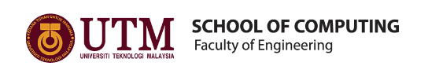

REPORT OF INDUSTRIAL VISIT 1

SEMESTER 1

SESSION 2018/2019

NAME: 1. AHMAD AZHAR ADILAN BIN INDRA (A18CS0012)
2. CHAN JUN YAO (A18CS0043)
3. ANIS HUMAIRA BINTI MOHAMMAD HAIZAM (A18CS0034)
REPORT’S TITLE: CICT
LECTURER’S NAME: DR ARYATI BINTI BAKRI
SUBJECT: TECHNOLOGY AND INFORMATION SYSTEMS (SCSP1513)
SECTION: 02

Table of Contents

INTRODUCTION 3
1. Organization Introduction 3
2. ICT Administration 5
3. ICT security 8
4. Customer Service Management 8
5. Achievement and Future Goals 9
DETAIL JOURNEY 10
REFELCTION 10
CITATION 12

INTRODUCTION

On 1/10/2018, Center of Information and Communication Technology (CICT) in collaboration with department of information system, school of computing, faculty of engineering, Universiti Teknologi Malaysia (UTM) has organized an industrial visit to CICT UTM JOHOR BAHRU.
This industrial visit has been proposed by Dr. Aryati Binti Bakri which is the director of Technology and Information System (SCSP 1015) subject. This program has been involved the students who took SCSP subject. Thus, almost 100 students have took involved in this industrial visits. The students that involved in this program is from different courses which is from bioinformatics and data engineering. The main primary objectives of this program is to expose the student about CICT all about. At the same time, student could write a report about this industrial visit.
Therefore, in this report we will tell you little introduction about CICT. This is included the organization of CICT, services that CICT provides, their achievement and information system that has been proposed by CICT. Next, we also will tell you detail of journey to CICT from the beginning until the end of the program. Lastly, our reflection towards this industrial visit.
The industrial visit to CICT started with the talk given by our kind speaker, En. Mohd Zahari. The talk covered 5 aspects, namely: Organization Introduction, ICT Administration, ICT security, Customer Service Management, Achievement and Future Goals.

1. Organization Introduction
History of CICT
CICT started up as a computer center back in year 1975. Afterwards, in year 1981, the computer center had merged with the Department of Computer Science and emerged as Computer Science Section (Bahagian Sains Komputer) under the care of Faculty of Science. Soon after 3 years of merging, CICT then upgraded to the Institute of Computer Science in year 1984. Furthermore, CICT has been given a new name, Computer Centre (Pusat Komputer, PKUTM) in year 1991. The current name of CICT was given in the year 2004, and CICT is now being recognized as Pusat ICT Lestari.
In the olden days (year 1985 to year 1975), some of the early services provided by CICT includes the process of employee’s salary, handling mainframe operations of IBM 390, managing employee’s credentials, performing hardware upgrades, providing financial system support. CICT not only provides services for UTM only, but also accepting out sources projects such as handling information regarding STP and SPM examination and teacher’s intake.
Several changes had been made throughout the development and operation of CICT. In year 1988, the Computer Centre in Johor Bahru Campus was temporarily located in the Faculty of Built Environment. While in year 1990, the mainframe system has been upgraded to IBM 3090-12J, and several systems had been added: Students Credentials System, Students Financial System, Students Examination System, and Timetable System. And network upgrade had been made in the year 1992, with the application of e-Mail through
BITNET. Moving forward to year 1995, computer network was being connected through System Network Architecture (SNA), Ethernet, and Token Ring.
Our speaker, En. Mohd Zahari then further explains the Vision and Mission of CICT.
Vision
Our vision for UTM is to become “Digital University pioneering the delivery of service which focus on academia”
Mission
To pioneer the development of digital ecosystem with entrepreneurial characteristic through developing innovative digital professionals and encourage collaboration in digital services.
CICT had 2 data centers, which one located in UTM Johor Bahru and the other on located in UTM KL’s campus. Both CICT JB and CICT KL cooperated closely, in many aspects of task. Some of the aspects including Infrastructure & Operation Management, Business Development, CICT KL management, Strategic Management, Corporate Management and Application Development Management.

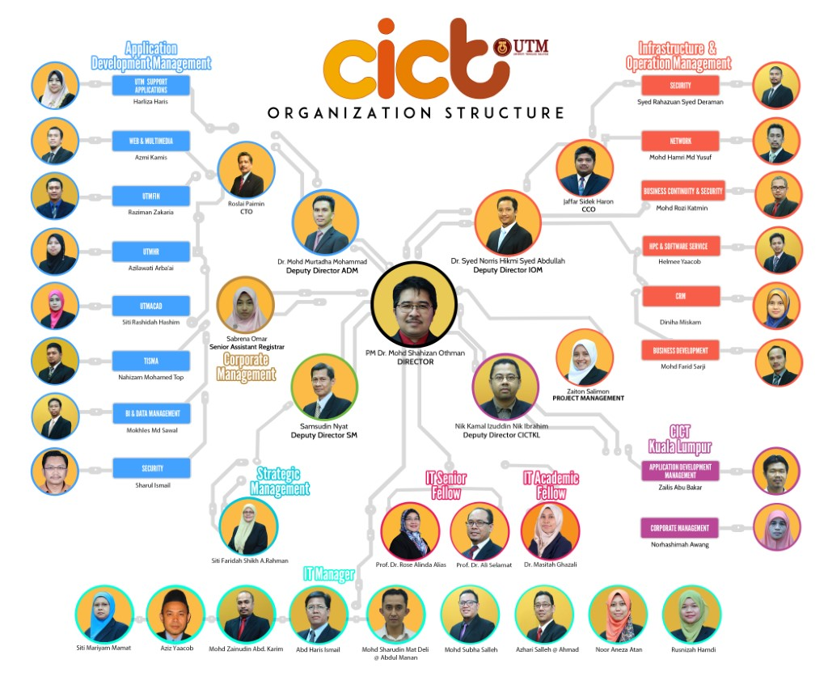

2. ICT Administration

Our speaker then introduced us about the UTM’s steps of ICT strategy and Objectives. The first step is to stabilize the performance of application where integration and integrity of the application is improved, to gain better trust and to ease sharing of information. Whereas, for second step is to develop safe ICT infrastructures which can be deployed or access anytime, anywhere. The adaptation of latest technology is also being scheduled at this period in order to optimize the effectiveness of the ICT infrastructure. While third step, including upgrading human resources in aspect of skill and knowledge, via continuous learning. Besides that, cultivation of ICT culture in order to shape the conducive and dynamic work environment. Last but not least, the fourth step is to stratify the practice of principle and administration of ICT which parallel with stakeholders and client’s expectation. CICT had made detailed planning in order to help UTM achieve the status of Digital Campus.

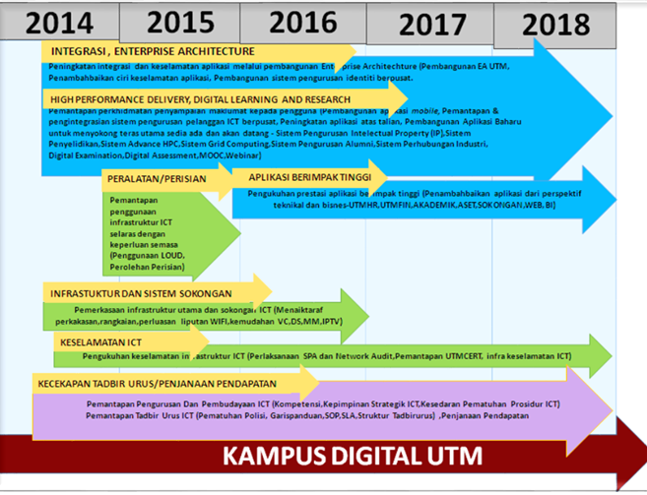

In the motion of UTM Global Plan of 2012-2020, CICT had given responsibility to complete several tasks including:
a. Sustainable Campus, Infrastructure, Information and Communication technology (ICT) System, and Community engagement & Industrial Network.
b. Total Campus Experience
c. High Performance Delivery
d. Financial Sustainability

CICT had given support in numerous applications in fields including Support System, Academic Computing, BI & Data Management, Academic Management, Financial Management, Human Resources Management. Our speaker then clarifies CICT had given upgrades throughout the years including upgrade in Wi-Fi Collage Services, Internet Gateway and Server Storage. UTM Wi-Fi has also upgraded recently CICT UTM has provided various services to organization, staff, student and community. One of the biggest services that CICT provided is Academic Computing ID (ACID). ACID is the unique ID assigned to the user through the authentication of the server. It is used to gain access to academic computing systems and other application systems. Basically, UTM student got their ACID ID after registering to their respective faculties while the staff must have official mail account first before applying UTM ACID account. The user that can use ACID ID is included the staff and students of UTM, UTMSPACE, Post Doctorate UTM and guests allowed. All user can apply ACID ID through http://acid.utm.my.
Besides that, CICT also provided wide range internet to whole UTM campus in JB and KL. WIFIUTM is a unified login portal that need user to login using acid id before they can access the internet. At the first stage, only 200 access point has been installed but now almost 1600 access point has been installed on September 2018 with larger and wider coverage. This is also included all student residential college. UTMWIFI is free to access; thus, student love to access it all the time especially during night. That is why the internet become slower during night. This problem makes CICT management triggered to increase the internet speed.
Lastly, UTM encourages their student to use licensed software. Therefore, CICT has been tasked with operating the software in UTM. As a service center licensed software to users in UTM, the CICT provides several rules that must be obeyed users. The software that license by UTM is Ansys, Endnote, Mathematica, Matlab, Microsoft Office and many more. Users can get it for free by sign in using UTM mails.
For community engagement & industrial networking, CICT and put forward a number of collaborations with big companies such as TM net, Huawei, Microsoft and much more. This offered opportunity and exposure of CICT to the public and big corporation, which encouraged further cooperation in between institutes.
Whereas, CICT had also developed high performance delivery systems. For financial sustainability, CICT had also shown positive results.

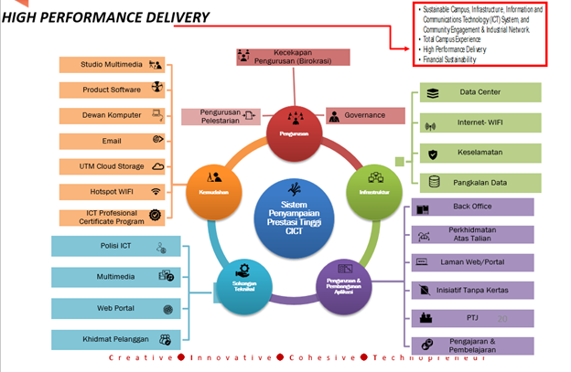

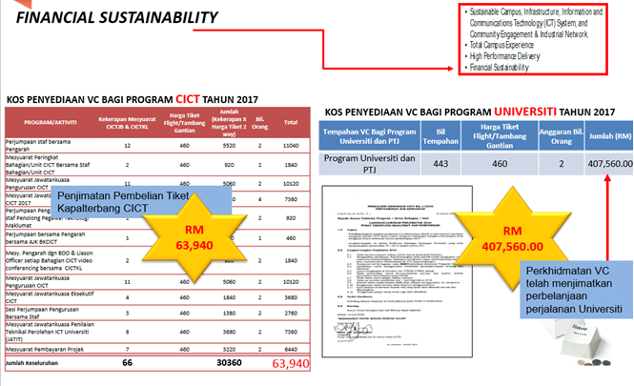

Our speaker also explained 4 excellent practices in CICT administration. First of all, is the strategic planning. CICT had strategic plans for year 2014-2018, annual strategic plans, blue print for Digital University, and Blue Print for UTM Smart Campus. Secondly, CICT has good practice of generation of income. This aspect includes Business Development Office, collaboration with industrial peers, project bidding, High-Impact Project Proposal and good marketing strategy. Furthermore, CICT is equipped with good customer service, which include CICT One Stop Centre, and the Customer Relationship Management unit (CRM). Finally, CICT also practice project surveillance, which include PMO, War Room, Jawatankuasa Teknikal Projek ICT and individual report card.

3. ICT security

CICT was also equipped with high measure of security precautions. Data recovery center is the infrastructure which made up of server, storage and database. This is to ensure “zero loss” of data when catastrophe struck. Power backup and gen set was also being deployed in order to provide emergency supply of electricity in time of power shortage. Command Control and Monitoring Centre (CCMC) unit is also established to ensure smoothness of ICT service such as server service, system application and network system. Surveillance is being made from time to time to avoid risk of “denial of service”. The UTM Computer Emergency Response Team (CERT) is formed to investigate and organize security incidents responsible of CICT. Next, CICT also has a financial management team to audit the procedures which involve financial activities. Whereas the OSHE panel play an important role in CICT to counter risk which threaten the compound building and employee’s health. Last but not least, the facility administrative is responsible to being active in fight and lower risks in CICT.
CICT also provided guidelines, which includes: Internet Application Policy, E-Mail Application Policy, Website Contents and Publishing Policy, Computer Distribution Policy, Student Computer Lab Policy, ICT Security Policy, Computer Equipment Loan Policy and Disposing of Computer Equipment Policy. For which Internet Policy and Email Policy is important to us as a student for we are using relevant service provided by CICT. The internet policy of CICT stated that the password is our own responsibility, and our device must be free of spywares, adware, viruses and worms before connecting to the UTM networks. UTM networks is prohibited for commercial use, access to pornographic and political materials. Hacking, network scanning, phishing and data decrypting activities are prohibited at all cost. Pirated software, gambling apps, gator, hotbar, searchbar, and cracked games are also prohibited. While email policy states that users are responsible for our own email account and password. Slanders, fouls language, sexually explicit words are not to be used in email at all email at all. Personal use of email is allowed but its use for commercial activities is strictly prohibited. CICT also states that dissemination of prohibited materials through email attachment is not allowed. Encryption is required for sending confidential materials, spamming and phishing activities are strictly prohibited. The use of email account by a third party is prohibited.

4. Customer Service Management

Mr. Mohd Zahari explains that there are 4 usual type of customer of CICT, which is the administrative, the community, staffs and undergraduates. CICT embraces the mission of customer service denoted which CICT is committed to provide high impact services and execute continuous upgrades in order to increase the satisfactory of customer, which this mission is parallel with vision and mission of CICT. CICT also declared the customer constitution (Piagam Pelanggan), which is to make ICT a basic utility of the university, provide central of service in order to give ease to customer. Furthermore, to provide integrated service in order to ease access of data and conduct effective upgrades in ICT service. The webpage, http://www.myutm.com.my. is an effort of CICT which provided one stop service for undergraduates to management their credentials, to access data and administrative tool such as UTM library, activity list, admission, eLearning and much more. CICT also provided UTM Software Centre which serves as a software download center, and UTM VPN in order to access UTM’s intranet service even user is not physically inside the campus.
The UTM ACID is also a great, successful tool which UTM ACID can use the single-sign-on feature, which means the user need only one account to access various features. Wi-Fi coverage and bandwidth also had been upgraded since June 2018. By date September 2018, CICT had installed 1600 total access points, in order to achieve the 100% Wi-Fi coverage in UTM campus. The High-Performance Computing (HPC), which offers to researchers refers to the practice of aggregating computing power in a wat that delivers much higher performance than one could get out of a typical desktop computer or workstation in order to solve large problems in science, engineering, or business and performing research activities through computer modelling, simulation and analysis. CICT also setup a gallery named Gallerium CICT, at second floor, D07, CICT. The gallery houses collections of artefacts such as old mainframe computers, magnetic tape recorder, electronic components.

5. Achievement and Future Goals

UTM had been performing well in the global stage. UTM was ranked #21 in QS World University Rankings Top 50 Under 50, 5 Stars Overall Ranking in QS Stars, ranked #253 in World University Rankings, and #49 in QS University Rankings Asia. Ever since, CICT is always working hard to help UTM to strike excellence. Along the way, CICT also gained recognition for their effort such as being rated as a Tier 3 Datacenter, won the prize UTMF in SAGA Compliance (AG) back in 22 November 2017. For which CICT became the first Public University which has a Tier 3 Datacenter in Malaysia. CICT also successfully provided services such that video streaming, live video conference and montage with High Definition video quality, that capable of reaching more audience. In the future, CICT aims to play a role in the cultivating the digital lifestyle in the movement of Industrial Revolution 4.0 in 4 waves. The first wave includes the implementation of internet, web and portal, E-Learning.
While second waves, which started in 2017 covers development of Mobile Internet, Staff and Student Profiling, Video Conferencing and more. The current third wave which take place from 2018 to 2019 will focus on development of internet of thing, data analytic, data science, e-wallet and more. For the fourth waves, CICT plans to offer AI and robotic service, Knowledge and Man-Machine Collaboration. By the end of fourth waves, CICT envision UTM to become UTM Smart Campus.

DETAIL JOURNEY

Our visit to the Center for Information and Communication Technology (CICT) was held in the 1 October 2018 inside the CICT building which is located at D07 in Universiti Teknologies Malaysia (UTM). In the beginning, we were asked to gather at the Students Laboratory at the third floor of the building to learn more about CICT and its history from En. Something who was representing the whole CICT organization. Some of the main points of his presentation was about organizations introduction of CICT, ICT management in CICT, ICT safety, customer management and achievements and future services. Just as the talk came to an end, we were brought downstairs to visit two places. One of it was the open laboratory whereby they had provided a large amount of desktop computers that can be used by the students for study purposes or lecturers for conducting a class. It is located at the second floor of the building next to the service counter where students or lecturers who had a problem regarding the services that was provided by the CICT center can get help from the experts themselves.
Next, we had visited the CICT Gallerium which was located at the ground floor of D07 near the main entrance of the building. Inside, they were showcasing all the previous computer technologies that was used from the Mainframe Terminal followed by the Controller, the IBM Mainframe CPU, the Mainframe Main System Power, the Mainframe Data Storage, the IB. Tape Drive System, the Mainframe Tape System Control Drive, the IBM Magnetic Tape Unit and the IBM Tape Control Unit. We had the privilege to see the actual devices that was used in the early stages of technologies and not only that, but we had the chance witnessed the evolution of computers taken place throughout the centuries. At the end of the tour, a gift ceremony was held as a token of appreciation from our part to the CICT organization for having us and allowed us to visit some of the facilities that they provide to all UTM staffs and students.

REFLECTION

The beneficial visit of CICT has given several reflection and inspiration which brought significant and great impact.
For a Computer Science student major of Data Engineering, the CICT visit has given insights upon our future goals. By witnessing the chronological development of technology, for example: from the mainframe technology, magnetic tape recorder, server racks to the modern computer technology of ours today, has been a strong evidence of perseverance of the modern pioneers in technology fields. Despite of hardships such as tedious workflow, high maintenance of hardware, these obstacles did not stop innovation and invention to happen.
Improvement in hardware has been so successful which can be seen in the significant decrease in the size of computers: from the mainframe to laptops, tablets and smartphone nowadays. Hence, our dream, is to match software’s development with hardware’s rapid pace. As a data engineering student, it’s safe to say that we hold the ability to contribute and participates in the next big thing of technology: the era of Big Data, and the Internet of Things (IoT). And we believe, with ability, there comes responsibility. Therefore, the goal is rather clear: to participate in the development and bring the change of IoT and Big Data to reality.
The visit has left meaningful impact to us: to understand and witness the whole process of function in a data center ourselves is an amazing experience for us. To able to observe the hardware at such close distance is such a hard-to-get opportunity: the hardware that supported our software which we used every day. By acknowledging how CICT function in the olden days has given us motivation and inspiration: by taking accounts of local conditions, CICT had been functioning smoothly matching the demand despite of having a handful, limited technology resources. For then, we learned that, limited resources and constraints aren’t obstacles or excuses of success. Hence, we need to equip ourselves with creativity like the CICT pioneers, and grit that allows them to persevere in the difficult time.
Furthermore, there aren’t only motivation reflections emerged via the visit to CICT, but also reflections in improving in the aspects of practical implementation and daily practices. First of all, the complete, organized environment in CICT data center had suggested a systematic way of organization is a crucial factor for success. In CICT, equipment is properly and systematically labelled, and display items which was being exhibited in the gallery was being taken care of in a tender manner: the display item was kept in the glass case for better preservation. Hence, we should also adapt, adopt, and practice this work ethic to ensure the project we are dealing didn’t ended up being too messy to deal with when the scale of the project increases.

Secondly, the collaboration and coordination skills displayed by CICT also inspired us in a meaningful way. CICT had been working closely with UTMKL data center for all the years in many fields of work. Nevertheless, it is the collaboration between UTMJB data center and UTMKL center had resulted the information technology systems to function as a whole. The speaker then mentioned that whenever we login to http://myutm.com.my, the data is being transmitted thru and from between data centers of UTMKL and UTMJB. This remind us the idea of decentralization computing, and in fact, CICT is already currently apply this key concept. Hence, we should also equip ourselves with innovative ideas like CICT in order to strive to success.
Thirdly, CICT scheduled regular maintenance and backup session. For a student, we often complaint about server breakdowns, and Wi-Fi downtimes. However, we should understand and be grateful that CICT is undergoing maintenance and regular update or backup session which ensure stability, security and efficiency of performance. According to our speaker, our personal data are being backup into several copies, to avoid accident such as loss of data. This safety countermeasure has granted all of us as a student peace of mind: for not having carry the risk of being a victim. Besides that, CICT had implemented numerous upgrades not only in hardware aspect but also the software aspect. The speaker explained about the history of UTM Wi-Fi, which started as a LAN room, Hotspot Area, to currently UTM Wi-Fi which is available with a wide coverage of area. The upgrade of such infrastructure had provided ease to students for internet access in order to complete each individual’s works. Not only that, CICT had provided software support such as http://myutm.com.my. maintenance, software installation support. Development such as UTM VPN is also an innovative effort which enable users to access intranet services without physically in UTM campus area. The continuous effort of CICT portrayed by its regular maintenance and backups taught us to be better safe than sorry: an ideal approach and smart solution.
In a nutshell, the CICT visit has been one of the most meaningful experience: it has broadened our horizon, which created such a massive impact that would give us new ideas to improve our daily life.

CITATION

- www.cict.utm.my
- www.acid.utm.my
- www.myutm.utm.my

