

INDUSTRIAL VISIT 2: ASEAN DATA ANALYTICS EXCHANGE (ADAX)

SCSP1513 – TECHNOLOGY AND INFORMATION SYSTEM
Dr Aryati Binti Bakri

Group 6 :
JASMINE CHAN YUAN QI
MUHAMMAD AYMAN BIN MOHYEDIN
MUHAMMAD AKMAL BIN HISHAM
Contents

1. 0 INTRODUCTION 3
2. 0 DETAILS OF VISIT 3
3.0 DETAILED DESCRIPTION 5
3.1 ORGANIZATION STRUCTURES 5
3.2 SERVICES 6
3.3 ACHIEVEMENTS 6
4.0 ADOPTION PROGRAM 7
5.0 COMMUNITY EVENTS 8
6.0 DATACAMP 8
7.0 PREMIER DIGITAL TECH 9
8.0 DIGITAL ECONOMY 10
9.0 MYDIGITALMAKER 10
10.0 FUSIONEX 11
11.0 DATA HERO 13
12.0 EXAMPLE OF AI IN INDUSTRY 14
13.0 SAS 15
14.0 REFLECTION 16
15.0 REFERENCE 16

1. 0 INTRODUCTION

ASEAN Data Analytics eXchange (ADAX) is a hub to catalyse data technology ecosystem by developing talents, promoting technology which related to data, and to proliferate adoption for the transformation of business intelligence in Malaysia as well as ASEAN regions. It is a platform initiated by MDEC to build crucial mass of talent pool in the Big Data Analytics Category and to cultivate collaboration between businesses, goverment, academia and professionals so that Data Analytics becomes one of the vital part of business innovation and decision making.

ADAX was formerly introduced through MSC Malaysia Implementation Council Meeting in October 2015 as one of the platform that presents innovative development models and showcases the latest Big Data Analytics (BDA) technologies. According to what Sharala Axyrd had said, “ADAX was established at the end of 2016 as one of the result for the successful public private partnership between MDEC and Ansys Sdn Bhd, which was the company that I found when I was running my telco training business. It is expected to help Malaysia achieve 20,000 data professionals by 2020; a goal set by the Malaysian Government in 2015.”
The objectives of ADAX are to advocacy vital information through Data Driven Organisations (DDO) for universities, industries and the public sector. Other than that, ADAX is platform to build ecosystem through trainings, data sharing, setting up framework and tracking quality and the number of data professionals in the country.

In short, ADAX pursues to be the definitive data analytics exchange portal and regional knowledge hub who produce pioneering thought leader and brand for data analytics and professional standards for industry. Other than that, ADAX are ready to share their information, resources, contents, collaboration and knowledges which enable the development for the entire Data Analytics ecosystem by building human capital, infrastructure, data aggregation and community to the ASEAN region.

2. 0 DETAILS OF VISIT

Technology and Information System students from University Technology Malaysia (UTM) were given an opportunity to visit ASEAN Data Analytics eXchange (ADAX) office on 26th October 2018 during our one-day industrial visitation trip in Kuala Lumpur. ADAX office was located at Vertical Business Suites Avenue 3, Bangsar South Kuala Lumpur. ADAX had organised a short seminar for us to have more understanding on the operation of ADAX. Seminar was separated into four sections. Mr. Mohamad Nazir Bin Ismail was the speaker for the first section of the seminar. He gave us a short brief about the missions of ADAX on developing talent and the purpose of Datacamp.
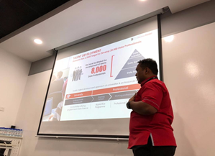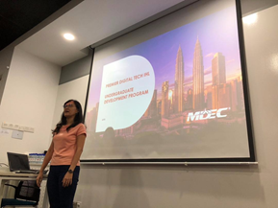
Picture 1: Mr. Mohamad Nazir Bin Ismail Picture 2: Miss Josephine Ung

For the second section of the seminar, Miss Josephine Ung had gave a speech about premier digital tech IHL undergraduate development program and digital economy key focus areas. She also explained on the linkage of ADAX with MDEC. As for the next section, Mr Gan Chun How explained on the misconception between data science and data scientist. He also introduced the capability of Fusionex and Data Hero on his speech.

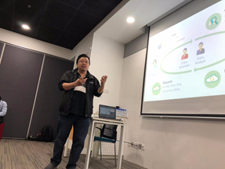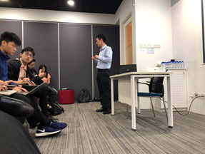
Picture 3: Mr Gan Chun How Picture 4: Dr Mark Chia

Dr Mark Chia was the last speaker of the seminar. He talked about the future of digital economy incorporating with the topic of SAS, Artificial Intelligence, Fourth Industrial Revolution and the Analytics economy. After the seminar, we were able to tour around the workshops and the facilities used in ADAX office.

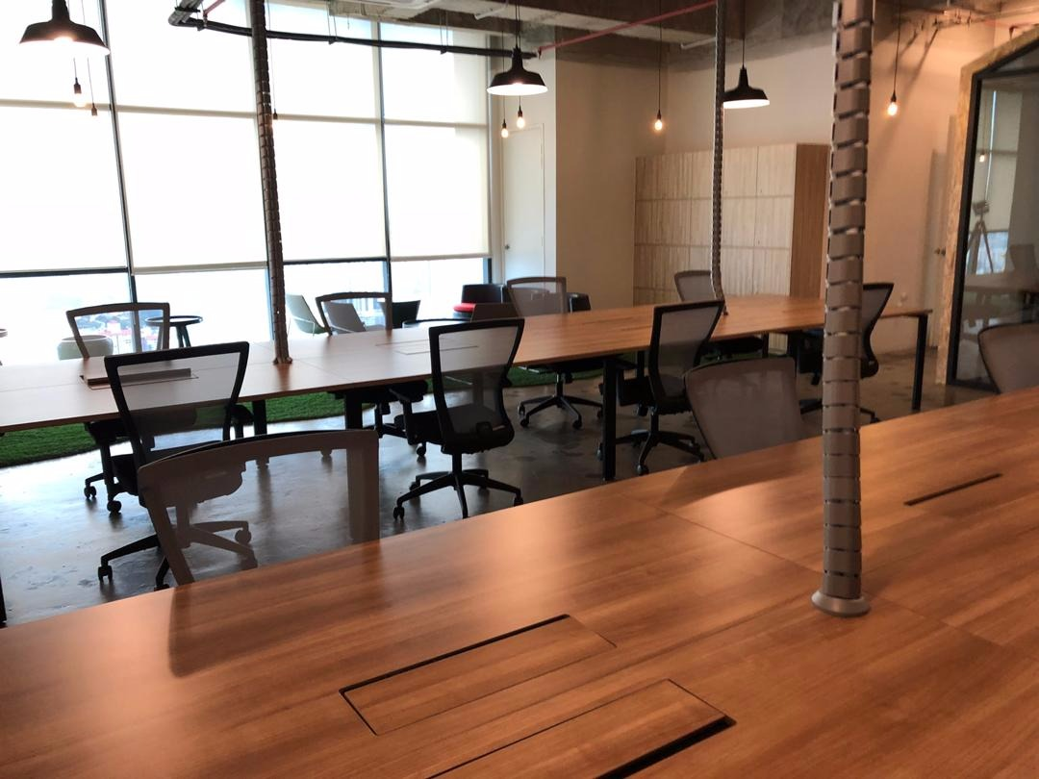
Picture 5: The surrounding in ADAX office

3.0 DETAILED DESCRIPTION

3.1 ORGANIZATION STRUCTURES

Since ADAX is a platform to build ecosystem through trainings, data sharing and setting up framework in the country, outstanding employees are hired to enhance the performances of this program to achieve its objectives.
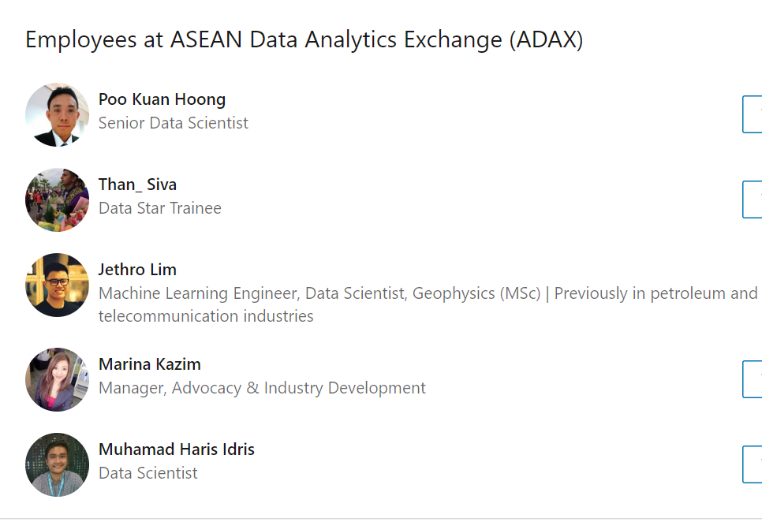
Picture 6: Employees of ADAX

3.2 SERVICES
ADAX has offered all kinds of training, advocacy and partnerships to develop data practitioners and data leaders. ADAX welcomes training partners in searching appointments through governance process. It also acts as a framework for professional sharing amongst industry partners by providing knowledge needed in an organisation that can explore fundamentals of data. Other than that, ADAX are partners with the key industry players that share similar goals in contributing the growth in BDA ecosystem.

ADAX also offered innovative lab, talent development, and start-ups services to the practitioners.
Services | Programs
Innovative Lab | Demo/showcase  Product launch & grow programme  Sandboxing  Experts meet and greet
Talent Development | Technical classes or massive open online  Courses  Hackathon  Job matching  Shared training and tech labs
Start-ups | Accelerator programme  Industry collaboration  Access to funding and go-to-market

Table 1: Services on ADAX

3.3 ACHIEVEMENTS

ADAX had exceeded expectations in achieving significant milestones on building a critical mass of talent pool in Big Data Analytics. ADAX has successfully organised 576 events conducted at ADAX’s state-of-the-art facilities. In the year of 2017, ADAX manages to develop 2390 data professional and managers and 396 data scientists. Through training providers, 19 training partners, 76 courses short-listed and 1800 data professionals trained had developed.

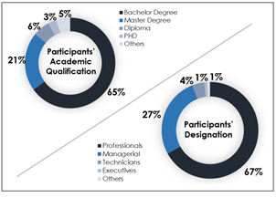
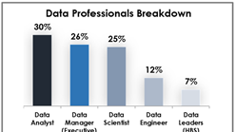
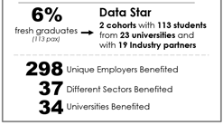
Picture 7:AchievementS of ADAX

4.0 ADOPTION PROGRAM

Adoption program is a process to transform analytic data into drive data technology. Under ADAX’s adoption program, there are two main components which are supply and demand. Data Technology Partnership Program is the supply of this program and it is an ecosystem for collaboration to catalyse data technology adoption. There are three types of partners such as technology partners, knowledge partners and training partners.

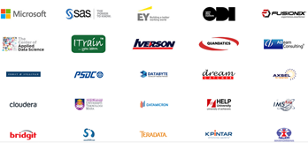
Picture 8: Training and Technology Partners of ADAX

The demand in this program is Data Driven Decision Enterprise (DDD) which is a two-pronged approach covering the whole spectrum of data-driven decision enterprises maturity level. The purpose of this program is to generate funnel for DDD Enterprise Adopters and to attract serious DDD Enterprise Adopters with Data Technology Partners. Once result and recommendation were given from the DDD assessment, MDEC will facilities and invite its partners to propose solutions based on the outcome of the DDD assessment.

5.0 COMMUNITY EVENTS

ADAX has been working with regional industry players for the enrichment of the communities beyond boundaries of insolation. Under community events, ADAX had cooperated with the private sector, universities, industry organisations (PIKOM) and NGOs (AI M’sia, Gain) on the areas such as industry pain points, national challenges and societal issues. Focal point for DS and AI community events are usually done via channel such as events, workshops, hackathons and meet ups.

6.0 DATACAMP

DataCamp is the digital platform that offered online courses and tutorials of data science by learning programming language R and Python to improved students capabilities of handling data in wide range and coding without having attend to class to learn. According to the reviews, DataCamp is a time flexible, online data science learning platform offering tutorials and courses in data science. Students can master data analysis from the comfort of their browser, at their own pace, and tailored to their needs and expertise. DataCamp has free beginner courses or the option to pay a subscription fee for access to all premium courses. Students can either pay $25 per month or $250 per year for access. In addition to tutorials, there are also coding challenges. DataCamp focuses on the technology R, used for Big Data, data visualization, and programming with R. DataCamp missions is to to democratize data science education by building the best platform to learn and teach data skills and make data fluency accessible to millions of people and businesses around the world. DataCamp also courses for classroom for 6 months with minimum of 10 students per class. Besides R and Python programming, Datacamp also offered other course to the registered students like data visualization, probability and statistics. The advantages of who taking premium access in the DataCamp will get Statement of Accomplishment after completely each topics provided online which will boosts morale and spirits of the students to mastered the topics. Another than that, you can get full access to entire course curriculum which are more significant and relevant to data science. Besides that, you can have in the leaderboards and private discussions forums and MDEC talent marketplace. Diagram bellows shows courses offered by topics:

7.0 PREMIER DIGITAL TECH

Premier Digital Tech is the undergraduate development program under MDEC know as Malaysia Digital Economy Corporation. The objective of this program is to create sustainable talent pipeline for industry and recognition for digital talents by strengthen awareness of & confidence in digital tech related career and become benchmark to be emulated by other institutions. According to the talk, Premier Digital Tech Institutions provide the optimum conducive ecosystem to produce graduates meeting industry expectations. Within this ecosystem, students, lecturers and industries actively engage each other, facilitated by qualified career centre personnel. This is further enhanced by easy admission for qualified students, who also have access to education fund providers championing digital tech education. In the talk mention that one of the key elements under the Premier Digital Tech Universities initiative is to identify talented and qualified students to be given the priority access to pursue studies in digital tech related courses in our Premier. Through this initiative, applicants have the privilege to select top 3 preferred choice of Premier IHLs from the list.

Diagram above shows that Digital Tech University capable to gives many services under various programs to ensure that talented students that are able to meet industry needs.

8.0 DIGITAL ECONOMY

Digital Economy is refers to a digital computing technology- based economy, although we increasingly see it as conducting business through the Internet and World Wide Web markets. Sometimes the digital economy is also called the Internet, the New Economy or the Web Economy. The digital economy is increasingly intertwined with the traditional economy, making clearer delineation more difficult. Digital Economy being developed by MDEC itself into global digital hub. It is to enabling Malaysians by digital means to improve productivity and living standards for everyone. MDEC tend to build a strong digital innovation ecosystem to protect the economy in the future as technology changes business rules as well as growing and transforming Malaysians into a technologically skilled workforce to support the growth of a digital economy.

9.0 MYDIGITALMAKER

#MyDigitalMaker is one of the MDEC’s strategy that involves students, educators, parents, corporates and technology partners to transform Malaysian youth from digital users to digital economy producers. This includes skills such as coding, app development, 3D printing, robotics, embedded programming and data analysis, all of which ultimately contribute to improving problem solving and creativity in our future generation. Mydigitalmaker will be introduced to the school students which is interested applying for Digital Tech IHL courses after leaving the school which have secured scholarship from government or industry and green lane placement for high potentials. Besides that, MDEC have introduced Digital Tech Foundation Courses and Digital Tech career awareness and counselling to the SPM leavers which still cannot decide what courses to apply after school. For undergraduates, they have been is dedicated to top talent interested in pursuing tertiary courses in careers in digital technology. One of #MyDigitalMaker movement is #Mydigitalmaker hero which is target to provide chances to Malaysian students from school to undergraduate to become digital creators and innovators. The diagram below shows the journey of Mydigitalmaker for Malaysian students:
10.0 FUSIONEX



Fusionex is a well-established data technology provider that has specialties in Analytics, Big Data, Machine Learning and Artificial Intelligence. They help people to oversee, comprehend and infer valuable information from the vast amounts of structured and unstructured data, which are at their disposal. In focusing on closing the space between business and technology, they give remarkable and positive experience to people of different fields. In doing so, they have achieved multiply awards such as Global Partner of the Year by Microsoft Partner Network and BigData World Asia for Data Analytics and Innovations.. Their vision, mission and qualities are:
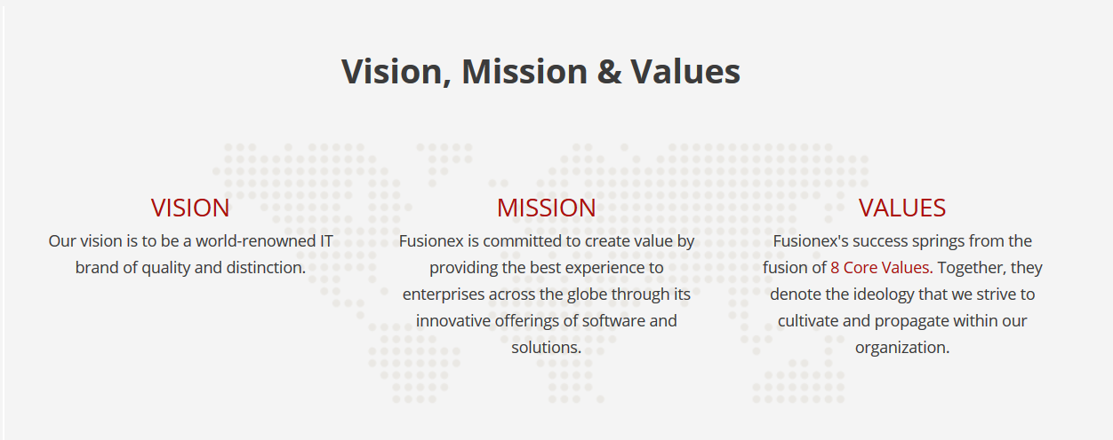
The reason of the name, FUSIONEX, is that there is a message embodied in it that represent who they are.
Faith
Through assurance in ourselves, our organization’s vision, and what we believe in, achieving goals that we set as well as those set by others becomes a natural flow of events



Unity
Working together knowing that nothing is impossible when we stand together


Success
Consistently striving to better ourselves through accomplishments and achievements


Inspiration
Relentlessly motivating and encouraging all around us


Nobility
Maintaining a noble spirit and remembering that it is always good to give something back to society whenever possible

Optimism
Firmly grounded with the knowledge that optimism is the foundation of true progress


Experience
Focusing on our experience to provide the best experience to all parties


Xcellence
Staying true to our vision by ensuring that we make NO COMPROMISE to provide top quality services and deliverables



11.0 DATA HERO

The talk given by Mr Gan Chun How, the solution architect for FUSIONEX was about Journey of a successful Data Hero. A Data Hero is someone who can analyse the sets of data that are complex in terms of the volume and variety and making is to big data. Mr Gan Chun How also referred as Mr Lan says there are two things that is need to be a successful Data Hero. Number is the knowledge of statistics. Second is the knowledge of Python or R language.

Statistics is crucial in ensuring meaningful and accurate in the deriving information from Big Data. Data quality, Missing data and observational nature of data so that causal questions such as the comparison of interventions may be subject to confounding are the is crucial issues intensified by Big Data. Therefore, the knowledge of statistics help translates and describe the data structure by underlying the system that generated the data and what is trying to access the parameter that is being estimated of predicted.

Secondly the knowledge of R or Python. R is a language and environment for statistical computing and graphics. R provides a wide variety of statistical and graphical techniques and is highly extensible. Moreover, Python is an in interpreted, object-oriented high-level programming language with dynamic semantics. It’s high-level built in data structures, combined with dynamic typing and dynamic binding make it very attractive for Rapid Application Development. Therefore, both program can be used to create the model to analyse the data to be translated to information.

Finally, everyone should remember what Mr Lan said. “How good someone is good in analysing data, data scientist is not a one man team. At few people are need to make a team who are good at data science.”

12.0 EXAMPLE OF AI IN INDUSTRY

An AI could provide valuable insights, suggests the best strategy and makes automatic move. AI in the industry can analyse bigger volume data faster and give a suggestion on what to carry out to make things more efficient compared the humanly way. The machine intelligence determines the best course of action and can execute is automatically. Examples of AI in the industry are:
- In Banking and Finance
  - In most cases, the everyday exchange volume is extremely high for humans to physically examine every transactions. Therefore, AI is utilized to make the frameworks that realizes what sort for exchanges are fraud. FICO, the organization that makes the notable FICO assessments used to decide financial soundness, utilizes neural systems to anticipate fake exchanges.
- In transportation
  - Transportation is the most known industry where AI innovation known for. While self-driving vehicles and trucks might be the most foreseen improvements, AI can go the extent that gathering information from an assortment of sources to optimize and adjust the delivery courses and simplify distribution networks.
- In Healthcare
  - Healthcare is seeing a help with AI-driven diagnostics that deal with gigantic measures of information at the same time suggesting the possible conditions and approaches to treat them. Inside the hospitals, there are AI-assisted anaesthesia delivery and professional AI support during medical procedures. According to Health IT Analytics, “Revolutionary changes in health and health care are already beginning in the use of AI-based health and health care tools.”

13.0 SAS

SAS is the largest privately own software company in Malaysia that started last 32 years of on 1986 in Malaysia. SAS aims to be the world leading company in data analytics. They envision a world where everyone can make better decisions, grounded in trusted data and assisted by the power and scale of SAS Analytics. They believe that when decisions happen at the right moment, advancements are going to happen and thus making the world moves faster. The representative from SAS Analytics was Dr. Mark Chia. He is the Advanced Analytics Practice Lead in SAS Analytics. He shared a lot on his 10 years working experience in the IT sector in the UK. His sessions was mainly about industrial revolution, internet of think and AI.

At this current time in history, we are facing the advancement of the industrial revolution 4.0. Dr Mark explained about all the previous industrial revolution and what had really changed in each revolutions. In the fourth revolution, the industry optimizes the third revolution by computerization. Computers are replacing most of the things in the industry such as there are many massed production factory that used computerized robotics to produced or assemble their products. Secondly, Dr. Mark explained about Internet of Things also known as IOT. The IOT is a network of physicals objects that used sensors and APIs to connect and exchange data over the internet. Dr Mark gave an example of IOT when he bought the Logitech Gaming Hub and Google Home. Both this devices enables Dr Mark to connect almost all his devices (including the lights and gaming systems) to be controlled just at the touch of his fingertips on his phone. Lastly, AI is artificial intelligence. Dr Mark gave an example on AI, which was Google’s Cortana. He explained in just 2 weeks using Google’s Cortana, it had already suggested him how to manage his daily routine by telling him when to go out to work and what route to use to avoid traffic. This AI shows it can make life or the industry more efficient considering it can analyse data much fast and at a higher intensity volume compared to human.

14.0 REFLECTION

After this brief period visit to ADAX, we can conclude that it was a very good and meaningful visit. For some of us, that was the first time seeing and meeting in person someone who is in the line of data analytics. Hearing their own experience and knowledge was really a good preview and a bigger picture on what we would being doing in this line of work. This really motivated us to achieve the best we can and to learn more skills so that it would be meaningful in the future. All of the programs that are being offered by MDEC is very good for us graduates. It can improve us as fresh graduates in the future so that we will be more marketable. Therefore, if we had the time and opportunity to join the programs, we think it would be useful.

15.0 REFERENCE

- http://higherlogicdownload.s3.amazonaws.com/AMSTAT/UploadedImages/49ecf7cf-cb26-4c1b-8380-3dea3b7d8a9d/BigDataOnePager.pdf
- https://www.sas.com/en_my/home.html
- https://www.fusionex-international.com/Solutions
- https://en.wikipedia.org/wiki/Digital_economy#Definition
- https://www.coursereport.com/schools/datacamp
- ttps://www.datacamp.com/courses
- https://mdec.my/growing-future-talent/premier-digital-tech-ecosystem
- https://www.mydigitalmaker.com/undergraduate-students
- https://www.mdec.my/

