
INDUSTRIAL VISIT 3: CIMB BANK
SCSP1513 – TECHNOLOGY AND INFORMATION SYSTEM

Dr. Aryati binti Bakri
Group 6 :
JASMINE CHAN YUAN QI
MUHAMMAD AYMAN BIN MOHYEDIN
MUHAMMAD AKMAL BIN HISHAM

November 15, 2018

Contents
1.0 INTRODUCTION 3
2.0 DETAILS OF JOURNEY 4
3.0 DETAILED DESCRIPTION 5
3.1 ORGANISATION STRUCTURE 5
3.2 SERVICES 6
3.3 ACHIEVEMENTS 7
4.0 GRADUATES OPPORTUNITIES 7
5.0 IT INFRASTRUCTURE IN CIMB 8
6.0 REFLECTION 9

1.0 INTRODUCTION

CIMB is a group of commercial bank in Malaysia which act as a leader in ASEAN universal bank. CIMB bank is one of the largest investment banks in Asia as well as one of the largest Islamic banks in the world. Since 1974, CIMB bank had established in Malaysia and the headquarter office was placed at Kuala Lumpur.
As the fifth largest banking group in ASEAN, CIMB bank has over 13.5 million customers nationwide and around 37,000 staffs in 15 countries. The vision of CIMB is to be the leader of ASEAN company. As for the mission of CIMB is to provide universal banking services to become a high performing, institutionalised and integrated company located in ASEAN and uphold the advancement of ASEAN integration and region’s links to the rest of the world.
As an indigenous ASEAN investment bank, CIMB provides market-leading conventional and Islamic financial advice on banking solutions to its clients. CIMB has a wide retail branch networks with 1,080 branches across the region. Beyond ASEAN, it also exists in Hong Kong, India, Sri Lanka, Korea, United State and United Kingdom. CIMB Group has separate into few branches to smoothen its operation. First, CIMB Group acted as the universal investment bank while CIMB represents the investment banking services, private banking franchise and asset management. Next, CIMB Bank represents the consumer bank and corporate banking franchise in Malaysia, Cambodia and Singapore. As for the franchises in Indonesia and Thailand, they were named as CIMB Niaga and CIMB Thai. As for CIMB Islamic, it is an Islamic banking franchise, incorporating products and services in compliance with Shariah principles.
CIMB believes in achieving the dreams, ambitions and aspirations of over 13.5 million customers across the ASEAN region as CIMB has the products, services and solutions that enable its clients to move forward confidently towards your goals.

2.0 DETAILS OF JOURNEY

Technology and Information System students of University Technology Malaysia (UTM) are given an opportunity to visit the headquarter office of CIMB group in Kuala Lumpur on 26th of October 2018. Three groups were allocated before we toured around the offices in CIMB.
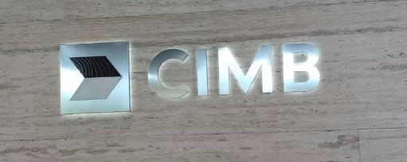
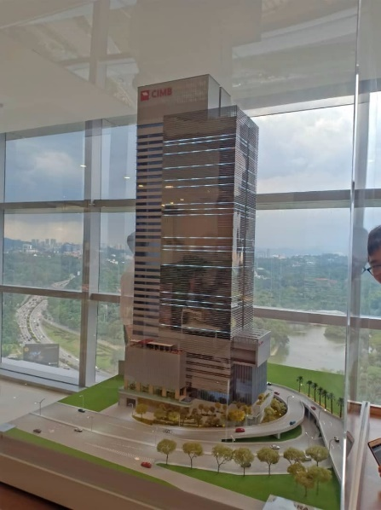

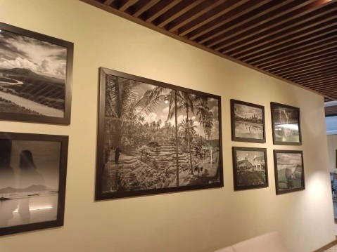

Picture 1:Internal views of CIMB offlce
The CIMB’s staffs also arranged a short seminar for us to have more understanding on the culture of their bank. On the first section of the seminar, assistant manager of CIMB, Mr. Qasmal Noor had introduced the vision, core values and corporate culture of CIMB to us. He also talked about the graduate opportunity and internship programme in CIMB.
As for the second part of the seminar, Mr. Ahmad Affzan Bin Mokhtar Anuar, the director head of production support and Malaysia IT infrastructure had given a speech on the IT structure and functions in CIMB. It had given a wider view for us to realise the important of IT on the applications and infrastructures of a bank.

3.0 DETAILED DESCRIPTION

3.1 ORGANISATION STRUCTURE

The pictures given below are the organization structure of CIMB group and the group structure of CIMB.
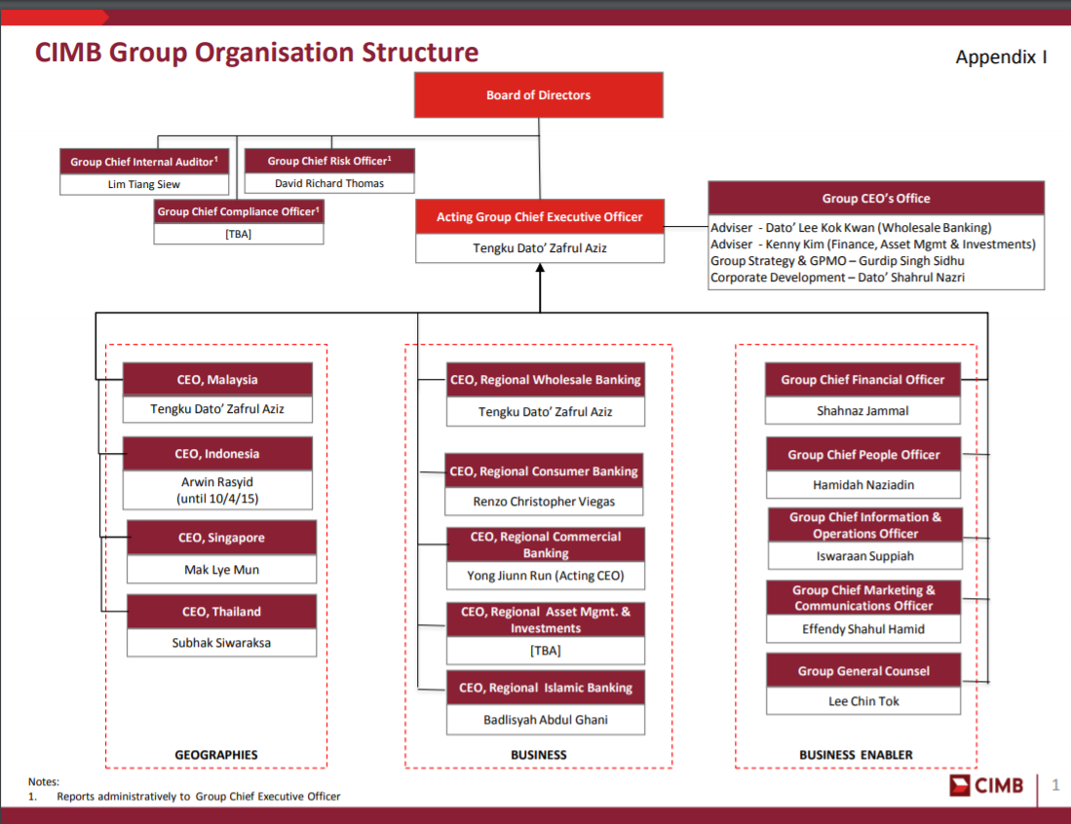
Picture 2: Organization structure of CIMB
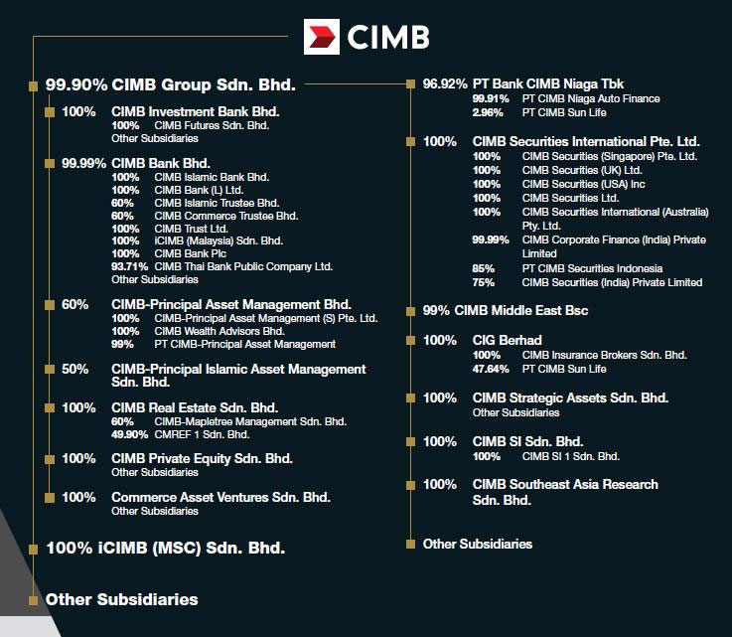
Picture 3: Group structure of CIMB

3.2 SERVICES

CIMB has promoted a few products and services in CIMB bank’s branches . The services offer by CIMB Bank can be declared into five segments which are wholesale banking, treasury, retail and commercial banking, asset management and Islamic banking. Under wholesale banking, there are services including corporate finance, equity capital markets, institutional broking, retail broking, equity derivatives, securities borrowing and lending. To offer treasury solutions to the customers, CIMB has promoted services like debt capital markets and syndicate, derivatives and government bond market making and cross markets trading for hedging the risk exposure and maximising returns on their business ventures.
Other than that, services on deposits, private banking, loan and financing, leasing, credit card, microcredits, ASBs, self-service terminal and wealth management are provide in retail and commercial banking to suite the needs of customers. On asset management, retail and institutional funds, real estate funds, infrastructure funds management, private equity funds and real estate funds services are offered in assisting customers to manage their funds. Services like wadiah, mudharabah and sukuk are supplied in the Islamic banking.

3.3 ACHIEVEMENTS

CIMB is ASEAN's fifth largest banking group. They have around 37,000 employees in 15 ASEAN countries and elsewhere. The CIMB Retail Banking network comprises around 850 branches and serves over 13.5 million customers. They have offices throughout ASEAN and China, Hong Kong, India, Sri Lanka, Korea, the United States and the United Kingdom. 30 June 2018 CIMB Group Corporate has total assets of RM 511.2 billion, total management funds of RM 84.1 billion, 15 global markets and total shareholder capital of RM 46.9 billion. In 2018, Malaysia CIMB Bank won numerous awards at the 12th Annual Best Financial Institution Awards 2018 in Alpha Southeast Asia, including Best Equity House, Best Islamic Finance Retail Bank, Best Islamic Finance Retail Bank and Best Islamic Financial Investment Bank. At the Asiamoney Best Bank Awards 2018 they also won the best cooperation and investment banks as well as the best banks for SMEs. At the Asset Triple A Islamic Finance Awards 2018 they won the best Islamic investment bank. There are many other CIMB branches under the names of other countries.

4.0 GRADUATES OPPORTUNITIES

There are a few programs and internship that CIMB offers to fresh graduates or undergraduates looking for internship. The program and internship is as following.
Under Graduates | Graduates
Internship | The Complete Banker | CIMB Fusion
Year 1,2 or penultimate year all degree backgrounds  Able to intern for 2-6 months  Strong academic result – minimum CGPA of 3.0  Active in extracurricular activities | Strong academic result from various field  Active in extracurricular activities including sports  Strong desire to learn and succeed  Energetic & versatile  Good interpersonal skills  Able to work independently  Year 1- Intensive class & job rotation (11 months)  Year 2- Elective development (3 months) & job placement | Strong academic result from various field (based on stream)  Active in extracurricular activities including sports  Strong desire to learn and succeed  Energetic & versatile  Good interpersonal skills  Able to work independently  Training towards specific department such as consulting, teaching/leadership, law, information technology and accounting

For the internship programme, CIMB ensures its interns that they will do on the job training. Meaning they will gain practical skills and a real world perspective on an occupation. Secondly, the interns will meet with the directors and interns from other departments to give opportunities for the intern to expand their networks. Thirdly, if the interns perform well, CIMB will offer them career opportunities and the intern can decide if CIMB is the right career for them.

5.0 IT INFRASTRUCTURE IN CIMB

In CIMB, their IT department are divided into 6 division to make it easier to monitor each department. These department are as follow:
Group IT | About
Applications | CIMB was used as a business-oriented setup that develops, manages and maintains business applications like their mobile application.
Infrastructure | Technology Domain has divided the infrastructure, it operates and manage IT infrastructure, including the hardware, software and IT environment.
Service Management | The service management have 4 type of management which is  1. Incident and Problem Management  2. Change Management  3. Helpdesk  - Capacity Management
IT Security | CIMB is a big bank. With that is has threats coming in everyday knocking on its door. Therefore their IT security monitors and checks:  - Parameter security  - IT Policy Management and Enforcement  - Vulnerability Assessments and Penetration Testing  - Security Operation Control (SOC)  - Cyber Security
Risk and Compliance | There are 4 type of risk and compliance  - Regulatory and Standards Compliance  - Audit management  - Ongoing Risk Assessment  - IT Risk Managements
Financial and Administration | This division operates under several Names or groups, which include CIMB Investment Bank, CIMB Bank, CIMB Islamic, CIMB Niaga, CIMB Securities International and CIMB Thai. This group are primarily in the areas of Consumer Banking, Wholesale Banking, comprising Investment Banking and Corporate Banking, Treasury & Markets, and Group Strategy & Strategic Investments, with its core markets being Malaysia, Indonesia, Singapore and Thailand. CIMB Islamic operates in parallel with these businesses, in line with the group's dual banking model.

6.0 REFLECTION

In short, this visit to the CIMB has given us enormous benefits for our own objectives. Because this visit, as a data scientist / data engineer, gave us a brief overview of what we are going to face for the future. In addition, the visit also shows us how important it is to seize every opportunity, especially in the field of data management and IT which are helped us to study in our courses. The visit also focused on the internship, which makes a difference in our course. This is because we have to prepare for a one- year internship at 2u2i. The CIMB management has already briefly explained to us how to copy and save an internship in CIMB.
In this context, we need to take various measures to improve our potential in the industry. As one of the measures that must be taken in general, we must focus on our studies and try to achieve results. However, we must also maintain our curriculum, such as joining university clubs. This is important because scoring alone in science does not provide the necessary social networks and soft skills in the workplace. Our social interaction and soft skills should also be improved. Social interactions, whether accidental or professional, are very important for our future preferences in building a large social network. Soft skills such as presentation skills, interviews and much more are also important for us to improve our future.
In order to improve our potential in this industry, especially the growth and the new wave of Industry Revolution 4.0, some plans need to be made. One of the most important plans is a set of framework conditions for certain industries or industries to which we want to join in the next five to six years. Industry 4.0 will be close to the vast, moving world. Therefore, future planning frameworks must be created to prepare us for possible opportunities.

