

INDUSTRIAL VISIT: CICT, UTM

SCSP1513 – TECHNOLOGY AND INFORMATION SYSTEM
DR ARYATI BINTI BAKRI

Group 6 :
JASMINE CHAN YUAN QI
MUHAMMAD AYMAN BIN MOHYEDIN
MUHAMMAD AKMAL BIN HISHAM

Table of Contents
Introduction 3
Details of Journey/Work Plan 4
Detailed Descriptions 5
- Organization structure 5
- Services 5
- Achievements 6
- Information systems 7
Reflection 8
Conclusion 9
References 9

Introduction
Centre for Information and Communication Technology (CICT) is a department that supports and delivers ICT services to the students and staffs in university especially for ICT infrastructure, system development and academic. It also responsible in providing all kinds of ICT services to users from the researching centres and marketing department. Main users for CICT are usually administrative staffs, lecturers and students in the UTM. Other than that, CICT also provides maintenance ICT hardware and software services for the need of university.
CICT unit was once known as ‘Pusat Komputer’ had established on the year of 1975. Modification and upgrading on status are done on CICT for the pass few years due to the addition of ICT services in the field of internet access, infrastructure, multimedia, security, software, web management, application development and ICT facilities.
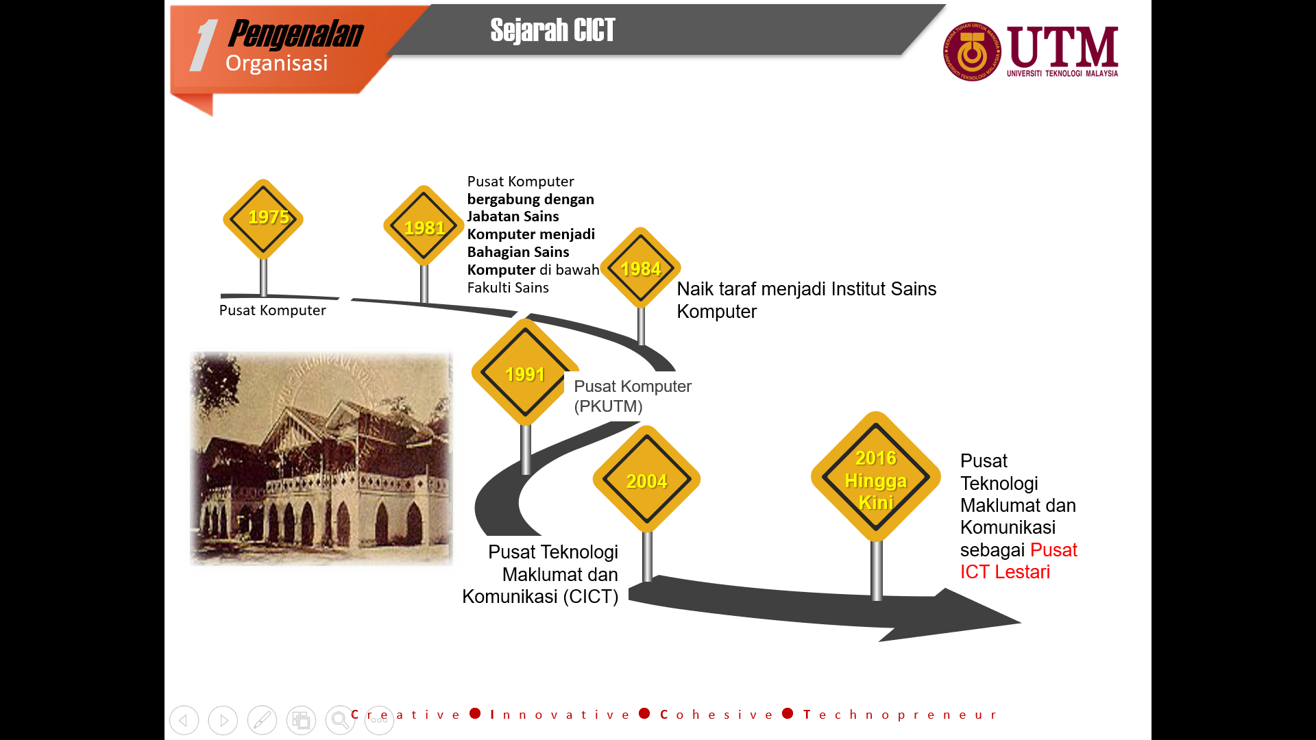
Picture 1:History of CICT (1975-NOW)
CICT’s vision forUTM is to be a frontier digital university spearheading academia centric service delivery. As for the mission of CICT for UTM is to To lead in the development of an entrepreneurial digital eco system by nurturing innovative digital professional and promoting collaborative digital services. They committed to provide a higher timeline ICT services and implement continuous improvement to increase the satisfaction of users following the view of vision and mission of CICT.
UTM Kuala Lumpur (UTM KL), which is a graduate campus of Universiti Teknologi Malaysia (UTM) also have the same corporate structure as the main campus in Johor Bahru, Johor. As the academic and administrative support on UTM KL are provided from the Centre for Information and Communication Technology (CICT) too.

Details of Journey
On 1 October 2018, we were invited to listen to a talk given by Center of Information, Communication and Technology (CICT) of Universiti Teknologi Malaysia (UTM). The talk was held at the seminar hall in the CICT building. Mr. Mohd Zahari, who works as an assistant officer in charge of the information technology in CICT gave the 2 hours briefing. The briefing was to expose more about CICT to the students for better understanding. After the talk, Mr. Mohd Zahari brought us to the Pusat Perkhidmatan ICT Pelajar ( PPICTP ). The PPICTP was fully equipped with around 200 computers/work space, a discussion area, Wi-Fi and the essential to for students. This is a one-stop centre for students wanting to us it equipment such as printing and photocopying services. After that, we went to CICT gallerium. Because CICT has been functioning for a long time, many of the old equipment like computers and storage was still preserved. This is a good opportunity for millennials like us who grew up through the time when technology was at its early stages of advancement.
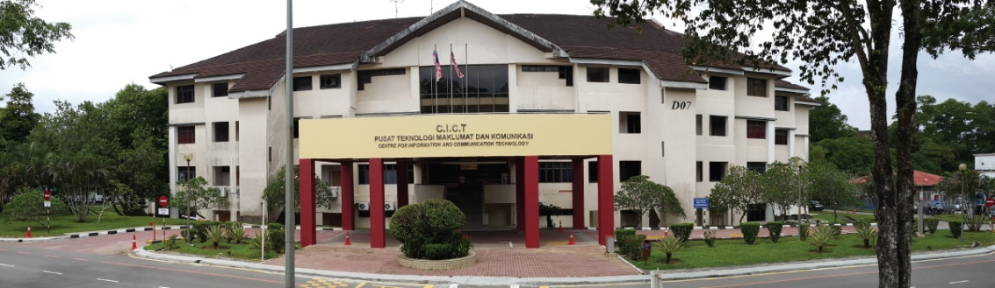
Picture 2: CICT Building
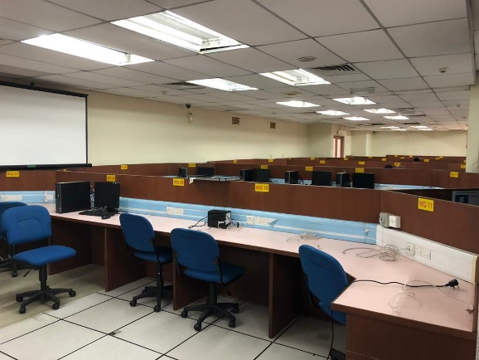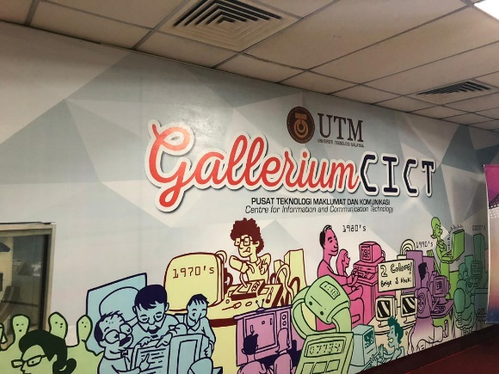
Picture 3: PPICTP Picture 4: GALLERIUM CICT
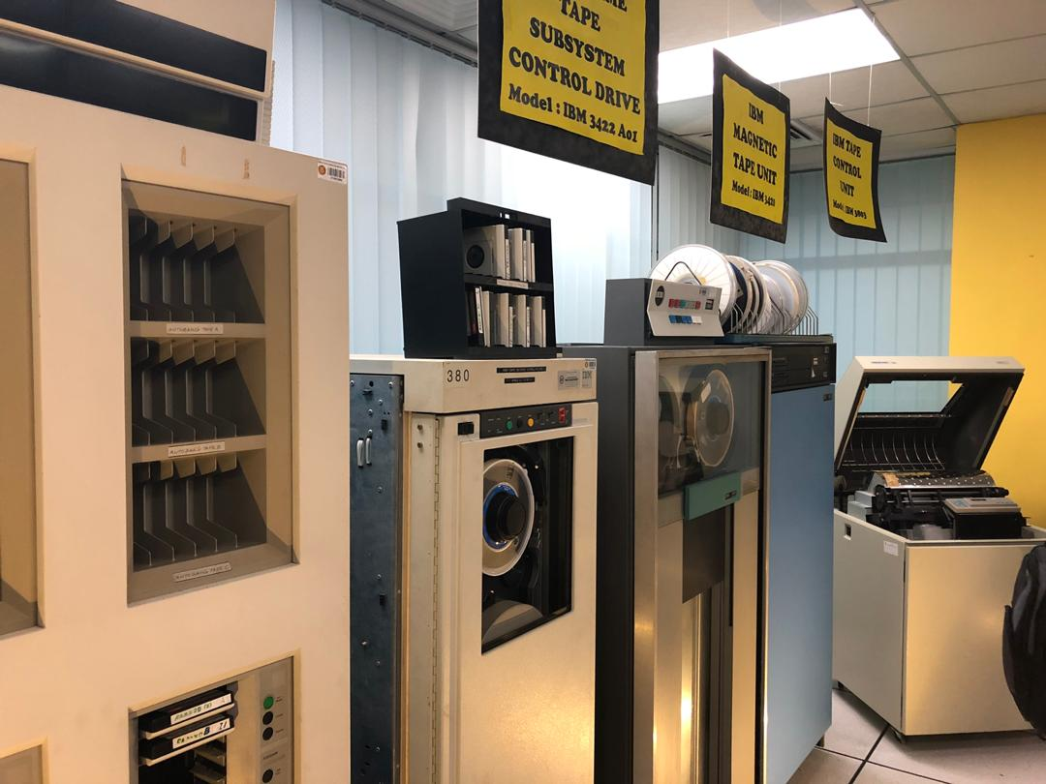
Picture 5: Old hardware at Gallerium CICT
Detailed Descriptions
Organization Structure
An uniform operating structure is used in the CICT unit to have a smooth run on their system. Clear organization structure will increase the ability and efficiency of CICT in delivering information and services to their users.
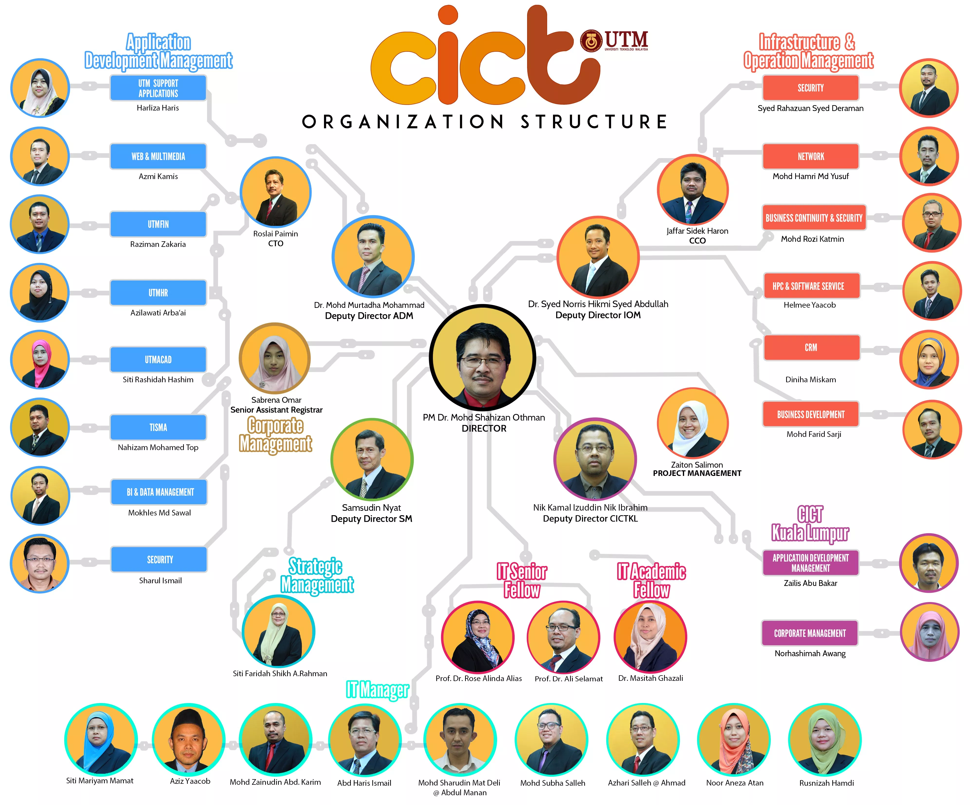
Picture 6: Organization structure of CICT unit
According to the flowchart above, Dr. Mohd Shahizan Othman is the director of CICT department followed up by four deputy directors for ADM, IOM, SM and CICTKL. CICT organization structure also involved five different management teams such as application development, corporate, strategic and infrastructure and operating management.

Services
CICT services have splitted up into four main services which are infrastructure and security, application development, software and facilities.
Some services are created under the category of infrastructure and security such as ACID, hosting services, High Performance Computers (HPC), Video Conferencing (VC), ICT security and Virtual Private Network (VPN). ACID is a special ID given to the users for the purpose on activating to the university systems. CICT also offer hosting services such as web hosting, server hosting and colocation server hosting to UTM and external customer for conference and special events. Next Generation Firewall is used as ICT security to reduce the complexity and cost of ownership. As for Video Conferencing (VC) service, it also allows UTM JB to communicate and have conference with UTMKL or other location via live streaming.
As for the application development service, system development service was built to manage administrative, multimedia, teaching and learning applications in the university. Next, mobile applications like Usmart and BusUTM were designed for the need of the users. Multimedia Development such as quality video editing graphic design for logo, presentation slide, web, bunting and banner were provided under the application development service as well. CICT also provided UTM Crowd Fund in helping community, departments and other creators in finding resources to support their needs.
A few software services are provided in CICT such as Antivirus, wifi@Hotspot and UTM extension, software license by UTM, Microsoft Product, Microsoft office and Research Software. For Antivirus service, Symantec Endpoint Protection 14 was applied to improve the computer's security of user in UTM. Extension of Hotspot@UTM is provided to Resident college for a better serving experiences. Software licensed under the DreamSpark Program is also available for students and staffs in the use of academic and administrative works.
Information Technology Galleria is one of the facilities located at the CICT UTM Johor Bahru campus which is a place that displayed all kind of computer components.Other than that, computer labs are provided by CICT for classes and training.
CICT provides a dedicated server and services to enable user to have maximum customization and configuration of servers and applications.

Achievement
CICT has contribute to this magnificent university ever since 1975 and greatly give a huge impact including staff and students and more communication and network within university increased efficiency. One of great achievement is its contribution toward rating & research in university data management and business intelligence. Its contribution is made UTM ranked 21st in world university ranking (top 50 under 50) , 49th (Asia) and 253rd (overall) including 6 subjects in Top 100 which is architecture/built environment, computer science & info system, chemical engineering, civil & structural engineering, electrical & electronics engineering and mechanical engineering. CICT achievement toward undergraduates and postgraduates of UTM also impressive which is manage intake and enrollment PG SRAD, analysis exam and graduate (UG-UGS), MyMOHES and AIMS..CICT also ease burden of the staffs with manage basic staff information (Basic information, position scheme, state-based, state-of-birth-based and position summary), education, healthcare, eLLPT and many more. CICT is the one who created AD HOC, Tracer Study, HRMIS, KPI Head Line within campus. They also contribute in Global Plan UTM Phase II which is outstanding achievement. They have 137 ICT system include support system, academic computing, data management, academic management, financial management and human resource management. They covered sustainable campus infrastructure, ICT system and community engagement & industrial network, total campus experience, high campus delivery and financial sustainability

Information System
There are many services that CICT has developed and maintains. Its main system is the Information Database System of UTM. This system is for UTM to record all the individual information regarding personal information, academic information, activities and achievements. Secondly is the E-learning system. This system is a platform to ease the work of lecturers and students. It is online-based so any of the lecturers or student can access it anywhere. All the assignments and lecturer notes and be submitted and distributed here. Lastly is the UTM Portal. This is for use of the staff/lecturers and students. It is to make ease of the community of UTM to get more information on UTM. In addition to, CICT also developed mobile application software. The first application is the GuideMe@UTM. This is a software to help the students especially the first year students to learning about UTM’s facilities. Secondly is the Usmart. This software is for the attendance of student to class. It is linked to a student’s ACID ID. Moreover, ACID is a system that is also developed by CICT. The system that generates the accounts for all the application and system is developed by CICT. All the students and lecturers ID are stored and generated in ACID.
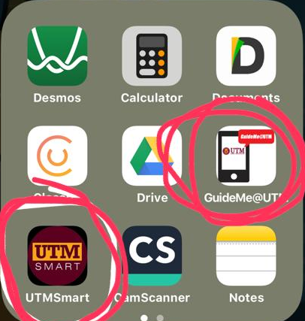
Picture 7: Apps developed by CICT (circled ones)

Reflection
This industrial talk made me thought about my goal and dream regarding my course that I'm taking right now which will lead me further in my life or otherwise. This program widens my vision to establish my dream to make contribution to country in aspect of technology and science. Besides that, Since the beginning of the 20th century, the course of human history has been dramatically transformed by the invention of several new technologies, each of which has impacted people’s lives in profound and complicated ways. One of the amazing things we have been given as humans is the unquenchable desire to have dreams of a better life, and the ability to establish goals to live out those dreams and live the expectations of the loved ones. The visit of CICT of UTM showed the amazing and outstanding technology that solely created UTM itself like provide wireless internet to whole campus with impressive internet speed of 1Gph/s. Furthermore, CICT management also created many medium and innovation to ease burden of staff and students themselves like New Academia Learning Innovation (NALI) which give platform to student present their creative and innovative idea to enhance education system, Jobs on Campus which alternative way to gain additional income without searching elsewhere. The CICT visit gave a huge impact on my plan of goal and dream which is I must strive harder and more hardworking to be good or better than CICT can ever do. I also want to maximize my effort to break my limit regarding my course which required high critical thinking skill and be more multitasking than anyone else. I also want everything begins in the heart and mind even though the courses that I am taking are difficult. Every great achievement began in the mind of ourselves. I wanted dared to dream, to believe that it was possible. Take some time to allow to ask, “What if?” Think big. don't let negative thinking around me if i want to be a “dreamer.” Dream of the possibilities for myself, my family and for others. If you had a dream that you let grow cold, re-ignite the dream! Fan the flames. Life is too short to let it go.
The action, improvement and plan are necessary for me to improve my potential in the industry. One of the actions that I going to take is spending a substantial amount of time thinking about strategies that will help myself achieve greater levels of success. I want to strive for more impressive job title, higher compensation and responsibility for more sizable revenues, profits and numbers of employees and wanted influenced by family, friends and colleagues. I want my career starts with an accurate assessment of your current skills and performance with identify my key weakness as soon as possible that involves meaningful reflection and almost always requires soliciting the views of people with honestly truth with somehow not always a good thing. Besides that, I must seek for coaching, asking for very specify feedback, and being receptive to input from a wide variety of people at various levels within industry. This type of initiative takes time, humility, and willingness to confront weakness, fears and blind spots that many of us would rather ignore but I want to improve once I recognize my shortcomings as well as my strengths.

Conclusion
As a conclusion, we have gained many new information about how Centre for Information and Communication Technology (CICT) function and what is the services and achievements of this centre throughout this visit. It inspired us to strive harder in the future so that we can play a role in the ICT careers. We should always be thankful to all services and equipments provided by CICT unit as it really brings convenience to the users.

REFERENCES
- http://cict.utm.my/
- http://cict.utm.my/organization-structure/
- http://cict.utm.my/vision/
- http://cict.utm.my/ict-services/hpc/
- http://cict.utm.my/video-conferencing/
- http://cict.utm.my/wp-content/uploads/2018/08/CICT-Services-Information-2018.pdf
- http://cict.utm.my/training-lab/

