


N A L I 2 0 1 8
SCSP1513 – TECHNOLOGY AND INFORMATION SYSTEM
DR ARYATI BINTI BAKRI

October 14, 2018
JASMINE CHAN YUAN QI
MUHAMMAD AYMAN BIN MOHYEDIN
MUHAMMAD AKMAL BIN HISHAM

CONTENT
2.0 INTRODUCTION 3
3.0 DISCUSSION 4
3.1 TRENDS IN NALI 4
3.2 TREND 5
3.3 BOOTH 31: FINAL YEAR PROJECT AND ITS IMPACT ON STUDENT MENGAGEMENT 5
3.5 BOOTH 33: DYNA (MECH) @ UTM DYSON PROGRAMME 8
3.6 BOOTH 34: MYLINE UTM-UNMC BCEDP MUET PREPARATORY TRANSNATIONAL COLLABORATION PROJECT 9
3.7 BOOTH 35: COLLABORATIVE ONLINE SOCIAL LEARNING ACTIVITY (COSLA) 11
3.8 BOOTH 36: MONSOONSIM BUSINESS SIMULATION 12
4.0 REFLECTION 14
4.1 JASMINE CHAN YUAN QI 14
4.2 MUHAMMAD AKMAL BIN HISHAM 14
4.3 MUHAMMAD AYMAN BIN MOHYEDIN 14
5.0 CONCLUSION 15
REFRENCE 15

1.0 EXECUTIVE SUMMARY

Our group members for Section 2 were given an opportunity to attend the New Academia Learning Innovation (NALI) 2018 exhibition organised by the Centre for Teaching and Learning (CTL) UTM on the 25th and 26th of September at Sultan Iskandar Hall, Universiti Teknologi Malaysia. NALI is a framework which adopting numerous learning modes, materials, student-centred and intermixed learning theories in the purpose of achieving entrepreneurial academia. Under the support of Dasar e-Pembelajaran Negara (DePAN), UTM had carry out courses that applying blended learning modes of NALI, which is one of the method in using face-to-face learning experiences via online when educating students. Multiple NALI research and innovation products in teaching and learning had shared through the exhibition. On that day, we had approached a few exhibitors on their exhibition booths to get more information about their innovations.

2.0 INTRODUCTION

NALI stands for New Academia Learning Innovation. NALI has been obligated to the Centre for Teaching and Learning (CTL), UTMLead. It is their responsibility to carry out activities that accentuates the idea of enterprise. By entrepreneurship, we allude to the setting of discovering that is more beneficial, imaginative and creative (Zaini, 2012). Picture 1 illustrates the model that CTL, UTMLead follows for NALI.
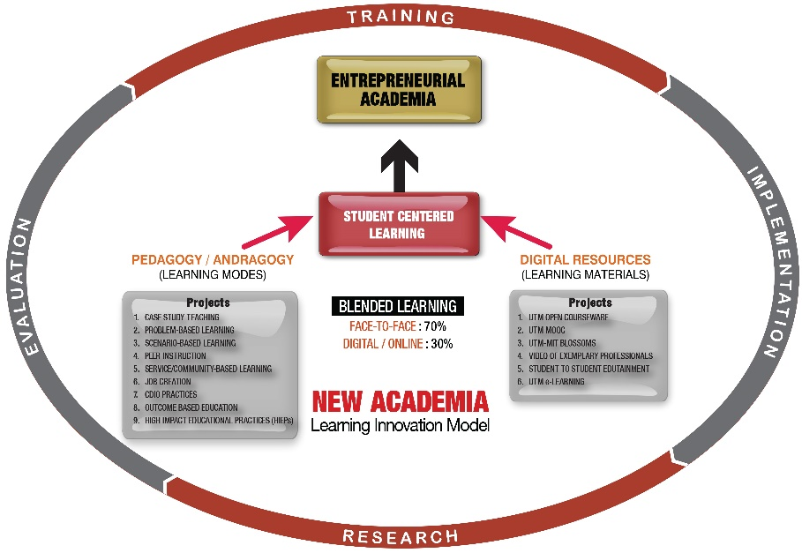
Picture 1: Model for NALI
NALI 2018 for education 4.0 creates a stage for sharing of research and advancement items in educating and learning in hopes of enhancement of educationist competency in practising in teaching and learning in the modern age through NALI talks and workshops. Besides that, NALI also hopes that the exhibitions and competitions held during the event can help spread awareness on Science, Technology, Engineering and Math (STEM) among the participants and visitors.

3.0 DISCUSSION

3.1 TRENDS IN NALI

As now in the edge of expansion on artificial intelligence, the trending for future education is more reliable on research and the ability for academia by taking the advantage on the use of educational technologies, which make learning more effective among learners. NALI has catch up with the pace of this trend with the aims of creating more sustainable learning methods, which can transform the learning and teaching landscape of university to be fully prepared in an era of 21st Century Learning. Wherefore, through NALI, UTM has started managing courses by using blended learning. Blended learning is one of the method, which apply both online and face-to-face learning experiences when educating students. More than half percentages of the course contents in UTM are conveyed through online such as UTM e-Learning, Video of Exemplary Professionals, MOOC, BLOSSOMS, Student-to-Student Edutainment and OBE Analysis System.
Realisation of integrating more technologies in the education sector have increased the desired level of learning among learners. As learners can expose themselves in an environment where they need to think and find solutions for the challenges they are facing. This will open up their mind set on creating new and innovative ways to achieve better results in the development sectors. Other than that, it also widens the research and education systems of our country at the global stage because students in today’s digitalization world are mostly trained but not be taught. They are required learn how to solve problems rather than the lecturer offering it to them in a rigid structure.
According to the research, changes in industry will actually give a direct influence on the development of education system. Wherefore, Education 4.0 needs to align with Industry 4.0 on preparing students for the next industrial revolution, which will happen in the future. Hence, NALI has carried out a framework of New Academia Learning Innovation Model for students to achieve an entrepreneurial academia. This will give an impact on creating students who are able to become one of the valuable members in the workforce. Thus, NALI 2018 will implant more motivation towards further exciting innovations in learning and teaching as NALI aims to develop future learners who prepared themselves in connecting with the world filled with rapid technological changes.

3.2 TREND

In Our group, we decided to assigned task for each member, Akmal is the one who combine all our booth in a single documents, organized the points with logically ordered and make sure it already fulfilled the requirement before submit this report. He also design report to make more comfortable to read with beautiful graphics and fonts. Jasmine’s task was to take photo of each booth clearly and can be read so it can be used as references to write a report. She also the one who make grammatical check and make sure all contents of the booth is included with excellent explanation. Ayman’s task was to summarise the report and explained the task to each member with more detail. He also find another source beside the booths like book in the library or the internet and make sure the sources can be trusted to use as reference related to the topic.

3.3 BOOTH 31: FINAL YEAR PROJECT AND ITS IMPACT ON STUDENT MENGAGEMENT

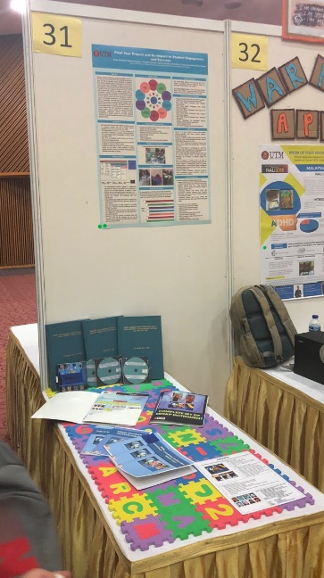
Picture 2: Booth 31
Booth 31 is about fundamental movement assessment battery for children CEKAP, which stand for Cemerlang Kemahiran Asas Pergerakan. This instrument produced is to measure the level of ability of the basic skills of children's movement. These instruments tested in kindergartens and children with special needs. Generally, normal children aged between 2-3 years old were being tested using this instrument. However, for children with special needs, this instrument can be used without limiting the age limit. According to exhibitor, Mastery of basic skills of movement should be mastered at children and is a prerequisite to optimum functionality in carrying out daily life activities, active participation of physical activity and the implementation of a healthy lifestyle. The basic skills of children's movements are measured using a variety of standard instruments. However, most standard instruments contain items, tasks, reference norms and criteria that tend to support the performance capabilities of the instrument building society. Measurement activities using external instruments and norms to measure the performance of the basic skills of Malaysian children's movements tend to yield biased results and underestimate the actual capabilities. Therefore, the CEKAP Instrument is produced to enable the performance of Malaysian children's skills to be measured and evaluated based on their actual needs and capabilities using the right reference source. According to exhibitor, CEKAP instruments contain basic skill test items that are aimed at testing fine motor skill components, gross motor skills and manipulative skills. This instrument is additionally assessed by containing test items that classify the type of child's pencil draws as well as skeletal testing items. The CEKAP instrument contains 5 test ideas:

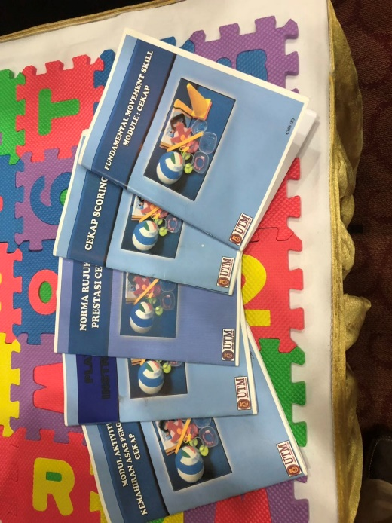
Picture 3: Modules of CEKAP

3.4 BOOTH 32: WARMUP YOU BRAIN (WARPUP) APP
ADHD stands for Attention Deficit Hyperactive Disorder. It is a mental disorder that normally effects children and teens but in some cases can continue until adulthood. ADHD is the most common mental illness globally with symptoms such as impulsiveness, excessive activity or restlessness and problems focusing on a task. ADHD has no known cure yet, but with help at an early age in life, ones ADHD can be managed or controlled.
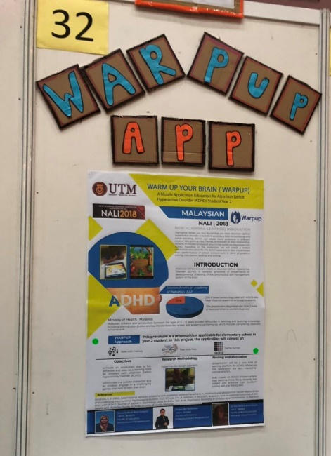
Picture 4: Booth 32
Booth 32 is a project by Nurul Syafiqah Binti Sulaiman (Faculty of Education), Firdaus Bin Mohamed (Faculty of Petroleum) and Siti Nur Azhana Binti Hassan (Faculty of Built Environment), named WARPUP. WARPUP was created to help the children of primary school that suffers from ADHD to stay focus when learning. WARPUP is a mobile application that consists of notes with melody, tree note map and game hunter to attract the attention of the child and focus on learning. WARPUP aims to create an application that is fun, attractive and easy as a learning tool for children with ADHD to eliminate the surrounding distraction and let children engage in a challenging game that help train their brain.
With an interesting interface and challenging games, WARPUP has affected ADHD children where they became more focus towards the subject that they are leaning at school and enhances their problem solving skills and literacy skill. It is very practical because it only need a smartphone and internet, which are all basic items that very household, has.
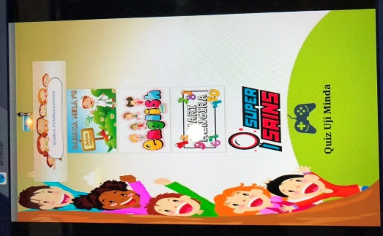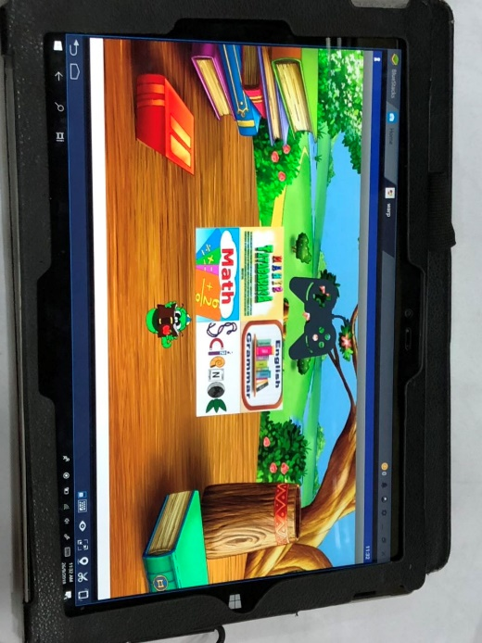
Picture 5: Interface of WARPUP

3.5 BOOTH 33: DYNA (MECH) @ UTM DYSON PROGRAMME

We are sorry but when we went to this booth, there was no exhibitor and the posters or information at the soft board was already not there. Therefore, we are so sorry because there is not any information regarding this booth. Below is a picture of the booth when we visited it.
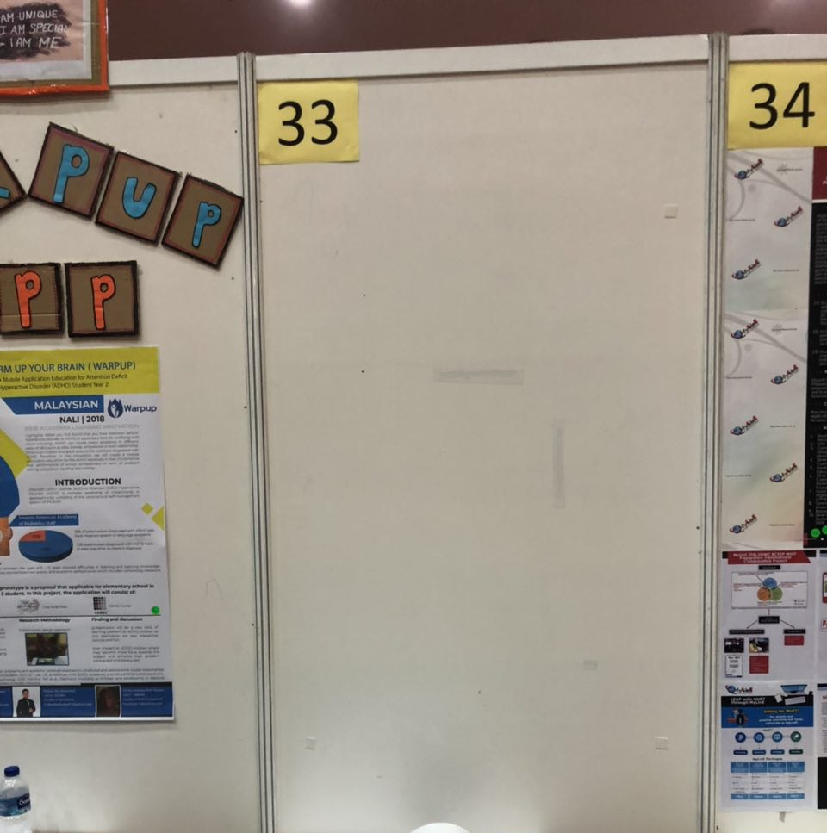
Picture 6: Booth 33

3.6 BOOTH 34: MYLINE UTM-UNMC BCEDP MUET PREPARATORY TRANSNATIONAL COLLABORATION PROJECT

Booth number 34 is about MyLinE (Online Resources for Learning in English) UTM-UNMC BCEDP MUET Preparatory Transnational Collaboration Project. MyLinE Online Resources for Learning in English is a service that prepare self-access language learning on study skills, academic reading, writing, listening, grammar and other resources of learning English. The Language Academy of University Technology Malaysia created MyLinE UTM. MyLinE UTM has collaborated with University of Nottingham Malaysia Campus (UNMC) in providing external English language training to the college professors and administrators from Bangladesh College Education Development Program (BCEDP), funded by the World Bank.
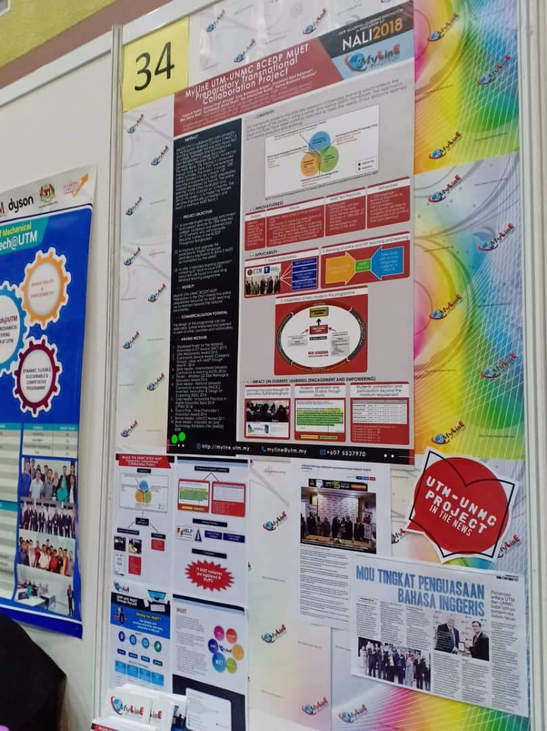
Booth 34
The purpose of this project is to improve and make the college professors and administrators who will become trainers in the BCEDP to be linguistically qualified with an achievement of minimum Malaysian University English Test (MUET) Band 5. To accomplish this task, MyLinE UTM applies blended learning method by conducting the training through face-to-face (F2F) teaching and extensive online learning activities. F2F teaching was supported by MUET preparatory modules developed by UNMC in MyLinE platform with guidance for duration of 12 months. Traditional practice of doing exercises and tests for MUET can now be done by online with the advancement of technology. MyLinE UTM MUET preparatory resources can be claimed as the first online platform for MUET candidates throughout Malaysia to practise for MUET exam.

3.7 BOOTH 35: COLLABORATIVE ONLINE SOCIAL LEARNING ACTIVITY (COSLA)

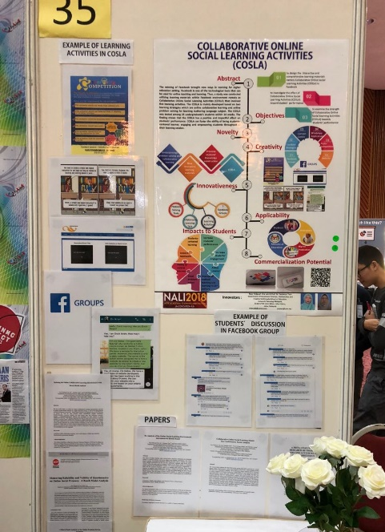
Picture 7: Booth 35
In booth 35, the exhibition promotes about collaborative online social learning activities known as COSLA. The objective of COSLA is to design the interactive and comprehensive learning materials namely COSLA and to investigate the effect of COSLA toward student performance also to examine the strength of COSLA towards student performance. According to COSLA, the existing of Facebook gives an advantage to brought new ways in learning for higher education setting in 21st century. Facebook a big media social network and one of the technological tools that can be used for online teaching and learning. Thus, a study was conducted utilizing learning materials within Facebook environment namely as COSLA that involved five learning activities which aimed developed based on online collaborative learning and online problem solving Authoring Language subject among 23 undergraduate’s students within semester . The study proved that COSLA has a positive and bring great impact on student’s performance. COSLA also can foster the ability of being students-centred, engaging, and refining students throughout in their learning sessions. The outcome of this online strategy is students can develop a high-level thinking to maximise the performance and encourages exploration of alternative perspective and solutions. It also stimulates critical thinking and helps students clarify ideas through ideas discussion and debate generates solutions that are typically better than what one student can develop working individually. The diagram showed that the novelty of COSLA by exhibiter:

3.8 BOOTH 36: MONSOONSIM BUSINESS SIMULATION

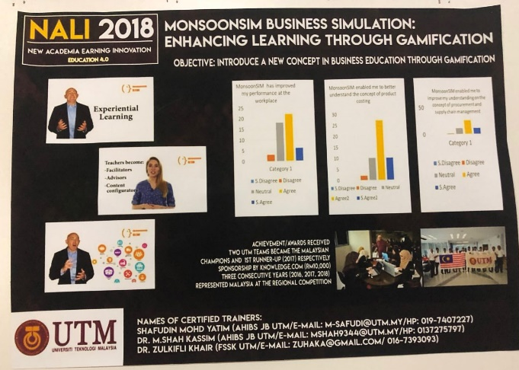
Picture 8: Booth 36
We visited our last booth, which is booth number 36 entitled “Monsoon Business Simulation (MonsoonSIM)”. Management Executives of MonsoonSIM, Mr Alex Ong had given us further introduction and explanation about MonsoonSIM on the exhibition. MonsoonSIM simulation (MonsoonSIM) is an enterprise simulation and experiential education platform for business studies and enterprise resource planning (ERP). Experiential learning is a process through which students develop knowledge’s, skills and values from direct experiences, in other words, learning by doing. The Faculty of Management, Universiti Teknologi Malaysia on the year of 2016, has subscribed this framework. The main objective of this invention is to enhance the learning skills of business education through gamification. According to the developer of MonsoonSIM, Monsoon Academy, this gaming concept is able to increase the students’ ability on business management skills, entrepreneurship skills as well as creative and innovative thinking skills, problem solving skills, teamwork and leadership skills. Once a student having a good understanding on the enterprise system and ERP concept, it will greatly expand their knowledge about how a business enterprise is being run and what is the connections among various departments such as customer services, marketing, procurement, finance, human resources, logistic and warehouse.
MonsoonSIM has served a platform for students to apply theories and principles where they had learnt in class into an immersive and competitive simulation environment. Since 2015, MonsoonSIM Academy had organised an annual Enterprise Resource Management Competition (ERMC), which is a business simulation competition at the national and regional level, and UTM students have taken this initiative to participate in the competition since 2016. Apart from this, MonsoonSIM business simulation system also applicable to the industry in various sectors to enhance the workers skills on enterprising resource management.
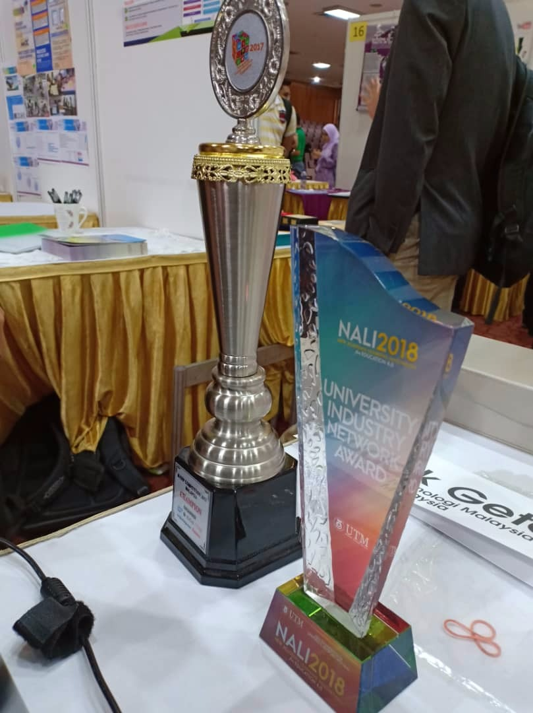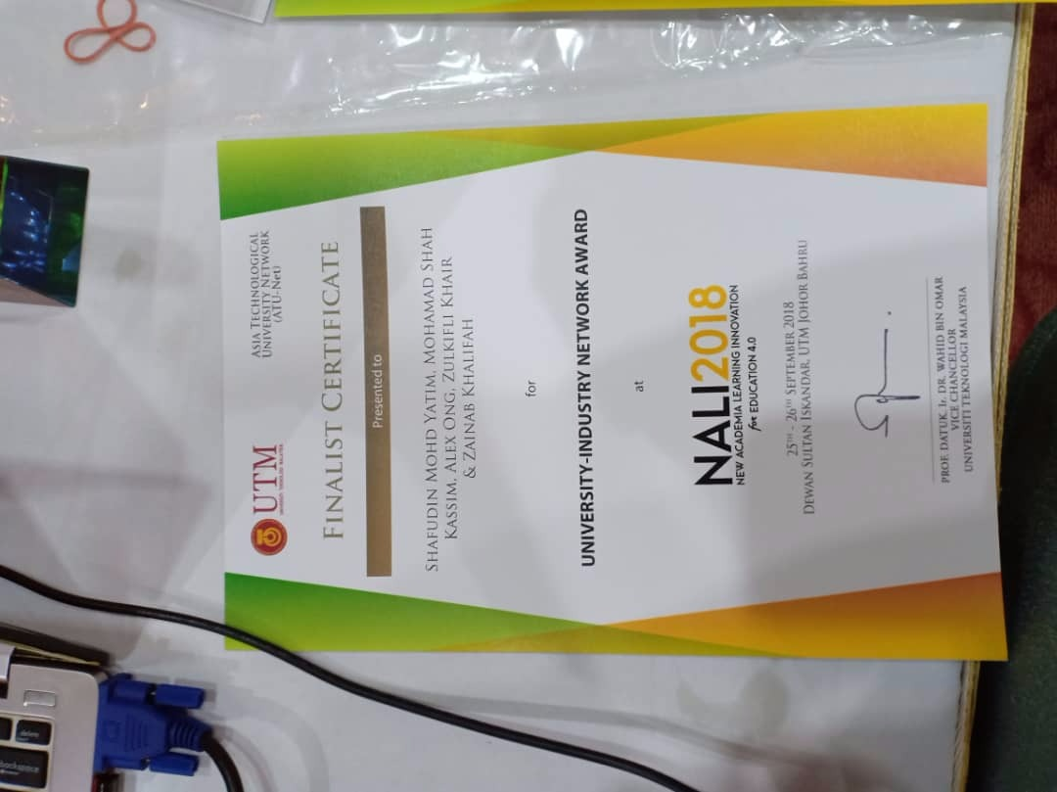
NALI 2018 University Industry Network Award UTM

4.0 REFLECTION

4.1 JASMINE CHAN YUAN QI
“Throughout this exhibition, I have a greater understanding toward the era of 21st century education systems which are more advanced on the implementation of new technologies on learning and teaching skills. I also feeling grateful for all the inventors who participated in NALI who had showed their efforts and enthusiasm on inventing systems, services as well as applications that can improve the absorption of knowledge’s among learners. As part of the new generation, this programme has inspired me to strive harder in the courses I’m taking now and apply it to the future by inventing something which able to enhance the educational system to a higher level.”

4.2 MUHAMMAD AKMAL BIN HISHAM
“The exhibition that I visited in NALI 2018 has really made me interested in how learning will be in the future. The conventional way of learning is by using a book and a person becoming a teacher but the exhibitions has proven to me that that all can changed and be replace but artificial intelligent. I think there will no longer be the conventional homework and practices given by the teacher but soon it’s just interactive games or everything digitalize meaning there will no longer be a need to use a piece of paper and pen to do homework. Therefore, I think NALI is a great platform for innovators and educationist (students and teachers) to show how the future of educating will be.”

4.3 MUHAMMAD AYMAN BIN MOHYEDIN
“This exhibition and presentation by exhibitor in NALI 2018 made me dumbfounded and have learning many possible ways to educate people all around the ages which can help them thoroughly knowledge more deeper and more understanding which have more efficiency than ever before. The first point in favour is the fact that most of the current generation has grown up with the technology we see all around like COSLA can be used as a digital medium for student to use technology to learn beside book and pen. The innovation and imagination ideas of the exhibitor during the exhibition is amazing because they can independently manage their own booth to tell the visitors theirs ideas for better future especially education system which needed to updated in this 21st century. As the student, this programme has bring more benefits to me which that I can use enhance my performance and ability make a better place for future generation.”

5.0 CONCLUSION
In conclusion, day by day there are always advancements in every field including education and learning. NALI is a great platform as a showcase to these advancements in education with great innovations being exhibitors. However, NALI should be more marketed every. This is because it could be more participated overall by having more exhibitors and visitors. Moreover, it is hoped that the innovations being exhibited in NALI been integrated in the education systems because it will improve the education system. In addition to, it will make the students more interesting in learning because of the many creative and interactive ways of learning.

REFRENCE
- http://ctl.utm.my/nali2018/
- https://elearningindustry.com/collaborative-online-learning-activities-reasons-effective
- www.webmd.com/add-adhd/guide/attention-deficit-hyperactivity-disorder-adhd
- www.healthline.com/health/adhd/
- http://www.fp.utm.my/cekap/cekap7/home.asp

