



industrial talk 1 (mdec – e-rezeki)
Dr Aryati Bakri

October 9, 2018
MUHAMMAD AKMAL BIN HISHAM
A18CS0122

TABLE OF CONTENT

1.0 EXECUTIVE SUMMARY 2
2.0 INTRODUCTION 2
3.0 DISCUSSION 3
4.0 REFLECTION 4
5.0 CONCLUSION 5
6.0 REFERENCES 5

1.0 EXECUTIVE SUMMARY
On 24 September 2018, an industrial talk held at seminar hall, building N28 (A) given by Mr, Mohd Ihsannudin Jamhari, one of the master trainers at Global Online Workforce (GLOW) on the topic of e-Rezeki. Mr Ihsan is very experience as a freelancer. Even though he did his studies in electrical engineering and education, but most of his current works are designing graphics. The talk was 1 hours long and filled with lots of information about e-Rezeki and how to find an income online in the country and abroad. It was a very interesting and inspiring talk to me.

2.0 INTRODUCTION
MDEC stands for Malaysia Digital Corporation. Its aim is the construct a dynamic computerized economy and to guarantee that Malaysia has a main influence in the world in digital revolution and advancements. In trying to do so MDEC has launch three main programs, which are eUsahawan, e-Rezeki (micro-task) and Global Online Workforce (GLOW). EUsahawan is a program that teaches small micro-entrepreneur how to market their product online without and overhead cost like rental of shop lots. ERezeki is a program that teaches local entrepreneur how to gain their reputation thus making it easier for them to sell their products or services in the local market. Lastly, GLOW is actually a rebranding of the old Erezek. It rebranded to GLOW in the interest to prevent people with the ERezeki micro-task. GLOW is a program that teaches people with skills market themselves internationally. It helps people find clients and build an income as a freelancer.
Many of the freelancers that joined GLOW are actually full time students that were searching an income part-time. They succeeded and made good money. The figure below are a few examples of students’ achievements as a freelancer.
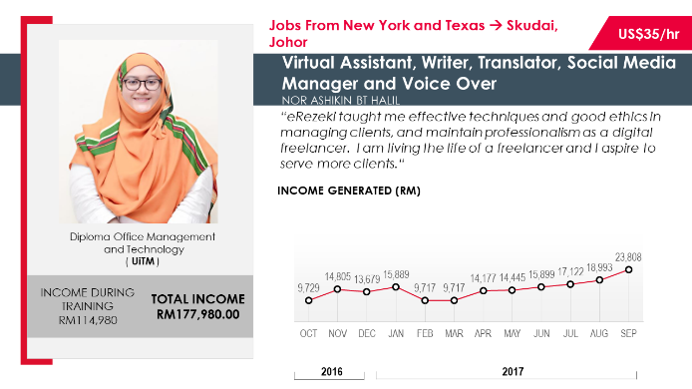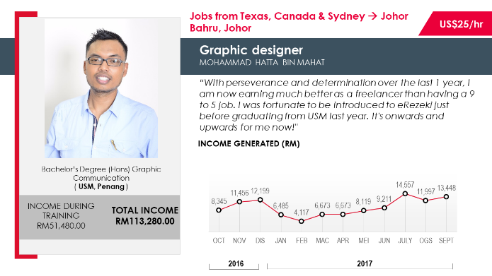
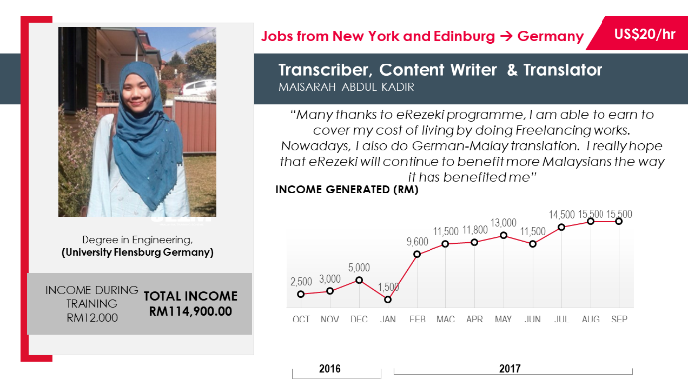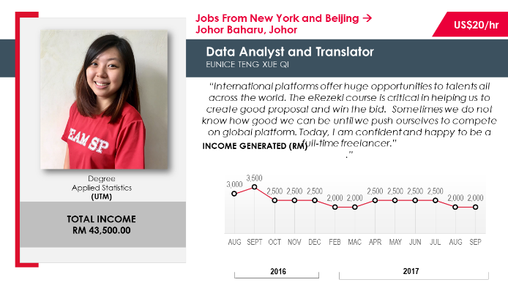

3.0 DISCUSSION

Global Online Workforce (GLOW) is one of the programs that MDEC implement under the supervision of the ministry of communication and multimedia Malaysia. GLOW can generate the income of people trough crowdsourcing. Crowdsourcing is a method of obtaining information or in this case work through the community in the internet. Therefore, MDEC has set a few aims for this program (GLOW) which are:
- To create a community that can work digitally
- To set up a sustainable model on GLOW programs with strategic partners
- To give elective source of pay to Malaysians by means of different online platform
- To build up a help program for Malaysian freelancers to stay roused, driven and submitted in gaining good income by means of crowdsourcing platform.
There are three type of programs offered in GLOW that people can choose to take part in. These courses are based on your skill and experience. Program GLOW @ HLI’s is for graduates from the field of computer science/information technology/multimedia, language, business and arts. Other graduates can take part in Program Fast Track. Both programs are free and consists of many mentoring sessions with experienced individuals. There is on program that is not free because it is a more intensive and short period of training. In just three to five days, you can be an expert in generating an online income.

Therefore, GLOW is a program that is universal to all. People who are interested to add their income could join with just one click of a button. All the registration and procedures to join are at www.glowmalaysia.com. After the registration process, MDEC and its partners will assess the person’s skills and criteria.
In addition to joining these programs, there are many benefits. If you join GLOW, not only the great income that could been generated but you will be recognise globally. This is because the crowdsourcing sites that the freelancers used are also globally used. Besides that, many of your skills will be polish. This includes your communication skills when you interact with people abroad. Moreover, your skills or traits will increase because as advancements happens around the world, it will create more demanding client. Therefore, if you want to attract more client, you will have to upgrade your own self.

4.0 REFLECTION
GLOW is a program created by the government to help its people. It is an alternative way to generate income as an individual. In doing so, the Malaysia’s government is not only help its people as individuals but also making an impact as a nation. When more of the citizen of Malaysia is generating income, it will help with the percentage of unemployed. Thus making the economy in Malaysia better. In addition to, GLOW is also increasing the number of IT experts in Malaysia. When many of the freelancers who joined GLOW is becoming successful, this shows many of the freelancers are achieving the world demanding. It is turning Malaysia into a more modern and high developing country due to the fact that its people will rely more on technology as a source of income.
Furthermore, after hearing this talk, I have become interested in making a living online. I believe that freelancing is an effective way. GLOW acts as a guidelines for people with close to zero experience and knowledge on how to start a career as a freelancer and how to market yourself internationally. Therefore, I am really interested in joining GLOW to help me generate my own side income and indirectly help Malaysia in becoming a more developed and modern nation.

5.0 CONCLUSION
In conclusion, MDEC’s initiative alongside its partners, in creating GLOW to help the people of Malaysia is an excellent platform to help everybody in achieving the demands of the industrial 4.0. With this program, this is no such excuses for the fresh graduates or in fact for anyone, in trying to find a source of income. In the future, I believe that freelancing is going to make a huge part of the industry because has many benefits to both the freelancer and the clients. Benefits to the clients is as such that it is saving their cost and time when hiring freelancers compared to a full time employee.
In addition to, I have just one proposition regarding on how to improve this program. MDEC should collaborate more with the universities in Malaysia. These universities including the matriculation collages, are platforms to promote GLOW and freelancing to the students who are not certain with what they are going to do with their future. MDEC’s promotion is not actually known among these students. Therefore, with this type of collaboration, MDEC could execute more programs with the students to expose them with the many benefits of GLOW.
Finally, I would like to emphasize that MDEC’s initiatives are very important in helping us achieving the demands of the industrial revolution 4.0. I hope that is programs will get more participation from the people of Malaysia especially the youth.

6.0 REFERENCES
- Mr Mohd. Ihsanuddin Jamhari, Trainer of GLOW MDEC
- https://glowmalaysia.com/
- https://www.mdec.my/

