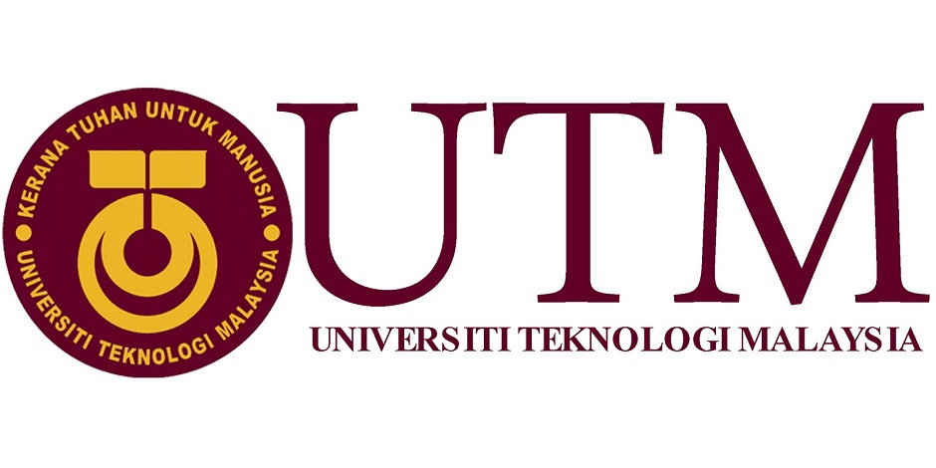
INDUSTRIAL VISIT REPORT
<Commerce International Merchant Bankers (CIMB)>
Course/Section: SCSP/Section 02
Lecturer’s Name: Dr Aryati Bakri
Group Members: Muhammad Hilman Bin Hashim (A18CS0148)
Law Xin Ying (A18CS0093)
Muhammad Afiq Danial Bin Amiruddin (A18CS0119)
Muhammad Amirun Haziq Bin Mohammed Fadzil (A18CS0109)

Table of Contents

1.0 Introduction 2
1.1 Details of visit 3
2.0 Detailed descriptions 3
2.1 Organization structure 4
2.2 Services & Product 5
2.3 Achievements 5
3.0 Graduate Opportunities 5
4.0 IT INFRASTRUCTURE IN CIMB 7
5.0 Reflection 7
6.0 References 8

1.0 Introduction

CIMB group act as the largest investment banks in Asia and one of the largest Islamic banks in the world. CIMB group is a leader in ASEAN universal bank. The headquartered of CIMB group is fixed in Kuala Lumpur. CIMB has a wide retail branch network with 850 branches across the region, serving more than 13.5 million customers. The major market are in Malaysia, Singapore, Cambodia, Indonesia and Thailand. Beyond ASEAN, they also have presence in China & Hong Kong, Korea, India, Sri Lanka, the US and the UK. The group operates under a few corporate entities, which include CIMB Bank, CIMB Investment Bank, CIMB Niaga, CIMB Islamic, CIMB Thai and CIMB Securities International . The group has more than 40,000 employees located in 18 countries. the rest of the world.

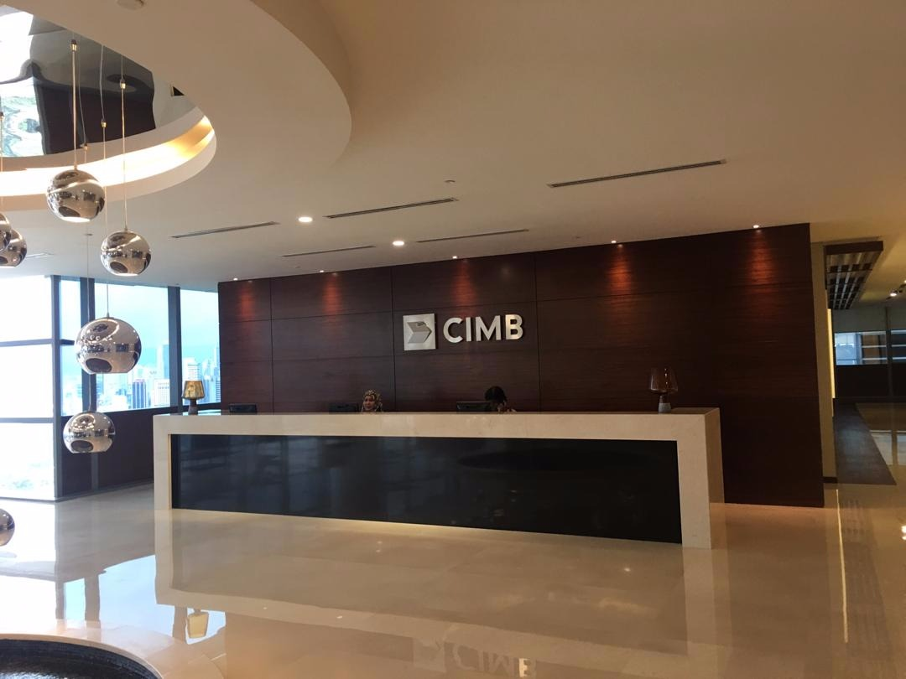

Picture1: CIMB in Kuala Lumpur.

1.1 Details of visit

The industrial visit to CIMB was on the 26th October 2018. This industrial visit to Commerce International Merchant Bankers (CIMB) is organized by the Faculty of Computing for all the first-year computer science undergraduates. The purpose of this industrial visit is to introduce first-year computer science undergraduates about the requirements and job specification needed for a career in IT, especially in financial field which is called the CIMB graduate programme.We firstly go to the 17th floor to visit their place. After visit the 17th floor, we go to 15th floor for our industrial talk. The first speaker is Sir Qasmal Noor who is an assistant manager in Graduate&Campus Engagement Group Human Resource. The speaker has explained to us about the CIMB group’s vision,core values and corporate culture. Their vision is to be leading ASEAN company and core values is integrity, customer centric, high performance, enabling people and strength in diversity. He also introduced us about the CIMB group’s services and product and also the internship programme. The second speaker is Sir Ahmad Affzan bin Mokhtar Anuar. From the talk, we know that the Group IT in CIMB group is including application, financial and administration, infrastructure, services management, risk and compliance and IT security. After the talk, the speaker give us the chance to ask any question. Everyone is very active in this Q&A session, the speaker is also very patiently when answered our questions. In the end of the talk, the staff in CIMB group give all of us one Touch 'n Go card. Then, we ended our visit and departure back to UTM Johor Bahru at about 4:40p.m.

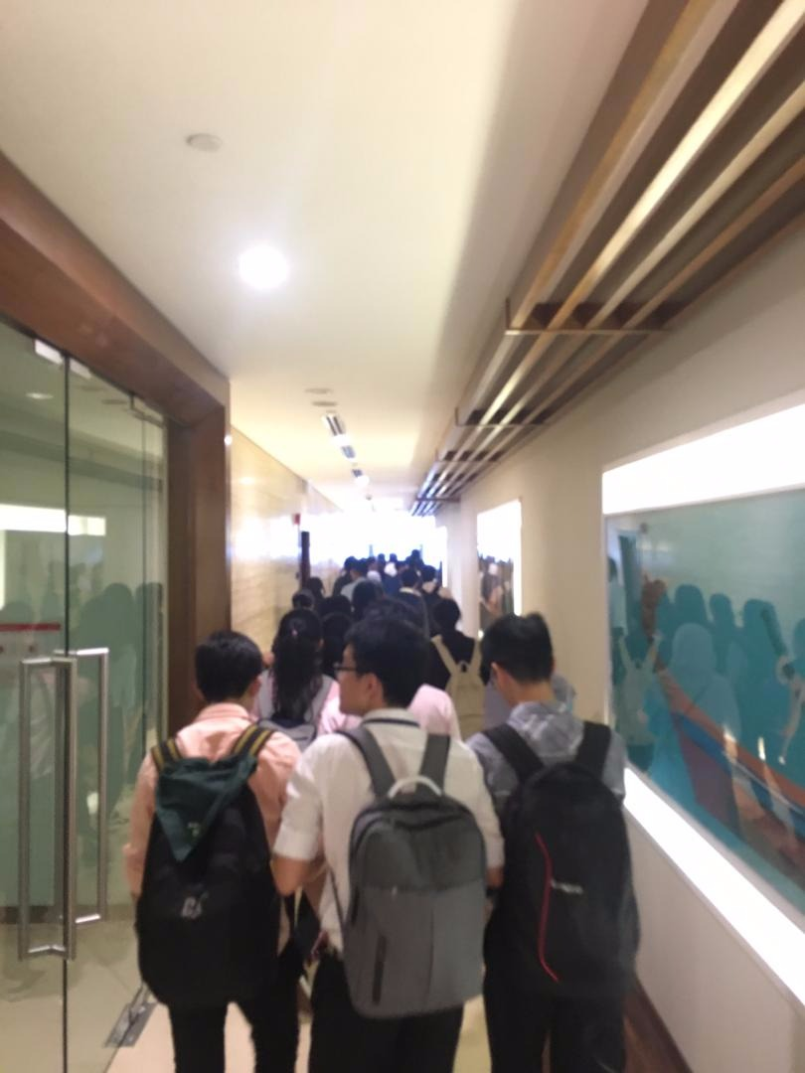
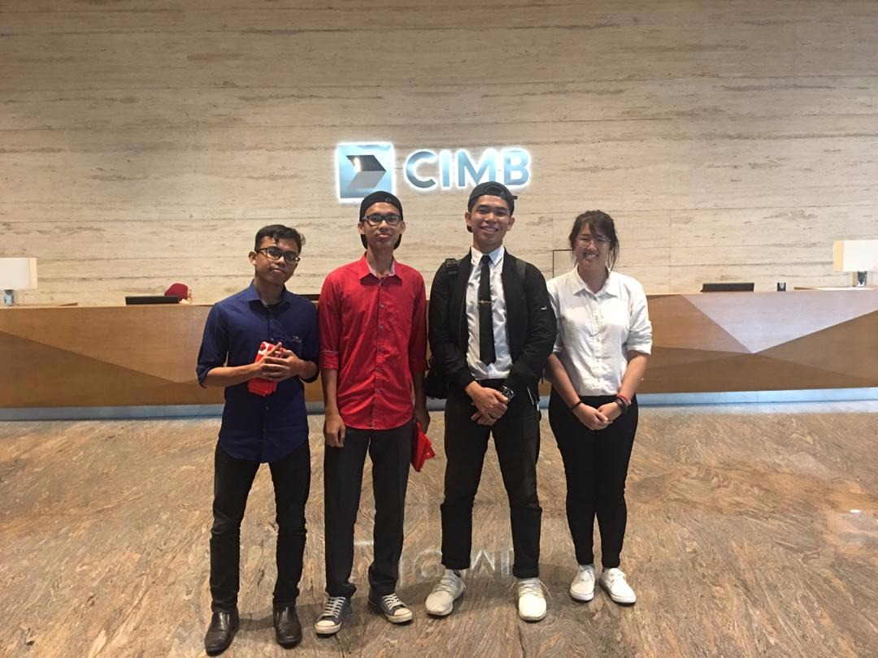
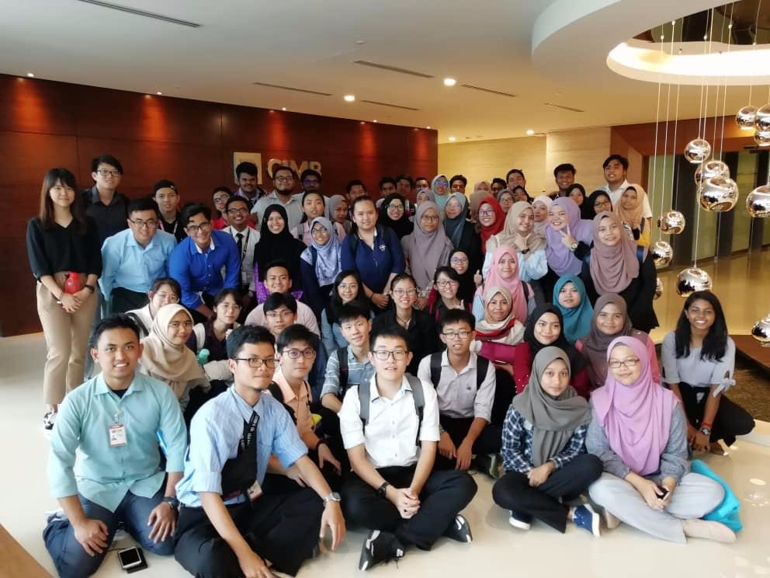
Picture4: Group members photo in CIMB.
Picture3: Student photo in CIMB.

Picture2: Visit the 17th floor of CIMB.

2.0 Detailed descriptions

2.1 Organization structure
The organization structure of CIMB group is shown in below picture.
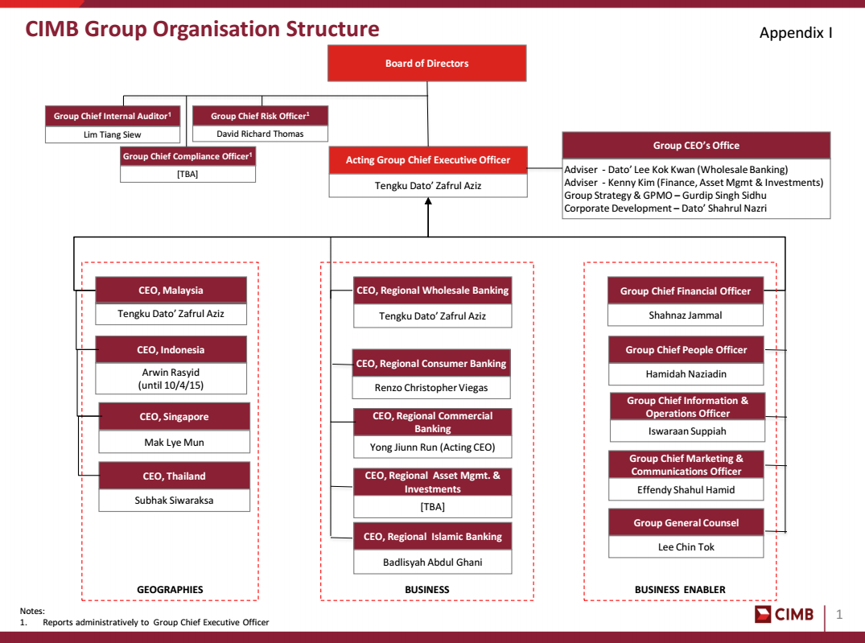

Picture5: Organization strcuture of CIMB group

2.2 Services & Product
The services are wholesale banking for cooperate finance, equity capital markets, institutional broking, value subordinates, securities acquiring and loaning, corporate saving money, exchange back, money administration securities administrations, worldwide monetary establishments, organized fund and syndication and research. Besides, treasury which contains obligation capital market and syndicate, cross markets exchanging and subordinates and government security showcase making. CIMB additionally serve resource administration which is incorporates retail and institutional assets (Islamic and Conventional), land reserves, framework finances administration, private value assets and land reserves. Next, retail and business keeping money which contains stores, private saving money, advance and financing, contract, renting, Mastercard, microcredit, ASBs, settlements, riches administration, self-administration terminal and computerized managing an account. CIMB also offered Islamic banking which contain ‘wadiah’, ‘mudharabah’, and ‘sukuk’.

2.3 Achievements
CIMB has become a leading regional universal bank offering customer banking,investment banking and Islamic banking.CIMB has operated in wide range of 16 countries as it become 5th largest ASEAN bank in South-East Asia.Among the places that CIMB had operated are Malaysia, Indonesia, Singapore, Thailand, Brunei, Cambodia,Myanmar,Vietnam,Laos,Hong Kong,China,New York,South Korea and United Kingdom.It has more than 900 branches in all over the world and expanding increasingly.Having more than 38000 staffs has proven a big challenge but as a resourseful bank, it managed to handle the finance as wide as that.

3.0 Graduate Opportunities

Under Graduates | Graduates
Internship | The Complete Banker | CIMB Fusion
Year 1,2 or penultimate year all degree backgrounds  Able to intern for 2-6 months  Strong academic result – minimum CGPA of 3.0  Active in extracurricular activities | Strong academic result from various field  Active in extracurricular activities including sports  Strong desire to learn and succeed  Energetic & versatile  Good interpersonal skills  Able to work independently  Year 1- Intensive class & job rotation (11 months)  Year 2- Elective development (3 months) & job placement | Strong academic result from various field (based on stream)  Active in extracurricular activities including sports  Strong desire to learn and succeed  Energetic & versatile  Good interpersonal skills  Able to work independently  Training towards specific department such as consulting, teaching/leadership, law, information technology and accounting

4.0 IT INFRASTRUCTURE IN CIMB

In CIMB,great facilities and infrastructures is a must as it is a means for the clients and industry to up-to-date as it can be a convenience factor that will give benefits to all people. The infrastructure can be categorized into seven different platforms:

- Internet Platforms.
- Data Management&storage.
- Computer hardware platforms.
- Operating system platforms.
- Networking telecommunications.
- Enterprise Software Platforms.
- CIMB corporate infrastructure.
These infrastructures are very much needed in the industry as it need to handle millions of data transactions and deals with the customers always non-stop.These infrastructures also must be updated to the latest version always, as the security attack is a common occurrence in the sector.A customer-friendly end-user interface is much needed as it can attract possible clients to connected with the bank.A good infrastructures will bring a lot of ease to the customers and industries as it will cut cost and time.Thus,it will cause the operation becoming more efficient and progress smoothly.

5.0 Reflection

After listening to the talk, we got a clearer picture on where we are heading with our studies. The skills that we gained from our degree course can be used in the real world on many levels. According to the talk from CIMB, fresh graduate from information technology fields can easily get a job with them in IT field with the right set of skills. To improve our potential in the industry, a lot of planning must be made to refine our skills in short and long term. Classes, workshops and talks can be attended to upgrade our skills to survive in this industry. The market of computer-based workers is often related to being independent and working as a freelancer. So, improving our skills are very crucial to survive in this industry. We could also apply to be an intern in certain computer related companies to get a clearer picture on what and where are we heading with our knowledge and skills. There are certain programmes offered by CIMB and the one that we’re interested to join is the CIMB Fusion: Information Technology (CIMB-DXC Technology). It is a collaboration with DXC Technology which is a world-renowned computer company. The duration for the fusion is 2 years which is 1 year with DXC and another year with CIMB. By participating in this programme, we believe that huge amount of knowledge can be gained from 2 years of experience with big named company. These knowledges can be used to survive in the real world with the skills that has been learned from that 2 years programme.

6.0 References

https://www.cimb.com/en/who-we-are.html

https://quotes.wsj.com/MY/CIMB/company-people

https://www.cimbbank.com.my/en/personal/index.html

