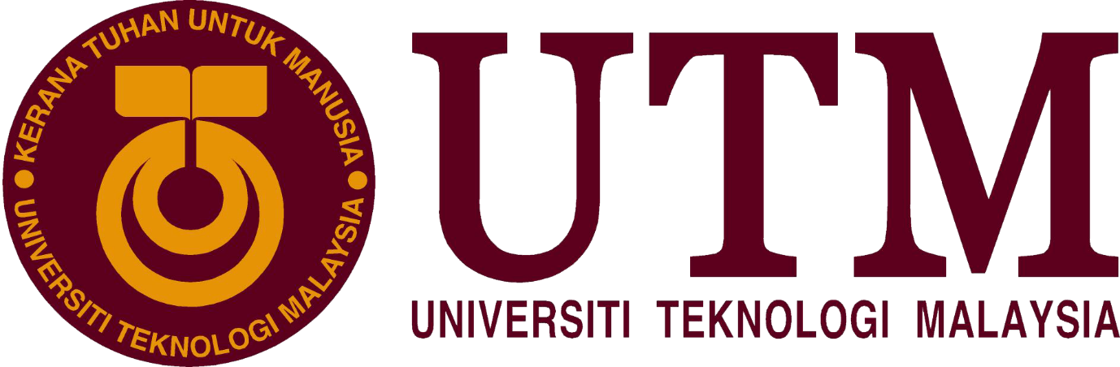

Industrial Visit Report

“New Academia Learning Innovation (NALI) 2018)

Course/Section: SCSP/Section 02
Lecturer’s Name: Dr Aryati Bakri
Group Members: Muhammad Hilman Bin Hashim (A18CS0148)
Law Xin Ying (A18CS0093)
Muhammad Afiq Danial Bin Amiruddin
(A18CS0119)
Muhammad Amirun Haziq Bin Mohammed Fadzil
(A18CS0109)

Table of Contents
Introduction 3
Executive Summary 4
Contents of Exhibits 5
Trends in nali 9
Reflection 9
Conclusion 10
References 10

Introduction

New Academia Learning Innovation (NALI) was carried out by Centre for Teaching and Learning (CTL), UTMLead to highlight on the concept of entrepreneurship, runs courses that execute blended learning approaches align with Dasar e-Pembelajaran Negara (DePAN) and also multiple learning modes such as games and simulations to attain academic based on entrepreneurship.
NALI is a platform where participants could exhibit their projects through exhibition and also competition to determine the quality and competency of their product to be marketed on a global market. Some of the objectives of this exhibition are to perceive NALI research and development items in educating and learning through presentation and contest, be the stage for sharing of research and advancement items in educating and learning and also to enhance instructor’s competency in working on educating and learning in the 21st Century through NALI talk arrangement and workshops.
There are 2 models under NALI framework model which are:
- Learning Mode (Pedagogy/Andragogy) which consists of Case Study Teaching, Problem and Scenario based Learning and also Peer Instruction.
- Learning Materials (Digital Resources) that composed of UTM e-Learning, UTM MOOC, and UTM OpenCourseWare (OCW)

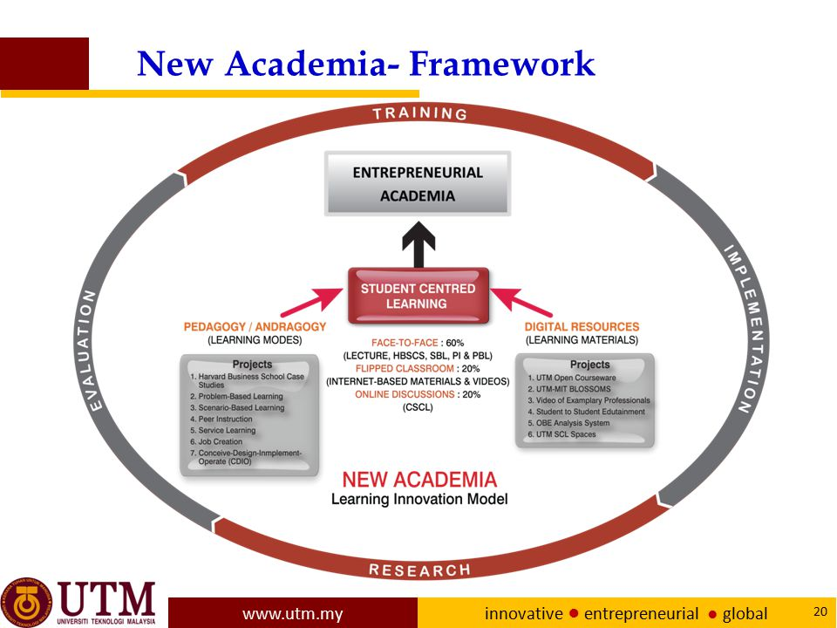
(Figure 1: Model of NALI Framework)
(Extracted from: http://utmlead.utm.my/new-academia-learning-innovation/ )

Executive Summary

On the 25th and 26th of September 2018, New Academia Learning Innovation (NALI) was held from 8am to 5pm at Dewan Sultan Iskandar, UTM Johor Bahru. Our group consists of 4 members visited the exhibition on the second day. There are total of 86 booths that participated in that exhibition and we separated our team members into 2 groups to visit booths from number 49-54. Unfortunately, only booths 51-53 has exhibitors that could explain their project to our team members.
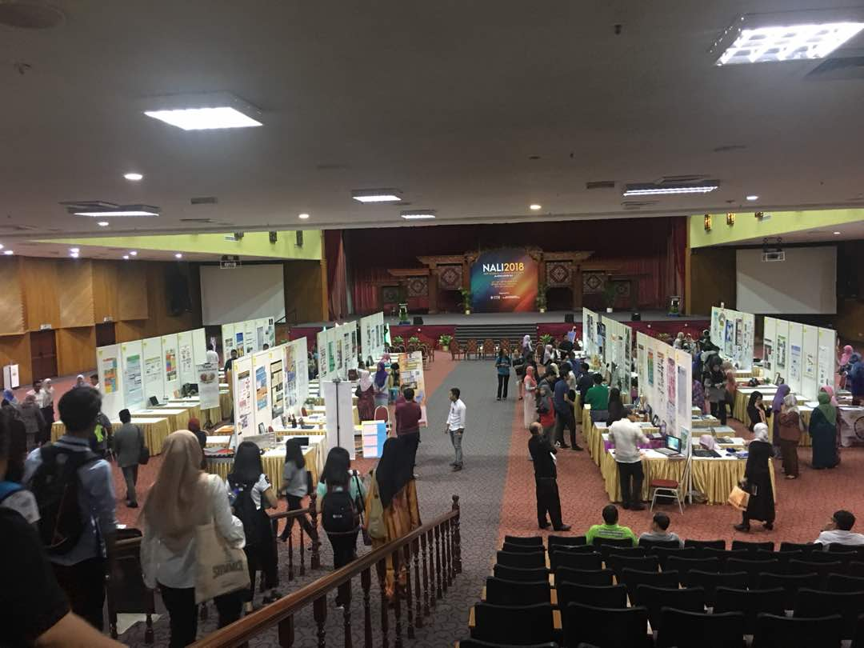
(Figure 2: The Atmosphere inside Dewan Sultan Iskandar during NALI 2018)
By visiting these booths, we managed to obtain some information and gained a clearer
image on how their projects works. There are various of ideas and models portrayed by the booths for example one of the booths which is Komuniti Kemboja 2.0 a continuation of Komuniti Kemboja, where a team of students and lecturer went to rural areas of Cambodia and innovate their way of living by inventing machines that could help them with their daily lives.
Other than the exhibitions, competitions, keynotes and workshops also held during NALI2018. This provides a platform for both students and exhibitors to interact and helps each other to provide better insights of their projects and innovation.
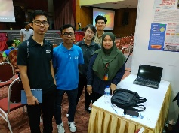
(Figure 3: Our team members at Komuniti Kemboja 2.0 booth)

Contents of Exhibits

On the 2nd day of the exhibition, we managed to go to 6 booths containing projects about Humanitarian Programme, Online Collaborative Learning, Case Study Teaching and also Massive Open Online Course but unfortunately only 3 of the booths has speakers. Despite the drawback, we managed to obtain valuable information on evolution and innovation in learning and its technology from the speakers.
The first booth we went to was an exhibit called GAp OC LMR which stand for Google Application Online Classroom in Leadership, Management, and Research. The details about this model is explained to us by Mr. Neil Madulara Martin. He told us, it is important to bridge the gap between online classroom and the traditional teaching. GAp OC LMR is a postulate an innovation which is personalized, creative and cooperative student-centered model in learning. Student-centered approach in teaching, so student will learn independently. There are five themes of online classroom. First, online classroom is a new thing that use tools or platform for learning. Second, this learning model is stressful yet convenient. You no need to go to the classroom every day and exercise or tutorial is submitted online. Third, the theme is stimulating and learning. There is specific of time given, students are giving option and they can be creative and make sense. Students can interact with some other members to review material or research. Forth, setbacks are one of the themes of online classroom. There is a problem of teacher and student like study without computer, laptop, and hotspot. So, university provided an opportunity for students and teachers to really get connection. The last theme is an online classroom is a stepping stone to greatness. This is because they are prepared for professional work, the subject matter prepares students to become potential leaders. The online classroom is also able to prepare students themselves to be responsibility and develop the leadership management. It is recommended that teacher shall have the shift from the traditional into the modern innovation model. Students must gear up and engage for greatness while exploring talents, skill, and values and to survive in the 21st century.
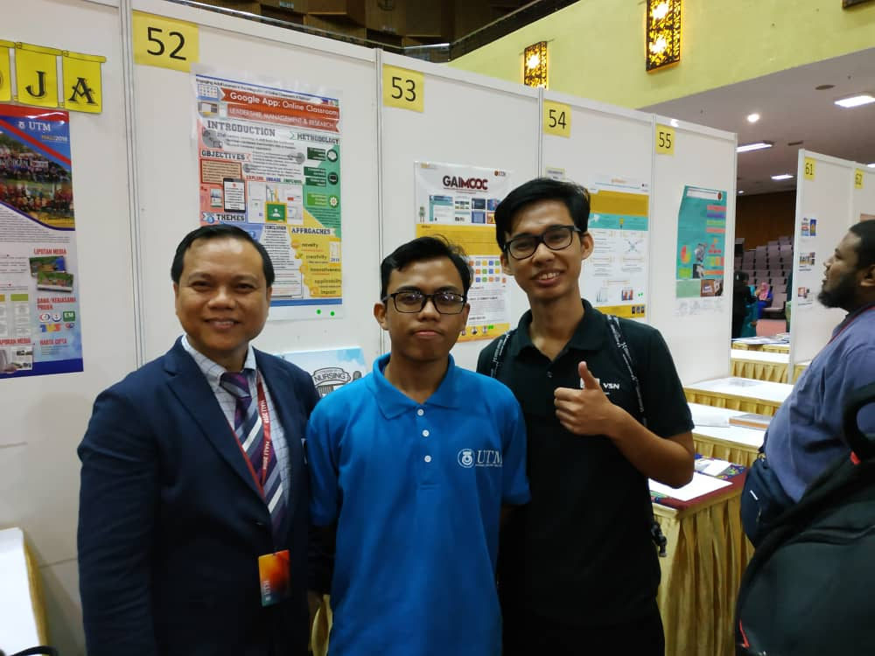
(Figure 4: A picture with speaker Mr. Neil Madulara Martin)
After that, we went to a booth called GAIMOOC which stands for Gamification Approach in Massive Open Online Course. The main goal of this model is to adapt gamification approach in learning to improve user engagement. The speaker Ms. Sarina Sulaiman told us the objective of this model was to identify the gamification elements that are suitable for open learning mechanism, apply the gamification elements in learning to increase learner’s engagement level, and to measure the learner’s engagement level towards MOOC by comparing the results between MOOC that applied gamification elements and those who did not. This model is a new way to increase user engagement in education and it can also attract students to learn and enroll in their course on MOOC platform. The innovation used by this project was it gives the flexibility of learning and students engagement from different countries as this project is based on online learning. Other than that, multiple elements such as videos, pictures, and even animation is used as teaching materials. By completing the games which is in form of quizzes, kudos and many more will give students badges and rewards for their hard work if they managed to finish the games with high marks. The instructor that used MOOC can give assessment, tutorial and also administrate their student easily as this platform is online and students from overseas could also benefit from this platform.
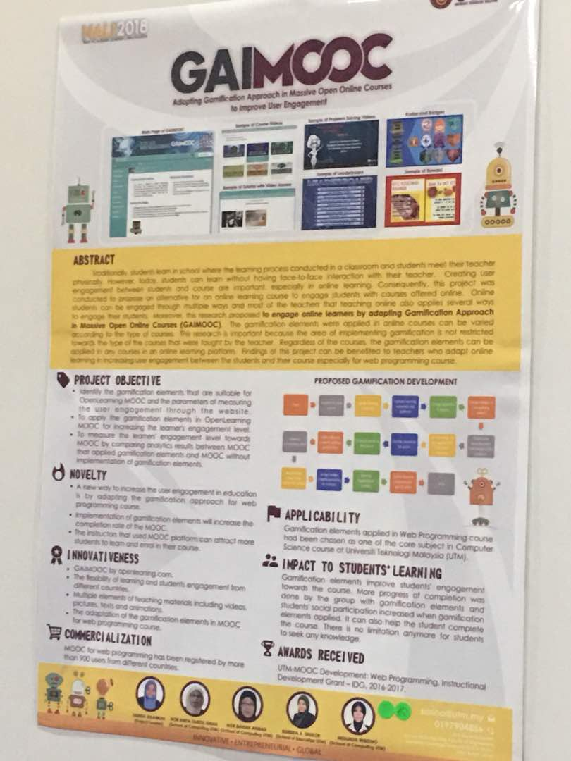
(Figure 5: Poster of GAIMOOC)
This project also managed to win Gold Award in the exhibition and also has been registered by more than 500 users from different countries. Gamification elements applied in Web Programming course had also been chosen as one of the core subjects in Computer Science course at Universiti Teknologi Malaysia (UTM)

We visited booth no.49. There, we learned about how a group uses Massive Open Online Course (MOOC) to design and implement Highway Engineering course. this project highlighted the importance to identify students’ awareness and accessibility towards the implementation Highway Engineering course through a MOOC platform. The objectives are to explain the origin and production of bitumen, discuss the composition, types and bitumen grading system and also identify evaluation of bitumen properties. The most significant impact that it had caused to student’s learning is the embedded self-determined learning and also cognitive engagement through time during the project build-up. Its creativity can be shown through real world problems solving, inquiry and thinking skills, discourse in a community of learners and student-directed learning. This formula is used to ensure design of ideas is benefited to students and society thoroughly. The formula is considered as successful as its evaluation qualified the program to win a gold medal for “Implementation of Educational Technology Course through MOOCs based on Authentic Learning Strategy in IUCEL 2017.A survey has been conducted related to MOOC to know the depth of knowledge the students have about MOOC. This survey had revealed some interesting result such as majority of students knew about SKAA2832 MOOC through their lecturer, 81% of students interested to participate in other civil engineering MOOCs but only 54% willing to pay for MOOC even though a certificate will be given at the end of the day, majority of them preferred power point with video explanation while game content is the least preferred one among the choices.
Next, our group went to booth number 50. At this booth there is no one to guide for this booth but such a good visual representation had been used to enlighten about this case study. This booth technically explains about case study for Islamic study with their objective in their mind which is to design training programme for Comprehensive Academic Programme Development and Improvement. This takes us to next chapter in this case study which is its curriculum foundation that consists of Philosophy, Learners’ Needs, Society and Learning Theories. Its philosophy can accumulate knowledge to make good or wise decision. This is important to ensure all students in the curriculum can use their decision-making skill to maximum potential. Then, Learners’ Needs which can be defined as encapsulation concept: believing they having accurate perception of reality but distorted or partial of reality. This to ensure everyone is ready to learn new things and can differentiate the right and wrong. Society can be defined as a collection of student ready to learn this curriculum. Without the society, it’s basically useless and it’s the most important block in this training programme. Learning theories can be described as conceptual framework on how the data processed is used to gain maximum benefit for the society. In the end an assessment is needed to make sure the foundation is followed to ensure the society is in a good track. The anatomy can be described as a cycle consists of aims, content, learning experience, and also evaluation. This training programme is pressing on the quality academic to ensure the future is in a right hand.

After that, we went to booth Projek Kembara Lestari Komuniti Kemboja 2.0 which is a sustainable development program with Cambodian inland communities based on community-based designs. The program is accompanied by students and academics from Universiti Teknologi Malaysia. The purpose of this program is to enhance collaboration and coordination by agencies involved in knowledge sharing and understanding and building technology skills through community based learning (CBR). 2 projects have been implemented which are innovation and humanitarian projects. 4 innovation projects have been carried out, namely innovation wells, profiling projects, hydroponics projects and medium-sized industries while 2 humanitarian projects are also being implemented which are circumcision and clothing donation programs. From this program, participants receive a lot of useful outputs and exciting experience that can be shared with our community from the activities that have been carried out. In addition, this practical form of learning triggers creative thinking and indirectly reinforces conceptual understanding. Participants also realized that the need for discussion was important to reach a consensus. This program runs smoothly as a result of good discussions with the agencies that involved.

Then, we went to goReason booth which is a platform for the students to enhance their reasoning skills through online collaborative learning environment with the aid of scaffolding. This program also creates the novelties which are integrated peer scaffolding in web-based learning and individual assignment into heterogenous group based on collaborative learning principles. goReason strives to create the learning atmosphere plus innovativeness such as collaborative report writing and digital collaborative work assessment which allow teachers to directly assess student’s collaborative work.

(Figure 6: goReason Nali Model)

Trends in nali

The trend NALI is in the form of support for the idea of ​​education 4.0 which is highlighted by the government. Education 4.0 aims to be practiced by institutions in Malaysia to contribute to the development of the fourth industrial revolution (IR4.0). It requires graduates from institutions to have digital skills and to create creative and innovative ideas. All NALI booths apply the concept of education 4.0 where they introduce teaching and learning techniques using digital technology as well as highlighting innovative ideas in every project undertaken. Among the interesting exposures is the application of learning and teaching concepts in the gadgets and online allows the sharing of knowledge can be done wherever and whenever we are. Besides, there is also a humanitarian mission based on knowledge sharing and contributing innovation ideas to targets. This proves that every wish, there is a solution in achieving it.

Reflection
Law Xin Ying: It was a very great experience and chances for me to attend this NALI exhibition 4.0. I learned more about the NALI. I am surprised that they have such many new academic learning innovations such as game-based, distance and community-based learning. Ie believe that the future of learning will major on the digital platform. NALI is a 21st century learning. It shifts from the traditional teacher-centered mechanism into a modern student-centered approach. This innovation sure will give students a better learning experience.
Hilman Hashim: This exhibition gave a good opportunity for the exhibitor and us as a student to learn and indulge more in this innovation in learning. We can see a trend that most exhibitor started to use online learning-teaching method as it is easier for everyone to use no matter where they are. We also get the chance to witness and experience these innovations first hand during the exhibition. I hope more events like NALI would be conducted to innovate our way of learning.
Amirun Haziq: I was stunned with all the projects and exhibits that were shown at NALI. Most of the exhibits focused on teaching and learning but personally I was attracted to the Komuniti Kemboja 2.0 exhibits because they used the innovation of technology to help the less fortunate people there. We don’t even know how hard their life was not until we visited the booth to get a clearer picture of it. It gave me a sense of what can we do and invent in order to help these less fortunate people.
Afiq Danial: I realize that the world is increasingly challenging especially in learning. As a student, NALI is very good at giving exposure to new methodologies that are more adaptive to latest version of reality. Now I have some ideas for improving my learning outcomes from the combination and teaching style from the exhibitions. I need to keep learning a new thing even if it just a small thing as the saying goes ‘it does not matter how slowly you go as long as you do not stop (Confucius).

Conclusion

Innovation in learning is crucial in this 21st century as the world keeps evolving and the way of teaching and learning need to evolve to adapt with it. NALI gave a huge platform for these exhibitors to show their project and how their innovation can change how we look at the curriculums now. We really hope that more events like this can be organized to search for more talents that can create new innovation that will help the future generations in learning in a good and effective ways.

References

- : http://ctl.utm.my/nali/
- : https://medium.com/troo-blog/7-key-trends-for-2018-innovation-in-educational-technology-ff22b2d8f442/
- : http://ctl.utm.my/nali2018/exhibition/
- : Figure 1: Extracted from http://utmlead.utm.my/new-academia-learning-innovation/

