

Industrial Talk 1 – MDEC e-Rezeki

Name: Muhammad Hilman Bin Hashim
Matrics Number: A18CS0148
Lecturer’s Name: Dr Aryati Bakri
Subject: Technology and Information System (SCSP1513)

Contents

Introduction 2
Executive Summary 2
Discussion 3
Reflection 4
Conclusion 4
List of References 5

Introduction

On the 24th of September, a representative from Malaysia Digital Economy Corporation Sdn. Bhd. (MDEC) Mr. Mohd Ihsanudin Jamhari gave a talk on Global Online Workface (GLOW) that was known as e-Rezeki. MDEC have 3 main programmes which is e-Usahawan, e-Rezeki and GLOW. And this talk is mainly focused on e-Rezeki to give us a clearer about what it is and to encourage us to participate in e-Rezeki as we students of computer science could utilise this platform efficiently as it is close to our field of study. Mr. Ihsanudin is a full time freelancer that own his own company called ‘XSUN GRAPHYX’ that provides various services that is based in Malaysia. He studied his degree in electrical engineering at University Teknologi Malaysia (UTM).
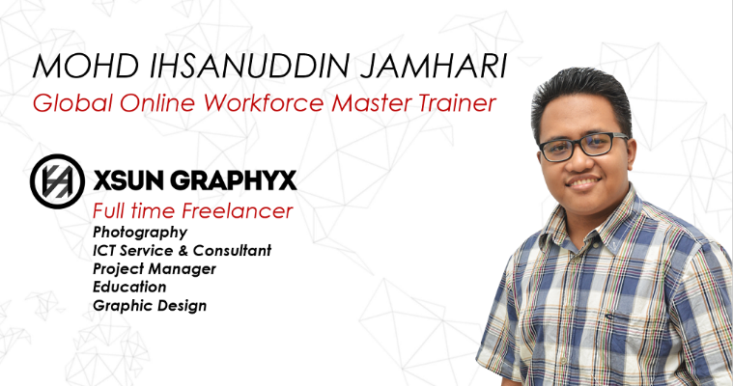
(Figure 1: Mr Ihsanudin’s Business Card)

(Figure 2: Global Online Workface (GLOW) Logo)

Executive Summary

According to Mr Ihsan, e-Rezeki is a platform where people can sell their skills to generate income via online platform especially for low-income groups. Most of the people who sells their skills were freelancer where they are not attached to any company. Various advantages can be obtained by using this platform for instance the freelancers could work from anywhere to any clients around the world since the platform is on the internet and anyone could hire their skills. This could ease both of parties as they could do their work from anywhere that they’re comfortable with. Other than that, he also stated that by selling their skills online, they could also gain a good reputation where it would affect the job and pay you will receive. The higher the ratings obtained, the better pay and more clients you will get. This could also improve their resume or CV which is very crucial in getting jobs both in the platform and real life. Besides that, people could also have their own work time as working on this platform is very flexible. Some of the freelancers even start selling their skills on e-Rezeki even during studying as a student and even housewives could even work from home. This shows that the internet could also be benefited by those who stayed at home rather than just getting information and working on online platform also gives a lot of advantages to freelancers as they’re free to choose their work according to their own worktime and workplace. All these benefits could easily help those who want to start a business or to build their own company.
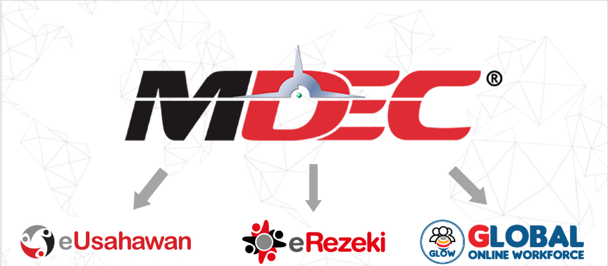
(Figure 3: Programmes offered by MDEC)
Discussion

MDEC encourages people to participate in their programme by implementing “Sharing Economy” method where people share under-utilized assets from Spaces to Stuffs to Skills for monetary or non-monetary benefits said Mr Ihsan. This creates an alternative work opportunity for skilled Malaysians to sell their skills since most of the big companies is looking for freelancers as they’re specialised in their own field and the contract is shorter as usually the work given has a duration in order for them to complete the work in a certain time given. e-Rezeki is open to people of all ages and mainly to the low-income groups as this platform helps people to sell their skills without putting out a lot of money. This program will also help those who want to start up their own business as it doesn’t need a lot of budget. Students could also join the program the program to produce a side income as it would help them in sustaining their life in university. Those who has retired but still have their professional skills could also participate in this programme in order to gain side income while not having a permanent job.
Najib (2014) stated that growth in the Malaysian Digital Economy, it was also vital to drive the development and promotion of key technology hubs for the nation’s information and communications technology industry. This shows that MDEC’s e-Rezeki programme helps Malaysia in becoming a technology driven country even in the global market. In other article, Yasmin (2018) said that with the initiatives, cottage industries, housewives with certain skills, small family businesses or even individuals with skills can put their products, services and skills on these two platforms to generate income without leaving their families to work in big cities. This would also help to modernise the rural parts of Malaysia by encouraging them to use the digital world as a platform. Other than that, by introducing this programme, we could promote the professional services and skills Malaysian digital workers to the global market.

Reflection

After listening to the talk, I’m more interested to join this e-Rezeki programme as it would help me to improve my skills and also help me to generate income even when I’m still doing my studies and will also be my source of side income even after I have graduated. This programme would also help me to improve my soft skills as I will also interact with clients not just from this country but based on the neighbouring countries and also from other continents. Skills on handling and satisfying various type of clients could be obtained by having relationship and partnership with client from all over the global. In my opinion, this programme is very good and should be shared to a wider range of audiences by promoting it on various medias such as the national television, radios and even ads on social media like YouTube. This effort will increase the number of participants that will use this platform as they have been given a clearer picture on what e-Rezeki is and how to fully utilise it.

Conclusion

Based on the talk, I have gained insight regarding the talk about e-Rezeki and it shows that digital platform on marketing is very important in this modern world. This talk also shows that it is also possible to generate a good income with just the right set of skills and target of clients. Some of the students also asked some questions on how effective this programme is and the answer from Mr Ihsan was very convincing as there are statistics shown on how the freelancers improved their skills and how their payments increases as time increases. In order to compete with other revolutionised country, we as the citizens of our beloved country need to participate in this kind of programme to become an all-rounder human to make our country more advance in all field especially in technology driven such as computing and networking.

List of References

- Najib: eREZEKI project to connect Malaysians at bottom 40pc if income pyramid. October 23, 2014. From https://www.nst.com.my/news/2015/09/najib-erezeki-project-connect-malaysians-bottom-40pc-if-income-pyramid

- Balqis Lim. MDEC's eRezeki and eUsahawan initiatives are revolutionising the local cottage industry. March 26, 2018. From https://www.nst.com.my/lifestyle/bots/2018/03/349416/mdecs-erezeki-and-eushawan-initiatives-are-revolutionising-local

- Figure 1: Mr Ihsanudin Business Card. From Talk’s slides softcopy

- Figure 2: Global Online Workface Logo. From https://glowmalaysia.com/logo-512/

- Figure 3: Programmes offered by MDEC. From Talk’s slides softcopy

