

Industrial Visit Report

“Asian Data Analytics Exchange (ADAX)”

Course/Section: SCSP/Section 02
Lecturer’s Name: Dr Aryati Bakri
Group Members: Muhammad Hilman Bin Hashim (A18CS0148)
Law Xin Ying (A18CS0093)
Muhammad Afiq Danial Bin Amiruddin
(A18CS0119)
Muhammad Amirun Haziq Bin Mohammed Fadzil
(A18CS0109)

Contents
Introduction 3
Detailed descriptions 4
8
ADAX(adoption program, community event, data camp) 8
Premier Digital Tech Ecosystems 9
Fusionex 12
15
SAS Malaysia 15
Reflection 16
References: 17

Introduction

On 26th of October, 2 sections of Data Engineering students and 5 more from Software Engineering course went to Kuala Lumpur for our Industrial trip to ADAX (Asian Data Analytic Exchange) which is located at Bangsar South, Bangsar, Kuala Lumpur. We departed from UTM Skudai at 10 pm and arrived at Bangsar approximately around 5 am the next day. We stayed at Masjid Ar-Rahah for morning prayers and getting ourselves ready to go the office. We arrived at ADAX around 8:30 am and waited in the lobby before going to the 27th floor of Vertical Business Suite. We had some difficulties because our name list wasn’t there but thanks to our lecturer, the problem has been solved quickly. We were warmly welcomed by representatives from ADAX and MDEC and were given breakfast as soon as we arrived. After that, we all went inside an event room to proceed with the talks from representatives of ADAX, MDEC and SAS.
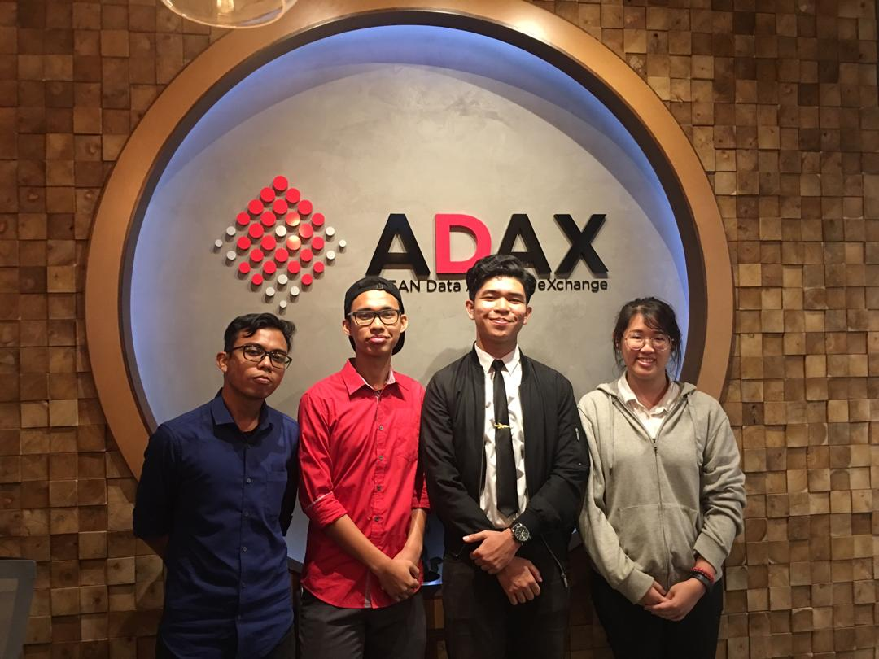

Detailed descriptions

ASEAN Data Analytics Exchange (ADAX) is an initiative by Malaysia Digital Economy Corporation (MDEC) to drive the Big Data community in Malaysia to greater heights. According to the CEO of ADAX, Sharala Axyrd, ADAX is a platform that first introduced as a regional platform that brings innovative talent development models and helps to develop Big Data Analytics(BDA) ecosystem. To build the BDA industry in Malaysia, it can only through shared values, skills building and collaboration around a robust data analytic ecosystem. The main goals of ADAX is to enable the development of critical mass of talent pool in the Big Data Analytics category to serve businesses, governments and academia. ADAX is important in foster collaboration between businesses, governments, academia and start-ups to enable that Data Analytics becomes a necessary part of business development and decision making. ADAX is jointly operated by MDEC and Ansys Sdn Bhd via Public-Private Partnership(PPP) model .There is a unique PPP initiative called Data Star programme. This programme is main to produce world-class talent in data professionals to suit the high demands of the digital world and accelerate the growth of talent in data professionals in Malaysia. Data Star programme will help Malaysia to nurture and achieve 20,000 data professionals by 2020 with a goal set by the government in 2015.
ADAX worked to manage the selection of ADAX training providers that are evaluated based on the BDA Talent Framework. Every training provider must go through a governance selection process that shown in the picture below.
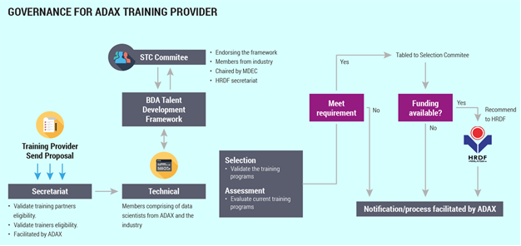
Picture: Governance for ADAX training provider.

ADAX acts as a platform for professional sharing and connect businesses with industry partners. ADAX are good partners that share similar goals in contributing towards the growth of the BDA ecosystem.

There are three types of services provided by ADAX such as Innovation Lab, Talent Development and Starts-ups. Innovation lab is using concept of sandbox for companies to experiment with analytics solutions before making full execution. Talent development is about technical classes, job matching and hackathon. These activities can enhance the ability of data professionals. ADAX will run accelerator programme to help start-ups to build analytics products and the selected start-ups will be given chance to access to funding and take to market.

Services | Details
Innovative Lab | - Demo / Showcase  - Sandboxing  - Product Launch & Grow Programme  - Experts Meet & Greet
Talent Development | - Technical Classes / Massive Open Online  - Courses  - Hackathon  - Job Matching, Shared Training & Tech Labs
Start-ups | - Accelerator Programme  - Industry Collaboration  - Access to Funding & Go-To-Market
Table: Services provided by ADAX.

According to the news of Media OutReach, ADAX had successful facilitated the development of 1,800 individuals from 298 companies across 19 industries as data practitioners, data managers and data leaders.

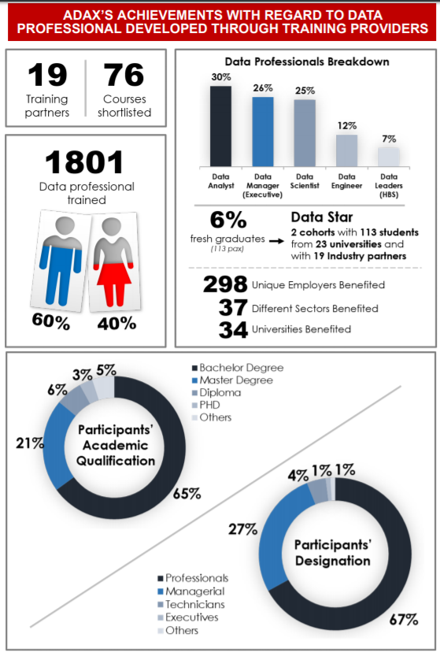

Picture: Achievement of ADAX.

ADAX(adoption program, community event, data camp)

ADAX provide an adoption program called Data Driven Decision (DDD) Enterprise. This program includes a two–pronged approach covering the whole spectrum of data-driven decision enterprises maturity level. Through this adoption program, it creates interest among the participants by reach out awareness and outreach in every moment of time that spent throughout the program. Besides, it also will increase the strength of linkage between partners. With adoption, scalability and collaboration purpose can be done easily.
In order to be spread the wings, ADAX has come out with the online platform-based learning called DATACAMP. In DATACAMP, the participants will have 6 months access for academics. Interesting topic has been provided such as R programming, Python programming, data visualization etc. Every person who joined DATACAMP will have a full access to entire course curriculum. They also been provided with leader boards and private discussion forums. By joining this program, you can put your worry aside because you have been marked in MDEC Talent Marketplace to pursue your own new career.

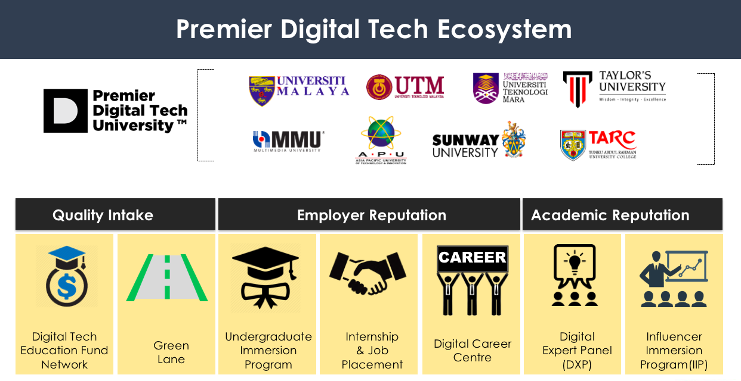

Premier Digital Tech Ecosystems

In the coming years, MDEC can be summarised to pursue their excellent especially in these key areas which is:
- Driving Investments: To ensure foreign investments and transaction to drive Malaysia’s economic and MSC Malaysia status.
- Growing Local Technology Champion : To make sure local inventor and innovator can stand a line with the great names in the eye of the world and driving dynamic economic forward locally and globally.
- Enriching Digital Economy Ecosystem: Increase chances of economy in crucial matters such as eCommerce, Cloud, Creative Technology, Internet-of-Things (IoT) as well as Big Data Analytics (BDA. The ecosystem is important to ensure the growth of the target stay relevant with the era especially in this Industrial Revolution 4.0.
- Digital Inclusivity: To ‘merakyatkan’ or to remove the stigma which is digital economic is something foreign but embrace and succeed with the changes of time together. Such initiatives such as eRezeki, eUsahawan and GLOW has created many entrepreneurs to succeed with correct knowledge and optimum effort together for the benefits of all.
To improve their chances of success, MDEC has created Premier Digital Tech Ecosystems to sustain quality mind workforces in the future industry, to appreciate future talents, increase alertness and gain confidence in the society for a better understanding of entrepreneur in various platforms, and benchmark to be emulated by others in the sector. MDEC has created some initiatives to cultivate the culture.

How MDEC focusing on different groups ?
- For Primary and Secondary students: Cementing computational thinking skills amongst this age group assists to form a steady talent pool for future digital economy jobs.

In order to produce curiosity amongst children, the Digital Tech @ Schools programme encourages the use of digital as a platform for teachers while introducing computing skills into the school curriculum. In order to do that, the eAspirasi immersion programme encourages promising talents to consider enrolling into IT courses at top Institutions of Higher Learning in Malaysia.

- For Undergraduates: Forming programmes that will help in increasing the pool of computer science and technological courses students at this level to ensure industry talent needs is in a better hand.

Working together with Institutes of Higher Learning (IHLs), the Economic Planning Unit (EPU), and the Ministry of Education (MoE) to improve IT-based graduate courses ensures a steady range of excellent skilled workers. Technical Vocational Education and Training (TVET) institutions are also deployed to increase diploma and certificate employability.

- For fresh graduates and professionals: Leading the formation of a sustainable industry-led talent nourishment centre for ICT-based jobs.

To meet current and future industry demands, MDEC are moving from an old approach that relies on the pool of skilled workers to a modern teaching approach that develops existing talent through certification programmes. In the future, an industry-led talent development model will expand the IT-savvy workforce.

Premier Digital Tech Universities | To provide excellent study space to create workforces that can meet future ever-changing demands .These qualities will be a benchmark to lead Malaysia’s digital economic in future. In 2017, Ministry of Higher Education (MOHE) and MDEC awarded and recognized 13 Premier Digital Tech Universities and Preferred Digital Tech Polytechnics as top institutions of higher learnings
Digital Maker   | Digital Maker Movement is founded to:  - Increase interest and skills in digital innovation and invention amongst school students and youths  - Increase the likes and pool in Science stream in upper secondary school and STEM undergraduate courses  - Ensure talent readiness for related economy job opportunities
#mydigitalmaker HERO | #Mydigitalmaker Hero is an initiative under the #mydigitalmaker movement, which targeted to produce chances to Malaysian brilliant minds to become digital creators and innovators.
Digital Maker Club & Digital Maker Champions | Realising not only coding is important in the industry. MDEC has formed four modules to help teachers and students in initiate their co-curricular activities.  - Aktiviti Sokongan Duta Penggerak Digital  - Kelab Fotografi Penggerak Digital  - Kelab Komputer Penggerak Digital  - Kelab Robotik Penggerak Digital  These modules can be downloaded on https://www.mydigitalmaker.com/programmes/digital-maker-clubs-digital-maker-champion.
Kem #MYDIGITALMAKER bersama PINTAR | ‘Kembara’ is a mobile learning squad started by #mydigitalmaker with PINTAR Foundation to reach out to students and teachers in rural areas and allow them to feel the first-hands.
Education Fund Network | The Digital Tech Education Fund Network is a network of many education funders collaborating to give access to brilliant students to chase their dreams in digital tech courses at Premier Digital Tech Universities
TABLE 1:Initiatives by MDEC


Fusionex

Fusionex is a successful multi-award-winning data technology provider that highly specialized in Artificial Intelligence, Machine Learning ,Big Data and Analytics. Fusionex are focused on connecting the space between business and technology, and in doing so, providing an exceptional and positive experience to customers of various markets. Fusionex’s business is to help customers manage, make use of and derive better insights and understanding from the amounts of structured and unstructured data at their disposal for better outcome. To summarise, Fusionex helps the clients to get an optimum result based on data and produced it in an information for a better use of the customer. Fusionex is committed to become a world-renowned IT-brand quality and distinction. This can be expressed by their values that embedded in their spirits.

- Faith
Through assurance in ourselves, our organization’s vision, and what we believe in, achieving goals that we set as well as those set by others becomes a natural flow of events
- Unity
Working together knowing that nothing is impossible when we stand together
- Success
Consistently striving to better ourselves through accomplishments and achievements
- Inspiration
Relentlessly motivating and encouraging all around us
- Optimism
Firmly grounded with the knowledge that optimism is the foundation of true progress
- Nobility
Maintaining a noble spirit and remembering that it is always good to give something back to society whenever possible
- Experience
Focusing on our experience to provide the best experience to all parties
- Xcellence
Staying true to our vision by ensuring that we make NO COMPROMISE to provide top quality services and deliverables

Eimer Smith (Vice President of Customer Service JC Penney) once said
“It all starts with data. Data leads to insights and actions. But you have to have the right data first”
So, why data is important?
The capability to understanding and act on data is increasingly vital to businesses. The pace of transition in this Industrial Revolution 4.0 requires companies to be able to quickly to meet the changing needs from customers and industry. Although instructed action may be needed, logic thinking is becoming more difficult as sectors compete in a global platform. Decision-makers may have to understand wider range of data before they can make the decisions. The importance of AI will sure affect all of us and these changes should be embraced and at maximum means.

Fusionex Speciality
Fusionex is a company that specializes in using data to improve their client’s needs based on the data that given to them. As a specialized company , Fusionex capable to perform better their in-depth understanding of the entire operation through consolidation of information from various data sources. Based on their track records, they managed to decrease costs by checking the KPI's frequently to enable faster and better decision making for a better outcome. They also managed to move forward planning with predictive analytics based on the data provided. Other than that, they manage to contribute to whole society by having better control over environmental conditions using the means of making statistics openly available to others. Next, they successfully increasing the profit margins by increase the efficiency of the processes resulting in measurable changes and output.

They also created systems that can be offered to their customers to increase process efficiency with automation of banking processes. These systems ready to improve product personalization to satisfy the needs of specific customers. It also makes operational more efficient without compromising productivity. Other than that, it enables legacy systems to interface with more flexible leading software. These systems also added security controls to meet stringent legislative and regulatory requirements.
Such examples of their systems are :
CORE BANKING SYSTEM: Transforming a bank's conventional systems to a streamlined front-end operation that is dynamic, flexible yet tightly integrated to the core backend with controlled and justifiable investment on returns. This can ensure a bank stay relevant with the needs.
INTELLIGENT CAPTURING SYSTEM: Providing a stable platform to handle large volumes of transactions and document processing by using industry proven OCR engines. The solution allows businesses to control the way the system works while eliminating rigid backroom operations and processes. This ensure efficiency during the process of working.
SELF SERVICE KIOSK SYSTEM: An interactive self-service kiosk solution capable of integrating with various hardware components and securely processing financial transactions.
This system will reduce cost and increasing the efficiency of bureaucracy.
NUMBER MANAGEMENT & DISTRIBUTION SYSTEM: This is our primary offering that assists Telco Companies handle their hardware inventory together with the millions of telephone numbers from existing inventories to upcoming numbers in the future.
ENTERPRISE RESOURCE PLANNING:A comprehensive ERP solution that provides a holistic operational platform, well suited and designed for various business lines and accomplished with the aid of up-to-date and multi-dimensional information being presented in meaningful ways.
CORPORATE PERFORMANCE MANAGEMENT: An astute and in-depth domain knowledge of Business Analytics and Insights resulted in the creation of our CPM solution, which provides you with a better understanding of your business and helps improve overall productivity and operational efficiency.

Example of AI in the Industry:
- In Finance and Banking: PayPal manages to reduce fraud in transaction by using sophisticated DL system that analyses transaction in real time.
- In Retail/Etail: Location targeted sales campaigns and price optimization such as the Darwin Pricing dynamic pricing software are also implementations of artificial intelligence worth using. This software uses artificial neural networks to simulate price expectations at different locations, enabling retailers to make better sale prices based on the information given.
- In Technology: As sectors usually have products that can be difficult to understand for the average layperson, chatbots and virtual customer assistants using speech recognition and natural language processing are usual for tech corporations.
- In Education: Data analytics help implement adaptive learning programs by letting teachers to get and construct data about the achievement and learning of each student and constantly adjust the learning needs according to their progress.



SAS Malaysia

The last speaker was Dr Mark Chia from SAS Malaysia. SAS is the largest privately own software company in Malaysia that has 32 years of history after its establishment on 1986 in Malaysia. Their target is everyone because they wanted to give the best data analytics available. Dr Mark is an Advanced Analytics Practice Lead in SAS. Before working with SAS, Mark worked with various UK companies in the IT sector for over 10 years. He worked for software development and internet dating companies. He has done diverse role from software engineering, systems administration, consulting, system analysis, project management and company management. He also has two bachelor’s degrees from University of Adelaide, Australia. Mark did his PhD in Electrical Engineering at the University of Edinburgh, United Kingdom. He is also registered as a Chartered Engineer.
Main topics that were discussed by Dr Mark was 4th Industrial Revolution. He stated that right now it is about digital fusion and based on the patterns from previous industrial revolution, he predicted that the 5th Industrial Revolution will revolve around Quantum Computer. He also talked about the impacts of data in industrial, society business and even to the nation. Ways on how data engineering works in a team with data analyst and scientist was also briefly explained by Dr Mark. It starts with a problem and then the data collected will be reviewed and explored. It will then be modified, and a model is created from the data which will then be validated. After that, the model will be deployed and later be evaluated. He continued his speech with the Internet of Everything (IOE) that plays a huge role in our lives nowadays. There are examples like geofencing that is used by google maps or even Waze that can keep you in track even away from home. He stated that this is the products that can benefited by us from the process of Artificial Intelligence where it will then change the way how we live.

Reflection

We really enjoy this industry trip and we also admit that this visit gave us a new spark toward our real ambitions. The experiences that gained from real-life scenario are the best lesson that we learn throughout this trip. We saw a lot of works and structures that has been maintain by the professionals thus make us to improvise ourselves towards the successes. We know that there would not be an easy way despite the lane full of barrier and challenging.
In our opinion, ADAX is the right place or platform to gain and experience the knowledge about data. It was been mentoring by a various expert in data in order to produce the best product to our community. As a student, we must take this opportunity to build ourselves up to be a greater person in the future. We can also share the opinion with other person to ensure the significant learning scenario.
There are a lot of programs that have been provide by ADAX and MDEC. If we are given the chance to pick the program, we decided to join it all. By joining, we are not wasting our precious time because we will be mentoring by experienced data experts and trainers. Not just the knowledge, we also will get the priority to pursue our career in data. In a nutshell, ADAX is a great place to attend and it also felt very good and feel ‘recharged’ when we went to the industrial visit.

References:
- https://www.digitalnewsasia.com/digital-economy/no-shady-business-behind-adax
- https://www.mdec.my/digital-innovation-ecosystem/big-data-analytics
- https://www.mdec.my/news/malaysia-to-accelerate-growth-of-data-professionals
- https://mdec.my/assets/newsletters/ADAX_infographics_V4.pdf
- https://www.mdec.my/news/malaysia-to-accelerate-growth-of-data-professionals
- https://govinsider.asia/innovation/inside-malaysias-national-big-data-plan/
- https://www.samacharlive.com/Business/adax-achievement-in-developing-talents-in-big-data-analytics/
- https://www.mdec.my/digital-innovation-ecosystem
- https://www.mdec.my/
- https://mdec.my/growing-future-talent/premier-digital-tech-ecosystem
- https://callminer.com/blog/16-examples-of-artificial-intelligence-across-6-industries/
- https://www.quora.com/What-is-the-importance-of-data
- https://www.fusionex-international.com/About-Us/Overview
- https://www.fusionex-international.com/Solutions
- https://www.sas.com/en_my/home.html

