Table of Contents
1 INTRODUCTION 2
2 JOURNEY OF THE INDUSTRIAL VISIT 2
3
3
3 ORGANIZATION STRUCTURE 3
4 SERVICES 4
5 ACHIEVEMENT 5
6 SERVICES MAINTANED 5
7 REFLECTION 6
7.1 GOALS 7
7.2 IMPACT 7
7.3 IMPROVEMENT 9
8 SUMMARY 9
9 BIBLIOGRAPHY 10

Table of Figures
Figure 1 : Mainframe Computer 2
Figure 2 : Computer and Laptop's Parts 3
Figure 3 : Professor Madya Dr. Mohd Shahizan Bin Othman 3
Figure 4 : CICT's Organization Structure 4
Figure 5 : Wifi Usage 6

INTRODUCTION
The industrial visit was held on 1th October 2018 at Centre of Information & Communication Technology (CICT) UTM at 2.00 P.M. All students who takes Technology and Information Systems (SCSP1513) must participate in the visit because the attendance is compulsory to gather as much as many of information for the report. For the visit, we were divided into some groups and need to stay in the group for the visit so all the report must be done in the group. The visit is all about CICT that have many things to discover by us all especially in ICT aspect because its delivers ICT services for the people in the university that support the ICT infrastructure, system development.
CICT has its own facilities which will support especially students of UTM in ICT which is computer & multimedia lab enable students to finish up their assignment and project for their own courses. CICT emphasize more on creative, innovative, cohesive and technopreneur to achieve its own objectives which are focus on client, efficient management of ICT projects, innovative digital professionals, increases operation quality and digital ICT services and digital entrepreneur ecosystem. It was located at UTM, D07, 81310 UTM CAMPUS JOHOR BAHRU.

JOURNEY OF THE INDUSTRIAL VISIT
All the students participated in the visit were gathered at the seminar hall at 2.00 P.M and compulsory to write down their matric number in the laptop prepared by the lecturers at the front of the seminar before the talk begin. We’ve all have to hear some briefing and introduction of CICT by Mohd Zahri Zainal Abidin before visiting the other places in CICT that we’re suppose to visit. The talk took about 50 minutes to finish before we all move to next place which is PPICTP. PPICTP commonly a place where filled with many set of computer that will be use for test that held by lecturers. There are about 300 unit of window computer, 20 unit of apple computer, 1 unit of lcd projector, a whiteboard and a pa system.
The last place we visit is the gallerium CICT which located at the first floor of CICT building near the front door. In the Gallerium there consist Mainframe Terminal, Controller, Mainframe Data Storage, Magnetic Tape Unit, IBM Tape Control Unit, and other parts of computer.
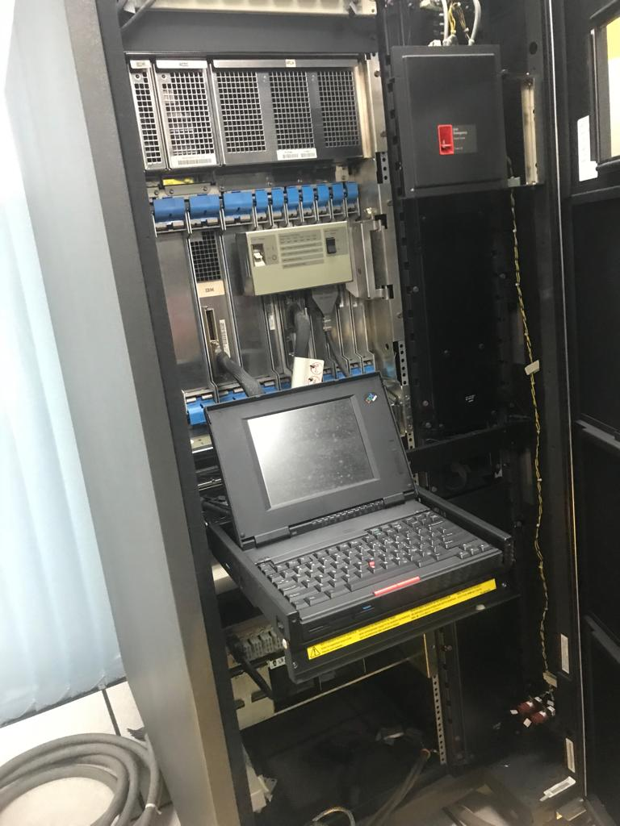

Figure 1 : Mainframe Computer
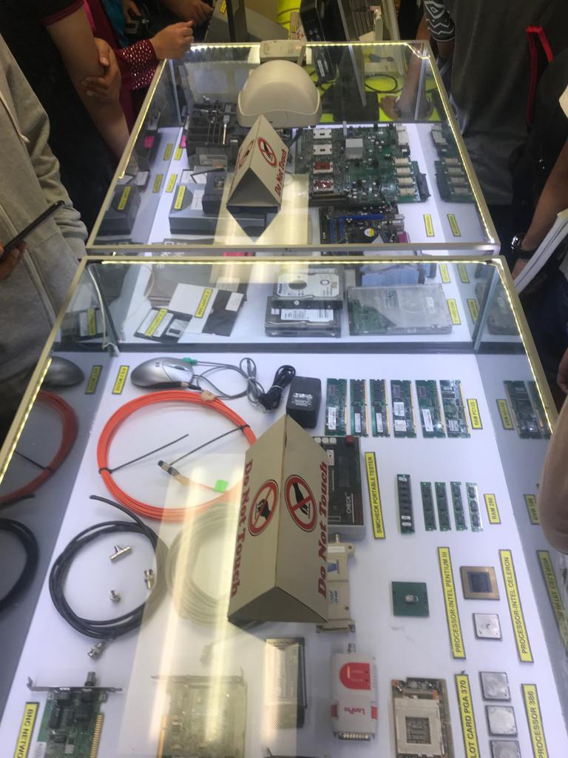

Figure 2 : Computer and Laptop's Parts

ORGANIZATION STRUCTURE
The Chief Information Officer (CIO) of CICT is Professor Madya Dr. Mohd Shahizan Bin Othman. He is a senior lecturer at the Department of Information System that has already been servicing under UTM for about 15 years. He also appointed holding many type of administrative positions in the university.
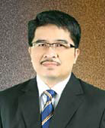
Figure 3 : Professor Madya Dr. Mohd Shahizan Bin Othman

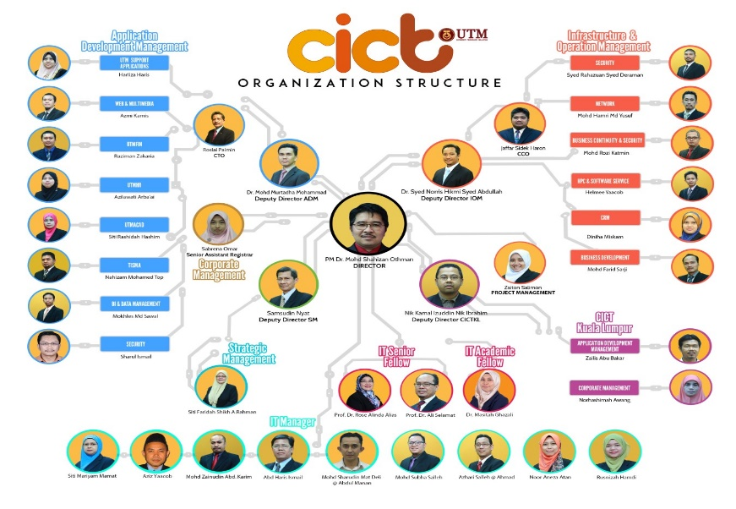
Below is the organization structure of the CICT,

Figure 4 : CICT's Organization Structure

SERVICES
In this services and information system it also called as CICT Services. There are six services that UTM provided which are internet, infrastructure & security, application development, web management, software and ICT support. As we know, internet is too important nowadays and many people use it to access anything that they want to. Same goes to UTM student. They use the internet to finish their work such assignment or research.
UTM provides wireless internet connection which mean UTM WIFI zone where all student can easily connect to the internet at anytime and anywhere. They also can connect either at their room or café. 2Gbps is link to the internet but 1Gbps link to the internet for resident college through “4G WIFI by YES@UTM” from YTL. So, they cannot give any excuse if their work are not done because they still can connect to the internet while they are in their room. But before that, students are not easily can use it. They must login using their ACID account. Steps to access to the internet are firstly turn on wireless device. Second is select hotspot @UTM from wireless list. Third is open the internet browser and lastly is login with ACID account. Easy and simple for those who study at UTM.
ACID account is known as Academic Computing ID for UTM students to log into their university systems. All students have their own ACID after registering the program through their respective faculties. Students can use their own ID to allow them to access internet e-learning, UTMOTION and School of Graduate Studies (SPS). E-learning is an education portal that assist students and lectures in the teaching and learning process to be more effective and flexible. Students can use it either to get some reference or notes for certain subject. It will make more easier for student to finish up their tutorial.

ACHIEVEMENT
In year 2017, researchers from University Teknologi Malaysia (UTM) have created an online system that enables lecturers to record their students' achievements and performances. The Integrated Academic Advisory System (IAAS) functions as a facilitator to manage data and student records, this upgrading the delivery system and efficiency of public service at the university. The innovative project was developed by its staff, including lecturers and administrators and it won the best team category in the Vice Chancellor Award during UTM's excellence award ceremony held at its Skudai campus here. The group of six from UTM Chemical Engineering and Energy Engineering faculty also walked away with RM10,000 and a trophy for their work on IAAS. The group's Chief, Dr Wan Rosli Wan Sulaiman, who is a senior lecturer from the faculty, said the system operates as a replacement for the old way of manually recording basic data. He said this would keep student academic achievements throughout the four years of study at UTM.
Bit only that, achievement that UTM got is On Eagle's Wings Institutional. Winner in Best Academia-Industry Collaboration (GradMalaysia Graduate Recruitment 2016) and also The Best Records Management Award 2016 for public sector universities. Award in winning educators at International University Carnival on E-learning (IUCEL) 2016. Lastly is student success that happen in year 2016 which is Robocon 2016 Asia-Pacific Champion Asia-Pacific Broadcasting Union (ABU).

SERVICES MAINTANED
Centre for Information and Communication Technology (CICT) had been and still is offering many services to University Technology Malaysia (UTM) in the regards of Information system and technology. Most of the things related to IT in UTM is handled by CICT.

One of the main services that is managed by CICT is Academic Computing ID (ACID). ACID is an ID which is unique to each user. It mainly used to log into the university systems like e-learning. Every students will be given their own unique ID upon registration along with an e-mail and access to UTM Wifi. Students and lecturers can use acid to assign and pass up them through online.

Speaking of which, UTM WIFI is also included in the services CICT manages. CICT had gone many efforts to enhance the quality of UTM WIFI. Nowadays, UTM WIFI has a coverage of 100% over UTM. Students and staffs alike can get access to UTM WIFI from anywhere in UTM. Currently, CICT is planning to increase the bandwidth of the UTM WIFI so that the users can get faster internet. The figure below shows the development that UTM WIFI underwent over the years.
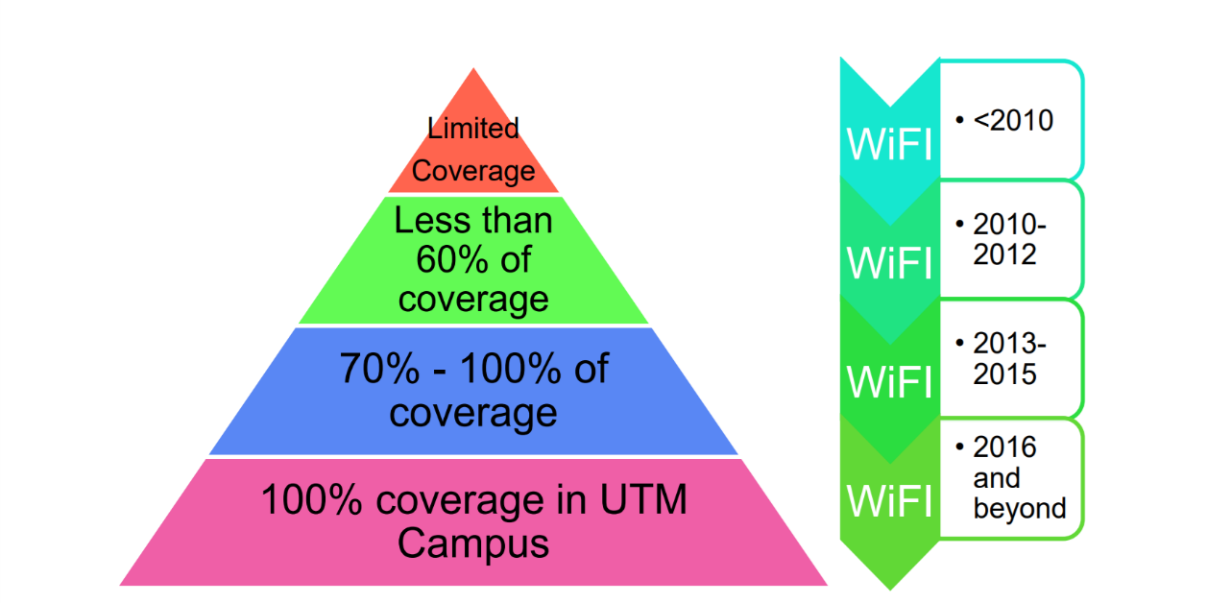
Figure 5 : Wifi Usage

Other than that, CICT is responsible for technical support center which is also known as PST. PST plays part in helping student who encountered problem in the services provided by CICT and in obtaining licensed software like Symantec anti-virus for the usage of students and lecturers.

REFLECTION

GOALS
The visit to the Centre for Information and Communication and Technology (CICT) had given us an insight about UTM’s backbone in the IT sector. It had given us an idea of how the course we are enrolling and the job we choose is important. As we are undergoing industrial revolution 4.0, there is a high possibility that the career we are choosing will be high in demand. So, it is important to our country to develop in the sector of IT. That’s why as the future of our country, we think that our job will give a significant effect to our country. Other than that, It also gave us an idea of how our future workplace will be.

IMPACT
The CICT: CENTRE FOR INFORMATION AND COMMUNICATION TECHNOLOGY visit was so helpful for us as a new student, because they were talking about how new student get their email, UTM account , etc.. , they told us what is CICT that is support unit that offers and delivers ICT services for the university both staff and student the benefits from the CICT is as shown in [figure 1]

Figure 6 : BENEFIT

And CICT gives us many other helping services that if anyone need help he can go to the CICT they will help you. They also after the talking took us to the CICT gallerium that has to many old devices that was so interesting for me, and they started to introduce the devices.

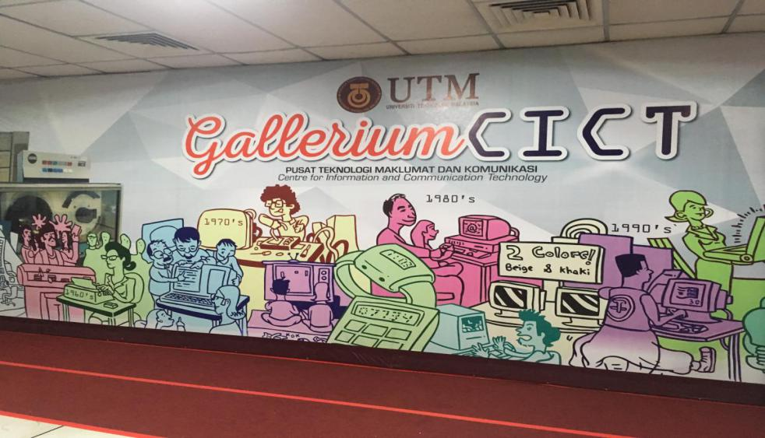
And this is one of the devices that was in the gallerium MAINFRAME DATA STORAGE (model IBM 9394 2)

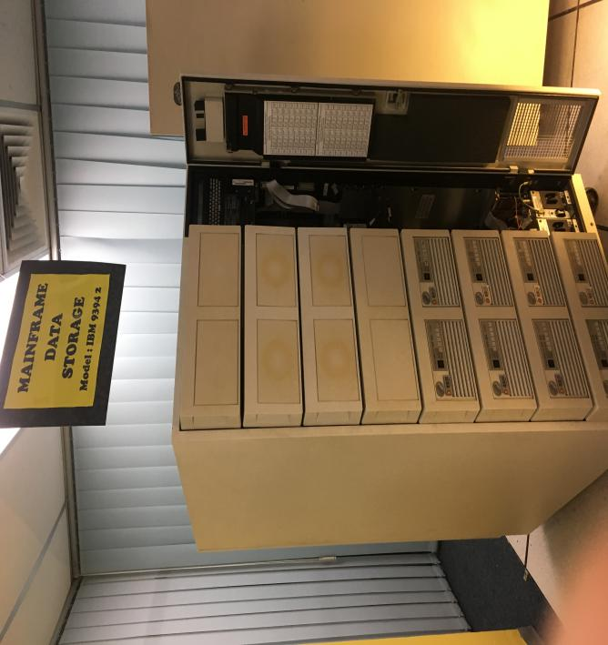
And that was how this visit impact my goal that that they show me this old device and I knew many information about it and took many pictures to remember this visit.

IMPROVEMENT
What is my plan to improve my potential in the industry:
- Providing an Opportunity to Improve
- Taking Action
- To learn from my failure and make a list of my weakness don’t be afraid from your weakness or failure
- Try to work on myself as mush as I improving myself at this work
- And try to see who just passed in this and take some information from them that will help you, and you will learn from their experience in this work

SUMMARY
CICT is UTM support centre for student and staff that help us in
- fixing problem with you MYUTM account
- providing you WIFI for the whole university
- etc.
The summary for the visit and the talk was in the (CICT HALL) at the first they talked about too many thing about what does CICT do such as:
- ICT services: student lab , UTMID, WIFI, VPN
- portal MYUTM: student management services, ICT instructional service
- software: MYUTM Portal, Microsoft Dreams park, Microsoft office 365

And after the talk the took the student to the CICT gallerium and start showing us some of these old devices such as:
- MAINFRAME TERMINAL model: IBM 3471 info window
- IBM MAINFRAME CPU model: IBM 9672-R21
- IBM TAPE CONTROL UNIT model: IBM 3803
There is more than this devices about 20+ devices and the gave some information about them and there is some picture i take it while the visit

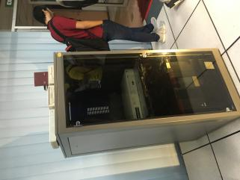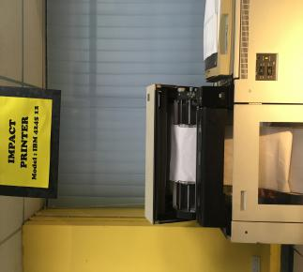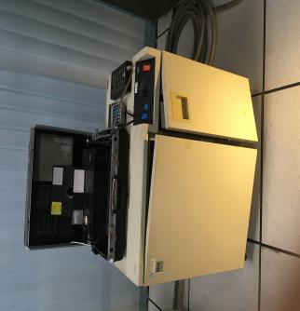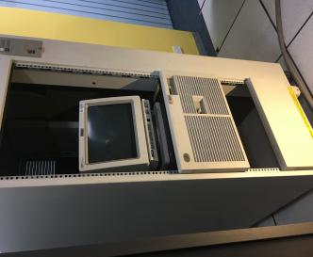

BIBLIOGRAPHY

Centre of Informations and Communication Technology. (2018). Info Program. Retrieved from CICTUTM. :

http://cict.utm.my/2018/10/maintenance-work-of-network-appliance-at-data-center-utm-johor-bahru/

Centre of Informations and Communication Technology. (2018). Service Program. Retrieved from CICTUTM. :

http://cict.utm.my/aduit/

