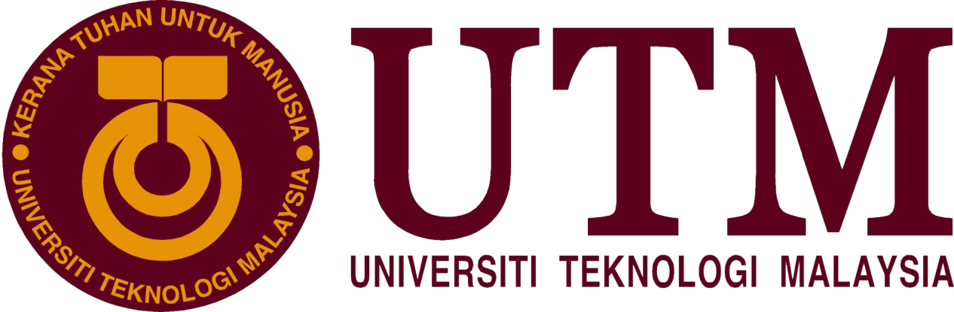
SCHOOL OF COMPUTING

INDUSTRIAL TALK REPORT 1
(MDEC e-REZEKI)

By
NUR HIDAYU BINTI MOHAMED
2018/2019

TECHNOLOGY AND INFORMATION SYSTEM(SCSP1513/09)

TALK PLACE: SEMINAR HALL N28a, SCHOOL OF COMPUTING, UTM SKUNDAI JOHOR.

TALK PERIOD: 11.00 a.m. - 12.00 p.m.

REPORT DATE: 08 OCTOBER 2018

TABLE OF CONTENTS
1.0 INTRODUCTION 3
2.0 CONTENTS 3
2.0.1 SPEAKER 3
2.0.2 eREZEKI 4
2.0.3 JOIN eREZEKI 5
2.0.4 IMPACT eREZEKI TO MALAYSIA 5
2.0.5 DO YOU INTERESTED TO JOIN eREZEKI? 6
2.0.6 REFLECTION 6
3.0 SUMMARY 7
4.0 BIBLIOGRAPHY 7

1.0 INTRODUCTION
Malaysia Digital Economy Corporation known as MDEC held in Seminar Hall , N28a on 24th of october 2018 to introduct and briefing the students about the benefits joined the MDEC while waiting for hired or to make the MDEC as a background to become a successful person in the future. MDEC slogan is connecting businesses and people to their digital future. 3 branches of MDEC that be a backbone for MDEC is eUsahawan,e-Rezeki and Global Online Workforce(GLOW). With the internet, we can be billionnaire with the bussiness that we involved in MDEC.

2.0 CONTENTS

2.0.1 SPEAKER

The speaker of the talk is Mr. Mohammad Ihsannudin Zamhari. He is Global Online Workforce Master Trainer in MDEC and full time freelancer, a person who is self employed and is not necessarily commited to a particular employes long term. Mr. Ihsannudin was worked in MYPC Computer sales and Services, Komasi Sdn.Bhd. And Technotronic Resources Sdn. Bhd. He is experienced coaching and mentoring for eRezki programme for 2 years (2016 until now) and become a freelance graphic designer in 2010 until now.He wide variety of clients from products to industrial associations and corporate conventions. The last education was in UTM with gradution in Master’s Degree, Technical, Vocational Education and Training (2012-2015). The achievement that he achieve is certificate Adobe Certified Associate in Graphic Design and Ilustration using Adobe Ilustrator and Practical Coaching and Mentoring Skill.

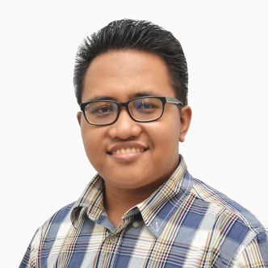
Figure 1: Mr. Mohammad Ihsannudin,a speaker of MDEC talk https://www.truelancer.com/freelancer/tluser8296f188

2.0.2 eREZEKI

One of the platform of MDEC is eRezeki. MDEC introduced the National eRezeki Programme that connecting bussiness with people around the world and focuses on families with a monthly income of RM4000, where they can join the eRezeki program, and make some simple digital tasks, and generate additional income through eRezeki . eRezeki programme was launched by 6th Prime Minister of Malaysia , Prime Minister Dato’ Sri Mohd. Najib Bin Tun Andul Razak with the support of Yang Berbahagia Dato’ Sri Ahmad Shabery Cheek, Minister of Communications and Multimedia on 17th of June, 2015. eRezeki have two majors components where individuals can register as digital worker and perform the digital tasks then generate additional income or go to eRezeki centre with wakil eRezeki that provides facilities such as computers and faster wiFi for the participants in eRezeki. The centre are managed and guided by qualified trainers called as ‘SiberGuru’.

The benefits from this program are people that works for the job with income below RM4,000 that generate the own additional income. Through the rough calculation shown on the eRezeki site, they say consumers can generate up to RM500 a month by doing roughly 3 hours a day for 24 days. Just 3 hours a days and doing digital tasks we can get additional income. We also can improve our skill in digital and technology while joined this program and can learn more about how what to make Malaysia become like another country. Next, the generation of young people that closer with technology can avoid the bad rumors and start do the bussiness.

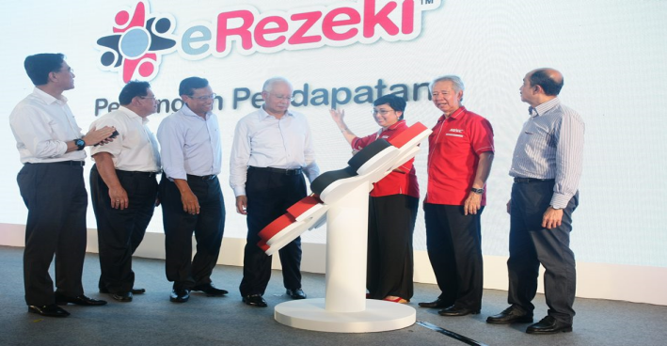
Figure 2: The lauched of MDEC
http://telusuribicara.blogspot.com/2015/06/projek-erezeki-untuk-kumpulan-rakyat.html

2.0.3 JOIN eREZEKI

MDEC get people to join eRezeki with MDEC launched the program known as “YouCanDUIT” that introduce people to make the income without do outdoor works and just need the high order thinking to complete the digital tasks given .In the concept, anyone can register and participate to be crowd worker as long as they can access the internet. Whether or not one will qualify or able to land a job or task via digital platforms is purely depending on one’s ability and competitiveness in providing services or skills in the open and free market. eRezeki have 6 branches of centre that people can get knowledge and learn hoe eRezeki works. These include, among others, Pusat Internet 1Malaysia (under MCMC), Pusat Internet Desa (under KKMM), Urban Transformation Centres (UTCs), relevant facilities operated by State Agencies and State Development Corporations, and computer labs under Kolej Komuniti, HLIs, libraries etc. At their centres , the proffesional trainer will teach you on what you need to do while joined the eRezeki and make high income per month. In Kolej Komuniti, eRezeki training is positioned as part of their ‘Life-long Learning’ modules, offered to general public during weekend.MDEC partnered with the popular program on Astro’s platform Maharaja Lawak Mega and created bespoke customised capsules to seemingly seed the campaign message as part of the program content. Branded content was also inserted into Hua Hee Sekolah, Mak Cun and MeleTOP, to amplify the campaign through humor and entertainment, things that everyone could easily relate to.

The program can be joined for people who want to increase their income and are willing to use digital and technology as a platform to complete the tasks given by the clients due to due date that clients asks.The program is free to join and every stage of society can join this program if they are want to make digital as a platform for additional income. The program also referred to the Bottom-40 (B40) group.

2.0.4 IMPACT eREZEKI TO MALAYSIA

Impact of the program to Malaysia is technique high schools will be housed in those institutions that adopt the computational thinking, computational science and coding as the official curriculum at the school. It also attract students who have talent and already exhibited digital innovation characteristics. The corporation would need to gather young talents throughout the country and give them the right level of exposure in design thinking, best technology and communication skills.This program can nurture Malaysian young talents for the future. Digital economy requires one million of jobs in the future include jobs like software programmer and engineer, Malaysia can have to a talent not only become workers but to become innovators.

Malaysia can have a lot of people that can be rival in internet technology with another country and seeks to transform the nation into a digital economy by 2030 and decrease the population of the unemployed in Malaysia. In the future, Malaysia will have a leader that can held this Malaysia to be a technology and digital country and can comparable with another country in the world beacuse economies around the world are being reshaped by seismic shifts in digital technology that offer global potential. Malaysia will have a creative and innovative citizens that make Malaysia a one stop centre to spur the proliferation of all types of creative content in the country.

2.0.5 DO YOU INTERESTED TO JOIN eREZEKI?

Yes, I interested to join eRezeki program because the program will improve my skill in technology because I weak in using technology items whether hardware or software. The program also can help me to build a leadership and show my responsiblity while doing the tasks given by the clients. I also can generate more income to further my studies in course graphic and multimedia software. I want to be like Jack Ma that create AliBaba group and be a billionaire with the only one platforms that Jack Ma create and he help him citiziens and worldwide to connecting between bussiness with people.

2.0.6 REFLECTION

There is some reflection from the Industrial Talk. Industrial Talk introduce us to get the bigger highly income you just need a knowledges about Internet Technology(IT) then, you will get it from the tasks that you already do. There are communications with other citizens. It is can build your confident to communicate with people around you. This talk was so great and clear briefing what is MDEC for students that not knowing about what MDEC do before. It also tells us with internet nothing is impossible.

3.0 SUMMARY
MDEC will position Malaysia at the forefront of creative multimedia content through the introduction of Content Malaysia. We need to cooperate to develop Malaysia be a number 1 digital economy country in the future. The comunity should focus on what happened around. YOU WILL NEVER REST UNTIL YOU DONE BECAUSE THE CHAMPION NEVER REST. Try hard, Pray hard and Wait for the results, you will satisfied with your own jobs.

4.0 BIBLIOGRAPHY
Mohd Ihsannudin Jamhari. (2017). True lancer 8296f188 . n d . from
https://www.truelancer.com/freelancer/tluser8296f188

Md. Yushak Sajari .(2015). Projek eRezeki Untuk Kumpulan
Rakyat B40 Tambah Pendapatan. Retrieved on June 22, 2015,
from
http://telusuribicara.blogspot.com/2015/06/projek-erezeki-untuk-kumpulan-rakyat.html

