
Title: Design Thinking
Group Members: TOK KAI XIAN (A18CS0267)
TAN ZHI QUAN (A18CS0260)
CHENG SHIN WEI (A18CS0046)
TAN WEI KOK (A18CS0258)
LEE CHEN HONG(A18CS0094)
Course: Technology and Information System
Lecturer: Dr. Aryati Binti Bakri
Section: 9
Table of Contents
1 Introduction 2
2 Detailed Description in Design Thinking 2
3 Detailed Description Include Problem, Solution and Team Working 3
4 Assessment 5
5 Empathy 5
6 Define 6
7 Ideate 7
8 Prototype 7
9 Test 8
10 Reflection 9
Table of Figures
Figure 2-1 Discussion the problem that obtain from respondents 3
Figure 8-1 The model and the frame creation of prototype 8
Figure 8-2 Application page design 8

Table of Tables
Table 1 The problem of respondents 6
Table 2 List of idea 7

Introduction
In this design thinking project, we had interviewed 3 respondents to get the problems of them during their study. From the problems of respondents, we gathered all the ideas from respondents. We discussed the common problem and the appropriated solution to the problem. The problem that we chose was to solve the limited reading resources among student. The solution also linked to other problems of respondents and we want to solved it with single application. At last, we decided to create a platform for students to discuss, distribute and publish the questions. The way that we embodied the platform was through development of application. By involved all of lecturers and students as the user of application, the accuracy of the questions and solution can be guaranteed.

Detailed Description in Design Thinking
The problem that we need to solve is limited reading sources among students. At first, we want to choose a platform for the students to gather and discuss the problem conveniently. The solution that we discussed was created a software or application to discuss the problem.
After that, we started to think about the user that we need to involve in this application. Initially, we want to involved all of Year 1 School of Computing students as the user of this application. However, we tried to consider the accuracy issues when first year students answered the questions. First year students had limited knowledge may spread inaccurate ideas among students. Thus, we suggested new idea which involved all the students in School of Computing and lecturers to this application. In this condition, senior students of School of Computing and lecturers will act as a guidance and make correction when mistake made.
Others subject that we discussed about the sources of questions. We want to create an application that students can post and answer the questions. The application also provide questioner, the right to choose a suggested answer.
Reward system also embodied in this application. We want to create this system for students, because we want to improve the motivation of students to answer the questions posted. However, not all the answer will be provided a reward to answerer. Only the suggested answer will be provided with reward point. When reward point sufficient to the item point, the user can exchange particular items or gifts. This system not only improve the students’ motivation, it acted as an avenue to address user to abuse the reward system which get the reward point by published wrong answer.
Lastly, we decided to create an application which included the characteristics of user who students and lecturers, online questions sources and reward system.
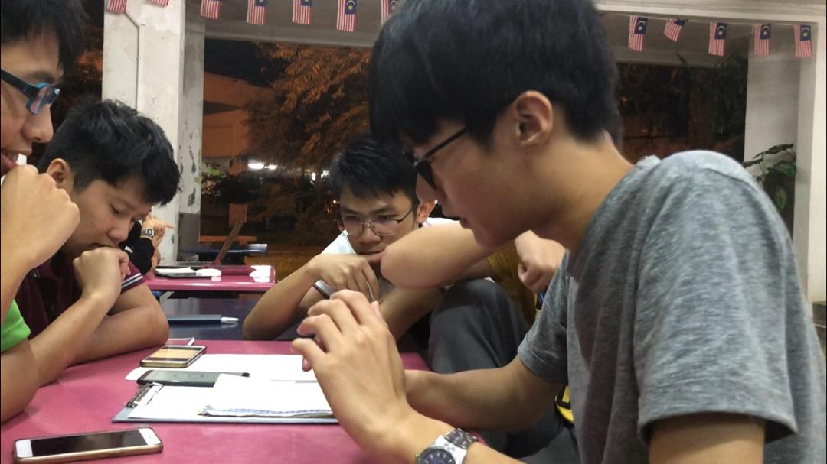
Figure 2-1 Discussion the problem that obtain from respondents

Detailed Description Include Problem, Solution and Team Working
There are many problems we faced during making this assignment. Our first problem is the group member always busy causing group meeting have to cancel. The reason is busy with other assignments. This affect in facing difficulty in adjusting the time for group meeting. Sometimes, some of our group member also have to help their club to conduct event as they are members of the club, this have been delay many times for this assignment. Next, the other problem is always reject by other during interview. This is because they fell shy when talking about what problems they faced in their study. The next problem is the background sound when taking the video. We find that it is very hard to take a good video because there are many background sound which will affect our quality of video. Then, we decided to settle all the interview and group discuss in a day so that we didn’t have to adjust the time for meeting again. We also need to consider the place of interview. In team working, we divide every group member for different work. We also do the prototype together to show the creativeness of our group members. Another problem we faced is we have to fulfil the needs of the respondent, so we have to keep on innovate until the respondent satisfied.

Assessment
All our group members have a good cooperation during the project, and during the end of the project demonstration, we had done the best of ourselves to promote our problem solution to our respondent and our work had got a good feedback from our respondents. However, some of us are lacking of the skill of interpretation but all of us still do our best as possible to present our idea to our respondents.
During the transition between design thinking phases, by the detail plan of our team, there are not taking too much time for us to change to next phase. As example, we had finished our interview of our three respondents in one day even it is some obstacles to get a time for us to get together. We think all of us had a will perform to share their idea to done the project and made the time taken in every phase was been shortened and it save us many time to finish the project.

Empathy
Empathy is the first stage of the design thinking and its very important step because it should immerse ourselves to the user’s problem. In this way, we can solve their problem in more appropriate ways which produces the best solution. The stage of empathy began with the interview session. In the interview session, we can obtain the personal information of respondent and what the problems they faced. We have prepared a set of question, for example, we ask the respondent to introduce themselves and ask for the problems they faced in their learning. After this stage, we can move to next stage which is Define.

Define
In the stage of define, we record all the problems faced by the respondent and arrange into a table.
Respondent 1  Background:  20 years old, 1SCSJ | Respondent 2  Background:  20 years old,1SCSP | Respondent 3  Background:  20 years old,1SCSV
Problem 1  Insufficient time  -Due to a lot of assignment  -Different lifestyle from secondary lifestyle  -Active in a lot of events  Problem 2  Hard to understand  -Impropriate language  Problem 3  Entertainment affects study  -Play games and does not do revision for exam | Problem 1  Insufficient time  -Course are completely packed  -Exam preparation time too short  Problem 2  Limited reading source  -Resources given in point form  -Not enough example  Problem 3  Electronic affects my study  -Entertainment  -Cannot focus when phone beside  -Always take phone to chat or play game | Problem 1  Insufficient time  -Spend time with friends  -Lack of time to study  Problem 2  Limited reading source  -Not enough exercise and answer  -No good reference book  Problem 3  Entertainment affects  -Unable to reject phone and friends
Table 1 The problem of respondents
According to table, we think that limited reading source is the major problem faced by the first year computer science students

Ideate
In this stage, we have a detail discussion which is ideate (brainstorming session) about the major problem gained from the previous step. We have a discussion and come out with some idea, the best idea will be chosen to solve this problem.

Problem:
Limited Reading Source
Idea:
Open WhatsApp discussion group 9. More learning programs
More study room and reading materials 10. Point checking educational games
Create a website that contain reading source 11. Create Artificial Robot to teach
Create an application
Virtual Reality (VR)
Learning videos
Direct mentor sessions
Get more information from the lecturer
Table 2 List of idea
In this stage, we decide to create an application to solve this problem

Prototype
Prototype is a model created from the best idea chosen from the ideate session. We decide to create an application which can help to solve the problem of limited reading source by using the electronic gadgets. In this way, we use a box and change the screen by changing the paper to represent the screen of the mobile apps.
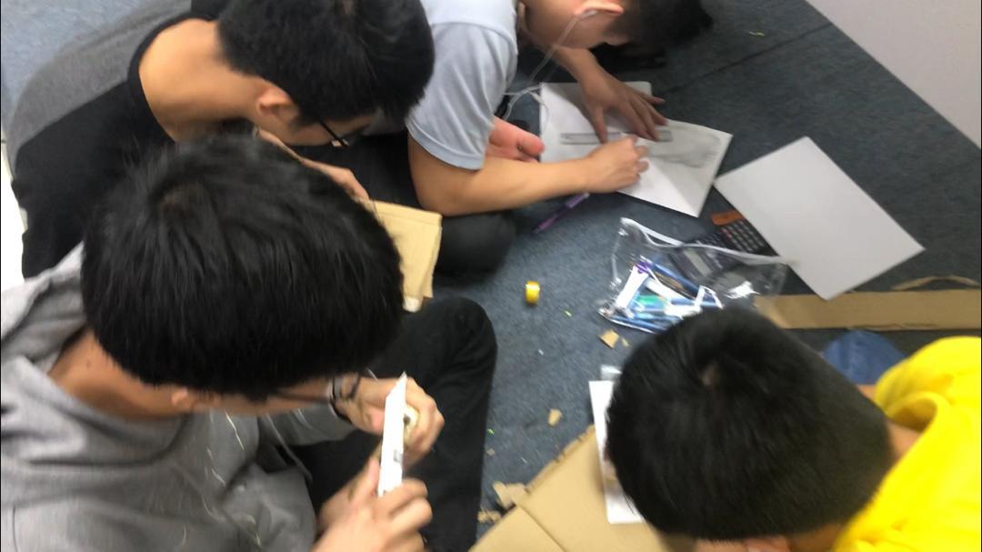
Figure 8-1 The model and the frame creation of prototype

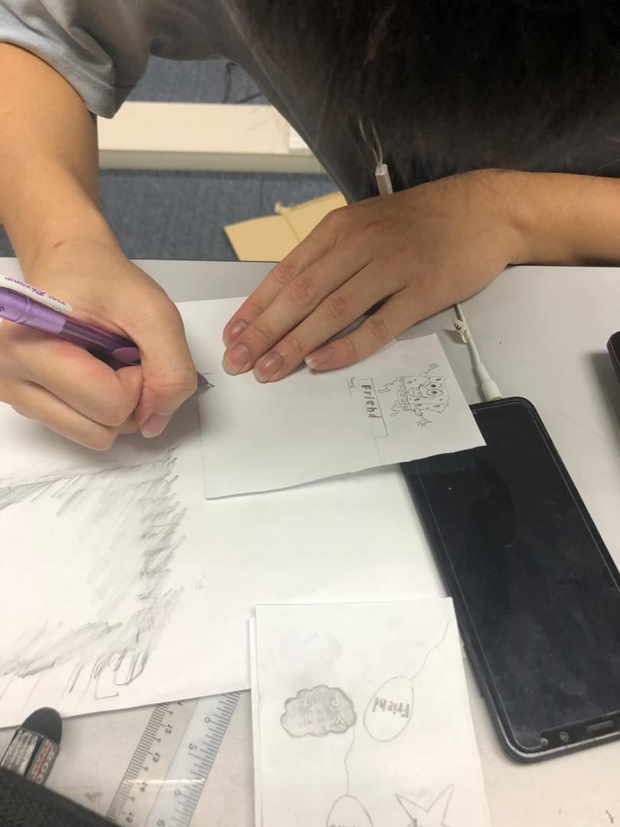
Figure 8-2 Application page design

Test
In this stage, we will test our prototype with the respondent to get the feedback from the respondent and keep on innovate until we get a perfect prototype for the user. Our respondent praises our product as it’s very useful and solve his problem. He hopes that we can make a real one in future.

Reflection
There are different reasons for people in choosing their course. For our group, we share the same goal by taking this SCSV courses which is become the game designer in our future. This is because most of the teenager nowadays are interesting in video games and we are also one of them. It is obvious because there are many tournament of video games (e-sport) held by many company to encourage more teenagers to play the games. In this design thinking assignment, we found that all of our respondent didn’t have enough resources of learning. Because of this, all of them are losing the interest in their study and spend all of their free time to play video games and then didn’t able to manage their time wisely. So, our group design a prototype where it can help the student to increase their sources of study to help them in their study. This assignment let us learned about how important of teamwork and manage time wisely in making a project. Without these two thing, we are unable to carry our job (game designer) properly. After making this assignment, we also found that what is our weak point that we must be improve so that it can improve our potential in the industry. Our weak point was altitude with others group member, poor speaking skill and also poor creative mind. To overcome these, we must spend more time to speak in language that we weak for, always be nice with others people and also learn extra information that cannot be found in the schoolwork. After solving our weak point, there will be better future waiting for us.

