

RUBRIC INDUSTRY TALK HP AND MAXIS

REPORT BY : -MUHAMMAD FIKRI BIN ISMAIL
(A18CS0139)
-NUR SYAFIQAH BINTI TASERIP
(A18CS0201)
-TAN ZHI QUAN
(A18CS0260)
SECTION :9
COURSE/YEAR :SCSV/1
LECTURER’S NAME :MADAM ARYATI BINTI BAKRI

Contents
Introduction 3
Internet of Thing (First Talk) 4
Internet 2.0: Transaction Based Networking(Second Talk) 5
Man computer symbiosis 5
History the trend 5
Distributed ledger technology/block chain 6
Use case 6
Summary 8

Figure 1: Sir Syahrul Hafidz Suid 4
Figure 2: Evolution of the Internet 5

Table 1:Difference between blockchain and database 6
Table 2: Advantages, disadvantages, opportunity and threat of blockchain 6

Introduction
On 18th November 2018, there was an open day named IoT Open Day that was held at Faculty of Electrical Engineering (FKE) in Universiti Teknologi Malaysia (UTM). All students from School of Computing were attending a talk that was one of the activity during the event. First talk was around 11 in the morning and it was a talk from Mr. Syahrul Hafidz Suid an Enterprise Consultant of Hawlett Packard Enterprise. He gave a talk about IoT (Predictive Maintenance Gets an Extreme Makeover). In his talk, he told us about how they want to maintain the internet of things for the future as they expect to have more than 28 billion IoT devices by 2020.

The first talk took around one hour. Then, 12 in the afternoon, the second talk by Mr. M Nazrul Hazeri Nazirmuddin a Solution Design Architect of Team of Maxis Berhad Cisco Service Provider Distinguished Innovation Award 2014. The talk that he gave is about Transaction Based Networking as internet 2.0 is the current state of online technology compared to the early days of the internet, it will have more efficient network connectivity and enhanced communication channels. Many interesting and informative knowledge that we got from both talk.

Internet of Thing (First Talk)
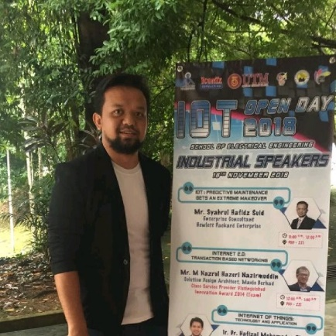

Figure 1: Sir Syahrul Hafidz Suid

The first talk which called IoT or better known as Internet of Thing was spoke by Sir Syahrul Hafidz Suid which is the enterprise consultant in commercial and public sector for Iot. IoT is basically a device, system or program that is developed to help humans organizing an events, machines, internets or programs by the help of Artificial Intelligence (AI). IoT goal is also to increase IT’s effectiveness in driving business performance and growth, which here means that it does not replace human’s actions completely in managing somethings but it provides people with a program that will reduce the time needed to complete a maintenance task. IoT also predicted that by the year of 2022, 75% of successful digital strategies will be built by a transformed IT organization, with modernized and rationalized infrastructures, applications, and data architectures. IoT realize that it requires more cost in maintaining a machine or program in industries without the help of artificial intelligence or system that can determine errors by itself as the process will require more man’s energy and money. IoT also provides security program that will ensure the safety of a program and maintenance process of a machine. Therefore, by the selected number of targeted years, IoT is targeting to successfully develop a program that will provide a complete set of program that offers all of the stated needs.
Some of the examples of the program that will be developed by IoT and can be used in providing a better and more efficient daily life are smart cities, smart cars that can interact with owners and drive by the AI programs, smart metering in maintenance activities and many more. All this are steps in bringing customers and users to the modern, futuristic and more stylish life. This also could be a benchmark on how far technologies have achieved year by year.

Internet 2.0: Transaction Based Networking (Second Talk)

Man computer symbiosis
In general, man computer symbiosis is the predicted development in cooperative interaction between men and computer machines. It shows that there will be a close coupling between human and electronic machines. The main purpose of this are to let computer to have more formulative thinking and also enable men and computer to make decision. In this symbiosis relationship, men will set the goals, formulate the hypotheses, determine the criteria and make the evaluations while computer will do the routinizable work to prepare the way for decision according to technical and scientific thinking. There are also have analysis show the result that symbiosis relation between men and computer will perform higher efficiency work compare to man alone can perform themselves. To make the higher efficiency of work from men and computer, development in memory components, memory organization, programming languages and also the equipment for input and output must be further done.

History the trend
For the history of internet, it start from Memex Conceived(1945) followed by A Mathematical Theory of Communication(1948), Silicon Chip(1958), First Vast Computer Network Envisioned(1962), Packet Switching Invented(1964), Hypertext invented(1965), ARPANET(1969), TCP/IP Created(1972), Internet Named and Goes TCP/IP 1984, WWW Created 1989, Mosaic Created(1993), Age of e-Commerce(1995). For the history about issue and problem of internet, there are seven problems which are walled off internet, cloud attacks, AI-built security issues, botnet problem, limited AI, lack of confidence and understanding IOT.
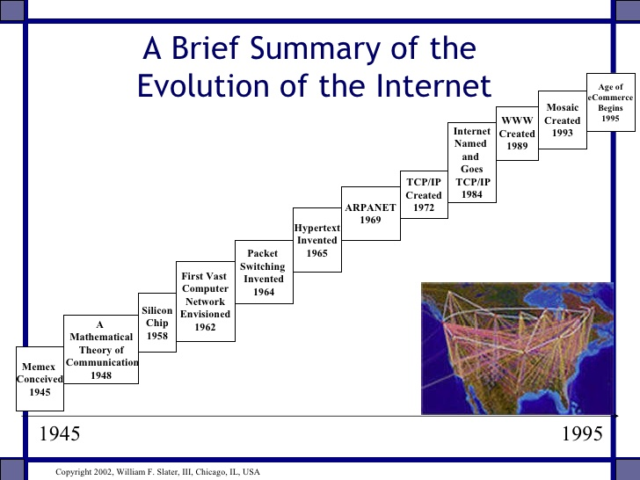

Figure 2: Evolution of the Internet

Distributed ledger technology/block chain
Blockchain can be described as peer to peer distributed ledger by consensus combined with a system for “smart contracts” and other assistive technologies. There are two types of blockchain which are public blockchain where everyone can participate and private blockchain where only hold by trusted participants. The example of private blockchain are bitcoin, ethereum while private blockchain are ripple and MONAX. Many people also misunderstand about blockchain and database, table 1 show the difference between blockchain and database. There are also many advantages, disadvantages, opportunity and threat for blockchain. Table 2 show the advantages, disadvantages, opportunity and threat for blockchain.
blockchain | database
Anyone can access(public) blockchain | Only entities with right can access database
slow | fast
No admin in charge | Controlled by admin
Anyone have right proof of work to write on blockchain | Only entities entitled to read or write
Table 1:Difference between blockchain and database

advantages | Zero percentage of fraud  No government interference  Instant transactions  Improved financial efficiency
disadvantages | Extremely volatile  Crime  Problem for not tech savvy
opportunity | Reducing cost  Increasing traceability  Improving customer experience  Enhancing security
threat | Environmental regulation  51% attack  scalability
Table 2: Advantages, disadvantages, opportunity and threat of blockchain

Use case
There are many uses of IOT that help us to improve our quality in many thing in our life. First, it can increase the harvest of farmer. For example, by using IOT sensor to determine whenever the moisture of soil irrigation systems and minimize water consumption and also to control the humidity and temperature of environment. IOT also help people to save their time in their daily life. For example, GPS show the shortest way to their destination and it can also help them to save the cost. IOT also able to improve our security in our life. For example, we can also connect the security camera to internet and able to see the situation of our home at anyplace and anytime.

Summary
In conclusion, the industrial talk held by Internet of Things (IoT) improved the development of Information technology. It helps in development in f the internet which does make it faster and more reliable from time to time. Like the purpose of the Internet 2.0 which the goals are to solve all the issues that has been faced in the world of internet and to invent a system that doesn’t require man’s energy in order to maintain it. Our IT communities need to take part and give support in order to achieve the goal of the program. Together, we will create a world that have super-efficient internet systems.

