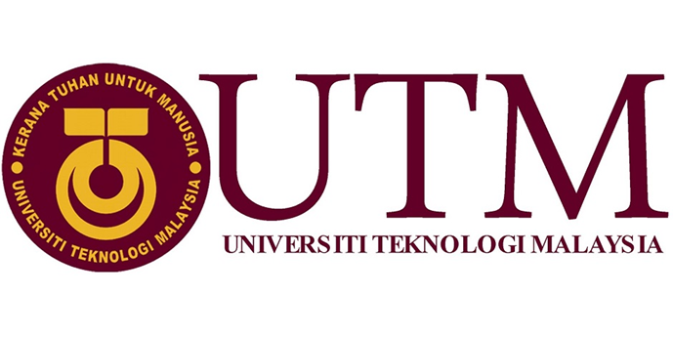
Industrial Visit Report:
Centre for Information & Communication Technology
(CICT)

REPORTED BY : -MUHAMMAD FIKRI BIN ISMAIL
(A18CS0139)
-NUR SYAFIQAH BINTI TASERIP
(A18CS0201)
-TAN ZHI QUAN
(A18CS0260)
SECTION : 11
COURSE/YEAR : SCSV/1
LECTURER’S NAME : DR. ARYATI BINTI BAKRI

Table of Contents
1. CICT Introduction 3
2. Detail of journey 4
3. Detail Description 5
4. Services 7
5. Achievements 7
6. Information system 8
7. Reflection 8
8. Bibliography 9

Table of Figures
Figure 1 : CICT Main Entrance 3
Figure 2 : The speaker giving the talk 4
Figure 3 : The example of devices 5
Figure 4 : Organization Structure of CICT 7
Figure 5 : ICT Services 8

CICT Introduction
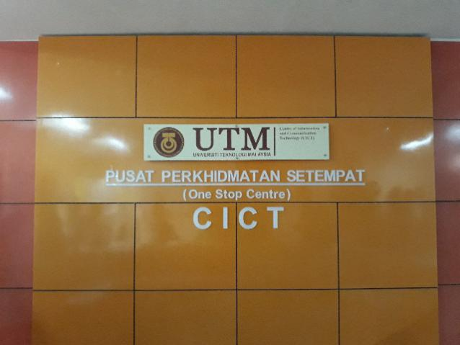
Figure 1: CICT Main Entrance
On 1st October 2018, there was an industrial visit had been made by Faculty of Computing to the CICT Centre located opposite to the N24 building. The visit was guided and lead by Mohd Zahri bin Zainal Abidin, a presenter/staff from CICT. CICT is a short term for Centre of Information and Communication Technology. They are responsible in giving support regarding to ICT infrastructure, system development and academic or administrative activities for staffs and students of Universiti Teknologi Malaysia. CICT is also the provider of the portal accounts, e-learning for both lecturers and students, which means once a student or a lecturer registered into UTM they will automatically receive their own portal account with passwords that can be changed as they wanted. Furthermore, CICT team had also been awarded the SAGA Award (Standard Accounting System for Government Agencies) by Malaysia Accounting Department on 22th November 2017. The main objectives of this industrial visit is to give exposure to students about the details and

Detail of journey
On 1 October 2018, all of our classmates including us had a visit to the Centre for Information & Communication Technology (CICT) UTM. This industrial visit was started at 2pm. Before the program was started, all of the students registered their attendance by key in their matric number on the system that was provided by the organizer.

The visit was started by hearing a talk by Mr Mohd Zahari Bin Zainal Abidin who is one of the staff that works in the CICT. He give a talk about what is CICT and what are the importance of CICT to Universiti Teknologi Malaysia (UTM). He explained clearly about the role that CICT hold all of this time to make sure all of the systems that are provided in UTM such as Wi-Fi and e-learning will running smoothly and ease all of the users. He also explained about the services that CICT have for all of the students and staffs in UTM. The talk finished at 3pm.
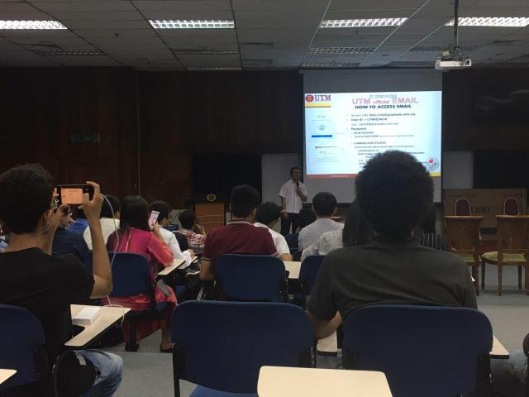
Figure 2: The speaker giving the talk
After the talk, Mr Mohd Zahari took all of us for a walk around the CICT. First he brought us to PPICTP Hall to show us the places that can be visited by the students to do their assignments or revision with the free internet services provided by CICT. Other than that, it is like a students lab especially for the UTM students. There have like 70 computers provided by the CICT in the lab.

Lastly, he brought us to the Gallerium of CICT. In the Gallerium of CICT, there are many types of the old version personal computers, mainframes, tapes, network cards and etc. We got a chanced to see all of it and Mr Zahari told us a little bit about the functions and storage of each devices in the gallery. All of us were amazed by the creation of each devices. Mr Zahari also told us about the differences between the oldest version of the devices and the newest version of it. Many things has changed and upgraded due to the improvement of our technology system nowadays. We got many information about the revolutions of the devices. Mr Zahari dismissed the industrial visit around 4pm and after that, all the students going back to their college.

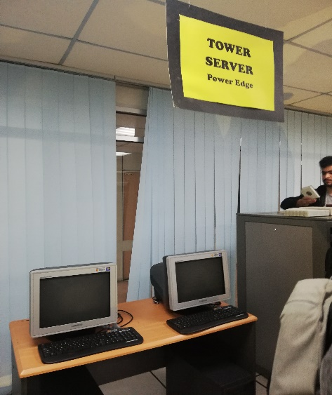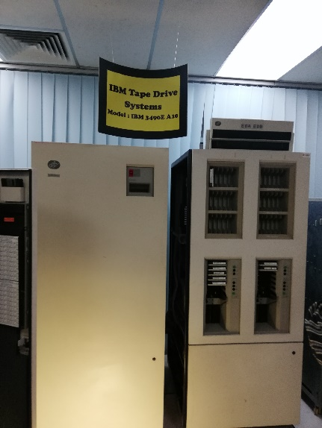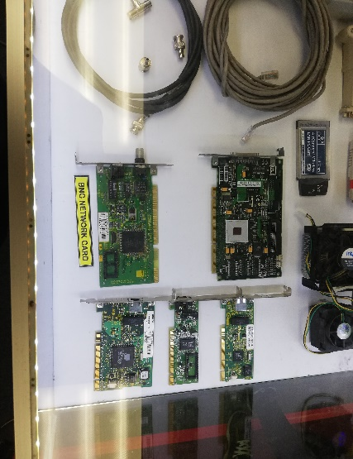

Tower server power edge IBM tape drive system BNC network card

Figure 3: The example of devices

Detail Description

CICT is a supportive unit that give and delivers ICT services for the whole UTM included both students and staffs especially in the academic, system development and also ICT in infrastructure. The vision of CICT is to let UTM become ‘ A frontier digital university spearhing academia centric service delivery’. Then the mission is to nurturing innovative digital professionals and promoting collaborative digital services to lead in the development of an entrepreneurial digital ecosystem. Actually, there are about 8 department in CICT which are CICT KL Campus, IT Academy Fellow, Business Development Office, Corporate Management, Project Management Office, Infrastructure and Operation Management, Application Development Management, Strategic Management.
The top management department is being led by Professor Dr. Mohd Shahizan Othman as Chief Information Officer(CIO), followed by 4 deputy direct and 4 other staff which is Dr Mohd Murtadha Mohamad as deputy director of (ADM) department, Encik Samsudin Nyat as deputy director of SM department, Dr Syed Norris Hikmi Syed Abdullah as deputy director of IOM department, Encik Nik Kamal Izuddin Nik Ibrahim as deputy director of CICTKL, Puan Siti Mariyam Mamat as Chief IT Officer in BDO unit, Puan Siti Faridah Shikh A.Rahman as Chief IT Officer in Corporate Branding in SM ,Encik Roslai Paimim as Chief IT Officer in ADM department, Cik Sabrena Omar as Senior Assistant Registrar in CM department.
The IOM department is being led by the Deputy director with assist of Encik Jaafar Sidek Haron as the Senior IT Officer. There are 6 part which is focus on more specific part such as the security management team, managed by Encik Syed Rahazuan Syed Deraman, business continuity security by Encik Mohd Rozi Katmin, Customer Relationship Management(CRM) which under Diniha Miskam, High Performance Computer (HPC) and Software service team by Encik Helmee Yaacob, network activities by Encik Mohd Hamri Md Yusuf.

The PMO department is led by Professor Dr . Mohd Shahizan Othman as the Chief Information Officer of CICT with assist of Puan Zaiton Salimon which is senior of the IT senior and Puan Aslinda Mohamed Aris as IT Officer. The SM department is led by the deputy director with assist of Puan Siti Faridah Shikh A.Rahman and Cik Azlina Ali as IT Officer.
The ADM department is led by the deputy director with assist of Encik Roslai Palmin as chief IT officer. There are 8 smaller part which are help to organise the department to become more efficiency such as UTM support applications by Puan Harliza Haris, UTM FIN by Encik Raziman Zakaria, web multimedia by Encik Azmi Kamis, UTM HR by Puan Azilawati Arba’ai, TISMA by Nahizam Mohamed Top and UTMACAD by Puan Siti Rashidah Hashim.
IT Academic Fellow is led by Prof.Dr.Rose Alinda Alias which is senior IT associate Fellow CICT with assist of Prof.Dr.Ali Selamat as senior IT associate Fellow, Dr Mastitah Ghazali as academic IT and also Prof .Dr Sevia Mahdaliza Idrus Sultan Nameh as senior IT associate fellow CICT( Project UTM linkages).
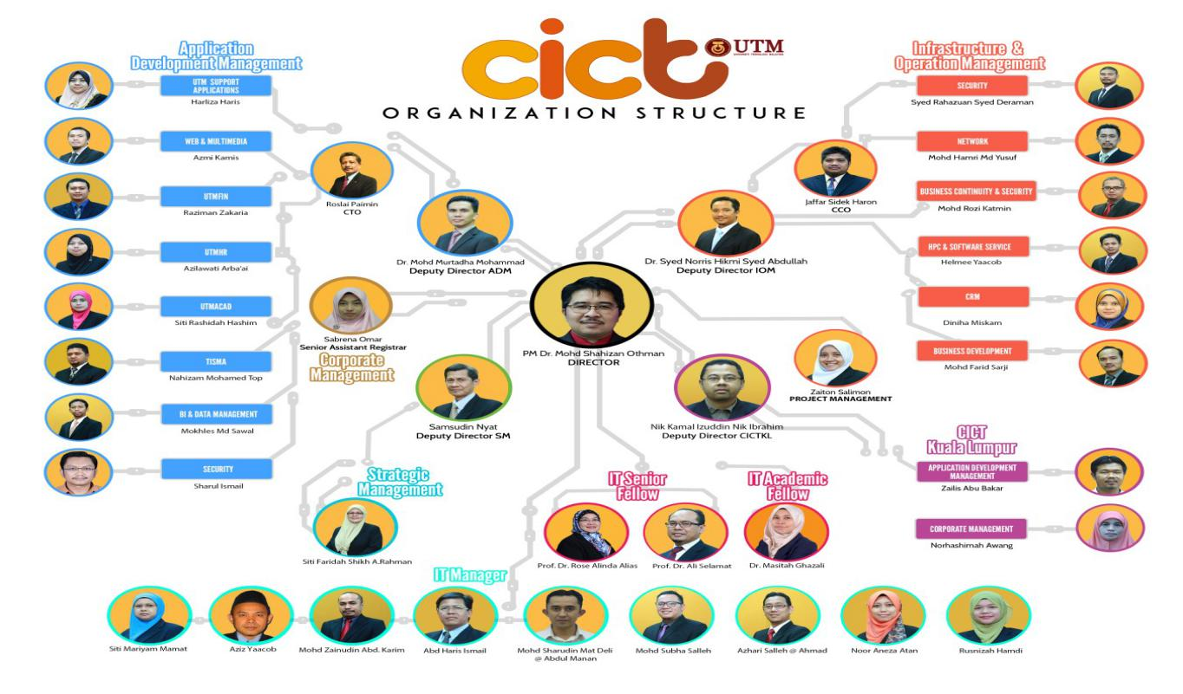

Figure 4: Organization Structure of CICT

Services

As I mentioned earlier, there are many thing which is prepared by CICT such as Student Lab. UTMID, Wifi and also VPN. For student lab, there are many available facilities provided such as computers, project discussion area, printing, scanning, CD/DVD burning and also Specialize Multimedia & Content Authoring Production Lab(SMAL). However, there is also have the rule when using student lab where UTM Dress code must strictly observed here and also Matric Card is compulsory. Next is the UTMID where all of students will get on the registration day. With the UTMID, students are able to login the UTM portal for e.learning, make the UTM mail, get the free software account such as Microsoft Dreamspark and Microsoft Office 365, accessing from outside UTM by using VPN provided and also there is the free WiFi provided which is available in 1600 locations in UTM, Johor.

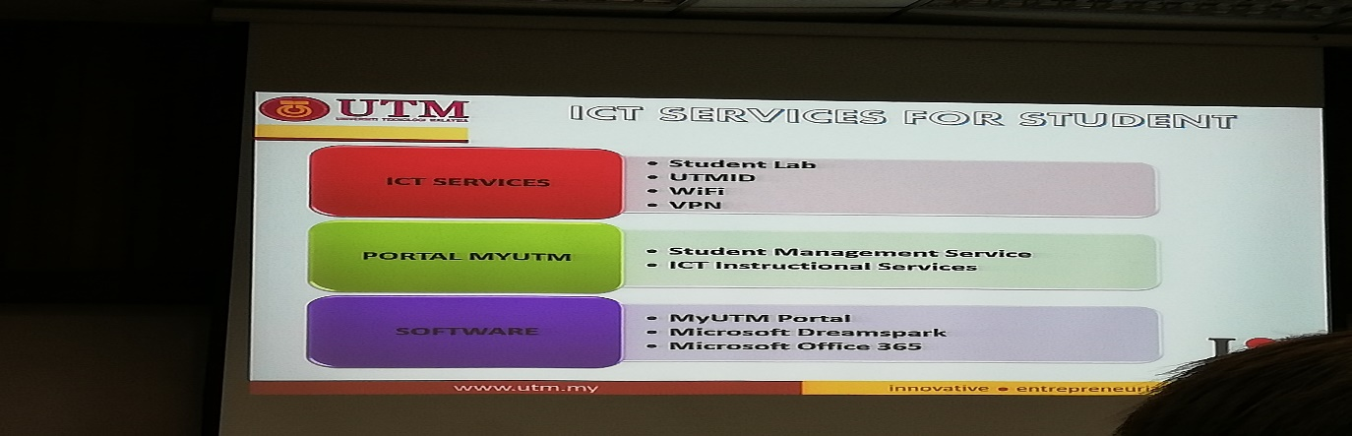

Figure 5: ICT Services

Achievements

The achievement of the CICT is that it success to prepare the best technical document and help the UTM to get the ‘SIJIL PEMATUHAN SAGA(Standard Accounting System For Government Agencies)2017 by the pihak Jabatan Akauntan Negara Malaysia on 22November 2017. This make UTM become one of the 59 from 416 agency who also achieved this such as USM,UPSI,UMP,UPNM, UNISZA, UTHM and also UPM. The next achievement is CICT become the most active PTJ in Senamrobik Perdana Siri2 on 7 Februari 2017, which held in Stadium Azman Hashim UTM Johor Bahru. The attendance of that day is about 50 staf CICT from 123 people which show about 40.7% attend the program.

Information system

There are 4 information system provided by CICT which are ACID, VPN, E-learning and also Wireless/UTM WiFi Zone. Actually, ACID is the ID used to login most of the website include VPN, UTM portal and also WiFi.. Every new student can get the ACID on the Registration day, where they can register the ID on the website https://myacid.utm.my with ic no for Malaysian and ISID no for international students. For former student, existing student and also UTM staf, they can use their existing account where it will be activated automatically after one day. For VPN, it is used to access UTM intranet services from outside UTM campus where u can access if from the website http://vpn.utm.my by login the UTMID. Normally, students use VPN to access intranet services such as UTMOnline, software and database from UTM library. For E-learning, every students and lecturer can use it by login in the UTMID. For students, they use e-learning for study, do the assignment and tutorial. For lecturer, they use it to upload the information and assignment to the student at anyplace and anytime. For WiFi, this is provided by the CICT to let the students, staf access the internet in almost every area of the UTM. There are about 1600 locations in UTM with wifi signal. To access the WiFi, just simply login the UTMID and then you are able to use the unlimited data with fast internet speed.

Reflection

Our goal with regard to our course/program
Our goal are to finish our studies in this course with the skills that are required according to the job market nowadays such as programming. We would like to upgrade our skills to be a professional programmer one day. Most of us would like to develop a game that makes many people happy and satisfied one day. Hopefully, by finishing our study in SCSV will help us to achieve our goal.

Impact of the visit to our goal with regard to our program
The visits makes us feel more motivated to work in ICT industry because for us this ICT industry is very important in order to ease every single soul that are using internet in their daily life nowadays. Moreover, in the future there are many innovation needed in order to build the more successful country for Malaysia. Many workers in this industry are needed in order to make every systems and works will going smoothly.

The action to improve our potential in the industry
In order to improve our potential, we are studying every single subjects that we take smartly and try to understand it better by searching for many information from other sources. We learn to make a simple program step by step by following what the lecturers had teach and try to make more complex program by watching the tutorial in YouTube. Other than that, we also try our best to achieve the best result in everything that we do in this program.

Bibliography
Briefing Slides For New Students Get Help. Retrieved from CICT@UTM:
http://cict.utm.my/home5/
http://cict.utm.my/wp-content/uploads/2012/10/Student_Ict_Service-2015_UGc.pdf

