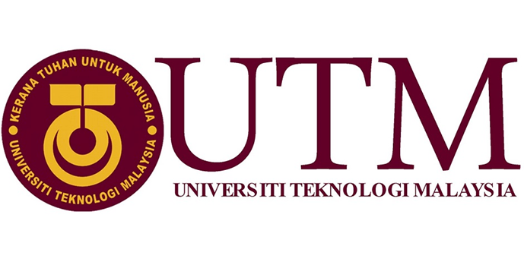
REPORT BY : -MUHAMMAD FIKRI BIN ISMAIL
(A18CS0139)
-NUR SYAFIQAH BINTI TASERIP
(A18CS0201)
-TAN ZHI QUAN
(A18CS)
SECTION : 11
COURSE/YEAR : SCSV/1
LECTURES’S NAME : MADAM ARYATI BINTI BAKRI

Industrial Visit Report:
NEW ACADEMIA LEARNING INNOVATION
(NALI)
Contents
NALI Introduction 3
Booth 45- E-PaLuVed 3
What is E-PaLuVed? 3
Impact of E-PaLuVed 3
Booth 46- The information about soft skill 4
Impact of soft skill 4
Booth 47 – Independent Learning Modules Based On Scenario-Based Learning 4
Impact of Independent Learning Modules 5
Booth 48 – International Service Learning Program (ISLP) 5
Impact Of Islp 5
Booth 49: Learning Highway Engineering Course Through MOOC Platform Based on Authentic Learning Characteristic: Students’ Awareness and Accessibility. 6
Benefits of Learning Highway Engineering Course Through MOOC Platform 6
Relation between NALI and Learning Highway Engineering Course Through MOOC Platform 6
Booth 50: Comprehensive Academic Programme Development & Improvement: Case Study for Islamic Study Curriculum 7
Impacts of Comprehensive Academic Programme Development & Improvement. 7
Reflections to NALI 7
Trends of NALI 8

Table of Figure
Figure 1: E-PaLuVed Poster 3
Figure 2: Booth 46 Poster 4
Figure 3: Booth 50 Poster 7

NALI Introduction
NALI (New Academia Learning Innovation) is an initiative of making and providing a better teaching and learning environments, materials, systems and many more in order to help align with the Malaysian National Higher Education Strategic Plan, needs of employers and requirements of accreditation bodies. It was formed in 2013 by Universiti Teknologi Malaysia in order to create its own identity related to teaching and learning models, activities, materials, environments and systems.

Booth 45- E-PaLuVed

What is E-PaLuVed?

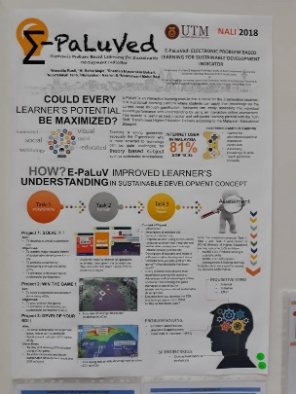
Figure 1: E-PaLuVed Poster
Nowadays, our life is full with technology and internet especially for the young generation. This can be shown where there is about 81% internet user in Malaysian from age 18-34. It can’t be denied that almost every youngster today has their own smart phone. Because of this, our government create the E-Paluved which is a practical platform where z-generation can apply their knowledge on the current issue through gamification. With this, student performance and understanding can be assess easily by using interactive online assessment.

Impact of E-PaLuVed
The first task is eCity and SimCity where there are 3 projects which is solve it, win the game and develop your SDI. For the first project, student need to develop sustainable city for identify major issue, enhanced understanding for sustainable development. For the second project, the student is required to solve the issue using eCity by winning the game, then the students have to solve the SDI by playing and develop SDI indicator using eCity game for project 3. The second task is Kahoot where student need to play the game in limited time. The task3 is writing report, where student need to submit report include content such as introduction, propose solution, description of selected city and so on. As the main purpose of these task, student will learn the problem solving skill, scientific skills and inquisitive mind.

Booth 46- The information about soft skill

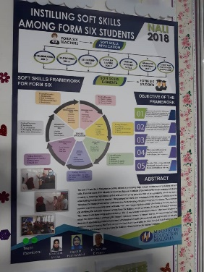
Figure 2: Booth 46 Poster
As we all know, form six is one of the good choice for the Malaysian Certificate of Education (SPM) leavers in our country. However, many people nowadays think that form six is same as the secondary school like form one to form five, and because of this many parents more willing to send their children to private colleges or university to further their education by spending a lot of money. Actually, form six are able to help the student in development of talents and creativity for fulfilling international standard. Recently, the research has been carry out to study the effect of instilling soft skills among form six students. The research was carried out by 12 respondents from selected zones in Johor to get the data from answering the research question. Based on the result, there are 24 dominant application theme used by teacher and 24 theme soft skills equipped by form six students which show the skills framework based on teacher’s instillation.

Impact of soft skill
According to the research, many skills can be learnt by the students when form six teacher teaching with soft skills application. The skill such as communication skills, team working skills, leadership skills, problem solving skills, critical thinking, information management skills, ethics and professional moral value. For the communication skills, students have to make presentation, report writing, discussion which all about the current issue, and this help them to improve their speaking and writing skills. For teamwork and leadership skills, the group will be formed and leader will be chosen, where the team will learn about teamwork, socialising, information sharing while leader need to be responsible, reliable and good in leading the team. For critical thinking and problem solving skills, students have to read more book and gather information to have more creative idea, and able to solve the problem by the mature thinking. For information management skills, the students will able to arranging and accurate systematic and resourceful information. The students will be etique and professional moral value such as responsible, self-confidence, motivation by doing group talk, discussion and presentation.

Booth 47 – Independent Learning Modules Based On Scenario-Based Learning
Based on the brief from this booth by Dr. Noor Azean Atan, she explained that scenario based learning is basically a method of educations that relates the daily routines life, works, events through social interactivity and aspects of materials with educations. From the brief that had been given to me from the speaker of the booth, I conclude that this program or method is focusing on hands-on activity during learning process in order to give better understanding to students about the things that they have learnt. This is also a fair method for some students who are more looking forward towards hands-on activity compare to in class studies. The aims of this program is to form educational module regarding to scenario based learning, active learning based on difference scenarios and also to evaluate the outcome of the usage of those two modules through self-learning based on scenarios.

Impact of Independent Learning Modules
This research has successfully helped students in supporting their creativity in designing and producing modules regarding to the activities and programs that they had carried out such as bakery, milks and eggs processing and many more. The modules also encourage students to get involve in scenario-based learning process which leads them into different kind of studies context.

Booth 48 – International Service Learning Program (ISLP)
ISLP is a program organized by Universiti Teknologi Malaysia (UTM) in collaboration with Universiti Muhammadiyah Purwokerto (UMP) based in Indonesia which provide consultation and training in the implementation of sit in SL/KNN (international) collaboration programs. Under this program, there were several programs which had been held between these two universities such as Program LOHAS (Living of Health and Sustainability) that is related to health issues, Beliapreunuer that focus on producing young, innovative and successful entrepreneur mong the students graduated from the universities and many more programs and activities. All of these programs have its own agendas and background which mainly involved students from Malaysia and Indonesia. There was also a program that called Project Kulneri which indirectly letting the participants of the both countries to learn about each other’s food culture and also teaching themselves about how to cook the foods from the outside of their own country which in this case is the Indonesian’s food.

IMPACT OF ISLP
Besides of helping in generating income sources for Faculty of Educations of UTM, this particular programs also help strengthens the collaboration network between the two institutions which leads to the stronger and closer bond between Malaysians and Indonesians. The participants also got to improve themselves especially in the terms of communication skills, team working, and leadership. Through that, a skilful and actives students will be born which going to be useful in fulfilling the industrials and employers need. Besides of what had been stated, our observations on this booth also show that both students from these two countries got the knowledge about Indonesians culture and the same way goes to Indonesians students which they got to learn and practices more Malaysians culture.

Booth 49: Learning Highway Engineering Course Through MOOC Platform Based on Authentic Learning Characteristic: Students’ Awareness and Accessibility.
The next booth that we visited is the Learning Highway Engineering Course Through MOOC platform’s booth with our exhibitor Noor Azean Atan. First of all, the objective of this project is to design and implement Highway Engineering course through a MOOC Platform Based on Authentic Learning Strategy. In order to be a good engineer, student must know how to solve the real-world problems and must have an inquiry and a good thinking skills. So, this platform provided an activity that involves the real-world problems for the students to accomplish it by using their creative ideas and thinking skills to direct their own learning in doing the project work. The second objective of this project is to identify students’ awareness and accessibility towards implementation Highway Engineering course through a MOOC platform. Result obtained showed that, 83% of the students were aware about the existence of this platform. For students’ accessibilities, it shows that university provided a limited internet speed to the students.

Benefits of Learning Highway Engineering Course Through MOOC Platform
The benefits of this project is that students can have a good skill to solve some real-world problems that they have to face after they are graduated. From that, they will have no problems to finish their work when they are working as an engineer one day. Then, students can access many problem solving videos easily using this platform. Student also can get many study materials in this platform that they can use to make a revision or maybe for their assignments.

Relation between NALI and Learning Highway Engineering Course Through MOOC Platform
The MOOC platform provided useful information and knowledge pertaining flexible education in UTM through the implementation of UTM-MOOC, aligned with New Academia Learning Innovation (NALI) framework.

Booth 50: Comprehensive Academic Programme Development & Improvement: Case Study for Islamic Study Curriculum
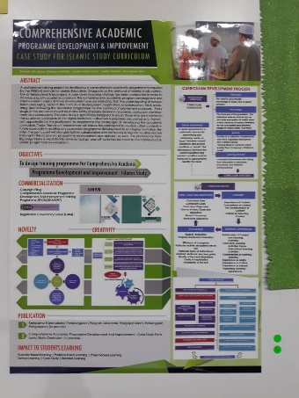
Figure 3: Booth 50 Poster
The exhibitor that tell us about Comprehensive Academic Programme Development & Improvement: Case Study for Islamic Study Curriculum is Noor Azean Atan. A professional training project on developing a comprehensive academic programme is required by the PERGAS institute for Islamic Education, Singapore as the demand of Islamic study curriculum at tertiary level is increased. A case study teaching strategy has been conducted in order to develop a quality academic program. This comprehensive academic program development and improvement consists of three development process including first: the understanding of educational philosophy, second: the curriculum development, registration, and execution, third: evaluating and reviewing the academic programme for the continual improvement purposes. The first objective of this program is to design training programme for Comprehensive Academic. A case study has been made in order to develop a quality academic system to all students. This case study is basically one of the initiatives to improve the learning method that is currently used by the system. Next objective is to make a programme development and improvement in Islamic study.

Impacts of Comprehensive Academic Programme Development & Improvement.
The benefits of this program is students have a new learning experiences during their learning process. Other than that, this program gives a new evaluation to the learning method that been used today. The students also can learn to make a good decisions and know the content of their studies.

Reflections to NALI
During the visit to New Academia Learning Innovation(NALI), we observed that we need new ways in the study environments in order to make the studies become more effective in developing eras. As for us, we think that all of these programs that are featured in the NALI could give a big positive impact to the students and also to the instructor and lecturers that are involved and using the program’s features. The students could easily find an extra learning materials and the lecturers can just give the notes and learning through online.

Trends of NALI
After visiting NALI, we found that the trend of this program is to produce the young generation with quality which are responsible and independent. I learnt that most of the program involved with NALI are able to develop the problem solving skill and creativity of the student. This is because students are encouraged to give their own opinion and creativity during the learning and teaching process. That is the reason why some of the booths at the NALI event promote hands-on learning process instead of only spoon-feeding method in the class. Most of the students nowadays are interesting in technology and internet where we can prove it easily because almost every student has their own laptops and smartphone. So more creative learning methods are needed to prevent the students feel boring and tired in the class by using mini games such as eCity, SimCity, Kahoot and so on. Hence, NALI playing an important role in learning and teaching process by providing new methods of learning with more benefits.

Task of Group Members
Tan Zhi Quan – Booth 45 & 46
Muhammad Fikri Bin Ismail – Booth 47 & 48
Nur Syafiqah Binti Taserip– Booth 49 & 50

Bibliography

http://ctl.utm.my/nali/pengenalan/

