

Industrial Visit Report 2

Name : Ishaq Sani Ishaq – A18CS0353
How Kah Hui – A18CS0074
Izzat Marzuqi Bin Ghali – A18CS0080
Course : SCSP 1513-09
Technology and Information System
Lecturer Name : Dr. Aryati Bakri

Table of content
1 Introduction 3
2 Details of the journey 3
3 Detailed Description 4
3.1 Organization Structure 4
3.2 Services and Products in Cool Code 5
3.3 Achievement 5
4 Reflection 6

Table of Figures
Figure 1 CEO of Cool Code, Mr. Arif Tukiman 3
Figure 2 The first 20 students 4
Figure 3 The remain 21 students 4
Figure 4 Organization structure of Cool Code 6
Figure 5 Omar & Hana Mobile Game 7
Figure 6 Didi & Friends Playtown 8
Figure 7 The photos when the company won the prize 8
Figure 8 Achievement of Cool Code 9

Introduction
Cool Code is a company that makes games, websites and applications. The CEO and founder of Cool Code is Mr. Arif Tukiman. He is a graduate of UTM Johor Bahru, he studied diploma in computer science at UTM Kuala Lumpur before deciding to further his studies at UTM Johor Bahru where he studied Graphic design and multimedia. He decided to further his studies after graduating from UTM. He started his personal business at second year in university by selling customized T-shirts, then he called a group of students from different computer courses to help him finish creating an app. By doing that, he was offering free tuition courses to other computer science students. After graduating he started his own company and he became an entrepreneur.
On 15th November (Thursday) we had the opportunity to visit Cool Code Sdn.Bhd, Johor Bahru. We had the opportunity to be briefed by the CEO, Mr. Arif Tukiman, he briefed us about Cool Code, how the company works, partners, plans and their achievement so far. Then we had the chance to walk around the company and talk to other members of the company, asked them a few questions and got some advice from them.

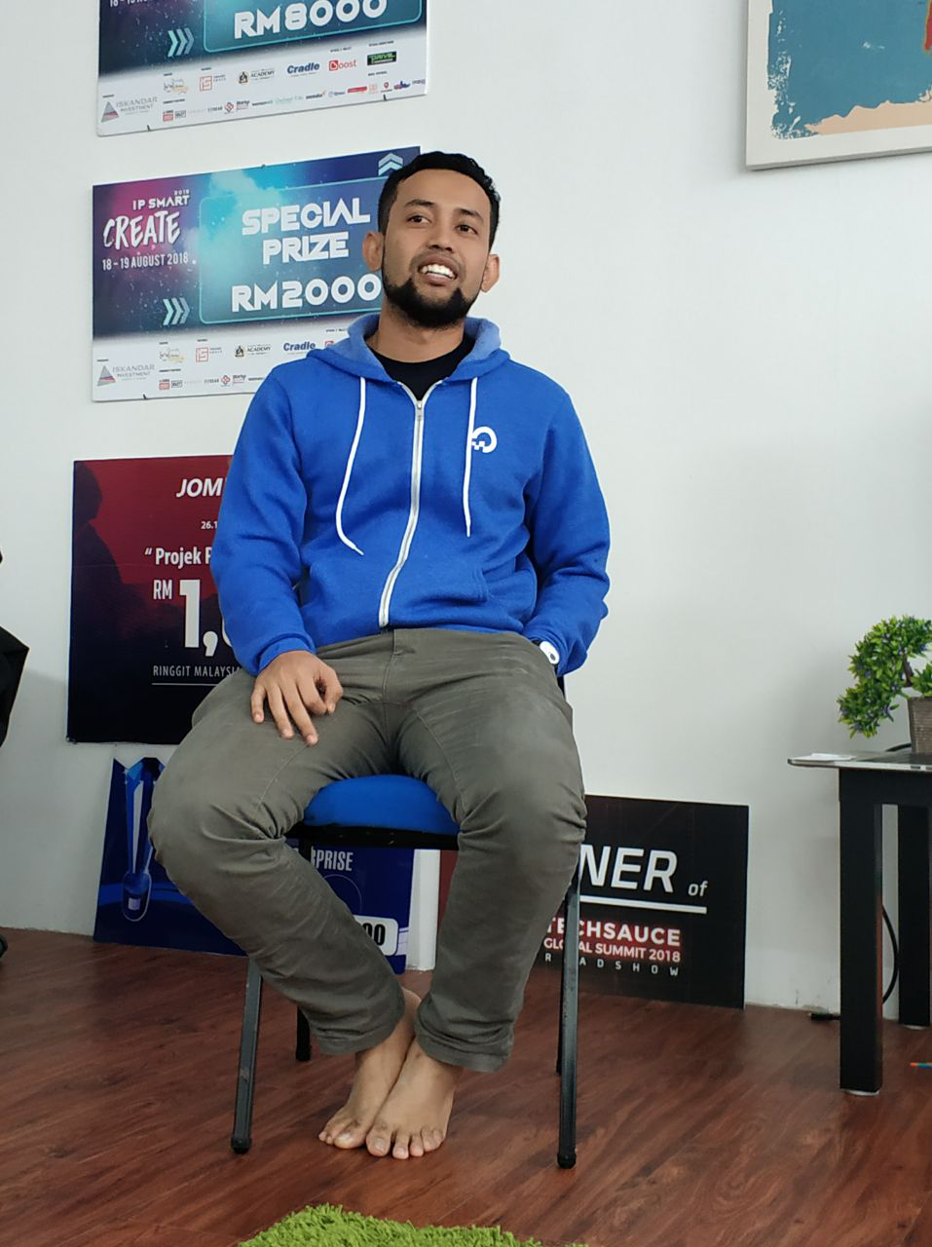
Figure 1 CEO of Cool Code, Mr. Arif Tukiman

Details of the journey
The trip was accompanied by Dr. Aryati Binti Bakri from faculty of computing UTM. The students gathered at Dataran KTDI (Kolej Tun Dr Ismail) University Teknologi Malaysia by 2:00pm. All the students boarded into the by 2:15pm, the bus had the capacity of taking 37 students, 4 students followed Dr.Aryati using her personal vehicle. We reached Cool Code Sdn.Bhd by 3:00pm. The first of 20 students were accompanied by Dr.Aryati to the company while the remaining waited inside the car. The first batch came back around 4:15pm, the second batch departed at the same time. We briefed by the CEO and some members of the Cool Code company on how the company works, achievements. By 5:30 PM the briefing ended and we got a chance to talk to other members of the company, ask them a few questions and got some advice from them. The visit ended by 6:00PM and we got back to Dataran KTDI by 6:30PM.
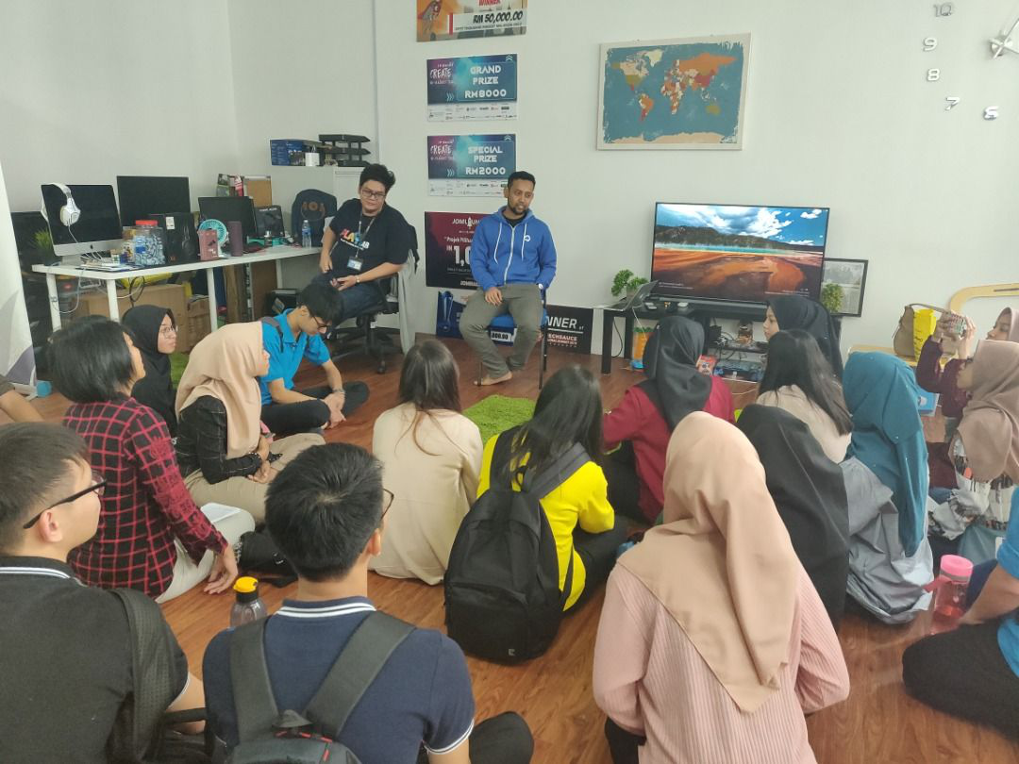
Figure 2 The first 20 students
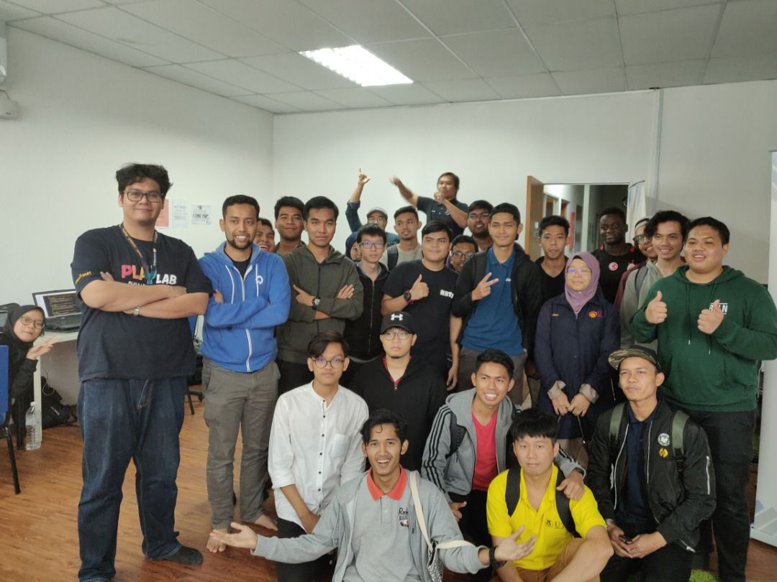
Figure 3 The remain 21 students

Detailed Description

Organization Structure
Cool Code is a company that develops apps, games and websites for clients. It consists of 5 departments starting from the top management, web design department, games department, mobile apps department, creative content department and the financial department.
The top management: it is the CEO Mr. Arif Tukiman, the CTO Mr.Ahmad Fikrizaman and COO Mr.Amir Fazwan. Mr. Arif Tukiman founded the organisation and got the team together followed by Muhammad Ridzwan the project executive, he takes care of all the projects, inspects the projects. He is followed by the business development executive called by his name Muhammad Arif Izzat, he handles all the contracts from the clients and makes the business deals in the company.
Web design department: this is the department that handles the web development section in the company, the head of the department is Muhammad Kamarool, he is a senior web system developer, he is followed by Muhammad Nazrin who is a junior web system developer and Muhammad Asyraf a junior web system developer as well.
Game development department: This is the department that develops and create games for the clients. It is lead by Sharif Tariq as the senior game developer followed by Mohd Alwi as the junior game developer.
Mobile App development department: this is the department that develops applications for the clients, the head of the department is Abdul Hadi who is a senior app developer.
Creative content department: this is the department that gives all the creative content on any projects, makes the videos and the creative idea. This is lead Muhammad Hafizuddin a creative content developer.
Financial department: this is the department that takes care of the financial activities in the company. Muhammad Haqqi the digital marketing executive, Badrul Hisyam is the account and finance marketing, Nadia is the sales executive.

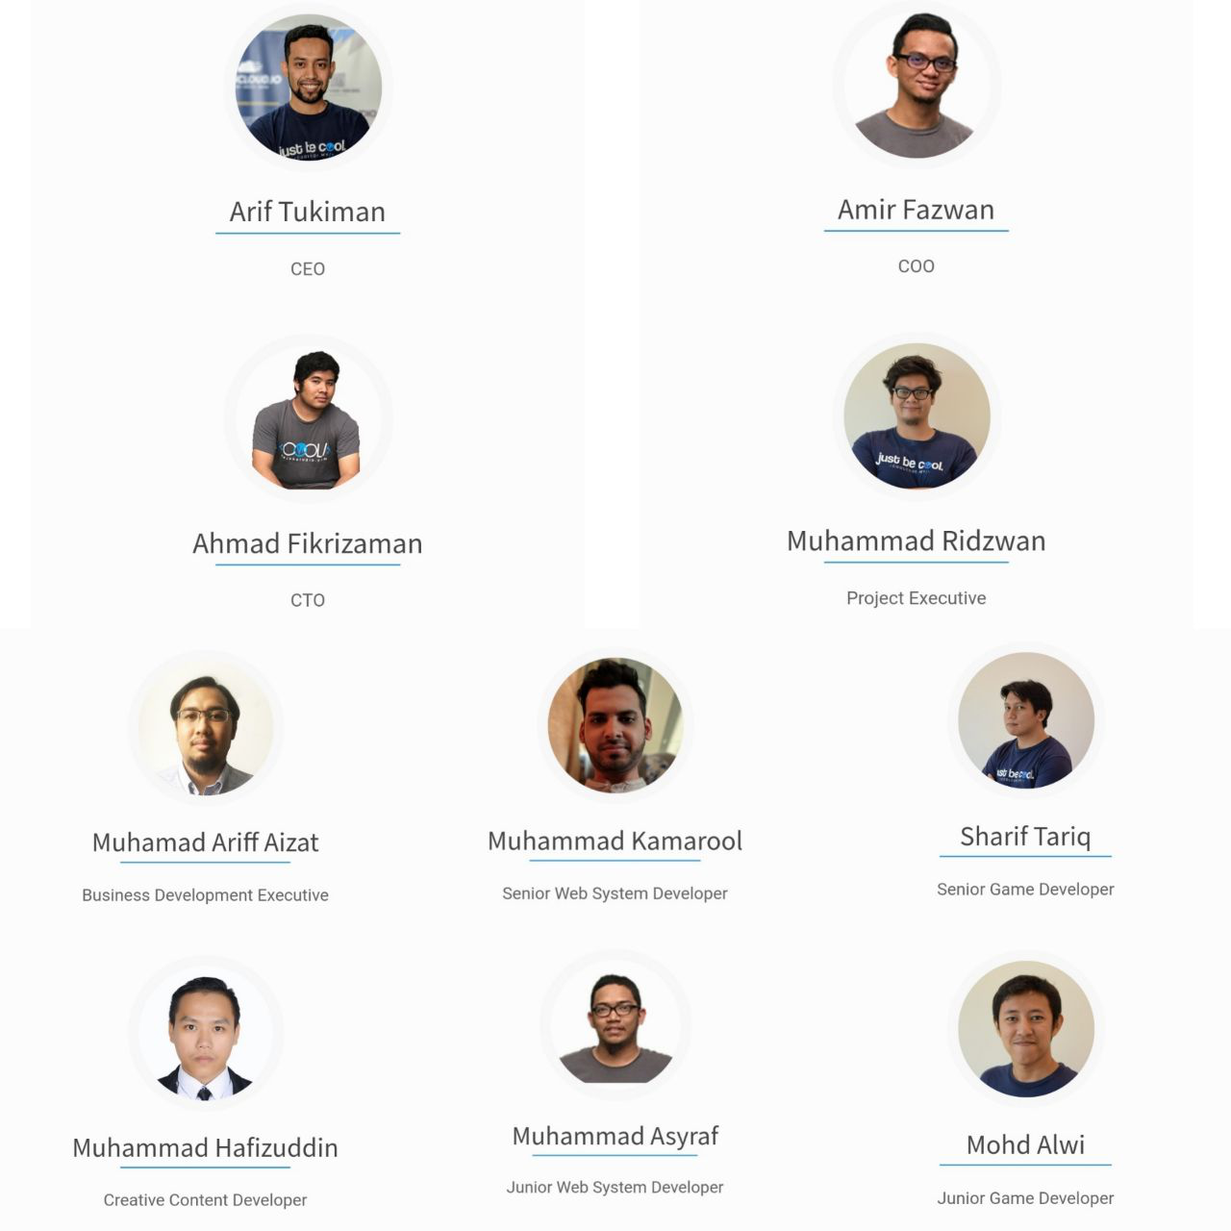
Figure 4 Organization structure of Cool Code

Services and Products in Cool Code
Cool Code is a company that develops mobile apps, games and web systems for its client. It has partnered with companies such as Astro, Malaysian Global Innovation and Creative Centre, Mdec, Twin System, Universiti Teknologi Malaysia, Yayasan JDT, Zamsaham Training and Consultancy and Sedania Innovator. There is a program called Cool Code academy, it is a program where someone registers and takes a course. Cool Code Academy provides training for people who need new skills by implementing sharing knowledge method from our expert in application development. It provides courses such as Mobile native application development using Android Studio,
Mobile hybrid development using Ionic framework, Game development using Unity 3D, Web application development using Laravel Framework. They has developed mobiles games for Astro such as Didi & Friends Playtown, Rainbow Jawi and Rainbow IQRA an application that allows a person to learn through playing a game, it teaches the person on the arabic alphabets and how to read in arabic. The company has developed applications like Smart Tebika Kemas. This is an application that allows children to learn through gamifications. The CEO briefed us on their plans for the upcoming year 2019. They are launching applications and mobile games such as Omar & Hana, it is a mobile game that is linked to children learning.

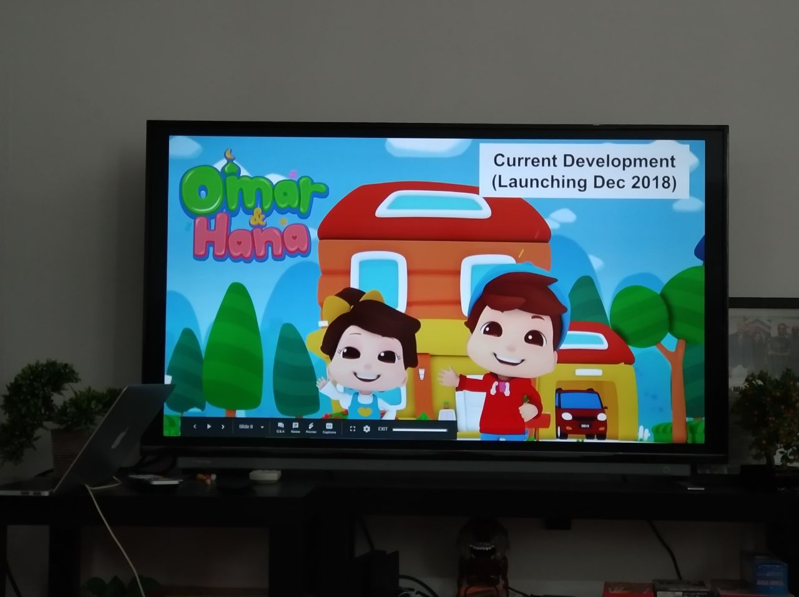
Figure 5 Omar & Hana Mobile Game

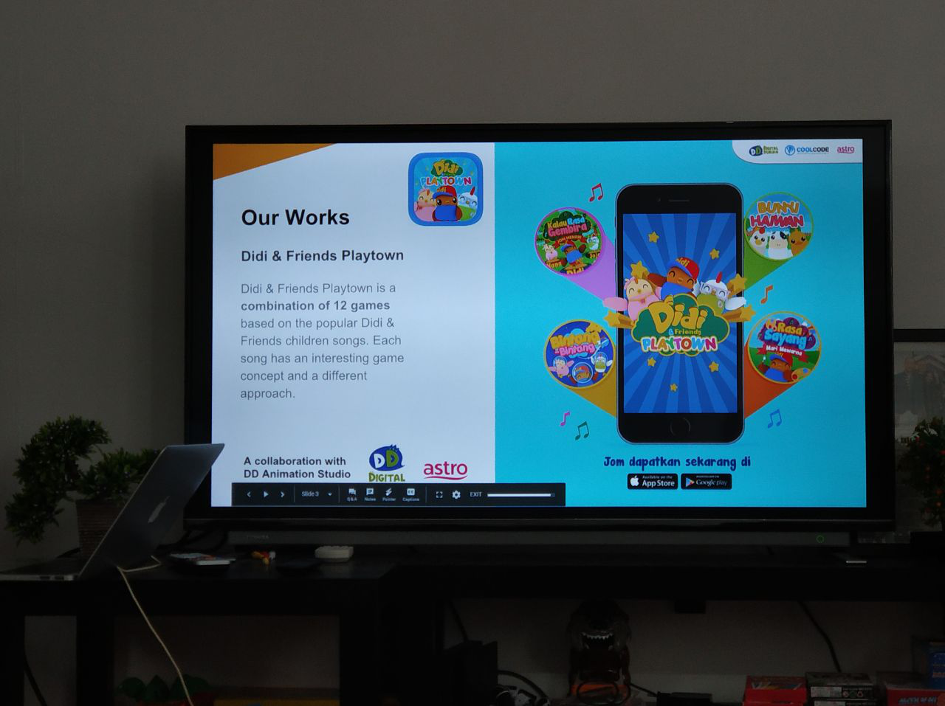
Figure 6 Didi & Friends Playtown

Achievement
Cool Code has achieved a milestone by winning the Malaysian digital games competition by developing a mobile game called Rainbow IQRA which came with a prize of 50’000 ringgit cash. The company has managed to stay top at google play store category of educational games for 2 years in a row 2017 and 2016, this is due to Didi & Friends Playtown being in the Top 3 and Top grossing Educational game at google play store. Didi & Friends Playtown was voted as one of the top 4 games in Malaysia in the year 2016. The company also won for Idea, Concept and MVP. They won the Grand Prize (RM8000) and Special Prize (RM2000). The company is one of the top rated mobile app and games developing company in Malaysia.
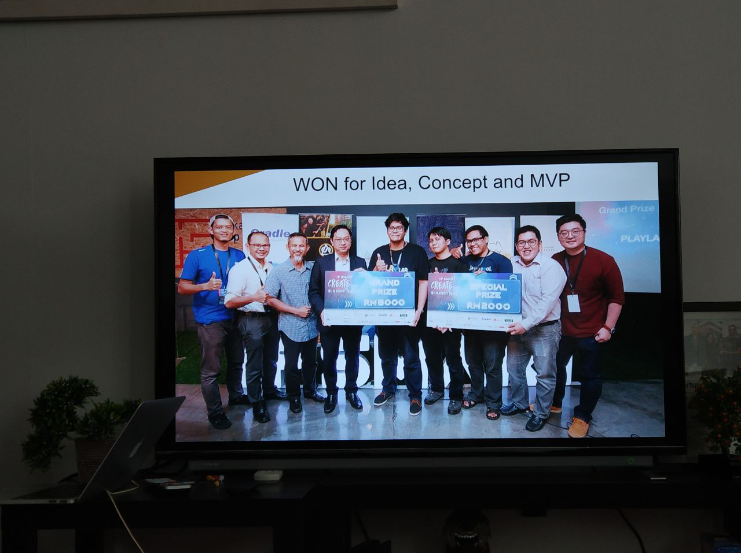
Figure 7 The photos when the company won the prize

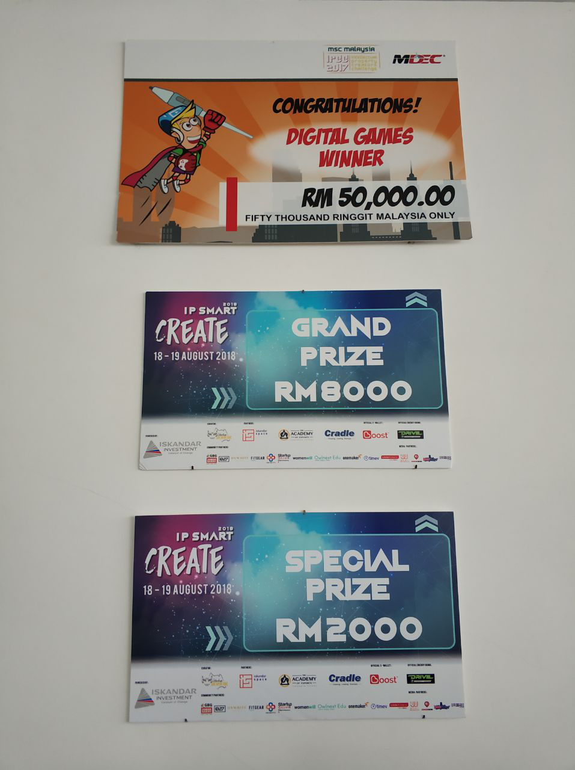
Figure 8 Achievement of Cool Code

Reflection
After the visit to Cool Code and having a chat with the CEO, it showed us that going to school and studying something does not stop you from achieving your dreams. The CEO started his business while he was in his second year, this is an inspiration for all of us. Nothing can stop us from achieving what we want to achieve in this life. It made us realize that we can achieve our other dreams while still having a degree in graphic and multimedia design. It showed us how we can change the way people think and their mind set because after the talk, he showed us that we can be who we want to be if we work hard. He inspired us and we are very grateful for this visit and learning a lot of things.

