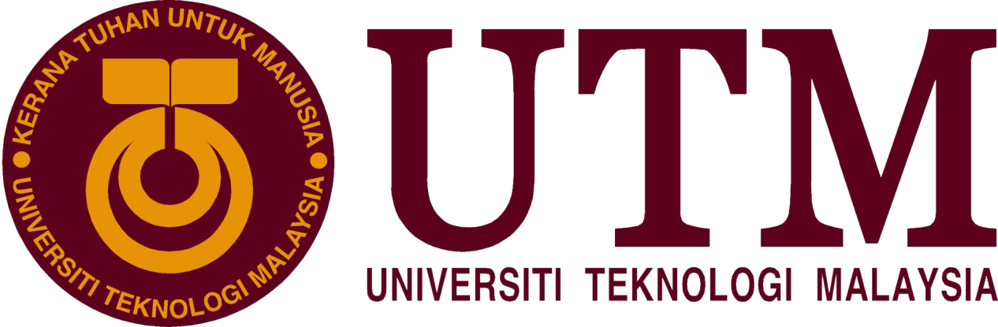

Industrial Visit: IoT & Internet 2.0
BY:
MUHAMMAD HAFIZUDDIN BIN ABDUL RAZAK
NUR IRDINA BINTI AHMAD RIFDI
TAN WEI KOK

Technology and Information Systems (SCSP1513/09)
School of Computing, Faculty of Engineering, Universiti Teknologi Malaysia
Date: 18th November 2018
Venue: P03-221, School of Electrical Engineering
Report Date: 28th October 2018

Table of Contents

1 Introduction 3
2 Activities during IoT 3
3 Public Lecture 4
3.1 Internet-of-Things (IoT) 4
3.1.1 Industry 4.0 and trends 5
3.1.2 Computing at the Edge 6
3.1.3 Flowserve 7
3.2 Internet 2.0 7
4 Summary 9
5 Bibliography 10

Introduction
On 18th November 2018, Internet-of-Things (IoT) Open Day 2018 for the second time was held at School of Electrical Engineering (SKE), Faculty of Engineering, Universiti Teknologi Malaysia (UTM). The open day was organized by Advanced Telecommunication Technology (ATT) Research Group in collaboration with Communication Engineering Program, ICONIX Consulting Sdn Bhd, JURUTEK and Kolej Tuanku Canselor UTM, and it took around 10 minutes from School of Computing if we go there by walking. There were so much activities during the event but we only had chance to join the public lecture by Intel and Mimos about IoT and Internet 2.0 at P03-221 around 11 am to 1 pm. Some of the activities that been organized by them in the open day are project showcase, hackaton, hands-on training and workshop, open booths, training registration and also industrial talks. Most of the booths are about technologies invention and also promote us to expose and aware with Science, Technology, Engineering and Mathematics (STEM). Besides, IoT Carnival 2018 is to attract the students and people to further their studies especially in IoT fields and also to promote their products such as research findings, final year projects and labs projects. In addition, this IoT Open Day is sponsored and collaborate with many popular companies which is Tenaga Nasional Berhad (TNB), Mimos, Intel, Hewlett Packard Enterprise and many more.

Activities during IoT
One of the activities that collaboration between UTM Advanced Telecommunication Technology (ATT) Research Group and Iconix Consulting during the open day is a hackathon challenge. This challenge is open to anyone who want to join it who are students from Universiti Teknologi Malaysia (UTM) or any other local universities and colleges in Malaysia. This hackathon challenge is to promote and learn about IoT technology and also utilizing Arm IoT technology and platform. This hackathon challenge is in between 24 hours and it will be based on the IoT solution while the development of the solution will be based on Arm IoT technology. By doing this challenge, the participants will be understanding about the concept of IoT system.
The another activity is the organization of the IoT Open Day 2018 also provide training for those who are interested in IoT systems. They provided four training sessions scheduled and the IoT training activity consist of IoT Things, IoT Data Protocol and Gateway and also IoT Cloud and Enterprise Application Software.

Public Lecture

Internet-of-Things (IoT)
During the IoT Open Day 2018 held at UTM, there is a talk organized by Hewlett Packard Enterprise. The speaker is Syahrul Hafidz Suid who is the enterprise consultant of Commercial and Public Sector. The agenda of the enterprise are Worldwide CIO Agenda 2019 Predictions by Internet Data Center (IDC), Industry 4.0 - Technology Trends, and IoT- predictive maintenance. Firstly, Hewlett Packard Enterprise (HPE) providing the services of storage, server, networking, and converged. Storage, which is data storage, the world’s most intelligent storage is provided to build the hybrid cloud world to help the customer to unlock the full potential of the customer’s data. After that, the server provided by the HPE is software-defined, cloud enabled enterprise servers and systems that help customer to operate at business speed, for example, rack server and tower servers. Thirdly, networking is a smarter portfolio of networking products from the access layer to the data centre, in example, campus and branch networking and data centre networking. Converged is a converged system model with fluid resource pools that increases business agility. In addition, HPE also aims to accelerate the digital transformation agenda from the view of technology, people, and economic. From the view of technology, it creates an intelligent, software-defined solutions and edge to cloud. From the view of people, it aims to train the people to having skills, processes and culture to keep pace with innovation. In economics, it aims to have an investment strategies and business models to speed growth.
There are 10 prediction predicted by the Worldwide CIO Agenda. The first prediction is, by year of 2021, driven by LOB needs, 70% of CIOs will deliver “agile connectivity” via APIs and architectures that interconnect digital solutions from cloud vendors, system developer, start-ups, and others. The second prediction is compelled to curtail IT spending, improve enterprise IT agility, and accelerate innovation, 70% of CIOs will aggressively apply data and AI to IT operations, tools, and processes by 2021. The third prediction, by year of 2022, 65% of enterprises will task CIOs to transform and modernize governance policies to seize the opportunities and confront new risks posed by AI, ML, and data privacy and ethics. The forth prediction is through the year of 2022, 75% of successful digital strategies will be built by a transformed IT organization, with modernized and rationalized infrastructure, applications, and data architectures. The fifth prediction is, by 2020, 80% of IT executive leadership will be compensated based on business KPIs and metrics that measure ITs’ effectiveness in driving business performance and growth, not IT operational measure. The sixth prediction is, by 2020, 60% of CIOs will initiate a digital trust framework that goes beyond preventing cyberattacks and enables organizations to resiliently rebound from adverse situations, events, and effects. The seventh prediction is, by 2022, 75% of CIOs who do not shift their organizations to empowered IT product teams to enable digital innovation, disruption, and scale will fail in their roles. The eighth prediction is, through 2022, the talent pool for emerging technologies will be inadequate to fill at least 30% of global demand and effective skills development and retention will become differentiating strategies. The ninth prediction is, by 2021, 65% of CIOs will expand agile/ DevOps practices into the wider business to achieve the velocity necessary for innovation, execution, and change. The tenth prediction is, by 2023, 70% of CIOs who cannot manage the IT governance, strategy, and operations divides between LOB-dominated edge computing, operational technology, and IT will fail professionally.
During the talk, the second prediction is emphasise by the enterprise which is 70% of CIOs will aggressively apply data and AI to IT operations, tools, and processes by 2021. According to a survey, “which of these disruptive technologies is most likely to have an impact on an organization over the next three to five years?” 30% on big data or analytics, 29% on cloud, 22% on self-service IT, 20% on Mobile payments and Internet of things, 19% on knowledge-based systems. The source of data is Computerworld Tech Forecast 2017.

Industry 4.0 and trends
The speaker talked about the revolution of the industry from 1.0 to 4.0. We can see that in the past industry 1.0 which were 17th and 18th Century, the water and steam power are used to make the mechanical production functioned while in industry 2.0, which was the beginning of 20th Century, the usage of the electricity power was growing rapidly. Next, the industry 3.0 which was around early 1970, the country started to develop Information Technology (IT) and the community used it to automate production. And now, industry 4.0, every single thing is using cyber-physical systems to monitor and analyse the business.

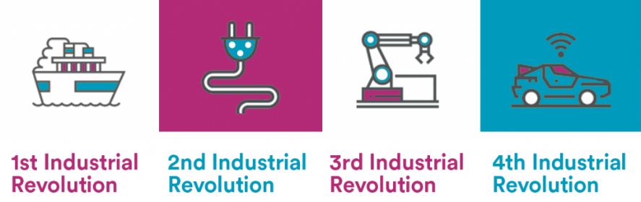
Figure 1 : Industry revolution from https://www.google.com/search?tbm=isch&q=industry+revolution&chips=q:industry+revolution,g_1:infographic:c5fS085DSFo%3D&usg=AI4_-kQIX_IbT31OngTcdXKxhgGRQ-80AQ&sa=X&ved=0ahUKEwj6jsT4lvfeAhUFQH0KHfSjBBoQ4lYILigA&biw=1536&bih=754
In addition, there are nine technologies transforming due to industrial revolution such as Autonomous robots. We know that the industrial internet of things (IIoT) refers to the manufacturing processes of industry and by using robots, it can be use in even greater utility. Next simulation can convert data that being processed to virtual model while horizontal and vertical system integration can make the larger companies and departments always connect to each other. The industrial internet of things made the devices in industry constantly connected and cybersecurity the cloud, additive manufacturing, augmented reality and big data and analysis. This is because, there are many advanced digital technologies are developed from time to time so we have to make it parallel with the industry 4.0 by transform the production. Moreover, most of the nowadays requirements include analysing data through machines because it faster and easier.

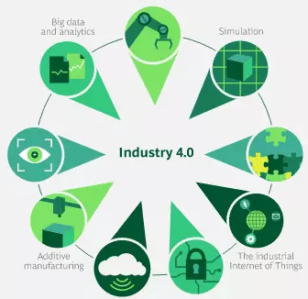
Figure 2 : Industry 4.0 from https://www.bcg.com/en-sea/capabilities/operations/embracing-industry-4.0-rediscovering-growth.aspx

Computing at the Edge
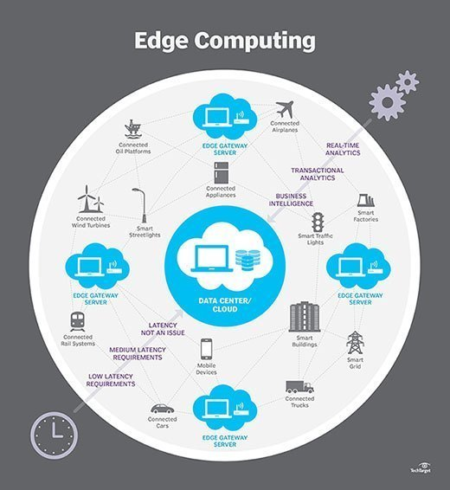
Figure 3 : Edge Computing
Edge computing is the practice of processing data near the edge of user’s network, where the data is being generated, instead of in a centralise data-processing warehouse. Hence it produced the two flow which is data flow and control flow. Internet of Things, “Things” that generate data and need control, there are four stage of data flow. Stage 1 is when the data is sensed, things controlled and flow to stage 2, data acquired and aggregated, these two stages are categorise as operations technology. In stage 3, early analytics and compute is carried out and flow to stage 4 which is deep analytics and compute. These two edges are categorise as edge IT, data centre and cloud. There is the edge between operation technology and edge IT, data centre and cloud. In this way, edge computing enables data-stream acceleration, including, real-time data processing without latency. It also allows for efficient data processing in that large amounts of data can be processed near the source.

Flowserve
Flowserve is a potential technology that will be widely used in the industry. It is because Flowserve captures sensor data from heavy-machinery, performs analytics, and then uses machine learning by comparing this data with information from other equipment to predict failures before they occur – extending the life of assets, improving safety, and reducing costs. In example, the Flowserve system embedded in the heavy machinery will enable the maintenance of the machine carried out easily. It also ensures the machine works in the most effective and efficient situation. Flowserve also help to solve the biggest flow-control challenges, which now is widely used in fluid machine system.
HPE also makes the analytics architecture on the field of oil and gas, manufacturing, transportation and health. It emphasise on oil and gas during the IoT talk, which is distance deep learning framework. During this framework, a detector is built to detect the mineral content underground with a distance. The detection data will be processed and sent to the data centre. In this way, the content of the mineral underground will be detected and stored as a data. It allows the manufacturer can look for the highest content of mineral to be mining. It will save the cost of mining due to the high fees spent in each time of mining activity but getting the low content of mineral. By doing so, highest content of mineral will be detected and carry out mining activity at that location. For the HPE Info sight, AI for the data centre will become the trend of the industry 4.0. AI system will process the data automatically and in a high efficiency and it will decrease the burden of the data workers.

Internet 2.0
The second talk by Maxis, Internet 2.0 which is transaction-based networking. The speaker is M.Nazrul which is work as network services. The outline of the talk is Man-computer Symbiosis, History or Trend of the Internet, distribute ledger Technology or Blockchain, strength, weaknesses, opportunity and threat, use case and summary. Man-Computer Symbiosis is a fundamental or key text of the modern computing revolution. J.C.R Licklider said that “In the anticipated symbiotic partnership, men will set the goals, formulate the hypothesis, determine the criteria, and perform the evaluations. Computing machines will do the routinized work that must be done to prepare the way for decisions in technical and scientific thinking.” Preliminary analysis indicate that the symbiotic partnership will perform intellectual operations much more effectively than man alone can perform them.”
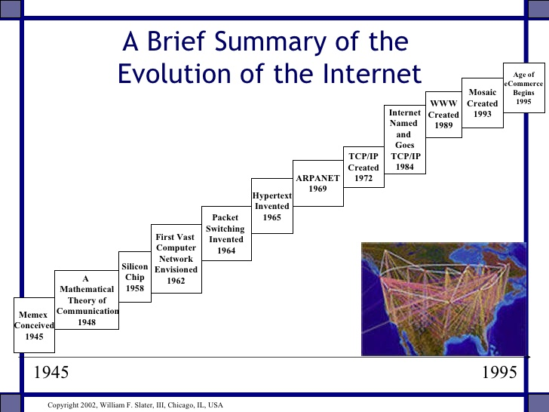
Figure 4: Internet History
In 1945, Memex conceived and there is a mathematical theory of communication 1948. Silicon Chip is created in 1958 and there has the first vast computer network envisioned in 1962. After that, packet switching invented in 1964. In 1965, Hypertext is invented and ARPANET created in 1969. In 1972, TCP or IP created and Internet Named and Goes TCP or IP in 1984. WWW and Mosaic created in 1989 and 1993 respectively. The age of eCommerce begins in 1995. However, there are issues and problems for the Internet. Surveillance and censorship and commoditized user data are the first issues and problems discovered. The second problem is the value stack of the internet. Communication operators were providers of wired telephony, mobile telephony, text messages (SMS), and data (internet) services. Historically, these were the direct services to be consumed by customers. Something fundamental has happened in the last decade: network operators have moved into being indirect providers of value. Direct consumption of services and products are being enabled by platforms and companies that leverage communications infrastructures. Traditional network operators are a piece of the value pipeline of which end-consumers rarely know about. To preserve the key elements of investment required in any growing business, it is existential to provide direct value to consumers and not be another widget. For the trend of the Internet, Internet 2.0 will be distributed as compared to past internet is disconnected and present internet is connected. Internet 2.0 will have the blockchain start-ups which will disrupt non-financial markets. So, what is the blockchain? A block chain is a peer-to-peer distributed ledger forged by consensus, combined with a system for “smart contracts” and other assistive technologies.” There are two types of blockchain which are open public blockchain and permissioned enterprise blockchain. Public blockchain is anyone can be part of the network having copy of the ledger, everyone can participate and no single person owns or controls. Private blockchains is held or distributed only with trusted participants and network may have owner who has permissioned to commit. There is also a difference between centralized databases and blockchain. The centralized database is developed by a controller and distribute to the clients or users via user agreement and term of use. It will allow user’s data to store at the database legally. While using blockchain, there are no database control by a controller but the data shared in the blockchain by self-permission. There are also having the strengths, weaknesses, opportunities and threats of blockchain.
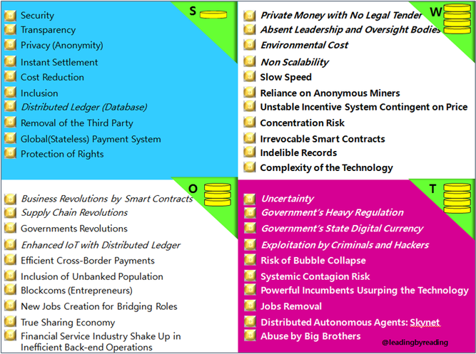
Figure 5: Strengths, Weaknesses, Opportunities and Threats of Blockchain.

Summary
The summary from these talk are we can learn something new that now involve in our real world. We can know what is going on the technology market area right now. When we know, we can clearly explore this new IOT technology for the future of technology. We also can prepare ourselves to be more productive because the talk was really open our eyes to see beneath the important of technology.
From the 1st talk, I can conclude that IOT is a future technology that will take place in our world to perform task that human has a limit to it. IOT was not designed to replace human but to make human’s work easier. IOT also will be in our hands real soon, and we can solve the problem occur in our world with the help from the devices itself. IOT can reduce the failure of a system or device, this record is being proved by the HPE that they reduce to 87% failure. This is a significant movement that we will avoid failure and the same time provide a better solution to repair it.
From the 2nd talk, I can conclude that blockchain will be our main uses in our real world. Blockchain is far more has its good from its bad, it protected our privacy, reduce the power of middle man, solve the commemorative data and the transparency of a data that we get. It is also reduced the government censorship on certain information, because the right of the user is give back to us. We can control our data, approve who can view our data, and we can get the original data that is fresh. In addition, we also can avoid the 3rd party can view and control our data. Here came the issue of trust, they can manipulate and send it to anybody they approve without we ever know. In the world of internet nowadays, privacy and security are main vital issue, therefore the blockchain and Internet 2.0 are the right and the best way to solve this issue in future world.
Finally, with these 2 talk, we can imagine and know the new technology that been developed right now to fulfil what the user right and our wants. These 2 technology also a significant movement towards a better way in term of the usage, privacy, security, transparency of a data, speed of data send and many more. Therefore, we as a Graphic and Multimedia students have to start to explore this new technology to get into Industry 4.0 that is booming right now.

Bibliography
-Industry 4.0 (2018) from https://www.bcg.com/en-sea/capabilities/operations/embracing-industry-4.0-rediscovering-growth.aspx
-Activities during IoT (2018) from https://iotcarnival.fke.utm.my/
-Industry 4.0: The Top 9 Trends For 2018 by Liubomyr (El.) Kachur (May 30, 218) from https://dzone.com/articles/industry-40-the-top-9-trends-for-2018
-What is Edge Computing (n.d) from https://www.hpe.com/my/en/what-is/edge-computing.html
-IT Infrastructure Products (n.d) from https://www.hpe.com/my/en/products.html
-Blockchain Revolution by Jay (April 4, 2018) from https://leadingbyreading.org/2018/04/04/blockchain-revolution-swot-analysis-book-review-part-8-9/
-Internet History and Growth by William F. Slater, III (September, 2002) from https://www.slideshare.net/nishantsri/internet-history-and-growth-2529158

