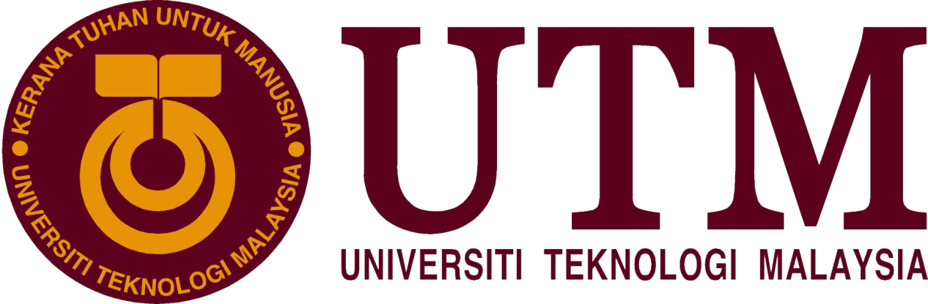

Industrial Visit: CICT, UTM
BY :
MUHAMMAD HAFIZUDDIN BIN ABDUL RAZAK
NUR IRDINA BINTI AHMAD RIFDI
TAN WEI KOK

Technology and Information Systems (SCSP1513/09)
School of Computing, Faculty of Engineering, Universiti Teknologi Malaysia
Date : 1st October 2018
Venue : Seminar Hall, Level 4, CICT
Report Date : 21st October 2018

Table of Contents

1 Introduction 3
2 Details of Journey 3
3 Details Description 4
3.1 Organization Structure 4
4 Services 5
5 Achievements 5
5.1 2016/2017 UTM achievements 5
6 Information System that have been developed 6
6.1 Transaction Processing System 8
6.2 Management Information System 8
6.3 Decision Support System 9
6.4 Executive Support System 9
7 Reflection 9
8 Bibliography 11

Introduction
Centre for Information & Communication Technology (CICT) was organized a briefing on ICT Services and Regulation about CICT. The talk was given by Muhd Zahri Zainal Abidin who is one of the senior staff at CICT on 1st of October 2018 at Seminar Hall Level 4, CICT. He shared variety of information and knowledge about CICT including the function of CICT, services that have been provided, ICT Regulations and Policy and also about the information systems that have been developed by them. In addition, the vision and mission of CICT is too close with the user of information technology due to the development of the industry and economy day by day. The director of Centre for Information & Technology (CICT) is Professor Madya Dr. Mohd Shahizan Bin Othman as known as Chief Information Officer (CIO). As we know, the main function of CICT is to provide ICT services for the University staffs and students in many aspects such as infrastructure, teaching and learning processes and system development.

Details of Journey
The industrial visit was held on 1st of October 2018, it took about 2 hours from 2pm to 4pm at Centre for Information and Communication Technology (CICT), UTM Johor Bahru. We went there by walking as it took only 10 minutes to arrive because CICT is just nearby Faculty of Computing. Firstly, we went to the seminar hall at Level 4 for the briefing session about CICT and it was given by Encik Mohd Zahri bin Zainal Abidin who is a specialist staff at CICT. The briefing content is about the introduction, objective, ICT services provided for student and ICT regulation/policy of CICT. After that, have a visit to CICT Galleria where the facilities of the CICT were kept. At the gallery, the speaker, Encik Mohd Zahri has a more detail explain on the facilities. We were told that we can use the facilities when we get the permission of the staff there. Besides, we also have a chance to see the evolution of the information and technology. A lot of hardware we can see at the galleria and the speaker told us that CICT often offer workshop to improve technical skills. In addition, CICT also have a lot of corporation partner outside. After the visit to CICT galleria, the journey to CICT was ended at 4pm.
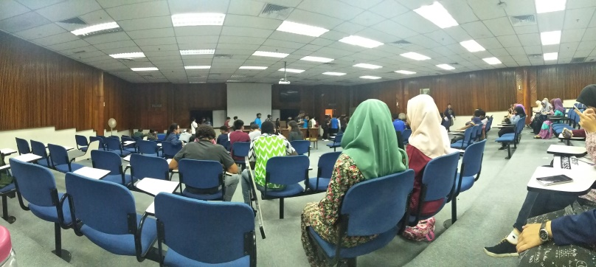
Figure 1 : Registration for CICT Talk

Details Description
3.1 Organization Structure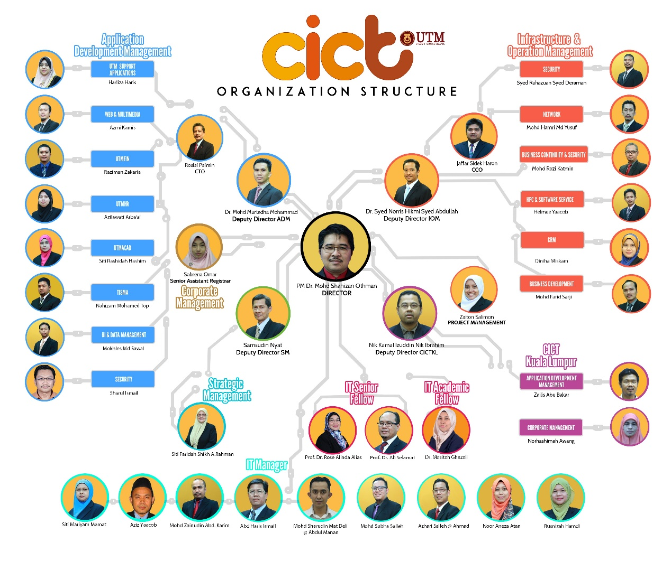
http://cict.utm.my/organization-structure/
Figure 2 : Organization Structure in CICT
There are 8 division in the organization structure, which are executive management, strategic management (SM), corporate management (CM), Application Development Management (ADM), Infrastructure & Operation Management (IOM), Project Management Office (PMO), Business Development Office (BDO) and CICT UTMKL. The CICT is located at UTM Johor Bahru and there are 36 staffs in CICT UTMJB and 4 staffs in CICT UTMKL. From the figure, we can see that the Director is PM Dr. Mohd Shahizan Othman and assisted by 7 Deputy Director for ADM, IOM, SM, CM, BDO, PMO and CICTKL. These peoples are the most important in the executive management of CICT UTM. In addition, there are 8 staffs under the Application Development Management of CICT, 6 staffs under the Infrastructure & Operation Management, 2 staffs under the CICTKL, a staff under Strategic Management, 2 IT senior fellow, 1 IT academic fellow and 9 IT manager.

Services
Centre for Information & Communication Technology (CICT) had provided variety type of services in Universiti Teknologi Malaysia (UTM) for their stuffs, workers, lecturers and also the students. This service will make the process of teaching and learning easier and more valuable. As we know, the CICT had prepared the student lab and it provided many facilities to make sure that the students of UTM can use the lab frequently. For instance, there are almost 100 computers in the lab and they also provide three spaces for the students to make a group discussion or assignments. Other than that, whoever wanted to make a printing or scanning service, they can go to the lab and have those services. There are also specialize multimedia and content authoring production lab (SMAL) in the student lab which is providing some facilities such as Mac Pro, Lighting and chroma key and whisper room. Besides, there are many type of software provided in the student lab like Final Cut Pro, Iwork, Adobe Suite and Roxio Toast.
The next services that produced by CICT is Student ID for every students that study in UTM. Each of a student have to register at CICD to get the UTMID as known as ACID ID and password so that they can access wifi in the college, faculty or any other places in UTM. In some places, we have to connect our laptop to the wired to get the internet connection but majority of the places around UTM are surrounded by wireless connection as known as Hostspot@UTM. Other than that, they also can enjoy the applications and facilities that connected with UTM such as MyUTM log in which is include e-learning, e-portfolio and many more about UTM. In addition, if there is any problem about our ACID ID, we can directly login to the ACID UTM website and check UTMID and reset our ACID password. By the way, the student also can have their own UTM official email by register in the URL http://mail.graduate.utm.my.
Furthermore, CICT also provide some platforms for the stuffs and the students to have their own software account or download the software. From what have been presented by Mr Zahiri, he said that there are two type of software. One of them is Microsoft Imagine and Office 362 and the other one is UTM License Software. We can easily access to the both of the network by searching the URL mail live UTM. The students and the staffs of UTM also can access the network that have been provided by UTM even the are outside of the UTM Campus by using Virtual Private Network (VPN). VPN allowed the students to access intranet services such as the databases from the UTM Library.

Achievements

2016/2017 UTM achievements
UTM 2016 Achievement Montage was launched on 16th January 2017 which corporate with the client UTM Vice-Chancellor & Office of Corporate Affairs (HEK). It was held at UTM New Year VC Engagement, Dewan Sultan Iskandar, UTM Development Timeline: Dec 15, 2015 to Jan 16, 2016. A video link is also provided which is https://youtube/chAA2S8EtVY.
Anugerah Sijil Pematuhan Saga 2017 & PTJ Paling Ceria & GempK Senamrobik Perdana
CICT team who have successfully prepared the best technical documents and bring the University Received the SAGA (Standard Accounting System For Government Agencies) Award 2017 which was submitted by the Accountant General of Malaysia on November 22, 2017. UTM is among 59 of 416 Agencies that have successfully received SAGA Compliance Certificate recognition other than USM, UPSI, UMPP, UPNM, UNISZA, UTHM and UPM.
It will be a catalyst for all CICT citizens to continue to provide excellent services to CICT and the University.

Information System that have been developed
Information system is a complex combination of computer hardware, software, data resources, procedures and trained people to capture, store, retrieve, transform and disseminate information within an organization. Information system also sometimes been used to describe an automated system which it is refer to computerized information system, which by then cover the machine, people and organized method to collect and process the data for the user or client. The information system is basically focus on to support operations management daily and decision making. And information system is the information and communication ICT that an organization use it daily.
The goal of an IS is to transform raw data into information that will help :
- Employees carry out routine business processes and operations
- Managers in decision making and problem solving
- Top executives can make strategic decision to strengthen the competitive advantages of the company
An IS is a complex because
- An is must model the organization processes
- The organization is dependent on its’ IS for a smooth operation
- The IS interface is complex due to many input and its outputs
- Input output relationship are structurally complex
- The IS requires a centralized data storage such as a database
All is must include the object such as, hardware, software, people, procedures and data

Figure 3 : Information System

- Hardware refers to physical components of a computer system

- This includes electric and electronic components, electromechanical components and mechanical components
- Computer systems may be connected by a network
- Such as input output devices, storage devices, computer cabinet and CPU

- Software refers to the non physical components of a computer

- A software program that instruct the hardware on how to process data into useful information
- This includes :
- Operating system = system software that manages application software and hardware
- Application software = programs for processing and end user data into information

3 . Data are fact that used by programs to produce useful information
- Audio data such as recording of human voice and other sounds
- Textual data and image data from the user
4 . A procedure is set of policy that users have to follow in order to operate the computer system
5 .People is the user that will be the key to success of an information system
- System staff such as programmers are required to maintain the IS
- People will use the system as a client to achieve the enterprise goals.
There are a many types of Information System such as transaction processing system, decision making system, management information system and global information system. But we will go through the based and classic information system that has been developed that all of us know, the 4 stage of pyramid.
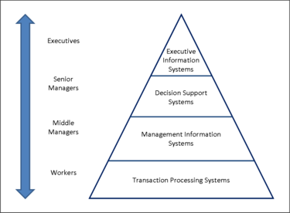
Figure 4 : Type of Information System

Transaction Processing System
- The purpose of this system is for collecting, storing and modifying records of routine and repetitive transaction
- The example of TPS include
  - Automated Teller Machine
  - Payroll Systems
  - Customers billing
  - Stock and purchase control
- A transaction is a logical unit of work
- The TPS processed record :
  - Listing = retrieve and display one or more record entered by the user
  - Merging = combine 2 or more list of records
  - Sorting = arrange orders according to a certain order
  - Updating = replacing the old record with the newest value

Management Information System
- The MIS is to support routine daily decision making and problem solving at operational level
- Managers and middle staff level use MIS to generate routine reports on business performance using result from the TPS and other internal data
- The reports are used to :
  - Monitor the present and past business performance
  - Predict future performance
  - Control business activities
- MIS has some general properties such as :
  - Its summarizes data for reports using simple routines such as comparison
  - Reports are formatted to answer routine, structured questions
  - It will generates reports on a regular basis using weekly, monthly and yearly results
- MIS also have different type including the Enterprise Resource Planning ( ERP ), Supply Chain Management ( SCM ) and Customer Relationship Management (CRM)

Decision Support System
- DSS helps managers to make decisions at the tactical level
- Summaries are generated using compiled information from the following sources :
  - Raw data from internal transaction files
  - Documents
  - Personal knowledge
  - Business model
- DSS also support both unstructured and semi structured decisions
  - Unstructured decision = it is non routine and complex problems and there is no known or clear method of obtaining solutions.
  - Semi structured decisions = Requirements are clear and predictable although non routine and there is some indication of the method to reach the decision
- DSS give some advantages include
  - Provides a combination of models, analytical tools, databases and automated processes to analyze data
  - Able to analyse unstructured situations to address uncertain or ad hoc business environment
  - DSS uses intelligent system such as rules in expert system and pattern detection in neural networks

Executive Support System
- ESS helps executives make decision at the strategic level
- They use this system to
  - Analyse current situation
  - Identify business trends and new opportunities
  - Formulate business strategies
  - Improve coordination and control\
- Role of ESS :
  - Summarize information of key business areas
  - Provides tool to analyse data
- Data and information collected for ESS are :
  - From various resources such as TPS, financial system, human resources and marketing department
  - Over a stretch time of time
  - Of 2 type such as soft data and hard data

Reflection
My reflection on this program is to encourage all of the people to understand this system management and its’ component such as software and hardware for the system. I hope that the history of the information system will continue to embark the generation for further improvement in information system.
My dream and my goal regard with my course are to full fill my dream since I was a kid to be a graphic designer and to be a game developer. Well, it is a hard achievement but I promise to myself and guarantee that I will be my best, reach the outstanding performance to purse my big dream. Nothing is impossible after it is done. I will continue further study to higher level to gain knowledge and to work big a gigantic company like Ubisoft and many more.
As I was stepped inside the CICT, I know in my mind I will one of those staff professional that working there. The program really left a huge impact and open my eyes that all work and job is hard but key to success is never ever give up. The talk really open my eyes to continue pursue my dream and it really related to my course that they will need graphic developer to increase the interactivity between human and system.
In my opinion, I will do my best and perform any task given to me. Alongside with that, I will search for any chances to gain experience from senior and programs that have been created special for this course. Later I will always reading news about the job scope and what industry want to have in every single employees depend on the time. I will improve also my soft skills from time to time and increase my English vocabulary. I will also improve my method to writing report or assignment in a neat and practical way. Besides that, I will focus on my study, joining many programs that related to my course either in this university or the outsider. That are my action regarding on what I need to improve based on what the industry need today.
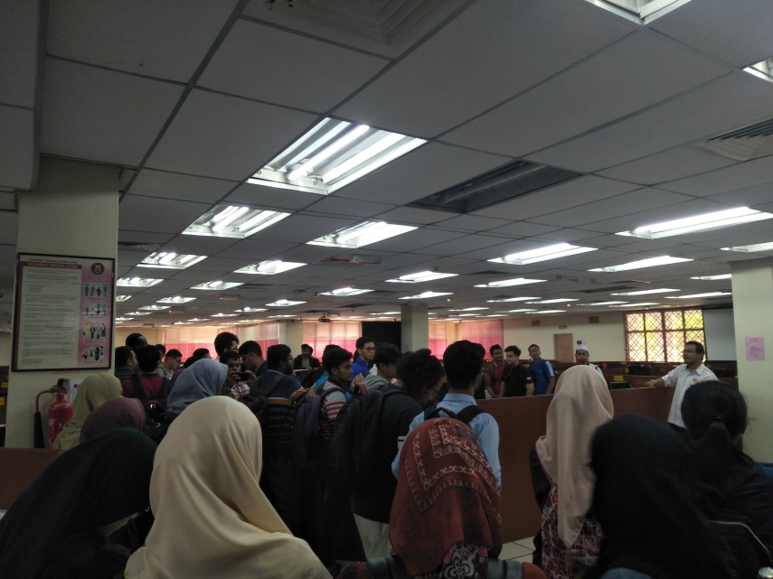
Figure 5 : Industrial Visit at Gallerium CICT

Bibliography
-Information system (n.d) from https://en.wikipedia.org/wiki/Information_system
-Information system by Vladimir Zwass (27th December, 2011) from https://www.britannica.com/topic/information-system
-Information Systems Development by Dave Bourgeois and David T. Bourgeois (n.d) from https://bus206.pressbooks.com/chapter/chapter-10-information-systems-development/
-Computer Science Oxford Fajar 2017 edition
-Centre for Information & Communication Technology (CICT), (n.d) from http://cict.utm.my/home5/

