

Industrial Visit: Cool Code Sdn Bhd
BY:
MUHAMMAD HAFIZUDDIN BIN ABDUL RAZAK
NUR IRDINA BINTI AHMAD RIFDI
TAN WEI KOK

Technology and Information Systems (SCSP1513/09)
School of Computing, Faculty of Engineering, Universiti Teknologi Malaysia
Date: 15th November 2018
Venue: CoWorking & Community Space
Report Date: 27th November 2018

Table of Contents
1 Introduction 3
2 Details of Journey 3
3 Details Description 4
3.1 Organization Structure 4
3.2 Achievement 6
3.3 Services and Product 7
3.4 Information System that have been developed 8
3.4.1 Transaction Processing System 10
3.4.2 Management Information System 10
3.4.3 Decision Support System 11
3.4.4 Executive Support System 11
3.4.5 12
3.4.6 Office Automation System 12
4 Reflection 13
5 Bibliography 14

Introduction
Cool code is a team that want to deliver some products that useful for the user and also the customer. The founder of this company is Mr. Arif Tukiman who is the Co-founder and CEO of RunCloud. He founded this privacy held company on 2014 and now the headquarters is at Setia Tropika, Johor Bahru. This company has around 10 employees and each of them have their own role and career. One of them is Mr. Muhammad Rizwan who was giving a talk to us at the Cool Code Office. Mr. Muhammad Rizwan is a project executive and he is one of the senior staff in that company. From this company, we can practise ourselves on how to be a game project manager, game designer, game animator, game programmer, game sound designer, game marketer, web developer, mobile application developer, social media manager and also digital marketing executive. Besides, Cool Code also develop some solutions for our problems by providing, designing and developing hybrid mobile application that can make our daily life routine will be easier. Furthermore, most of the products that have been developed by Cool Code is game properties. The game is focusing on how to give an education to the children out there because we know that today is moving forward to industry 4.0 where people are closer to the social media and technologies rather than to the others. Even Cool Code Sdn Bhd is a private company, it is also works with the government and another private company and also Astro.

Details of Journey
The industrial visit was held on Thursday, 15th November 2018 at CoWorking & Community Space, Setia Tropika. It took about 10 minutes from Universiti Teknologi Malaysia (UTM) to reach there. We’re going to the Cool Code company by UTM bus and the participants were the students of Graphic and Multimedia course (SCSV). Dr Aryati Binti Bakri is the lecturer that on duty to bring us there since she is also the lecturer that teach us subject Technology and Information System. After we arrived at the CoWorking & Community Space, we have been divided to two groups and each group consist around 20 students. We will took turned in making the industrial visit by group because the office is not too large for us to go inside together. Then, we had a briefing session and some talk was given by Mr. Muhammad Rizwan who is the senior in making a coding at the Cool Code company. He is a very talented person and have many experiences in designing and developing mobile and game development. He was also a UTM student a few years ago and now he has been one of the important person in a private company in Malaysia. We had been given too much knowledge about the company especially about what had they developed for the community and all of their achievement are very inspiring us. This is because, most of the employee are from UTM and now they succeed with their own career and role. In addition, we also got opportunity to meet the founder of Cool Code, Mr. Arif Tukiman who was also a UTM student from Diploma at UTM, Kuala Lumpur to degree at UTM, Skudai. He shared many of his experiences in becoming a successful man and get a good career with a stable income. After all the sharing and briefing sessions, we got the chances to meet all the employees and asked the various of questions due to our courses and also regarding of the career for the future. After an hour, we ended our session and the next group began their session.

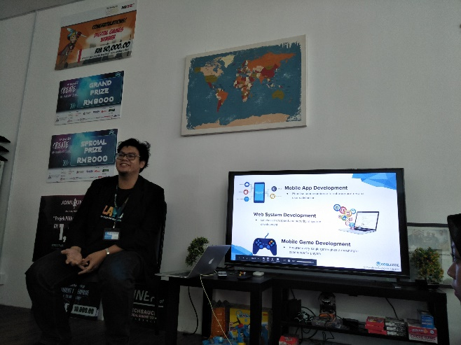
Figure 1 : Mr. Muhammad Rizwan (Project Executive of Cool Code company)

Details Description

Organization Structure
  CEO  Arif Tukiman |   CTO  Ahmad Fikrizaman |   COO  Amir Fazwan

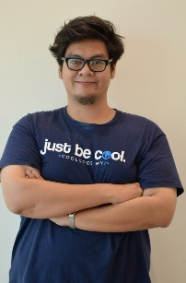  Project Executive  Muhammad Ridzwan | 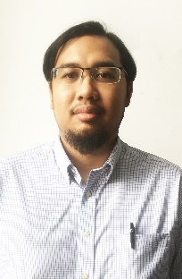  Business Development Executive  Muhamad Ariff Aizat |   Creative Content Developer  Muhammad Hafizuddin

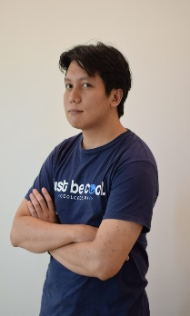  Senior Game Developer  Sharif Tariq | 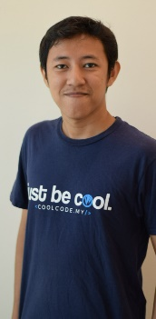Junior Game Developer  Mohd Alwi | Senior Mobile App Developer  Abdul Hadi |   Senior Web System Developer  Muhammad Kamarool |   Junior Web Sysem Developer  Muhammad Asyraf

Digital Marketing Executive  Muhammad Haqqi | Account and Finance  Badrul Hisyam | Sales Executive  Nadia

Figure 2: Organisation Structure of Cool Code Company from https://coolcode.my/

The three main executive management is represented by Arif Tukiman (CEO), Ahmad Fikrizaman (CTO), Amir Fazwan (COO).
There are also Project Executive by Muhammad Ridzwan, Business Development Executive by Muhamad Ariff Aizat and Creative Content Developer by Muhammad Hafizuddin.
Besides, there are also developer in the organisation structure of coolcode. Senior Game Developer by Sharif Tariq, Junior Game Developer by Mohd Alwi, Senior Mobile App developer by Abdul Hadi, Senior Web System Developer by Muhammad Kamarool, Junior Web System Developer by Muhammad Nazrin and Muhammad Aysraf. There are also Digital Marketing Executive by Muhammad Haqqi, Account and Finance by Badrul Hisyam, Sales Executive by Nadia.
When the company carry out a project, Aizat as a business development executive will have the role of executive summary, scope of project, training and transfer of technology, warranty and maintenance and service level agreement. After that, Hafiz as a creative content developer will responsible for Environment concept and design, Creative Content Requirements. Sharif as a senior game developer will fulfil the general requirement, technical requirement, security and privacy requirement. Lastly, Ridzwan as a project executive will do the project management.

Achievement
1. Didi & Friends Playtown featured list in Best Game of 2016 Google Play Store
2. Top Educational Games Google Playstore
3. MOHE Entrepreneurial Awards 2015 - Best Student Enterprise (2nd Runner Up)
4. Featured in TV Alhijrah for "Aplikasi Pilihan" segment
5. JomLaunch 2016 - Project Choice of Sponsor
6. They have also won the digital games with the prize RM 50,000 and get the grand prize and special prize of the event IP SMART CREATE in 2018.

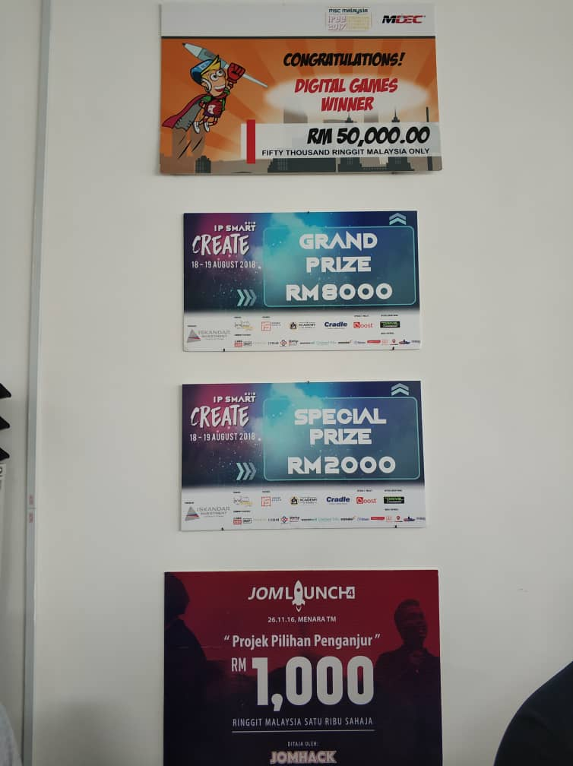
Figure 3: Achievements of Cool Code

Services and Product
Cool Code had provided and designed some mobile game, web system and mobile application development for the community. They provide many services and product to make sure that our activities will be easier by using technologies. Most of the product that have been developed by Cool Code are games. In addition, the games that they created is focusing on education and it give many benefits to the children and also the kids to have some fun and also learn through the games. Mobile application development
One of the product that have been created by Cool Code Sdn Bhd is Didi & Friends Playtown which combined 12 games based on the nursing and children songs of Didi & Friends that have been very popular throughout the whole country. We know that kids are very attracted to the happening songs and colourful environment. So, Cool Code used this idea to create and develop a game that can take the attention of the children so that they will be attract to the game that can improve their learning skills and make them more active by using that games. As for the example, by using the ABC song, the children or the player of the game can learn on how to complete the alphabet.
Next, the other game that have been developed by Cool Code is Remember Asma’Ul Husna. This game is a flash card game to make us easier to memorize 99 Names of Allah. From this game, every cards comes with sound and writing with dual language which is English or malay translation. Moreover, this games also have mini game that ask us to match the meaning for the names of Allah.
Then, Rainbow Iqra’ also one of the games that have been designed and created by Cool Code Sdn Bhd. This game is focusing on how to learn Iqra’ especially for children that aged between 3 to 7 years old. As we know, Iqra’ is the basic step to learn on how to read Al-Quran. So, by using this application, the children will get the skills to learn Iqra’ earlier because in fact, majority of the children are very addicted to the gadjets since their childhood.
In December 2018, Cool Code will be launch their new development which is Omar & Hana. Omar & Hana is the latest TV shows that popular in Malaysia because of the Islamic songs and learning on how to worship to the Almighty God.
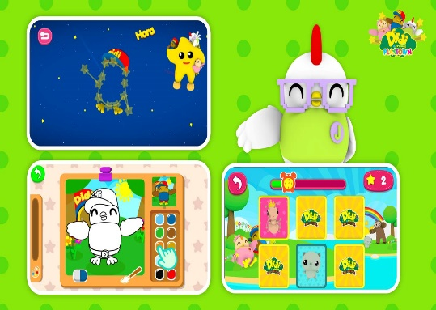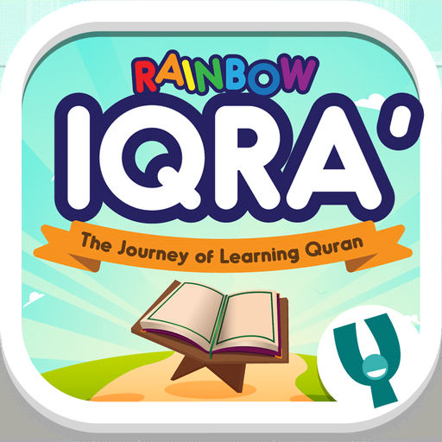
Figure 4 : Some applications that have been developed by Cool Code from http://playlab.coolcode.my/

Information System that have been developed
Information system is a complex combination of computer hardware, software, data resources, procedures and trained people to capture, store, retrieve, transform and disseminate information within an organization. Information system also sometimes been used to describe an automated system which it is refer to computerized information system, which by then cover the machine, people and organized method to collect and process the data for the user or client. The information system is basically focus on to support operations management daily and decision making. And information system is the information and communication ICT that an organization use it daily.
The goal of an IS is to transform raw data into information that will help:
- Employees carry out routine business processes and operations
- Managers in decision making and problem solving
- Top executives can make strategic decision to strengthen the competitive advantages of the company
An IS a complex because
- An is must model the organization processes
- The organization is dependent on its’ IS for a smooth operation
- The IS interface is complex due to many input and its outputs
- Input output relationship are structurally complex
- The IS requires a centralized data storage such as a database
All is must include the object such as, hardware, software, people, procedures and data

Figure 5: Information System

- Hardware refers to physical components of a computer system

- This includes electric and electronic components, electromechanical components and mechanical components
- Computer systems may be connected by a network
- Such as input output devices, storage devices, computer cabinet and CPU

- Software refers to the nonphysical components of a computer

- A software program that instruct the hardware on how to process data into useful information
- This includes:
- Operating system = system software that manages application software and hardware
- Application software = programs for processing and end user data into information

3. Data are fact that used by programs to produce useful information
- Audio data such as recording of human voice and other sounds
- Textual data and image data from the user
4. A procedure is set of policy that users have to follow in order to operate the computer system
5. People is the user that will be the key to success of an information system
- System staff such as programmers are required to maintain the IS
- People will use the system as a client to achieve the enterprise goals.
There are a many types of Information System such as transaction processing system, decision making system, management information system and global information system. But we will go through the based and classic information system that has been developed that all of us know, the 4 stage of pyramid.
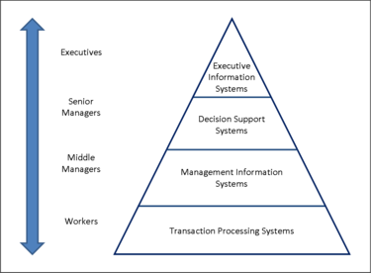
Figure 6: Type of Information System

Transaction Processing System
- The purpose of this system is for collecting, storing and modifying records of routine and repetitive transaction
- The example of TPS include
  - Automated Teller Machine
  - Payroll Systems
  - Customers billing
  - Stock and purchase control
- A transaction is a logical unit of work
- The TPS processed record:
  - Listing = retrieve and display one or more record entered by the user
  - Merging = combine 2 or more list of records
  - Sorting = arrange orders according to a certain order
  - Updating = replacing the old record with the newest value

Management Information System
- The MIS is to support routine daily decision making and problem solving at operational level
- Managers and middle staff level use MIS to generate routine reports on business performance using result from the TPS and other internal data
- The reports are used to:
  - Monitor the present and past business performance
  - Predict future performance
  - Control business activities
- MIS has some general properties such as:
  - Its summarizes data for reports using simple routines such as comparison
  - Reports are formatted to answer routine, structured questions
  - It will generate reports on a regular basis using weekly, monthly and yearly results
- MIS also have different type including the Enterprise Resource Planning (ERP), Supply Chain Management (SCM) and Customer Relationship Management (CRM)

Decision Support System
- DSS helps managers to make decisions at the tactical level
- Summaries are generated using compiled information from the following sources:
  - Raw data from internal transaction files
  - Documents
  - Personal knowledge
  - Business model
- DSS also support both unstructured and semi structured decisions
  - Unstructured decision = it is non routine and complex problems and there is no known or clear method of obtaining solutions.
  - Semi structured decisions = Requirements are clear and predictable although non routine and there is some indication of the method to reach the decision
- DSS give some advantages include
  - Provides a combination of models, analytical tools, databases and automated processes to analysis data
  - Able to analyse unstructured situations to address uncertain or ad hoc business environment
  - DSS uses intelligent system such as rules in expert system and pattern detection in neural networks

Executive Support System
- ESS helps executives make decision at the strategic level
- They use this system to
  - Analyse current situation
  - Identify business trends and new opportunities
  - Formulate business strategies
  - Improve coordination and control\
- Role of ESS:
  - Summarize information of key business areas
  - Provides tool to analyse data
- Data and information collected for ESS are:
  - From various resources such as TPS, financial system, human resources and marketing department
  - Over a stretch time of time
  - Of 2 type such as soft data and hard data

Office Automation System
Purpose of OAS is for
- Coordinating data workers of an enterprise working in various location by improving communication
- Performing basic daily task which include scheduling, record keeping and document imaging
Two type of OAS
- OAS for basic office work
- OAS for intellectual work

OAS | EXAMPLE TOOLS
Managing document | - Word processing  - Desktop publishing  - Work flow manager
Communicating | - Presentation software  - Email  - Voice mail  - Groupware  - Intranets
Scheduling | - Electronic calendars  - Intranet

Advantages of OAS are:
- Many task can be accomplished faster
- Similar task can be done by a smaller group of staff
- Provide simultaneous update of data by multiple people

Reflection
My reflection on this industrial visit to encourage other student to have their own dreams to have a big stable company that involve in this course, their achievement really opened our us to the best and can planning our future plan work starting from right now. Moreover, they are our senior from our course, that is really can make our opportunity to us to make them as our real role model. They achieve with gloriously, why we as a junior can’t be as them? What is the difference between us? That question really opened my mind that if I do the best, I can get what I dream all of the time as long as we know better our plan and do not fail.
My goal from this course is to have my own company that based run on game and apps developer. I will team up with my friends to start a business to recruit some of other professional worker to line up with us. The company start with a child game that help children and un capable children to learn something such as addition in mathematics or English word of dictionary in a very interactive way apps. It will be published to Android platform and IOS platform that target to this among of this group stage that mentioned before. And then, my dream is to team up make a collaboration with Ubisoft company or Frosbite international company that make really amazing game that use amazing graphic. I want to make a game that have Malaysia view and land inside of the game. So that, when gamers playing game, they will know our country and our history a little bit. We can make First Person Shooting game that have really stunning graphic and can be Malaysia that was back in World War 2. Somehow we will include the historic city, amazing graphic that look the same with a place in Malaysia, a story that have history of our beloved country and a message to the world that war will never be a last option. We must maintain peace as we can because history taught us war is not the right solution. Furthermore, this will promote our country to the world, in term of beautiful place, culture and our history. This will make them want to visit Malaysia and know our country based on game.
Apart from that, this industrial visit really opened my mind and my eyes that I can achieve my goal in a right way. They successful develop the game application for the children, I can learn from them to maximize my skills in apps developing game. They can give me a better tuition based on my experience and can learn from the pros to be the pro. This industrial visit also helped me to realize that successful come from a hard way to be the best among the best.
Last, to get what I dream, I must be mentally and physically prepared to get ready what any circumstances that will get along my journey. I will prepare myself by exploring new things before the lecturer teach us. Like how to develop an application, HTML language for web develop, and master in coding in every language. I also may be different from anybody else by be an advance student and planning my final project starting from now. I also must be creative and professional in design thinking to solve many problems. Last but not least, I must be study hard and perform in any subject specially programming. This will be my credit for my achievement and I will empower myself to market myself to what industry need now.

Bibliography
-Information system (n.d) from https://en.wikipedia.org/wiki/Information_system
-Information system by Vladimir Zwass (27th December, 2011) from https://www.britannica.com/topic/information-system
-Information Systems Development by Dave Bourgeois and David T. Bourgeois (n.d) from https://bus206.pressbooks.com/chapter/chapter-10-information-systems-development/
-Computer Science Oxford Fajar 2017 edition
-Cool Code Sdn Bhd (n.d) from https://coolcode.my/
-Play lab Cool Code (2016) from http://playlab.coolcode.my/
-Activities that have been organized by Cool Code from (n.d) https://www.facebook.com/coolcodemy/
-About Cool Code Sdn Bhd (n.d) from https://www.linkedin.com/company/cool-code-sdn-bhd

