

GROUP REPORT

COOL CODE
(INDUSTRY VISIT)

TECHNOLOGY AND INFORMATION SYSTEM
SCSP-1513/09
Dr. Aryati Bakri

GROUP 11 MEMBERS:
1. P’NG YI (A18CS0231)
2. SYAFA NABILA MAULIDYA (A18CS0328)
3. PREMA KARIRA ANAS SULAIMAN (A18CS0320)
4. UMAIR BIN ZAINAL KIFLI (A18CS0269)

Table of Contents
1. Introduction 3
2. Details of Journey or Work Plan 5
3. Detailed Descriptions 7
4. Reflection 10
5. Bibliography 11

Table of Figure
Figure 1: Logo of Cool Code 3
Figure 2: The Team of Cool Code. Taken from https://coolcode.my/our-team/. 4
Figure 3: Mr. Rizwan and Mr. Arif. 5
Figure 4: Game animators creating interactive animated images and environments 5
Figure 5: Game programmers design and write computer code that runs and control the game 6
Figure 6: Game designers design characters by using Blender 6
Figure 7: Didi & Friends Playtown application 7
Figure 8: Rainbow IQRA application 7
Figure 9: Rainbow Jawi application 7
Figure 10: Smart Tabika Kemas application 7
Figure 11: Giga Bite!, a gamification on marketing 8
Figure 12: Puteri Harbour Theme Park, a gamification on tourism 8
Figure 13: Game app ‘Didi & Friends Playtown’ in Google Play Store 8
Figure 14: Achievements for Cool Code 9

Introduction
This report is talking about a visit to Cool Code on 15th November 2018. This company is located at Setia Tropika, Johor Bahru.
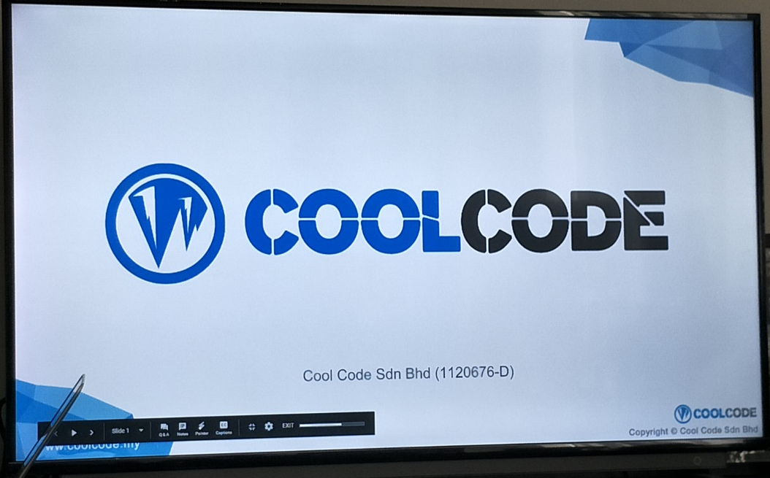
Figure 1: Logo of Cool Code
Cool Code is a software development company focused on Wed, mobile application, mobile games and interactive content development. The CEO of this company is Arif Tukiman while the following names are his team in this company:
  Arif Tukiman, CEO |   Ahmand Fikrizaman, CTO
  Amir Fazwan, COO |   Muhammad Ridzwan, Project Executive
  Muhamad Ariff Aizat, Business Development Executive |   Muhammad Hafizuddin, Creative Content Developer
  Sharif Tariq, Senior Game Developer | 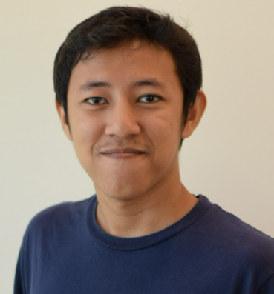  Mohd Alwi, Junior Game Developer
Abdul Hadi, Senior Mobile App Developer | Muhammad Kamarool, Senior Web System Developer
Muhammad Nazrin, Junior Web System Developer | Muhammad Asyraf, Junior Web System Developer
Muhammad Haqqi, Digital Marketing Executive | Badrul Hisyam, Account and Finance
Nadia, Sales Executive
Figure 2: The Team of Cool Code. Taken from https://coolcode.my/our-team/.
Cool Code deliver the best services and boost businesses in mobile application development, game development, interactive content, Web application development, Web design and portal development and training course and consultant.

Details of Journey or Work Plan
On 15th November 2018, One class of first year students from School of Computing, Faculty of Engineering gathered at Dewan Sri Resak (KTDI), Johor Bahru to attend an industrial visit to Cool Code company. The visit began at 2.00 p.m. and ended at 6.00 p.m.
First, all students are queuing to board the bus around 2.15 p.m. and the industrial visit program began with listing the attendance and dividing the group into two sections. Each section spent about one hours and a half for listening, asking, watching and learning. Then we arrived at the location of Cool Code Company around 3.00 p.m.
Section 1 who entered first are listening the explanation from Mr. Rizwan, a project executive and Mr. Arif Tukiman, the CEO of the company and they shows some videos about their company, their activities and their projects. After that, Section 1 changed with Section 2 to learn about their programme.
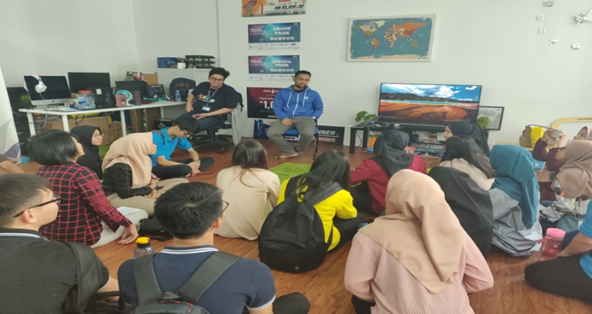
Figure 3: Mr. Rizwan and Mr. Arif.
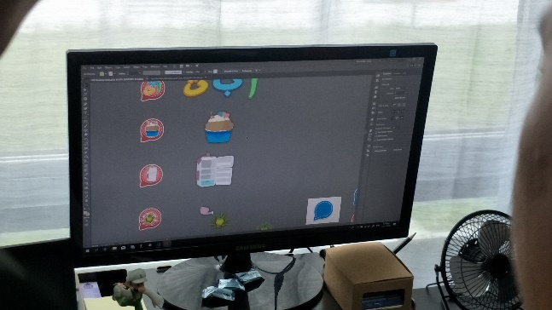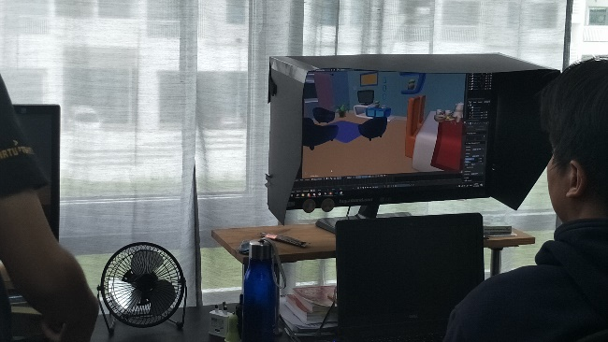
Figure 4: Game animators creating interactive animated images and environments

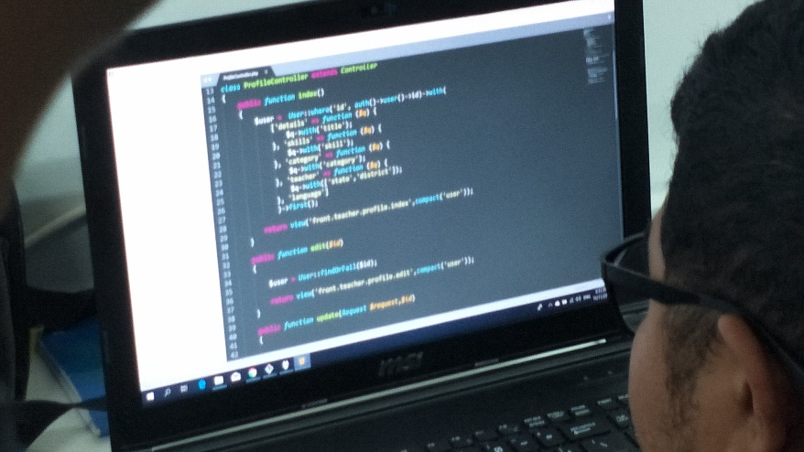
Figure 5: Game programmers design and write computer code that runs and control the game
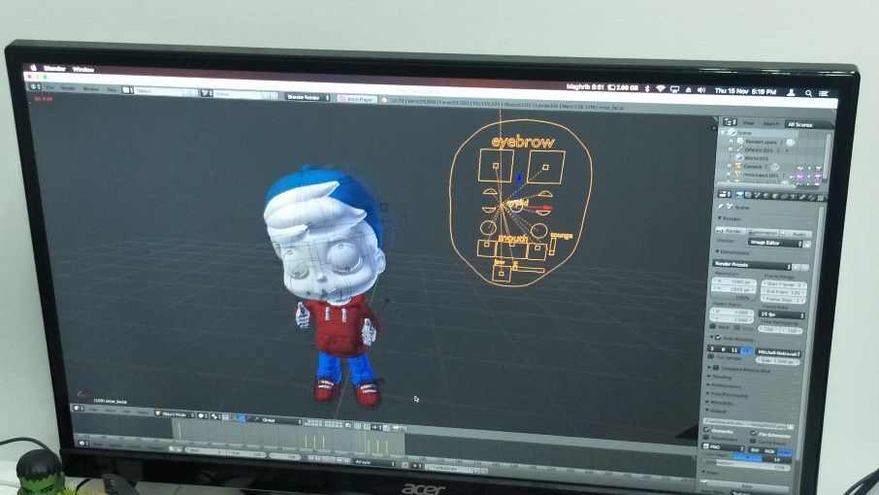
Figure 6: Game designers design characters by using Blender
After the talk done, all students got inside the bus at 5.00 p.m. and we went home. We arrived at the UTM around 6.00 p.m.

Detailed Descriptions
Cool Code is a software development company focused on Wed, mobile application, mobile games and interactive content development. The CEO of this company is Arif Tukiman. They provide services and boost businesses in mobile application development, game development, interactive content, Web application development, Web design and portal development and training course and consultant.
The products of this company developed are Didi & Friends Playtown, Rainbow Jawi, Rainbow IQRA, Smart Tabika Kemas, Giga Bite! and Puteri Harbour Theme Park. The current development of game application is called Omar & Hana, a game application in which will launch on December 2018.
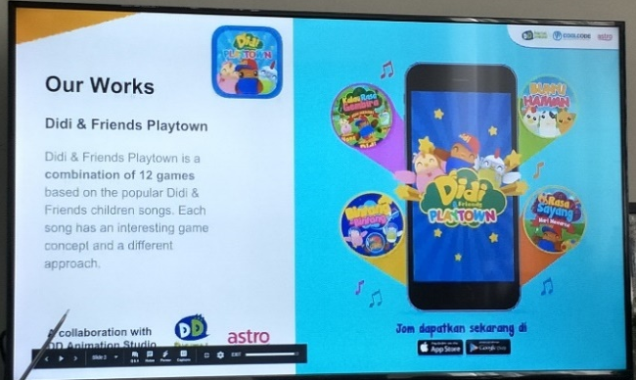  Figure 7: Didi & Friends Playtown application | 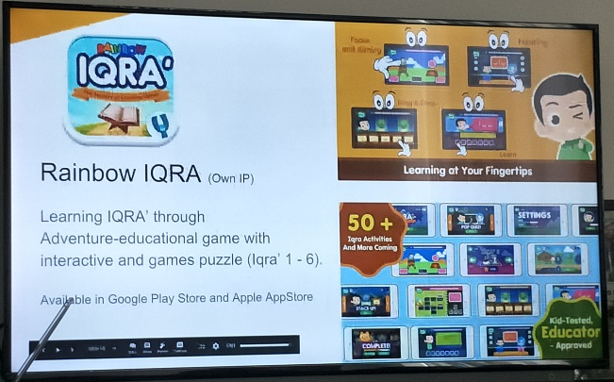  Figure 8: Rainbow IQRA application
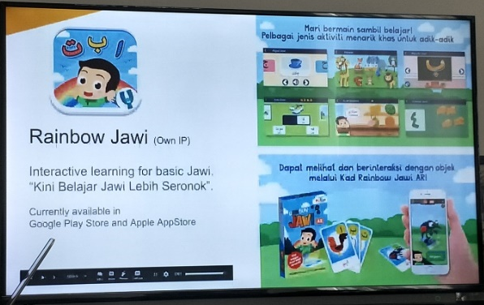  Figure 9: Rainbow Jawi application | 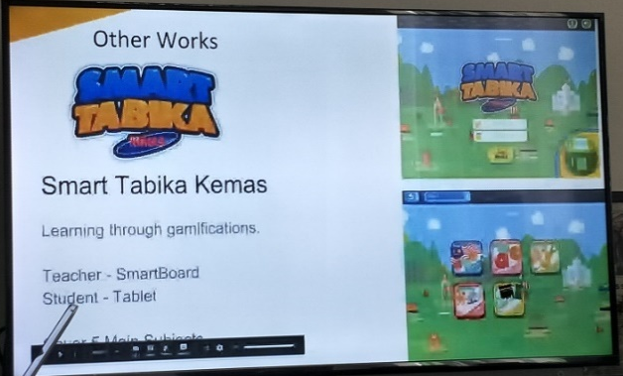  Figure 10: Smart Tabika Kemas application

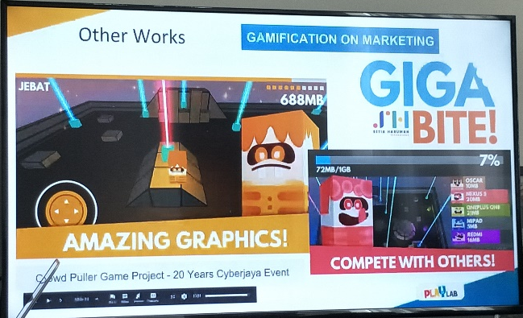  Figure 11: Giga Bite!, a gamification on marketing | 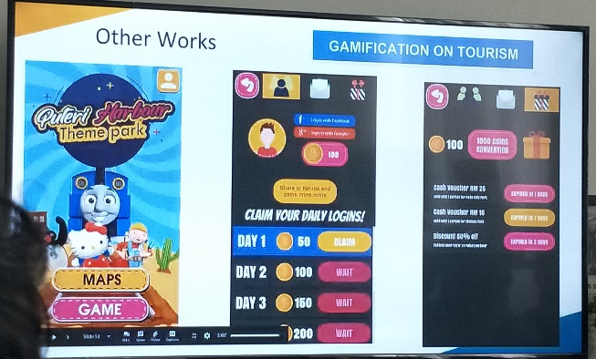  Figure 12: Puteri Harbour Theme Park, a gamification on tourism
For the achievements of this company, the game app ‘Didi & Friends Playtown’ had downloaded more than 2 million users as of 22nd May 2018. In 24th August 2016, this game app had been in top 4 in the popular apps & games and in 17 December 2016, this game app had in the best games of 2016 in Google Play Store. As for the educational games, ‘Didi & Friends Playtown’ had a top 3 and top grossing educational games in 2 years since June 2016.
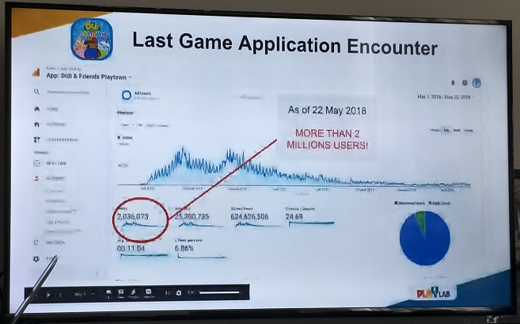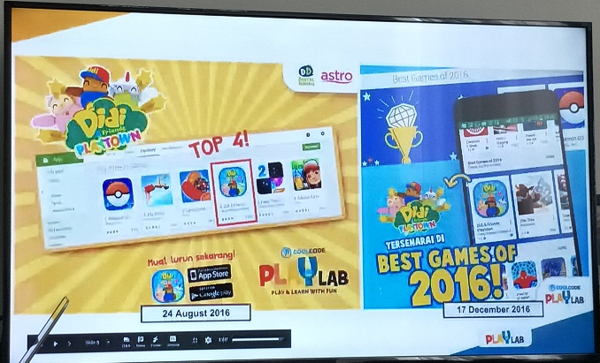
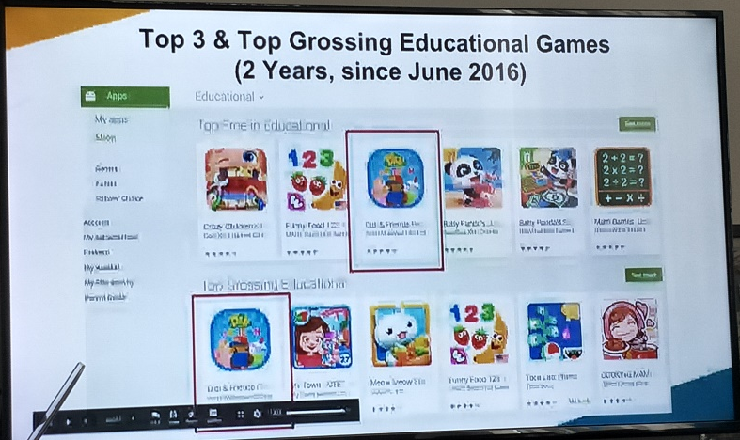
Figure 13: Game app ‘Didi & Friends Playtown’ in Google Play Store

Other achievements for this company are they got the second runner up for the best student enterprise in an event ‘MOHE Entrepreneurial Awards 2015’, ‘Didi & Friends Playtown’ featured in TV Alhijrah for ‘Aplikasi Pilihan’ segment and the company chosen as the project choice of sponsor in ‘JomLaunch 2016’.
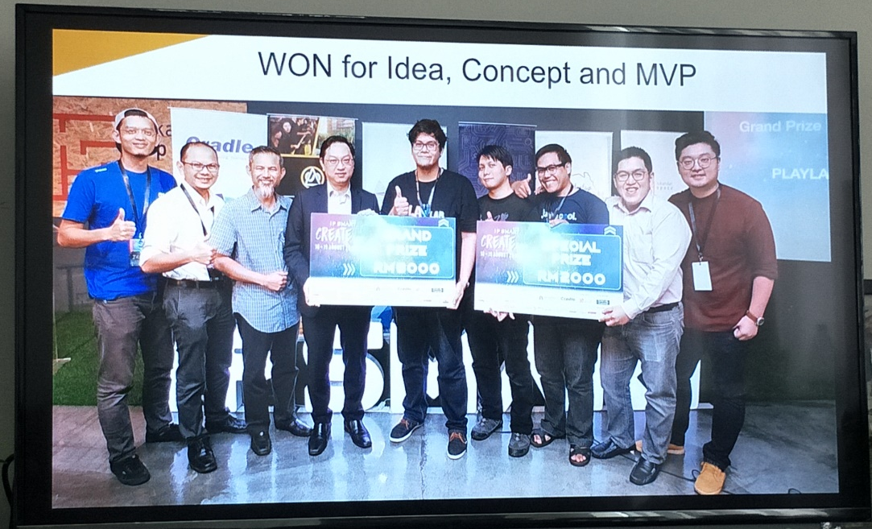
Figure 14: Achievements for Cool Code

Reflection
After visiting the Cool Code Company, we learned about the Cool Code Company itself (when did they start the company, who are the cool coders, what their activities are, what their projects are, and how many achievements have they gained). Cool Code is a proof that learning doesn’t always have to be boring and sitting in classroom, watching the whiteboard until the class dismissed. Games are not always just for having fun or wasting time.
An application made by Cool Code is a game where we can also study and have fun. There are many ways to study. And every educational apps made by Cool Code are not just getting the best rates in Google Play Store or App Store, but also very useful for the users especially for the kids.
From this visit, we also get motivations to keep on studying hard, start planning our future, change our learning style to a better way, always practice to do coding, and do whatever we have to do as a student, so that one day we can see ourselves as a successful people, which gave a very big impact to continue our journey in reaching our dreams.
Our goals are to understand what the codes are used for, to know how to develop a useful program or app by doing programming and designing. Our dreams are not very different from being a successful programmer and developer. Just like the Cool Code Company, we want to be something like them or maybe even better.

Bibliography
- Code, C. (2011). Cool Code. [online] Coolcode.my. Retrieved from https://coolcode.my/.
- Facebook.com. (2018). Cool Code. [online] Retrieved from https://www.facebook.com/pg/coolcodemy/about/.

