

Industrial Talk 2 – NALI Symposium

BY:
MUHAMMAD HAFIZUDDIN BIN ABDUL RAZAK
NUR IRDINA BINTI AHMAD RIFDI
TAN WEI KOK
GROUP 10

Technology and Information Systems (SCSP1513/09)
School of Computing, Faculty of Engineering, Universiti Teknologi Malaysia
Date : 25^{th –} 26th September 2018
Venue : Dewan Sultan Iskandar, UTM
Report Date : 14th October 2018

Table of Contents

1 Introduction 3
2 Booth 28: Project-Based Learning approach through mock-up workshop for value management in construction 3
3 Booth 29: KEMBARA NOMBOR 4
4 Booth 30: Application Development of Augment Reality in Geometry Topic Based on Multimedia Learning Cognitive Theory 5
5 Booth 31: Final Year Project and its Impact to Student Engagement and Success 6
6 Booth 32: Warm Up Your Brain (WARUP) 6
7 Summary 7
8 Bibliography 9

Introduction
New Academia Learning Innovation (NALI) was organized by UTM Academic Leadership Center (UTMLead) with Faculty of Education and was written in the book titled New Academia in 2012. The importance of NALI is to recommend to the students and the lecturers on how to create a better platform in the processes of teaching and learning. The exhibition and competition was open to all educators that want to promote their skills to recognize to the students and lecturers especially for the students that are studying in School of Education, UTM. Every participant that took part in this exhibition and competition was given a booth to present their project on NALI. There were 86 booths that contained variety of platforms that have been presented to the people. Most of the booth were presenting about some skills or platforms to make sure that the processes of teaching and learning going well and success in the future. We have been task for writing a report about booth 28 to 32.

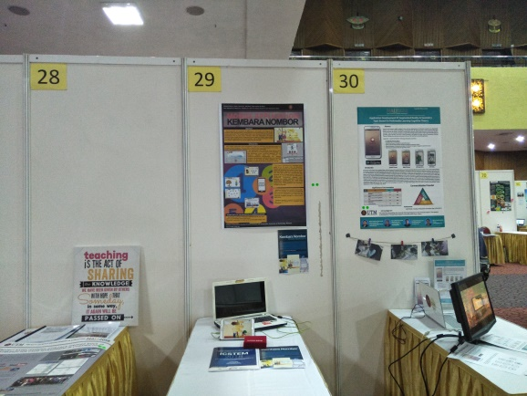
Booth 28 to 30

Booth 28: Project-Based Learning approach through mock-up workshop for value management in construction
First of all we all start with the booth number 28, it is about a based learning approach through mock-up workshop for value management in construction that made by Faculty of Built and Environment. So it’s basically it is the new ways for the people to value management of construction through a mock up way. It will provide a software specially designed for special type of construction. This way can be perform by many software such as Kahoot, Prezi and Moodle. This software can help us to do the mock up for the construction that way better than the traditional ways to do. So this workshop will help the people easily to do the value management in their construction progress. They have their tutor and all of them are professional in this section that have some title for what they teaching.
The uniqueness of the VM is the used of structured approach known as the “VM Job Plan”. As it is better learning platform, it will provide the application of PBL enables expolaration and learning the knowledge by doing. The problems will identified real life and will implement the VM after learning the theory by class and some activities. They have the workshop that teach student to analyse given the project. Several visits were conducted and some parties were engaged to answer all the question of function of the project.
Apart from that the methodology that been used in this workshop is based on the “VM Job Plan” by the Society of Value Engineers (SAVE) International Standard. The students that join this program will get briefing at the early of the beginning of the semester. Students were grouped and they have their own task like client, architect, civil and structural engineer and many more. Each group were given a project that will located in the campus. They must have adhere to the VM Job Plan and they must get through 3 stages of VM implantation.
Its state also that the implementation of PBL in this program which it is based on project based learning approach that entitled Learning Awards UTMLead and P5 rating for the program and its relevant content.

Booth 29: KEMBARA NOMBOR
This mobile application was developed in order to facilitate the learning process of primary school students. The principle of garnification was emphasized in its design. The application was authorized using Adobe Flash C56 using AJR as it’s their main language of programming. It was developed using creativity and innovative by the approach students. Beside that, the element of Student-to-Students Edutainment was applied in this software.
It was found that 2 avatars are been put in to interact with the female and male user. The interface was designed to be in contact with its owner. In the design stage, all the interface was sketched as storyboard. The instructional designer later then planning the mobile application architecture. Implementation and evaluation are still in planning.
First of all, this booth specially for the mentally and physically challenge for the children. This is a software that specially designed for the children to know numbers and its form. It is purpose of offering learning to the students with enjoyment, constructive and garnfication as its fundamental elements. It is in mobile application that serve under android platform and it is equipped with Graphic User Interface (GUI) that really interesting, colourful and exciting to explore. It is open for user to download it at Google Play Store and it has higher interactivity through the application of accelerometer. All these elements in this mobile application is fun to be explored and learned.
This software has highly significance that can see through their stimulating the application of garnification and education. And it is confirmed that this mobile application is ready to be sold through Google Play Store.
Kembara Nombor is a versatile mobile application and it is capable of capturing and obtaining focus from the E-Generation. The user interface is really interactive and interesting to the students and have high response to the user interactivity.
Finally, it is said that the Kembara Nombor is ready to be commercialized. It is still waiting for its copyright to be completed.

Booth 30: Application Development of Augment Reality in Geometry Topic Based on Multimedia Learning Cognitive Theory
The next booth is booth number 30 which is about Application Development of Augment Reality in Geometry Topic based on Multimedia Learning Cognitive Theory. The objective of this booth is to develop a better platform for the students due to the changes of learning environment based on the industry. We know that in order to produce more creative generation for the future, we have to provide them with the skills that they talented to. That’s why in many university or schools nowadays are providing with many kind of courses and subjects. Therefore this booth is all about in making an online service as a platform in educational field. Augmented Reality (AR) is used to interact with other people in real world or even virtual world in real time communication. Geometry Augmented Reality (GeoAR) is one of the application that invented by AR. This application is used in learning service that connected with geometry instead of having a person that have a good visualization skill. Moreover, it can used to determine the shape of a polygon and the calculation of the perimeter and the area of the particular polygon. So, it will be easier for the students in solving problems for the particular subjects. Besides,, Augmented Reality (AR) is also can be used in observing the movement of a planet and also in determining the molecular structure in chemistry subject. With this statement, we can see that this technology are very connected to educational field especially for the Science, Technology, Engineering and Mathematic (STEM) students.
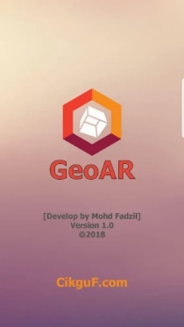
Geometry Augmented Reality Application (GeoAR) https://play.google.com/store/apps/details?id=com.Edubyte.GeoAR
In addition, in this 21st century, majority of the educational places are having their learning and teaching session by using online services. As for the example, most of their homework and assignment have to be submitted by portal or e-learning. The fee for each students also become higher year by year due to the usage of the information technology (IT) in their studies but it is very worth for them because it will be easier for the students to understand what had they learned in that subjects.

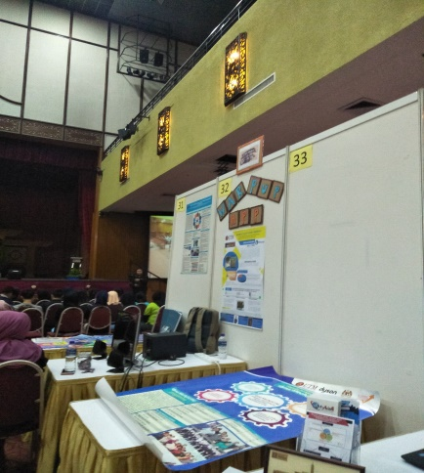
Booth 31 and 32

Booth 31: Final Year Project and its Impact to Student Engagement and Success
The next booth is all about final year project and its impact to student engagement and success. Basically we know that final project is a compulsory task that have to do by the undergraduate students to complete their degree seasons. For instance, the students of School of Education, Faculty of Social Science and Humanities (FSSH), Universiti Teknologi Malaysia, have to complete their final project in two semesters. They are allowed to carry any research about education that connected with their courses. The marks will be given based on their presentation, manuscript and also their management in that project. Final Year Project (FYP) is actually connected to High Impact Educational Practices (HIEPs). This is because the main objective of HIEPs is to maintain and enhance student engagement and also to make sure they success in their study. In this case, student will apply what had they learned in class and put all of their efforts to make sure that they pass this final project. This can be related with the situation of final year project in 2013wheres the topic of the project was “Fundamental Movement Skills among Young Children”. This theme was given to 3-4 students and they have to make a research on that theme in many aspects. We can see that even though they made it for the sake of the project, they also can increase their knowledge about young children and also made some experiences regarding the project. On the other hand, it is also help the students to be matured and trying to solve their problems by themselves so they can practise their skills on how to solve a problem in a certain conditions.

Booth 32: Warm Up Your Brain (WARUP)
During the exhibition, I found that WARUP is a Mobile Application Education for Attention Deficit Hyperactive Disorder (AHDH) Student Year 2. It is founded by Nurul Syafiqah Bt Suhaimi, Siti Nur Azhana Binti Hassan and Firdaus Bin Mohamed from University Technology Malaysia. The objectives of this project are to create an application that is fun, attractive and easy as a learning tools for children with ADHD and to eliminate the outside distraction and let children engage in a challenging games that help to train their brain. Why it is necessary to help the ADHD student? It is because ADHD can cause many problems in different areas of life’s such as jobs, friends, schoolwork or even relationship. The exhibition contains more detail information about ADHD. In 1992’s, Hinshaw, who is a psychologist mentioned that ADHD is a complex syndrome of impairments in developmental unfolding of the unconscious self-management system of the brain that will affects significant numbers of children, adolescents, and even adults, but it can be treated effectively with appropriate medication. Additionally, ADHD is a specific developmental disorder seen in both children and adults that is comprised of deficits in behavioural inhibition, sustained attention, resistance to distraction, and the regulation of one’s activity level to the demands of a situation (hyperactivity). Thus, in Malaysia, ADHD is one of the most frequently encountered childhood-onset neurobehavioral disorders in primary care settings. It has defining features of inattention, over-activity and impulsivity. The core symptoms co-exist with other emotional, behavioural and learning disorders. In a survey amongst Malaysian between the ages of 5-15 years showed a prevalence rate of 3.9 and it is more common in males compared to female (Toh et.al, 2006). This actually related to their difficulties in learning and applying knowledge. Through this problem, a prototype of mobile application known as WARUP is proposed to improve their cognitive along with their emotion. The application consists of note with melodies, a free note map and a game hunter. This application is emphasise to build the cognitive of the ADHD children in term of their critical thinking, creativity and innovativeness. However, it is still need the corporation from each parties to allow the project works. This app will use widely in the new academic learning innovation (nali) to solve the problem faced by year 2 student diagnosed by ADHD.

Summary
All of the booth were talking about the innovative technology help us in life and make our life easier than ever. Technology become our backbone in life and the innovative and creativity comes along to ensure that our education more prioritize more than now.
We looking into the booth by booth especially booth number 29, its main focus on the uncapable children to learn about number but they have their intention and effort to learn number, there is where the creativity meet technology. They success to develop a program software based on Android platform to ensure that the children can learn about number and more interesting. This will help the children in many form such as their interactivity and how they think to solve a problem given. The user interface also more like colourful to attract the children to learn because children much more get interest in something like E-game and others.
In the other hand, booth 32 has exactly like the same with the booth 29, its focus on Atttention Deficit Hyperactive Disorder (ADHD), it is a software program that been develop by Student Year 2. This software is to help the children to learn in fun way, more attractive and to eliminate the outside distraction and let the children to engage in a challenging games. This application is emphasize to build cognitive of the ADHD children in term of great thinking and how their creativity to solve a problem once it was given. That is how the application help the children faced in their daily life.
Moving to bigger sector, like booth number 28, it is a software designed for the the building architecture. It is a new way to implement this kind of way to make them easier to spot any problem and to sketch the construction through mock up learning. They also provide us some workshop tutored by professionals to teach us and apply the knowledge into real situation. The work shop also make the people easily to evaluate the management in the construction progress,
When talking about building and construction, booth 30 serve us the application used to develop a better platform for the students due to changes of learning environment based on what industry need. The application in Argumented Reality (AR), that used to interact more efficiently with other people in real world that its connected with geometry instead of having a person with good visualization skills. This will help people increase their productivity and creativity to create something better.
Apart from that, booth 31, this is about the final year project to study the impact of student engagement and success of a student. We can see that young children nowadays learn some knowledge through experience regarding what task give to them. On the other hand, it will help to mature students in term of thinking and let them try to solve their problems by themselves. So that, they will have experience how to deal with in future.

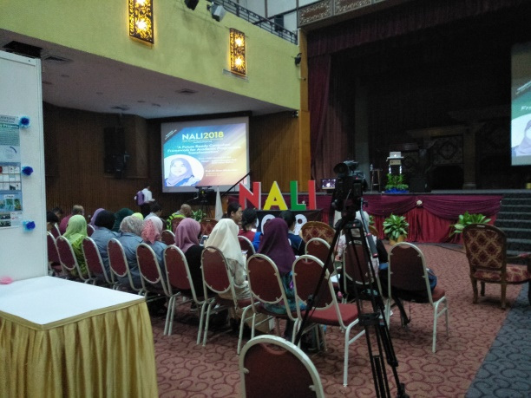
NALI 2018 at Dewan Sultan Iskandar

Bibliography

Mohd Nihra Haruzuan Mohamad Said (2018, June 12), New Academia Learning Innovation (NALI) 2018 Symposium. Retrieved June 12, 2018 from https://news.utm.my/2018/06/new-academia-learning-innovation-nali-2018-symposium/

Cikgu Fadzil (2018, July 21), GeoAR from https://play.google.com/store/apps/details?id=com.Edubyte.GeoAR

Mohd Shafie Rosli, Mohd Nihra Haruzuan Mohamad Said (2018), Proceedings of the New Academia Learning Environment (2018) Exhibition and Competition from http://ctl.utm.my/nali2018/wp-content/uploads/sites/10/2018/09/PROCEEDING-OF-NALI-FINALIZED-w-BARCODE.pdf

