
Title: Hand Made 3R Craft
Group Members: TOK KAI XIAN (A18CS0267)
LIM WEI QIN (A18CS0101)
KAM SHWU CHIN (A18CS0089)
TAN ZHI QUAN(A18CS0260)
Course: Graduate Success Attributes
Lecturer: Dr. Mohd Fa’iz Ahmad
Section: 15
Table of Contents
1 Name of Product 4
2 Material used 4
2.1 The uses of each recycle material on product. 5
2.2 The reason why we choose these material 5
2.3 Where we get the material 6
3 The Speciality of the Recycled Product (Revival) 6
4 Function of Revival 8
5 The value of the Revival Product 9
6 Purchaser of the Revival product 9
7 Attachments of Each Minutes Meeting 11
7.1 First Meeting 11
7.2 Second Meeting 12
7.3 Third Meeting 13
7.4 Fourth Meeting 14
8 Conclusion 15
9 Reflection 16

Table of Figures
Figure 2-1The materials used 5
Figure 3-1Dried and preserved Frangipani flower 6
Figure 3-2 Frangipani flower before preservation 7
Figure 3-3 Recycle items 7
Figure 3-4 Revival 8
Figure 4-1Functionality of Revival 9
Figure 6-1 The Buyer of Revival, Lim Bao Ren 10
Figure 7-1 First Meeting 12
Figure 7-2 Second Meeting 13
Figure 7-3 Third Meeting 14
Figure 7-4 Fourth Meeting 15
Figure 9-1 Environment pollution 17

Name of Product
The name of our product is Revival. Revival is a multifunctional product as it can use to hold books, documents, papers, files and also stationary. We called our product as Revival because we renew, reuse and recycle the unwanted items that can be found on our daily life. The materials that we found was cartons, empty bottle, plastic bag and a few small boxes that obtained from the packaging of commodity. With taking colours designing, materials construction, aesthetic and functionality into consideration, we able to get a product which is multipurpose and more attractive than a common pen holder. After product completed, we also eliminated the unwanted parts and enhanced the physical structure of product to ensure its physical strength and exquisiteness.

Material used
- Plastic bag (recycle material)
- Box (recycle material)
- Plastic bottle (recycle material)
- Leaves
- Gum
- Scissor
There are many recycle material (metal, plastic, paper) that we can reuse to remake the product or create the new product. In this assignment, we used plastic bag, box and also plastic bottle to create a new product for sale. We didn’t spend any cost in collecting these items because all of them can be found easily in our surrounding. For example, we can get clean plastic bag by purchasing anything in the shop or get it from anywhere that threw by other people and clean it up. In the 1st meeting, we discuss each other about what is our product and what material we should use. Then, we all decided to make the small cupboard. The idea of using these object as material to make our product is suggested by Tok Kai Xian who is the leader of the group.
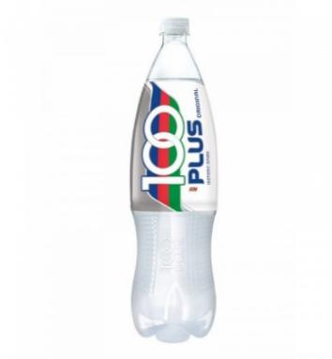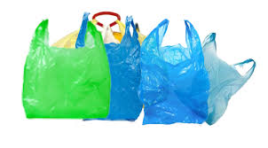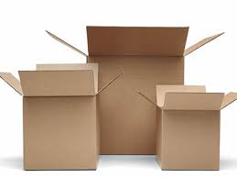
Figure 2-1The materials used

The uses of each recycle material on product.
For plastic bag, we used many different colour of plastic bag to decorate the product and make it more attractive and beautiful. Next, we used many different size of boxes in making the cupboard so that the user can put their objects based on the size of the boxes. Then, we add the pencil case on the product by using transparent plastic bottle (100-plus bottle) to let the users find their pencil easily. To make the product more attractive, we used the leaves to make the flower shape on the cupboard.

The reason why we choose these material
As we all know, not every recycle material are suitable in making the new product. This is because some of the material cannot last longer such as paper and newspaper which will decompose in the very short time. The reasons we used plastic bag, plastic bottle and box are because it can last longer, light and it is safe to reuse. With these advantages, we believe it can attract more customer to buy our product. Why we didn’t use other recycle in making these product? For example, the main reason we didn’t use metal can to make pencil case is because it is very sharp and may cause injure to user. We also used plastic bag instead of colour paper to decorate the product, this is because plastic bag can last longer and no easy to decompose compare to colour paper. We didn’t use any metal material because this will increase the weight of the product.

Where we get the material
For plastic bag, we get it from purchasing thing in the shop. For plastic bottle, we get it on the floor where thrown by other people. For box, we get it from our own group member (Lim Wei Qin) and also friends where they didn’t use it after purchasing the boxed item.

The Speciality of the Recycled Product (Revival)
One of the special characteristic of our group’s recycled product(Revival), is that we use dried and preserved frangipani flowers to do the decorations to make the storage box looking more presentable. The duration of preserving the frangipani flowers was about one and a half month while the preservation method is the simple traditional way by pressing it between books. Every flower has its own symbolic language. For the most common one, rose represent “I love u”. While frangipani flower symbolizes a sign of immortality (ability to live forever, eternity). This also symbolize that our recycled product, revival is a very high quality product, which is very long lasting.
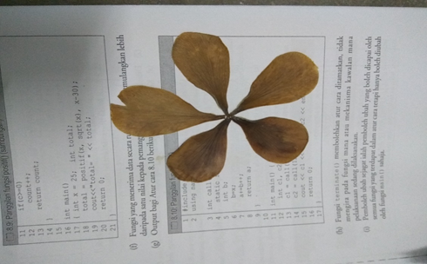
Figure 3-1Dried and preserved Frangipani flower


Figure 3-2 Frangipani flower before preservation

The most significant special characteristic of our recycled product is the name of the product. The word “Revival” means rebirth or the improvement of condition and strength of something. The reason why we named it Revival is because we are using the same concept as recycling which is unwanted and abandoned items are reused to recreate something unique and new. Those unwanted items are literately “revive” or “rebirth” to recreate its new value and become a brand new and useful product.
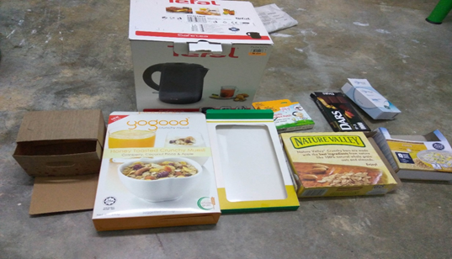
Figure 3-3 Recycle items

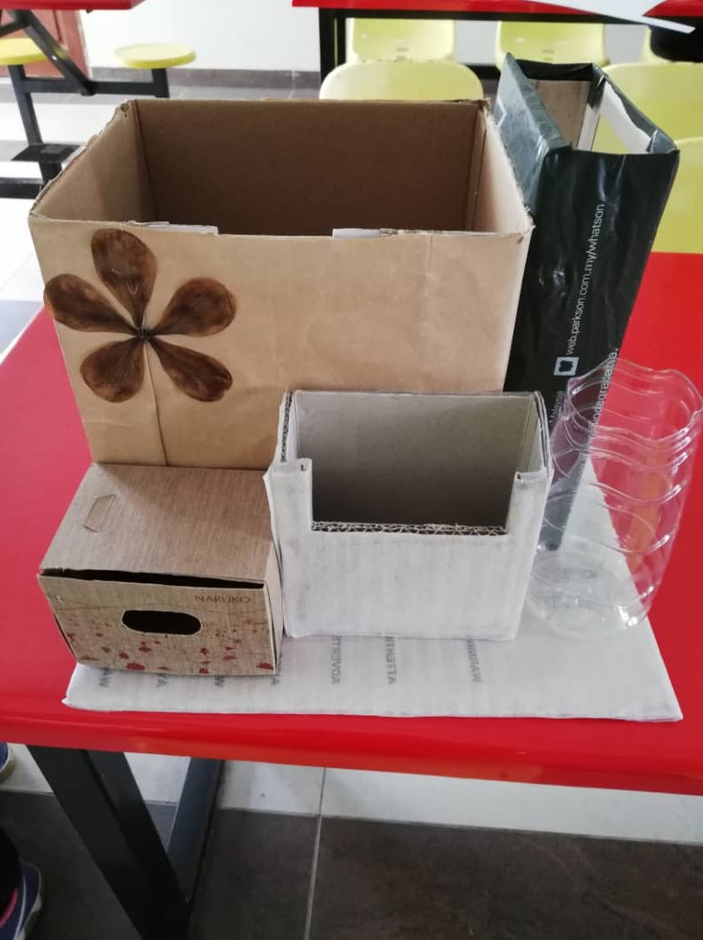
Figure 3-4 Revival

Function of Revival
Revival is a 5 in one storage box which includes a pencil holder, a mini multipurpose storage box, book storage book, drawer storage box and a transparent storage box. For the pencil holder, we can use to put our stationaries such as ruler, highlighter, pen, mechanic pencil, liquid paper as well as using it as a flower pot. For the multipurpose storage box, you can use to store anything according to your preference. As for the book storage box, it is used for storing files, books and magazines and any other reading materials. Besides, for the drawer storage box, it is an ideal storage place for small items such as clips, eraser and so on. Lastly, the transparent storage box can be used to store things that according to your preference.

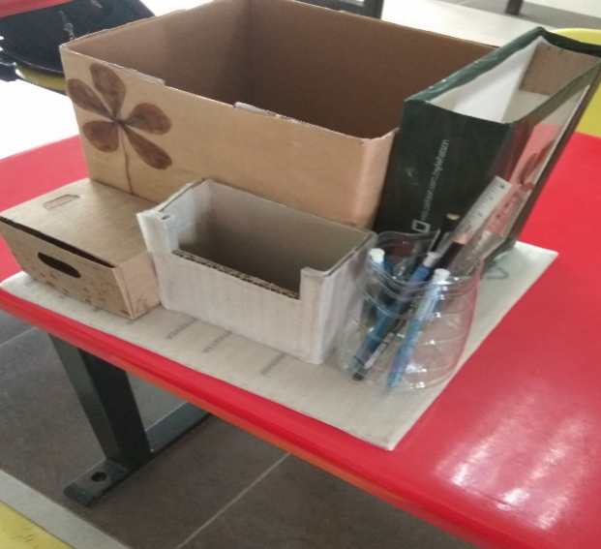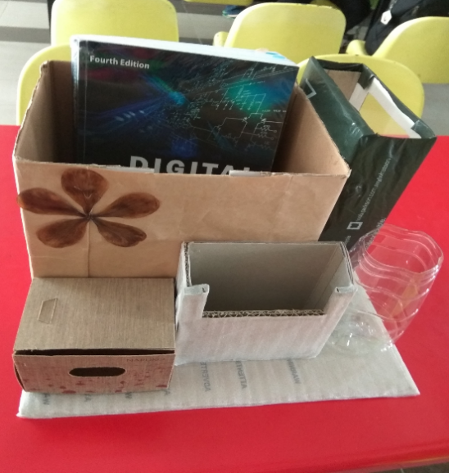
Figure 4-1Functionality of Revival

The value of the Revival Product
The price of the recycle product is RM 5. Although materials that used to make this product costs us RM 0, yet sacrifices of our time and efforts worth the price. The money that we made is donated to a charity box which use to help those in needs.

Purchaser of the Revival product
Our product, “The Revival” is sold to a first year software engineering student, named Lim Bao Ren. He is from faculty of engineering and school of computing. One of reasons that he is interested in our product is that he found this product useful which he needs it to store his stationaries and reading materials properly as well as to keep his desk tidy. The second reason that attracted him to purchase this product is the speciality of this product. One of the most significant speciality of our product is the name as well as its design. He also said that this product is Eco-friendly as it is made from recycled items and it is time that initiatives should be taken to conserve the environment before it is too late.

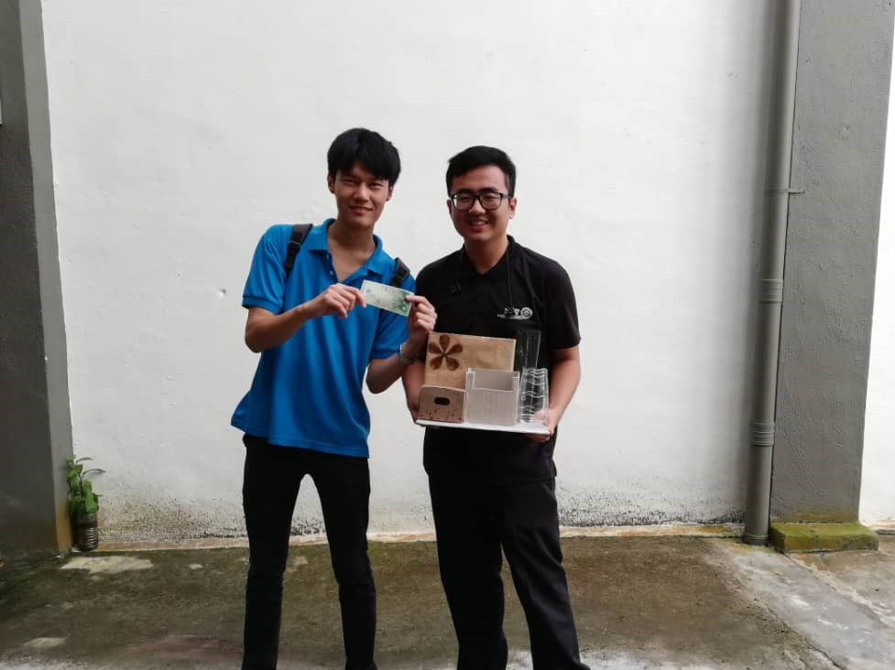
Figure 6-1 The Buyer of Revival, Lim Bao Ren

Attachments of Each Minutes Meeting
During creation of Revival, we had done four times of meeting to discuss the issues and problems met in each stages of product creation.

First Meeting
Our first meeting held on 24th September 2018, 7.30p.m. to 9.30p.m. In our first meeting, we prepared the recyclable materials earlier and brought to KTDI communication hall which was the place for our discussion. This meeting was leading by Tok Kai Xian and Lim Wei Qin took the notes when decision made.
Firstly, we discussed the materials that probably can be used and filtered unwanted materials. In the discussion, Kam Shwu Chin gathered ideas from team members, she decided to use cartons, and empty bottle to made the pen holder. The most difficult parts in the discussion of product decision was coordinating the ideas from each member. We have to listen and try to accept and compromise to each other to yield an idea which all members satisfied. After receiving opinions from team members, Tan Zhi Quan suggested the product name which was Revival.
In this discussion, we found some limitations and difficulties to made the products. The one of limitations was we do not have enough materials to do our product. Insufficient in materials also limited our ideas generated. We had to find other ways to obtain extra materials in order to improve our product’s quality.
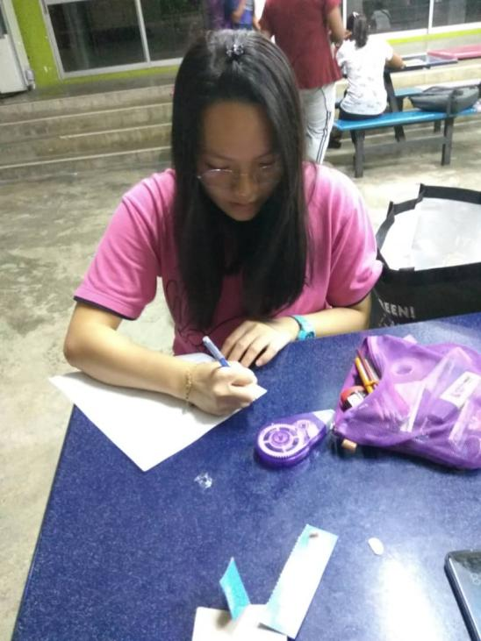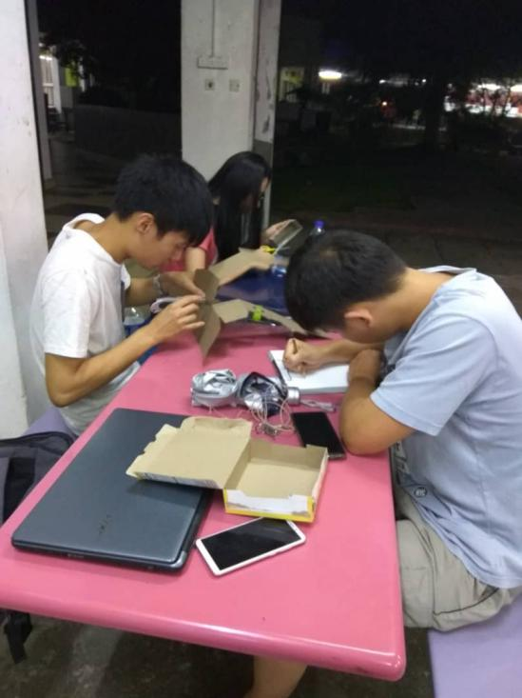
Figure 7-1 First Meeting

Second Meeting
Our second meeting held at Makmal Komputer KTDI, on 26th October 2018 at 4.00p.m. to 6.00p.m. In this meeting, Tan Zhi Quan became the people who lead the discussion and Kam Shwu Chin became the people who recorded the ideas.
In this meeting, we requested unwanted materials from friends to improve our materials store. Tok Kai Xian used the ideas that decided in first meeting to construct and draw the draft for our product. We used a big carton pieces as the basement of product and put the lower part of bottle on the basement with some decoration on the bottle. After that, Lim Wei Qin identified the function of our product. This process important for us to promote our product during selling time to our customer.
With the increment of materials, Kam Shwu Chin tried to get some references from Youtube and Google. She suggested to improve our product’s functionality and design. After discussion, we agreed to make some changes to our product. One of changes in our product was we added a few of medium size cartons on our basement to improve the functionality. At last, Tan Zhi Quan asked all team members for next meeting time and location. He arranged suitable time schedule for team members to next meeting.
We tried to add new ideas to our product. Thus, it become the difficulties for us in this meeting. We had to reconstruct the product arrangement to ensure its functionality improved and aesthetic maintained.
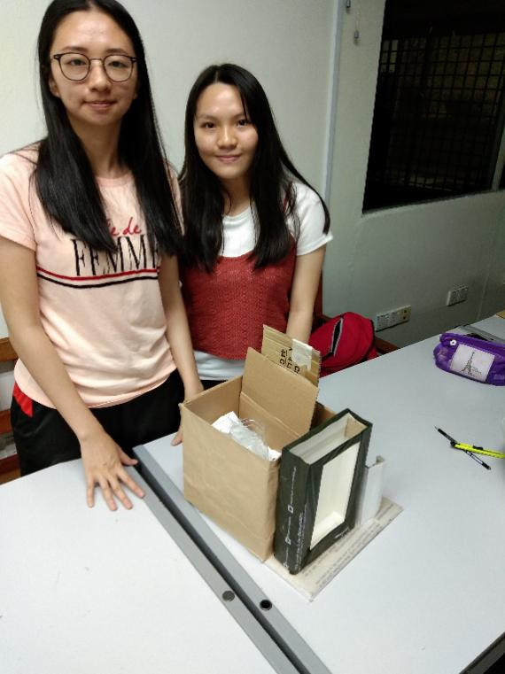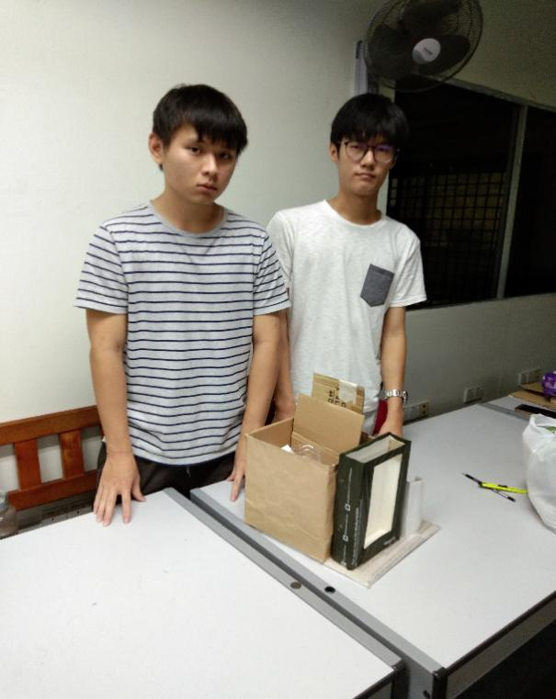
Figure 7-2 Second Meeting

Third Meeting
This meeting held on 27th October 2018 at 9.00a.m. to 11.30a.m. Location of this meeting was KTDI Makmal Komputer. This meeting conducted by Kam Shwu Chin and Tok Kai Xian took the notes about the information discussed.
Kam Shwu Chin suggested the idea to improve the aesthetic of product. She suggested to use plastic bag to cover the surface of each components of product before jointed. Thus, we used plastic bags as our product colour design. After that, Tok Kai Xian distributed the works to all group members. We worked together to jointed each small components of product to become a big and multifunction product. The product basically completed in this stage.
Lim Wei Qin try to improve the materials construction of product by added small carton pieces to the structure of boxes. Thus, our product’s physical strength can be enhanced and it becomes long lasting. The limitation of this meeting was we had to be cautious about the sequence of constructing product, which we cover each parts of components with plastic bag before jointed to ensure the process can be done smoothly and successfully.
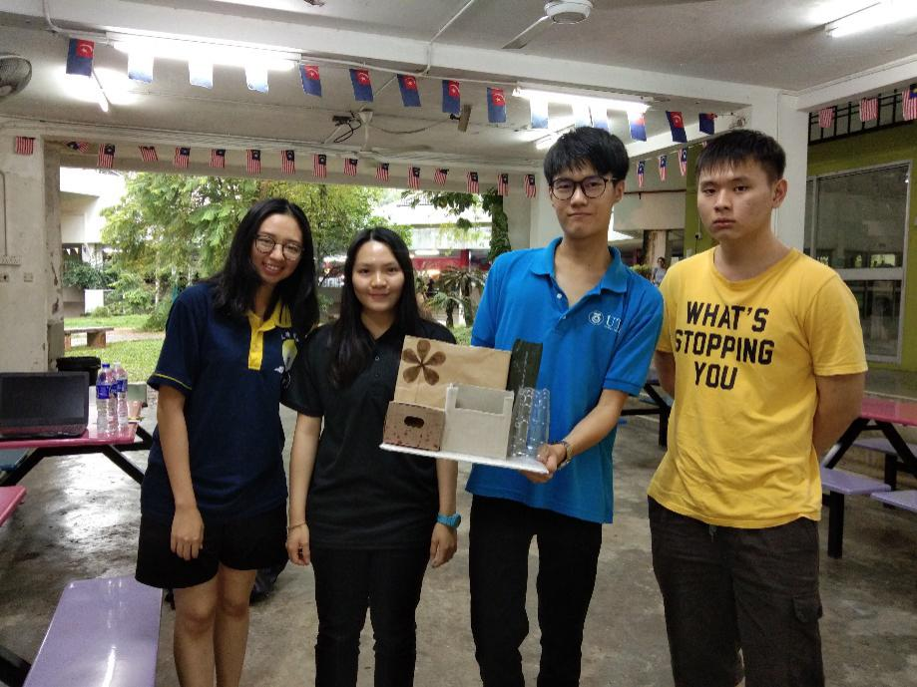
Figure 7-3 Third Meeting

Fourth Meeting
Fourth meeting held on 1st November 2018, 2.00p.m. to 4.00p.m. The location of the meeting at KTDI Makmal Komputer. This meeting was leading by Lim Wei Qin and Tan Zhi Quan took the notes during meeting.
In this meeting, Tan Zhi Quan suggested to set a price to our product. Thus, he received suggested price from other three members and calculated the average price for our product. Tok Kai Xian planned to find buyer to buy our product, Revival. He suggested to carry group’s product and moved around at KTDI area. After that, we found a buyer to buy our product.
At last, we gathered together again at KTDI Makmal Komputer to discuss our impression and Tan Zhi Quan recorded the information. The main difficulties of this meeting was we need to be courageous and brave to communicate with a stranger. Not only the communication with stranger, we had to convince them to buy our product and show them the specialty of our product.
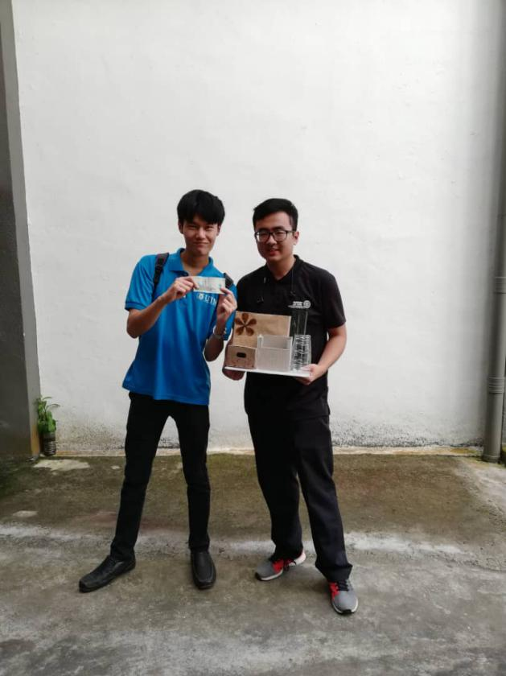
Figure 7-4 Fourth Meeting

Conclusion
“Hand Made 3R Craft” project gave our group members a significant opportunity to carry out a recycle product. Rubbishes like carton packing, plastic bag, wheel, cloth waste and bottle can recycle, reuse and reduce to reproduce a functional product. We used Youtube and Google to do reference, how to use ‘rubbish’ to regenerate a useful product. After group discussion, we decided to make a functional storage box.
The material owns have are carton packing, plastic bag, and bottle, there all materials are come from trash bin or useless items. We named the storage box as “Revival”, means rebirth or the improvement of condition and strength of something. We reuse the useless items to produce a functional product and give the value and function to that product.
In the processing of storage box, all of our group member gave the cooperation based on time and venue to each other. However, we also meet so problem such as lack of material, difference in opinion on the design and so on. Fortunately, our group members are respect to each other and we decided to use the most suitable suggestion to design the product.
After the 4 times group meeting, the ‘revival’ was produced. After that, we needed to give a price of our functional storage box. It is because we need to promote and convince customer to buy our 3R product. In this section we need communication with stranger, it was a challenging to us. Finally, we sold out ‘Revival’ in price RM 5. Hopefully, the customer can cherish and take the advantage of this storage box.

Reflection
Nowadays, the increase of mankind living standard, the increase the amount of rubbish. Every year we dump a massive 2.12 billion tons of waste. If all this waste was put on trucks they would go around the world 24 times. The rubbish constitutes a threat to environment, soil, ocean, and forest. Thus, 3R is very important to our environment there are, recycle, reduce, and reuse. Recycle means using used material and remanufacture it again. Definition of reduce is reduction of waste during produce process. While, reuse refer to help reduce waste by using items multiple time before discard them.
This is a cherish experience for our group member to produce a 3R product. We reuse carton, plastic bag, bottle, and small boxes to produce a utility storage box. This experience also improved our environment awareness. If mankind continued to waste and discard without recycle, reduce, and reuse. Before long, mankind will face problems like, high sea level, poor quality of air and water, flora and fauna near extinction. So that, we should cherish the environment and take an active part in environmental activities. I cherish environment, I love earth.
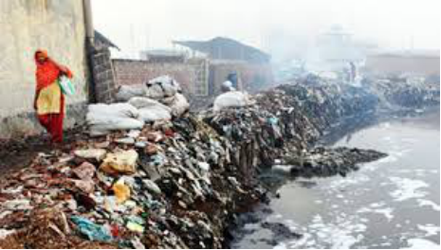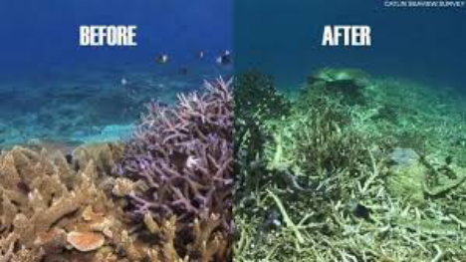
Figure 9-1 Environment pollution

