

NAME | TAN WEI KOK
MATRIC NUMBER | A18CS0258
COURSE | 1 SCSV
LECTURER’S NAME | DR. ARYATI BINTI BAKRI

Table of Contents
INTRODUCTION 3
e-Rezeki 3
Global Online Workforce (GLOW) 4
How MDEC get people to join e-Rezeki or GLOW program and Who can join the programs? 4
The effect of e-Rezeki and GLOW program to Malaysia 5
Summary 6
Bibliography 7

INTRODUCTION
Today, technology is growing rapidly and there is various type of platform that allow people to earn money. By this, I had attended an industrial talk organised by Malaysia Digital Economy Corporation (MDEC) to have a better understanding about the advantage of these platforms. In the industrial talk, I had impressed by the speaker namely MOHD IHSANUDDIN JAMHARI. He is the master trainer of Global Online Workforce and full time freelancer. Firstly, MDEC had organised a lot of programs which providing platforms such as e-Usahawan, e-Rezeki, Global Online Workforce (GLOW) and so on. In this report, I will emphasis on e-Rezeki and GLOW programs. These are organised based on the concept of sharing economy, sharing economy is an economic model based on sharing under-utilized assets from spaces to stuff to skills for monetary or non-monetary benefits. There are a lot of company gain benefits from the concept of sharing economy. For example, Airbnb providing the services about space, Uber by Garret Camp providing the services about stuff and there is a lot of freelancer providing their personal skills. These people have become exemplary on the concept of sharing economy. In addition, these programmes have successfully providing a lot of work opportunity and stimulate the flow of finance in country.

e-Rezeki
The e-Rezeki is a nation programme based on crowdsourcing concept. The government of Malaysia via MDEC, has taken a unique country-level approach in developing and managing local crowd-labour or crowd workers. This programme is aim to benefit the population in the bottom forty percent of the income or referred to as the B40. Moreover, e-Rezeki program enables citizens, especially low-income groups, generate additional income by doing digital assignments via online crowdsourcing platform. The e-Rezeki participants will matched with digital work in line with their respective skills. The e-Rezeki platform also allows individuals to register as digital workers and perform simple digital-based tasks to generate additional income.
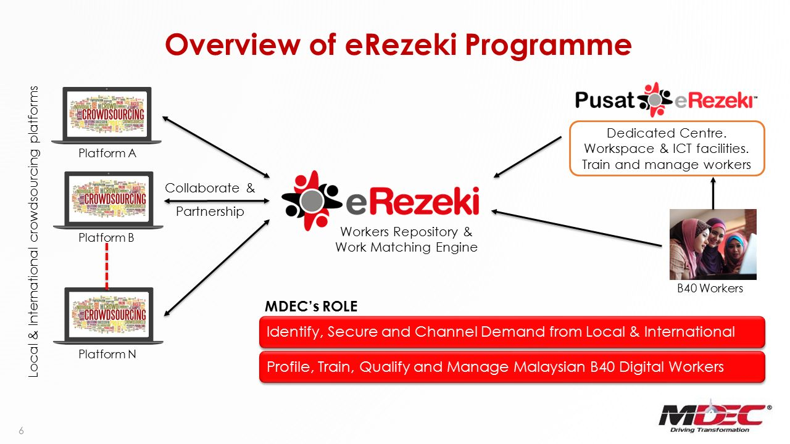
Figure 1:Overview of e-Rezeki Programme.

Global Online Workforce (GLOW)
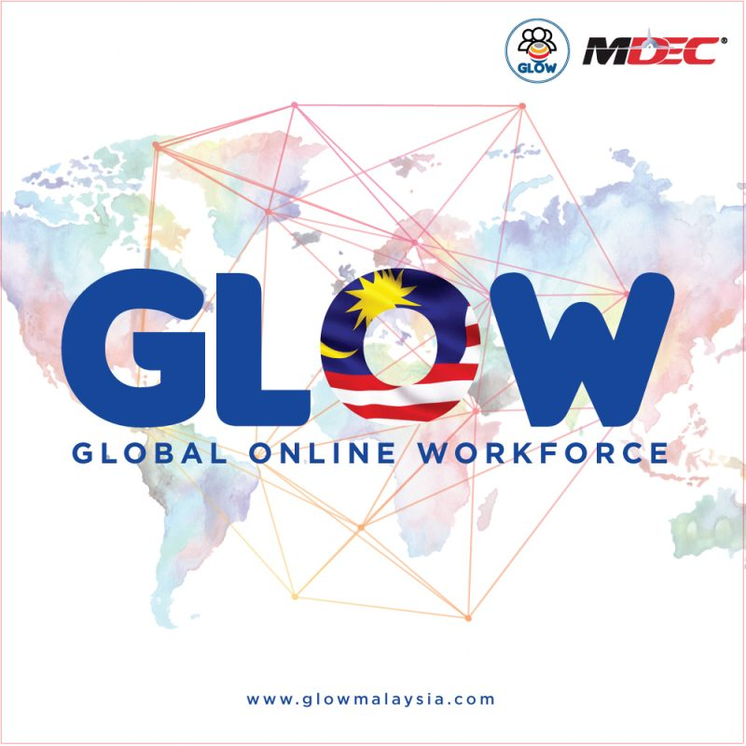
Figure 2 : GLOW programme under MDEC
GLOW programs almost the same like e-Rezki programs, it’s a program that guide Malaysians to generate income through digital work via crowdsourcing. GLOW program being implemented because it is to create a community of full time high quality crowd workers among Malaysians. It also aims to establish a sustainable model on the GLOW program through engagement with strategic partners. Additionally, it also providing alternative sources of income for Malaysians via multiple online platforms and developing a support program for Malaysians freelancers to remain motivated, driven and committed in earning digital income via crowdsourcing platform.

How MDEC get people to join e-Rezeki or GLOW program and Who can join the programs?
MDEC is using various ways to get people to join e-Rezeki and GLOW program to allow more people acknowledge the benefit of these programs. In this way, more people can join these programs and gain the benefit from these program. MDEC is also in the midst of partnering with the Employees Provident Fund and insurance companies to provide a proper retirement plan for freelancers who involve in the e-Rezeki and GLOW programs. By doing so, MDEC can attract more people to join the e-Rezeki and GLOW programs. e-Rezeki is open to individuals who are 18 years old and above. It’s only open to Malaysian citizens that hold a MyKad. Malaysians residing abroad are not encouraged to participate in e-Rezeki. However, valid MyKad number is required during registration.

The effect of e-Rezeki and GLOW program to Malaysia
e-Rezeki and GLOW programs providing a lot of work opportunity to Malaysians. In this case, Malaysians will become more productive and it stimulate the economy of Malaysia. By this, the foreign investment will be attracted to Malaysia and it will have increment of work opportunity. For example, the people who advanced in programming skill, digital marketing, translator and so on will required in the platform provided by the programs. I also believe that more Malaysians will attracted to these programs because for those who is easily home sick will stay at their home to do work as freelancer. When these people start to work, the average income of whole Malaysia will increase. In this case, Gross GDP will increase and it is easier to achieve ‘Wawasan 2020’ which promoted by Tun Dr. Mahathir bin Mohammad. It also helps to decrease the crime such as robbing, kidnapping because more people afford to face the living cost. In this case, the standard of living will be upgraded. It will encourage Malaysians to live peacefully and harmony. Below figure shows the aim of e-Rezeki in Malaysia.

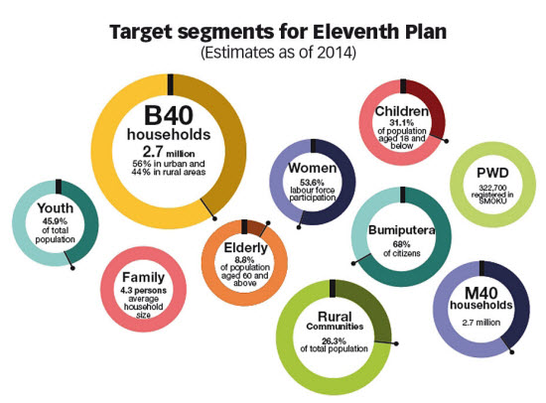
Figure 3: Target of e-Rezeki in Malaysia.

Summary
Malaysia Digital Economy Corporation(MDEC) has organised a lot of programs with can bring a lot of benefits to Malaysians, for example, e-Rezeki and GLOW program. After participating the talk, I had made a lot of consideration about registering the e-Rezeki or GLOW program. I think I’m interesting to join e-Rezeki or GLOW program. It is because these programs bring a lot of advantage for us. It providing a platform that allow me to get use of my skill for earning money. I can take advantage of these programs to decrease burden of family. Additionally, working online also allow me to improve my skill practically. It is because academic syllabus always emphasis on theoretical but not practical. When I work as freelancer in the program, I will learn how to apply my study on the work and become a more practical person. Otherwise, working as freelancer will also face some challenge such as communicate with others. Although it is communication via online, it will also improve my communication skill. By doing so, I will become a holistic person and more adaptable to future. Today, living cost is increasing rapidly, high salary is a must for people. Hence, programs like e-Rezeki or GLOW are very helpful for us. After participating the MDEC industrial talk, I have some reflection about the programs. Firstly, I impressed with the job of becoming a freelancer due to the clear explain by the talk speaker. There are a lot of exemplary success freelancer which had been shared by the speaker. They having high income by doing freelancer and it’s worth for us to learn from them. Secondly, I also notice that anyone can get high salary when they are hardworking to do work as a freelancer. For example, the speaker MOHD IHSANUDDIN JAMHARI is a full time freelancer by doing photography, ICT service and consultant, project manager, education and also graphic design. In this case, I notice that possessing a lot of skills can make myself have a better life in the future. Hence, I will try to work hard as them to face the challenge in the future.
Figure 4:Example of People who work as freelance under these programmes.
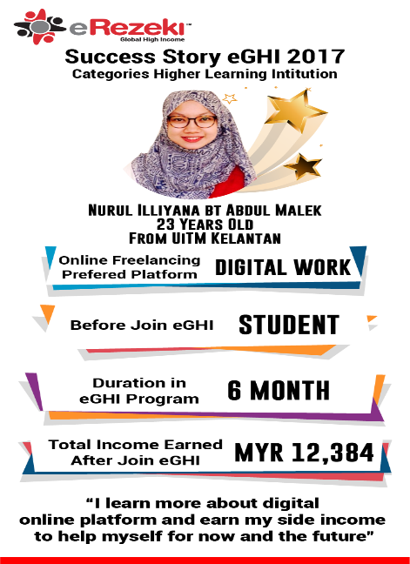  Example 1 | 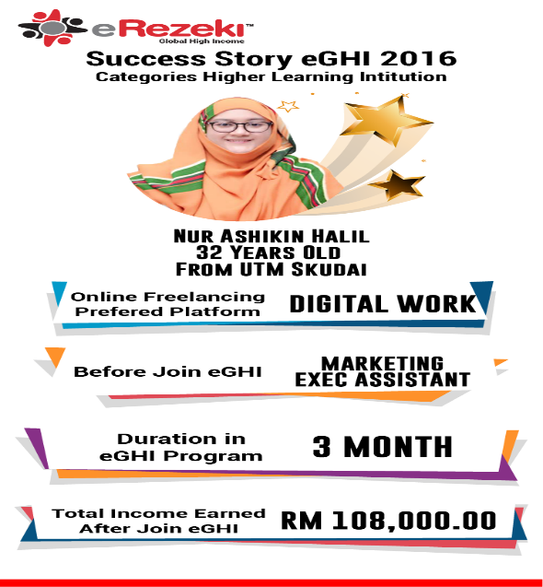  Example 2

Bibliography
- Attending an Industrial Talk which prepared by Mdec
- https://slideplayer.com/slide/11162123/
- http://www.thesundaily.my/sites/default/files/thesun/Catalogue/rm25_c14260_c1426044_15521_444.jpg
- https://www.mdec.my/
- https://erezeki.my/
- https://glowmalaysia.com/?lang=en
- https://www.google.com/url?sa=i&rct=j&q=&esrc=s&source=images&cd=&cad=rja&uact=8&ved=2ahUKEwitwNPOwfbdAhVMO48KHdauC9EQjRx6BAgBEAU&url=http%3A%2F%2Feghi.my%2Fsuccess-stories%2F&psig=AOvVaw1UNAVJaT9A8wT-2SEnowbV&ust=1539076267304810
- https://www.google.com/url?sa=i&rct=j&q=&esrc=s&source=images&cd=&ved=2ahUKEwiutqqFxPbdAhVKMI8KHXRfDVsQjRx6BAgBEAU&url=https%3A%2F%2Fwww.google.com%2Furl%3Fsa%3Di%26rct%3Dj%26q%3D%26esrc%3Ds%26source%3Dimages%26cd%3D%26cad%3Drja%26uact%3D8%26ved%3D2ahUKEwjV0JqEwPbdAhXEM48KHaD7A2wQjRx6BAgBEAU%26url%3Dhttp%253A%252F%252Feghi.my%252Fsuccess-stories%252F%26psig%3DAOvVaw1UNAVJaT9A8wT-2SEnowbV%26ust%3D1539076267304810&psig=AOvVaw1UNAVJaT9A8wT-2SEnowbV&ust=1539076267304810

