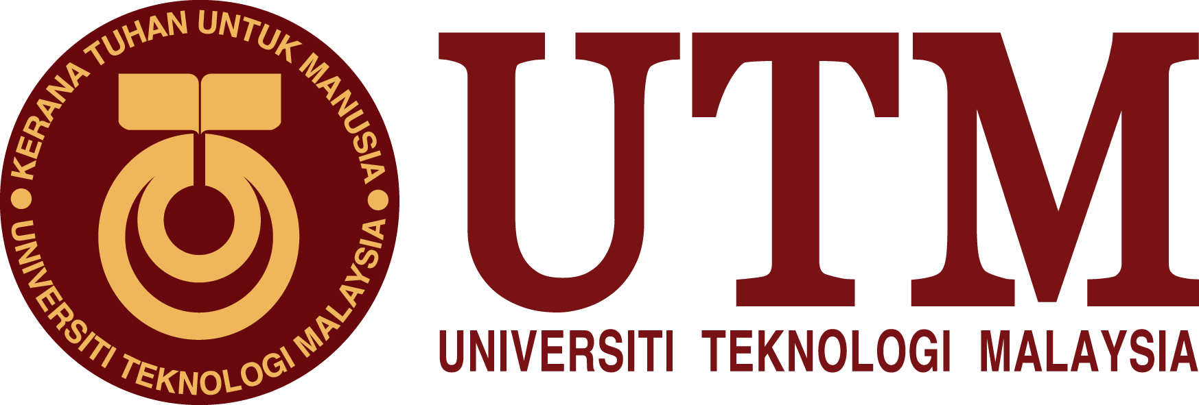

INDUSTRIAL TALK 2 – NALI SYMPOSIUM (GROUP)

NAME | - AFIF HAFIZIN BIN HAMIZAN (A18CS0008)  - ALEEF HYQAL BIN HILMERIZA  (A18CS0023)  - CHENG SHIN WEI (A18CS0046)
SECTION | 09
LECTURER’S NAME | Dr. Aryati Bakri
Table of Content

Table of figure 2
1 INTRODUCTION 3
2 CONTENT 3
2.1 Booth 81 (Continual Quality Improvement) 3
2.2 Booth 82 (Teaching and Learning Using a Novel Pico Hydro Turbine Kit) 4
2.2.1 Objective and Impact 4
2.2.2 Trend 4
2.3 Booth 83 (InMotion Concept and Industrie 4.0) 4
2.3.1 Objective and Impact 5
2.3.2 Trend 5
2.4 Booth 86 (Capstone Project) 5
2.4.1 Objective and Impact 5
2.4.2 Trend 6
2.5 Booth 87 (PABELILAP 2.0) 6
2.5.1 Objective and Impact 6
2.6 Booth 90 (Drops of Light) 6
2.6.1 Objective and Impact 7
2.6.2 Trend 7
3 SUMMARY AND REFLEXTION 7
4 TASK FOR EACH MEMBER 7
5 BIBLIOGRAPGHY 8

Table of figure
Figure 1 Dr Peing Ling Leow 5
Figure 2 Pico Hydro Turbine Kit 6
Figure 3 InMotion Concept 6
Figure 4 Capstone Project 7
Figure 5 PABELILAP 2.0 8
Figure 6 Drops of Light 8

INTRODUCTION
New Academia Learning Innovation (NALI) organized by the Center for Teaching and Learning (CTL), UTM was held in the 25th and 26th September, at Sultan Iskandar Hall, Universiti Teknologi Malaysia, Johor Bahru, Johor. New Academia Learning Innovation Model is a framework comprising student-centred and blended learning philosophy, multiple learning modes and materials towards achieving entrepreneurial academia. Entrepreneurial Academia is the outcome of New Academia Learning Innovation Model. All the practitioners were able to share and present their research findings that have been or being carried out in relation to the NALI field. In comparison to traditional teaching, for example face to face learning, the concept of blended learning is emphasized in this model. Blended learning is a combination of active and systematic strategy with the use of digital teaching materials in class. This encourages better and more meaningful learning experience. One of the purposes of NALI is to align UTM teaching and learning models, activities, materials environments and systems with Malaysian National Higher Education Strategic Plan, needs of employers and requirements of accreditation bodies. Other than that, NALI also offered a chance to create meaningful and interactive learning activities, materials, environments and systems appropriate to UTM Graduate Student Attributes.

CONTENT

Booth 81 (Continual Quality Improvement)
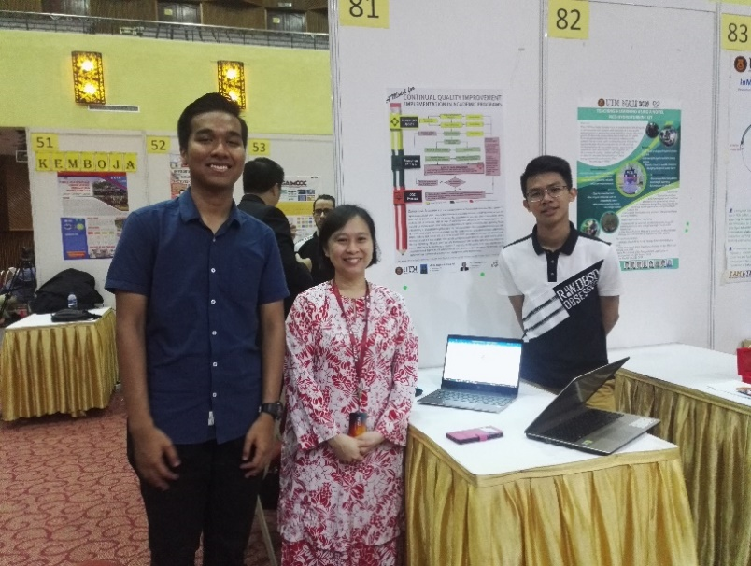
Continual Quality Improvement (CQI) is an important element in Outcome-Based Education (OBE). A proper CQI implementation ensure better understanding by academic staff on the philosophy behind OBE, as they are given the opportunity to become part of the CQI process. The implementation promotes sense of responsibility among academic staff to continuously seek for ways of improving course delivery so that the learning outcomes. The proposed CQI Implementation Model has been conducted since 2014 at the School of Electrical Engineering, Faculty of Engineering at UTM. The implementation of the proposed model that involve face-to-face discussion among the academic members and CQI Coordinators thus far has promoted better understanding among academic staff on their role as a course lecturer in OBE, particularly on the aspect of continual quality improvement of the program. The proposed CQI implementation model has been a practice at the School of Electrical Engineering, UTM for the past 5 years and has been proven to be beneficial particularly during the audition process conducted by the Engineering Accreditation Council (EAC). The CQI process can be clearly explained with the evidence provided through the CQI report produced every semester for all the programs. This innovation can be easily transferred to other academic programs as a best practice on CQI implementation. The trend of this program is letting the staff of university or lecturer to have a close relation with students and easily for them to help or guide the students. So that students could be more active in class section and discussion section.
Figure 1 Dr Peing Ling Leow

Booth 82 (Teaching and Learning Using a Novel Pico Hydro Turbine Kit)
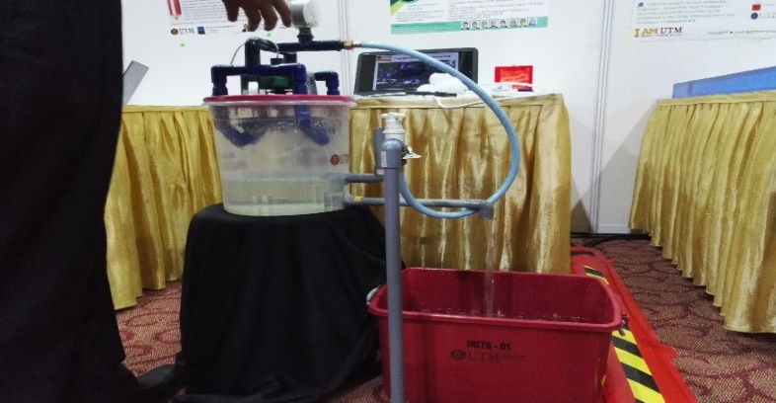
The UTM Pico Hydro Turbine Kit is an experimental kit designed to demonstrate the concept and workings of a renewable energy system in producing clean electrical energy. The total power of electricity produced is dependent on the water flow rate generated by the mechanical rotation of the turbine. The kit comes with a comprehensive Pico Hydro Turbine Module that incorporates the STEM (acronym for Science, Technology, Engineering, and Mathematics) concept, the fundamental of renewable energy, experimental procedures and assessments. This complete set of a renewable energy system will help the students to visualize the operation of clean energy system thus enhancing their knowledge in STEM.
Figure 2 Pico Hydro Turbine Kit

Objective and Impact
The objectives for this project were to provide students with knowledge and hands on application in generating energy, to understand water flow rate concept and electrical power generation using Pico Hydro Turbine Kit and to increase motivation and enhance STEM knowledge among students. Students will be exposed to interactive teaching and learning environment using Pico Hydro Turbine Kit experiment. A Pico Hydro Turbine Module is provided for teaching references and assessments in evaluating STEM values.

Trend
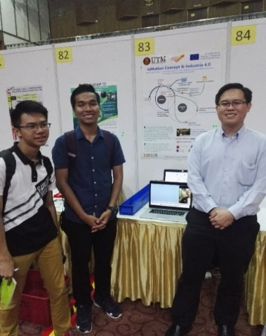
The trend of this turbine kit act as an exciting approach to expand student's interest in learning about alternative energy generation system.

Booth 83 (InMotion Concept and Industrie 4.0)
A European Union Grant project carried out in FKM (UTM), which aims to create new e-Learning Materials for Computer Modelling and Simulation for Engineering (CMSE) field with Open Modelling and Simulation Environment platform (OMSE) base on innovative teaching strategies and creative learning approaches. InMotion targets to train graduates, engineers, researches from European Countries and Pacific Countries to be competent in the CMSE field and hence the realization of Industrie 4.0.
Figure 3 InMotion Concept

Objective and Impact
This concept is important as the students or engineer can access to internet and done their laboratory work anywhere else other that lab. Students or engineer needs only register in a certain website and send the tasks to the server. The cloud computing will distribute these tasks accordingly to specific lab and the programmed system will conduct the experiment automatically and send the result back to the user. Different tasks are done by different system. For instance, remote 3D printing will construct the 3D printing results, advanced human-machine interfaces will remote operated robots to conduct lab experiment. This concept is helpful as certain experiment is time consuming. For example, to study the wavefront of water. Normally the apparatus to conduct this experiment is expensive and certain school does not have many such apparatus to fulfill all the students. Furthermore, this experiment requires the water wave fully immobilise just then following group can conduct the experiment. Thus, this concept saves the time and easier for the students or engineer to finish the report. The result done by advanced human-machine interfaces are more accurate and precise compare to students as certain errors likes random error and systematic error can eliminate.

Trend
The trend of this concept is to bring students to technology lab which is less time consuming and

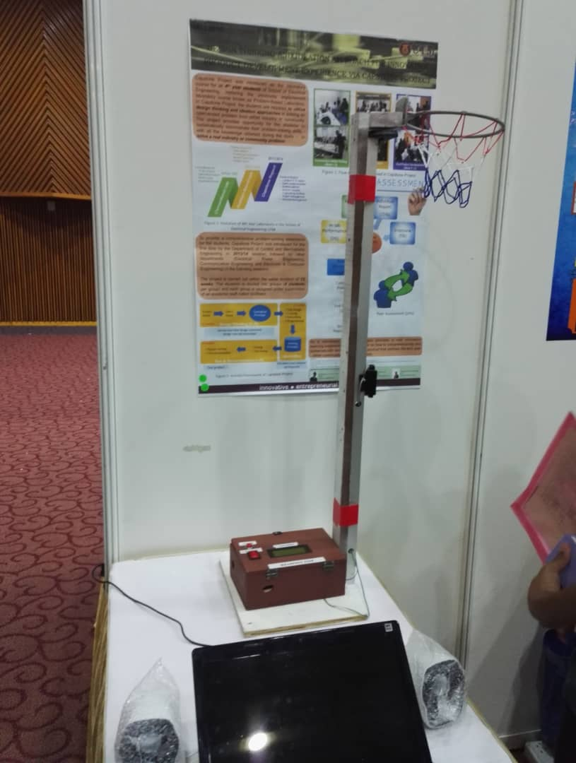
Booth 86 (Capstone Project)
Figure 4 Capstone Project
From this booth, we learned about how to utilize design thinking and ideation approaches. Capstone Project was introduced as the laboratory course for all fourth years students of School of Electrical Engineering, replacing the previously implemented laboratory course known as Problem-Based Laboratory. In Capstone Project, the students are required to utilize design thinking in solving an open-ended problem from either industry or community. This project provides opportunity for the students to systematically demonstrate their problem-solving skills. With all the knowledge that they learned, they can solve a real industry or community problem.

Objective and Impact
To provide a comprehensive problem-solving experience for the students, Capstone Project was introduced for the first time by the Department of Control and Mechatronic Engineering in 2013/14 session, followed by other departments which is Electrical Power Engineering, Communication Engineering and Electronic and Computer Engineering in the following session. The project is carried out within the same duration of 12 weeks. The students are divided into group of four and each group is assigned under supervision of an academic staff called facilitator. At the first four weeks, students are test with design thinking which include project intent, user’s need and conceptual prototype. Then, they require to build their prototype with the help of their facilitator in the aspect of assembling, programming, costing and engineer design. The last four week is test and documentation which require the students to test, fine tuning, write a report and oral presentation about their ideas.

Trend
This trend provides an initiative to train students with critical thinking and problem solving.
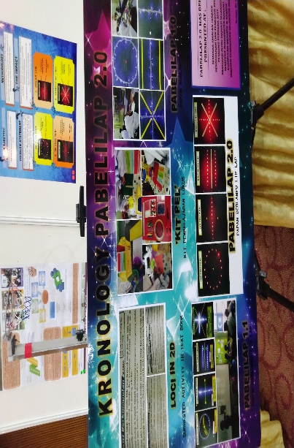

Booth 87 (PABELILAP 2.0)
From this booth, we are investigated about physics concept which is light. PABELILAP 2.0 is a tool that will help students in laboratory to find loci point. Loci is the set of all points, lines or surfaces that satisfy a given requirement. Loci has 4 types which are a one fixed point, two fixed, one line and intersecting lines. PABELILAP 2.0 is invented because at early stage students are difficult to comprehend the concept of moving point in loci. Other than that, loci is an abstract concept and these problems cause teaching and learning process to be longer than usual.
Figure 5 PABELILAP 2.0

Objective and Impact
PABELILAP 2.0 is invented to help teachers to find the best tools to comprehend the subtopic of loci in 2D. The impacts from this project is it can generate student’s thinking with the activity of ‘PABELILAP 2.0’, save time and easier for teachers to explain the concept of moving point, to help students to comprehend the concept of loci in 2D, more attractive and innovative and very useful for teaching Loci in 2D.

Trend
The trend of this booth is to provide sufficient understanding for students by creating an apparatus that can allow students to investigate by themselves. By doing so, students will feel happy by finish the task given by the lecturer.

Booth 90 (Drops of Light)
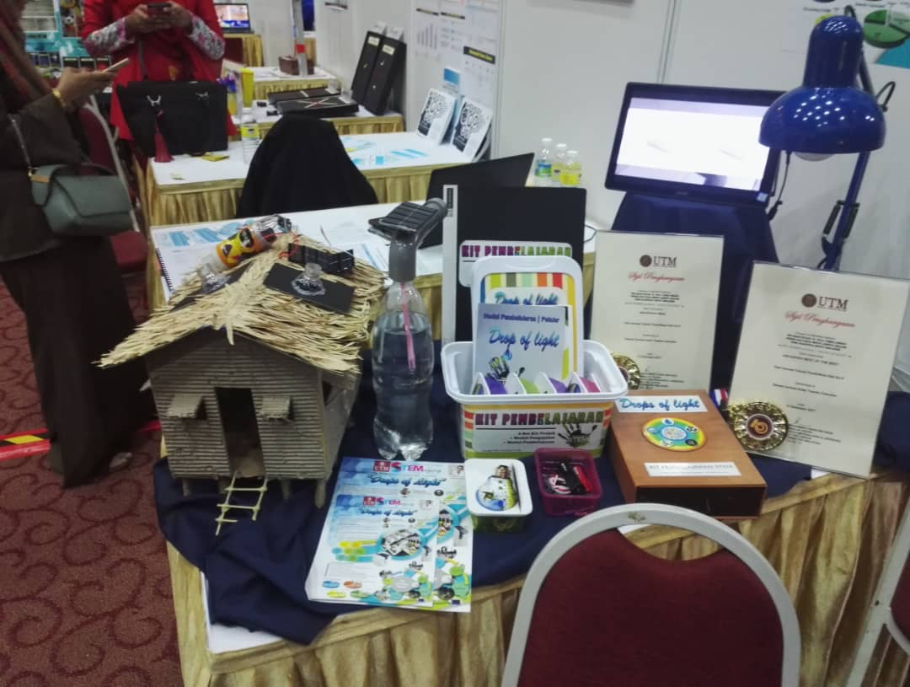
From this booth, we learned also about physics concept which is light refraction. This project known as ‘Drops of Light’ is a learning kit that is related to the phenomenon of refraction of light and renewable energy. The curriculum designed and developed intended to provide students with useful and meaningful knowledge, skills and value through activities inside or outside the classroom. The acquisition of STEM knowledge in this project is progressively and dynamically. “Drop of light” is a is a learning kid about light and it could help many people especially for those poor which cannot get the light source at night. This model can be design on top of the roof, so that at night it can produce light source. During the daytime, solar plate will recharge the battery and the light source automatically shut off and open at night time. The stored energy can last for a night and enough bright.
Figure 6 Drops of Light

Objective and Impact
The aims of this project are to innovate the production of lightning for area with electrical power problems either due to locations, costs or other factors. Other than that, to give students an idea of how to generate light energy using solar energy and can be use continuously without the limitation of location, cost and time. This project benefits primary till upper secondary students as it enhances the better understanding about light. This is because the syllabus in secondary school only include the theory but not application. With this learning kit, it allows better understanding about the application of light to our daily life. Next, it can maintain the green environment by which this project using renewable energy and not producing waste.

Trend
The trend of this learning kid is to provide understanding for students about light, so that students manage to design and modified more and more these circuit to the person who needed. By doing so creativity and innovation of students are enhanced.

SUMMARY AND REFLEXTION
NALI is an exhibition held by UTM by which each exhibitor shares research and innovation products in teaching and learning to the audience. By doing so, the audition can know their effort on how them conduct the program and then apply to their field respectively. For instance, it provides a chance for the staff or lecturer in UTM to share experience based on their research and innovation product. This program improves STEM awareness and the educator competency in practicing teaching and learning in the 21st Century. Most of the innovation product are created by the exhibitor and register under UTM. This prove that the staff in UTM are creative enough on solving the problem facing on the teaching and learning section. For instance, when the staff of UTM know students are not perform well in loci, so they create an PABELILAP to enhance better understanding of students in this chapter. Some staff found out that students are weak in application of light in our daily life, so they created a learning kid for students to modify the learning kid. Besides, some exhibitor shares their research and achievement on conducting their research to other staff so that more students are being benefited. For instance, some exhibitor found out that students are weak in utilize design thinking, so they organised a program likes Capstone project to enhance the design thinking of students. This type of innovation in teaching and learning, provide better understanding and skill enhancement to UTM students. This type of teaching section is different with the previous times by with students just study in class. This type of teaching section provides a practical or hands on activity for the students to investigate how it functions. Students will have the sense of accomplishment when they started to know how the apparatus works. This could enhance the interesting of the students about the subject and causing them more active and progressive in the teaching section.

TASK FOR EACH MEMBER
INTORDUCTION, CONTENT | AFIF HAFIZIN BIN HAMIZAN  ALEEF HYQAL BIN HILMERIZA  CHENG SHIN WEI
BOOTH 81,82 | ALEEF HYQAL BIN HILMERIZA
BOOTH 83,86 | AFIF HAFIZIN BIN HAMIZAN
BOOTH 87,90 | CHENG SHIN WEI
SUMMARY | CHENG SHIN WEI

Bibliography
Exhibition and Competition. (n.d.). Retrieved from NALI: http://ctl.utm.my/nali2018/exhibition/
NALI. (n.d.). Retrieved from Exhibition and Competition: http://ctl.utm.my/nali2018/exhibition/

