

INDUSTRIAL VISIT TO COOL CODE SDN BHD
(Technology and Information System)

NAME | - AFIF HAFIZIN BIN HAMIZAN  (A18CS008)  - ALEEF HYQAL BIN HILMERIZA (A18CS0023)  - CHENG SHIN WEI (A18CS0046)
SECTION | 09
LECTURES’S NAME | DR. ARYATI BAKRI
DATE | 15 NOVEMBER 2018

TABLE OF CONTENT

1 INTRODUCTION 3
2 DETAILS OF JOURNEY 4
3 ORGANIZING STRUCTURE 5
4 SERVICES AND INFORMATION SYSTEM 7
5 ACHIEVEMENTS 7
6 REFLECTION 8
6.1 What is your goal or dream with regard to your course/program? 8
6.2 How does this visit impact on your goal or dream with regard to your program? 8
6.3 What is the action or improvement @ plan necessary for you to improve your potential in the industry? 8
7 BIBLIOGRAPHY 9

TABLE OF FIGURES

Figure 1 Cool Code Logo 3
Figure 2 Our Group with Cool Code's team members 4
Figure 3 Organizing structure 5
Figure 4 Team Members of Cool Code Sdn Bhd 6

INTRODUCTION


Figure 1 Cool Code Logo
On the 15th November 2018, our lecturer, Dr. Aryati Bakri has organized an industrial visit for our section to Cool Code Sdn Bhd. Cool Code Sdn Bhd is a team of passionate people that wants to deliver great solution and products to the customer. They were the team that willing to develop solution and solving problems. They were specialize in designing and developing native and hybrid application. They were also active in mobile game development and focused in endutainment sector. Gamification in games in their core expertise. Other than that, their company was warded the “Best student enterprise” award in MOHE Entrepreneutrial Award 2015. They worked with government agencies includes Ministry of Higher Education, private companies and constitution. Some of their famous and well known products include, Didi & Friends Playtown (Collaboration of Digital Durian and ASTRO), Rainbow Jawi and RunCloud (Hassle-free PHP Application and Server Management Panel).

DETAILS OF JOURNEY
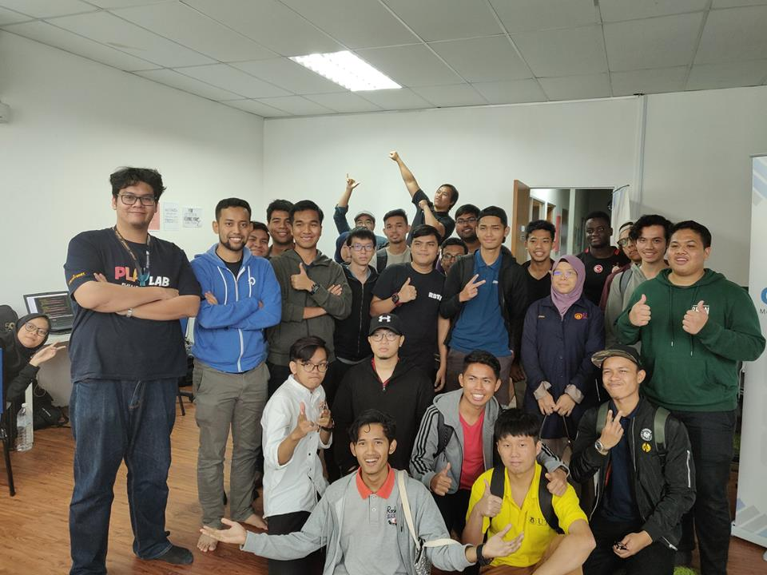
Figure 2 Our Group with Cool Code's team members
The industrial visit was held on the 15th November 2018. At around 2.30 pm, all students gathered at KTDI before depart to the destination. We went to the Cool Cool Sdn Bhd by bus . It’s located at 52-2, Jalan Setia Tropika 1/18 Setia Tropika, 81200 Johor Bahru, Johor. When we reached the destination, we were divided into 2 groups for 1 session at the Cool Code studio. After the first group has finished, it’s time for our group to visit the places for the second session. Mr. Arif Tukiman, the Founder of Cool Code as well as Co-founder & CEO of RunCloud has given the talk regarding what was actually they were doing and their on-going projects. He explained about the company and how he build the company from scratches. Some of their famous and well known products include, Didi & Friends Playtown (Collaboration of Digital Durian and ASTRO), Rainbow Jawi and RunCloud (Hassle-free PHP Application and Server Management Panel). Cool Code Sdn Bhd was actually rebranded from Sejuk Studio back in January 2014 after it has became one of the successful company in term of designing and developing native and hybrid application.
After about 1 hour session with him, we were introduced to their team members and what their job at the company, One of the them were our seniors which is a 4th year students at UTM. The team members shared many useful things and experience about the courses that we took right now. Mr. Arif Tukiman has really inspired many of us to go further and never give up in the courses no matter how hard it is. After about 1 hour showing around the places, we went back to UTM at 5.30 p.m.

ORGANIZING STRUCTURE

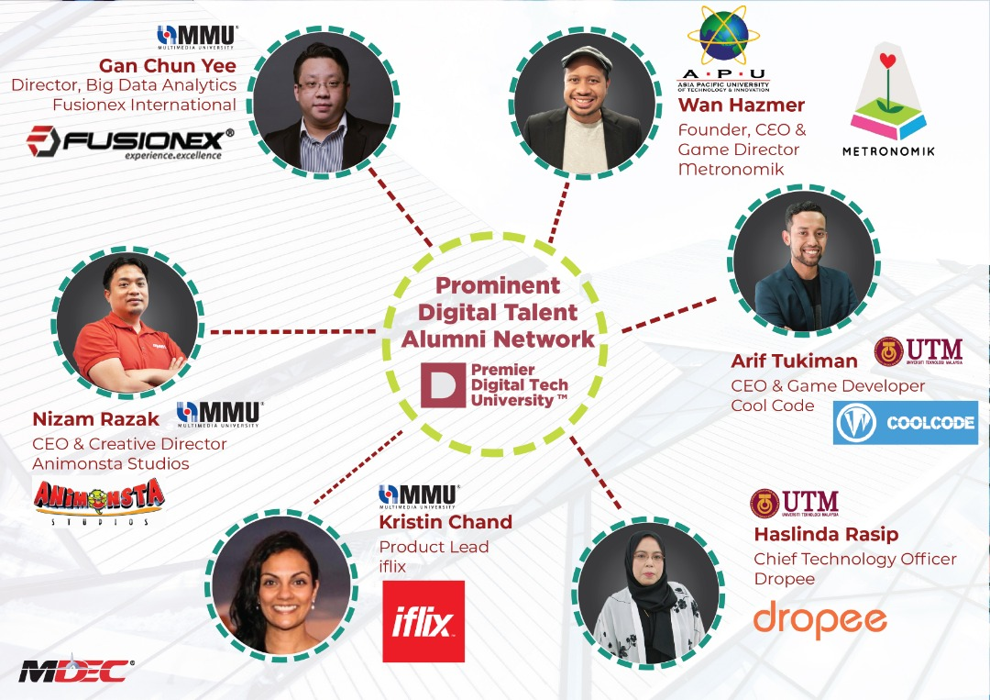

Figure 3 Organizing structure

The company was run by a several team members with different job expertised. It’s very important to have an orgazing structure in a company in order to produce some quality products for the end users.

Mr. Arif Tukiman were the Founder of Cool Code and Co-founder & CEO of RunCloud. He was an Experienced Chief Executive Officer with a demonstrated history of working in the information technology and services industry. He is also skilled in Research, Management, Game Development, and Business Development as well as strong business development professional with a Master of Science (M.Sc.) focused in Information Technology Entrepreneurship from Universiti Teknologi Malaysia. He created the Cool Code company back in January 2011 when he was about second year students in UTM.

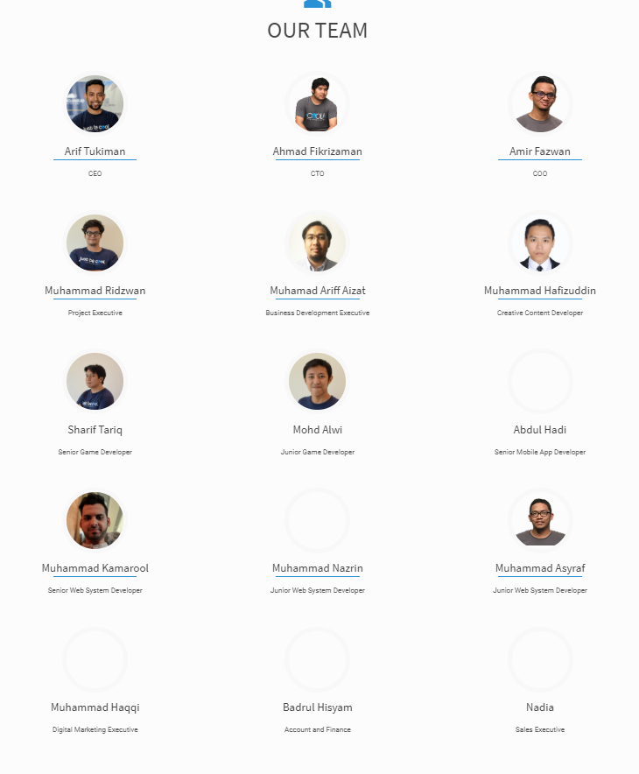

Figure 4 Team Members of Cool Code Sdn Bhd

SERVICES AND INFORMATION SYSTEM

Cool Code Sdn Bhd offers variety of services and also boost businesses.

JOB EXPERTISE
Mobile Application Development
Game Development
Interactive Content
Web Application Developemnt
Web Design and Portal Development
Training Course & Consultant

ACHIEVEMENTS

Cool Code Sdn Bhd has achieve many awards throughout the entire year since it was created back in early 2014. In a year 2015, Cool Code company was awarded the “Best student enterprise” award in MOHE Entrepreneurial Award 2015.

In 18th September 2018, they managed to win in 2 category in IPSmart Hackathon Challenge, at Iskandar Space Johor. They has received the grand prize and entitled as Crowd Favourite Winner for the event. In 23 September 2018, another big achievement for the company for winning 2 categories in APICTA ICT Award 2018 for the “Best ICT Services Solution” and “Best Startup.

Back in August 10 2017, Cool Code PlayLab has won a “Digital Games” category in program called Inllectual Property Creator Challenge (IPCC) 2017 organised by MDEC at Cyberjaya. They have received a total amount of money which is RM50,000 as a winner for the category.
In 26 November 2016, Team RunCloud from the Cool Code has been award as a winner for Project Pilihan JomLaunch4, and received RM1000 as a price winner. The program was a community program, JomWeb at Menara TM.

Some of their famous and well known products include, Didi & Friends Playtown (Collaboration of Digital Durian and ASTRO), Rainbow Jawi and RunCloud (Hassle-free PHP Application and Server Management Panel). Furthermorem, from what Mr.Arif Tukiman explained to us, Didi & Friends Playtown has been trending in Google Play Store for a long time since it was develop. The app itself was very interactive and educational especially for children to learn new things. It was a great example that a small company can create such an impactful app that could bring benefits to the users.

REFLECTION

What is your goal or dream with regard to your course/program?
Our goal or dream with regard to our course is we want to create popular game engine that equivalent with Unreal Engine, Unity and so forth to put the name of Malaysia equivalent with other country that already more advance in field of graphic and multimedia. This is said so because Malaysia still need expert programmer and as we can see, Malaysia still low in production of video games that have the perfectionist from the aspect of graphic, smoothness and other important aspect like Dota 2, Fortnite and other popular games. So, from the production those game engine, not only the purpose to pursue the luxury, but we want to use this advantage to improve programming skill in our society especially among youth. So, from this effort, the benefits that country will get is we will see in the generation where more production of expert programmers from Malaysia because the ideas from the next generation will become more advance as well as the passage of time.

How does this visit impact on your goal or dream with regard to your program?

From this visit, the impact on our goal regard to our program is this visit has motivated ourselves that in the future, the things that will controlling everything is the technology of computer. As we know, revolution is always happen and referring back to the Fourth Industrial Revolutionary , exactly the manpower should be reduce and all works can be done by machine. From that, we no need to worried about our program because it guaranteed a bright future for us soon!

What is the action or improvement @ plan necessary for you to improve your potential in the industry?

As a student, it is important for us to improve our potential in order to be successful in the industry after we graduate. There are many ways or action that we could take. For instance, we could find a mentor or shadow a colleague. Think of a successful individual we know, admire and would like to learn from. We could also try to find low- cost or free ways to lear new things, such as taking free online courses or finding a mentor in the company if there’s no formal mentor program.
Attending conferences or hands-on workshops will give us a chance learn about the latest developments in the field that we are on and keep our skills and knowledge up to date. It can also be a great way to meet and exchange ideas with other professionals in the industry. Volunteering could also be one of a good way to improve to be better. Although volunteering outside of work will require a considerable time commitment on our part, it can be an excellent way to master skills we haven’t been able to practice in our current line of work. This can be especially beneficial if we’re thinking of making a career change and want to gain some practical experience in a new area. Last but no least, joning an inline community could open a big chanccs for us to seek for a new knowledge that might be useful in the industry. Technology has made networking easier than ever before, and online communities and platforms have become important tools for professional development.
For instance, joining a specific group on LinkedIn or signing up for online forums and discussion boards will allow you to exchange ideas with likeminded individuals and participate in relevant discussions, while Twitter can help you to connect with key people in your industry and track relevant hashtags to see what’s trending.

BIBLIOGRAPHY

About: Cool Code. (January, 2014). Retrieved from Cool Code Sdn Bhd Linkedin Web site: https://www.linkedin.com/company/cool-code-sdn-bhd/about/

Facebook: Cool Code Sdn Bhd. (2014, January). Retrieved from Cool Code Facebook Page: https://www.facebook.com/coolcodemy/

Home: Cool Code. (2014, January). Retrieved from Cool Code Sdn Bhd: https://coolcode.my/

Tukiman, A. (2014, January). About Us: Arif Tukiman. Retrieved from Linkedin: https://www.linkedin.com/in/ariftukiman/

