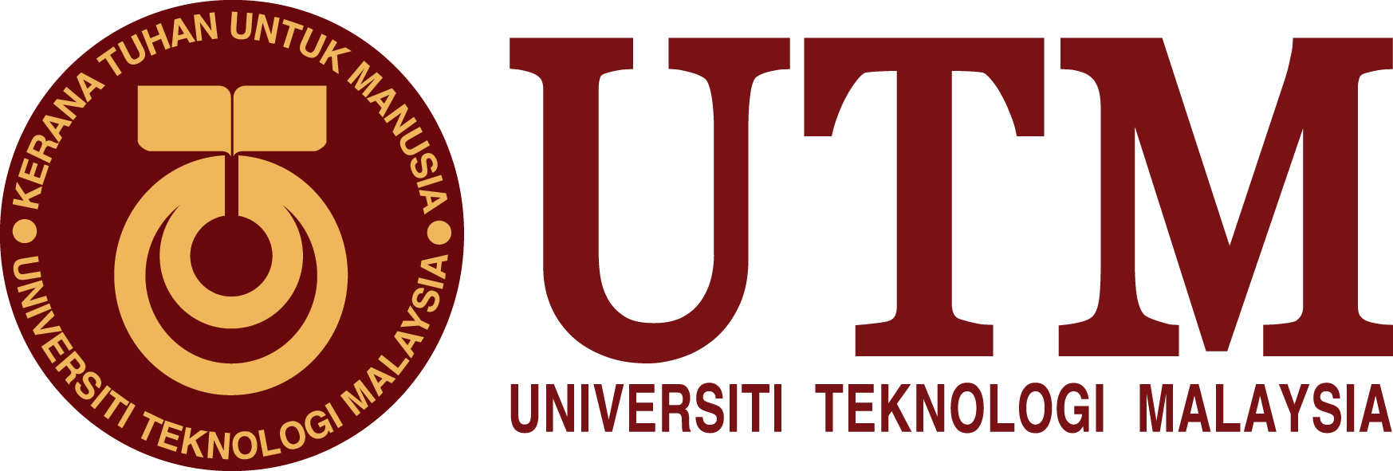

Internet of Things & Internet 2.0

(Technology and information system)
NAME | - AFIF HAFIZIN BIN HAMIZAN  (A18CS008)  - ALEEF HYQAL BIN HILMERIZA (A18CS0023)  - CHENG SHIN WEI  (A18CS0046)
SECTION | 09
LECTURES’S NAME | DR. ARYATI BAKRI
DATE | 28 November 2018

Table of Contents
1. INTRODUCTION 2
2. CONTENT 3
2.1 IoT-Predictive Maintenance 3
2.1.1 Worldwide CIO Agenda 2019 Prediction by IDE 3
2.1.2 Industry 4.0 – Technology Trends 5
2.2 Internet 2.0: Transaction Based Networking 6
2.2.1 History of Internet 7
2.2.2 Distributed ledger Technology / Blockchain 8
2.2.3 Strength, Weaknesses, Opportunity and Threat 9
2.2.4 Use Case 9
3. SUMARRY 10
4. BIBLIOGRAPHY 11

Table of Figure
Figure 1 : Hewlett Packard Enterprise 4
Figure 2: Industry 4.0 Technology Trend 6
Figure 3: History of Internet 7
Figure 4 : Centralized databases and Blockchain 8

Table
Table 1 : Blockchain strength, weakness, opportunity and threat analysis 9

INTRODUCTION

Advanced Telecommunication Technology Research Group (ATT RG) in collaboration with ICONIX Consulting Sdn Bhd, JURUTEK, Kolej Tuanku Canselor (KTC), UTM, on behalf of the School of Electrical Engineering (SKE), Faculty of Engineering, Universiti Teknologi Malaysia (UTM), have organized the Internet-of-Things (IoT) Carnival 2018 for the second time. This carnival was held on 17th and 18th November 2018. The committee of IoT carnival organized a lot of activities including project showcase, hackathon, hands-on training, workshop and industrial talks. The first day of the IoT carnival run with hackathon including hands-on training and workshop while the following data is project showcase and industrial talks.
On 18 November 2018, the industrial talk was held at P03 near to school of Electrical engineering, UTM. The main purpose of this talk is to give exposure to student on the importance of information technologies and how to manage them. The talk had two section which is first talk started from 11.00 am to 12.00am while second talk start from 12.00am to 1.00am. First talk, which is about "Predictive Maintenance" was given by Mr. Syahrul Hafidz Suid and followed by "Transaction based networking", the second talk which given by Mr. M. Nazrul Hazeri Nazirmuddin.

CONTENT
The talks have separated into two section and each section provided the slides to students for better understanding about what will be talked.

2.1 IoT-Predictive Maintenance
First talk
Title : Predective Maintenance
By : Mr. Syahrul Hafidz Suid

2.1.1 Worldwide CIO Agenda 2019 Prediction by IDE

In this talk, Mr. Syahrul has delivers to us about some prediction that maybe will happen in future with his subtopic about IDC FutureScape: Worldwide CIO Agenda. He said, the youth must concern about future and students must manage from the beginning the plan in other to face the Industrial Revolutionary. At the first, he introduces about Hewlett Packard Enterprise (HPE) which is an American multinational enterprise information technology company based in Palo Alto, California, founded on 1 November 2015 as part of splitting of the Hewlett-Packard company. Mr. Syahrul said the objectives of this business are focused on Enterprise Group, which works in servers, storage, networking, consulting and support. In addition, this business is focused on Financial Services.

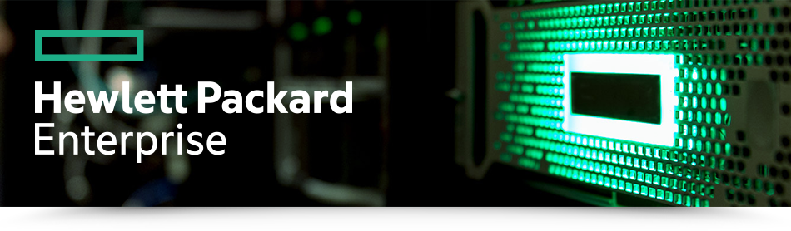
Figure 1 : Hewlett Packard Enterprise

Some of their products is:
(a)HPE Server:
ProLiant, Synergy, Cloudline, Edgeline, Apollo (High-Performance Computing).
(b)HPE Networking:
ProCurve, 3Com and Aruba Networks.
(c)HPE Storage:
HPE 3PAR, Nimble Storage, HP XP and HPE GreenLake Hybrid Cloud.

HPE has “Accelerating your digital transformation” agenda. There are three aspect to fulfill this agenda. In the aspect of technology, it focus on intelligent software-defined solutions edge to cloud. In the aspect of people, them focus on skill processed and culture to keep pace with innovation while the aspect of economics, them will focus on investment strategies and business model to speed growth.
Then, Mr. Syahrul shared the predictions that IDC Agenda already predict. The first prediction is, by 2021, driven by Line-Of-Business (LOB) needs, 70% of Chief-Information-Officer (CIO) will deliver "agile connectivity" via APIs and architectures that interconnect digital solutions from cloud vendors, system developers, start up, and other. The second prediction is Mr. Syahrul said, compelled to curtail IT spending, improve enterprise IT egility, and accelerate innovation, 70% of CIO's will aggressively apply data and AI to IT operations, tools, and processes by 2021. Next, the third prediction, he said by 2021, 65% of enterprises will task CIO's to transform and modernize governance policies to seize the opportunities and confront new risks posed by AI, MI and data privacy and ethics. Furthermore, he said, through 2022, 75% of successful digital strategies will be built by a transformed IT organization, with modernize and rationalized infrastructure, applications, and data architectures. Not only that, he said more that by 2020, 80% of IT executive leadership will be compensated based on business KPIs and metrics that measure It's effectiveness in driving business performance and growth, not IT operational measures. As additional, by 2022, 75% of CIO's who do not shift their organizations to empowered IT product terms to enable digital innovation, disruption, and scale will fail in their roles. Otherwise, through 2022, the talent pool for emerging technologies will be inadequate to fill at least 30% of global demand and effective skills development and retention will become differentiating strategies. And the last prediction, by 2023, 70% of CIO's who cannot manage the IT strategy and operations divides between LOB-dominated edge computing, operational technology and IT will fail professionally.

Industry 4.0 – Technology Trends

Mr. Syahrul showed us a statistic about disruptive technology which most likely to impact the organization in the next 3 to 5 years. Among the disruptive technology, the big data or analytics contributed approximately 30%, the highest technology disruptive in an organization. The cloud, self-service IT, mobile payments and internet of things (M2M) contributed approximately 29%, 22%, 20% and 20% respectively. The knowledge-based system had the least disruptive technology in an organization which contributed only 19%. Disruptive technology will displace an established technology and shakes up the industry or a ground-breaking product that creates a completely new industry likes industry 4.0. The industrial revolution began from 17th and 18th century by which the uses of water and steam are important as power to run mechanical production facilities. Then at the beginning of 20th century, industrial are developed to the use of electrical power to enable work-sharing means production. At the early 1970, the uses of electronic and IT to automain production. But today, we already come to industry 4.0, the uses of cyber-physical systems in monitor, analyze and automate business. Industry 4.0 uses the industrial Iot to take processes by which traditionally managed on factory floor by people and machines and move them to the cloud where they can be managed remotely and even autonomously.

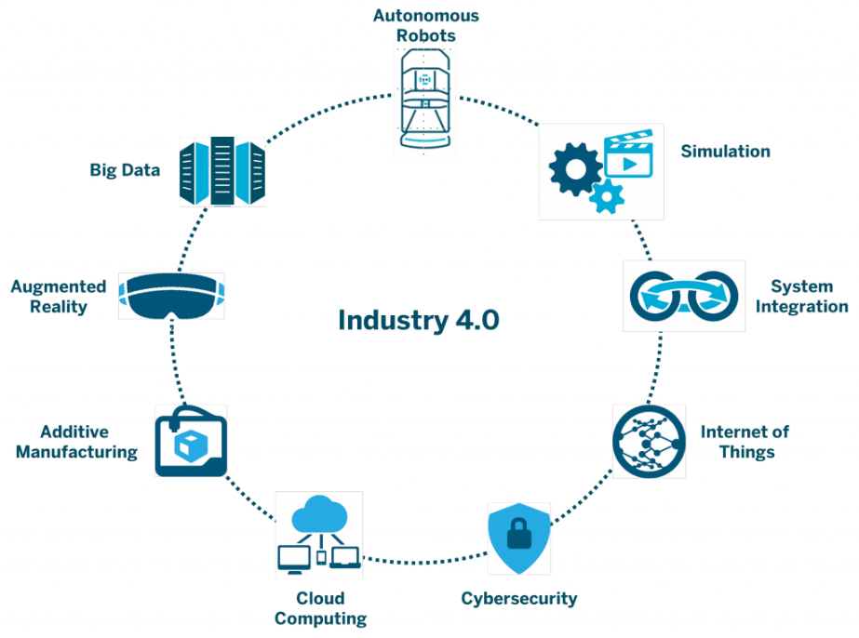

Figure 2: Industry 4.0 Technology Trend
Industry 4.0 technology trends are important as it will transform production, lead to greater efficiencies and change traditional production relationship among supplier, producer and customer. The important element in this trend are autonomous robots, simulation, horizontal and vertical system integration, industrial internet of things (IIOT), cybersecurity, the cloud, additive manufacturing, augmented reality, big data and analytics. The theory of industrial 4.0 are based on computing the edge. At first the data flow is pass to control flow, at this moment, “things” generate data and need control, then data is sensed and things controlled, at the operations technology the data is acquired and aggregated. Then the data will pass through the edge IT, data center and cloud, at first the early analytic and computer will done follow by the deep analytic and computer. After that the processed data will flow back to data flow.

2.2 Internet 2.0: Transaction Based Networking
Second talk
Topic : Internet 2.0: Transaction Based Networking
By : Mr. M Nazrul Hazeri Narirmuddin
Mr. M Narzul begin the talk with Man-computer symbiosis. It was about men who will set the goals, formulate the hypotheses, determine the criteria, and perform the evaluations. While the computing machines will do the routinizable work that must be done to prepare the way for insights and divisions in technical and scientific thinking. Based on Preliminary analyses, the symbiotic partnership will perform intellectual operations much more effectively than a man can perform. This could show that Man-computer symbiosis is a fundamental or key text of the modern computing revolution.

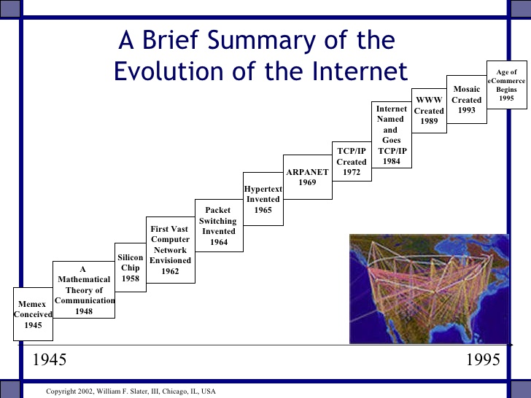
2.2.1 History of Internet

Figure 3: History of Internet

Today, the Internet serves as a global data communications system that links millions of private and public networks via an international telecommunications backbone that consists of various electronic and optical networking technologies. The history of the Internet begins with the development of electronic computers in the 1945s which the Memex was conceived. Then, mathematical theory of communication is developed followed by silicon chip, computer network envisioned, packet switching and hypertext invented. In 1969s, the development of ARPANET project enables the sending of message from a computer to another computer via network. In 1972s, Internet protocol suite (TCP/IP) was developed and became the standard network protocol on ARPANET. In 1989s, a British computer scientist resulted in World Wide Web, linking hypertext documents into a information system, accessible on network. While the Commercial Internet service providers (ISPs) began to emerge in very late 1984s. Today the internet continues to grow, driven greater amounts of online information, entertainment and social networking. Although internet bring development to our life but it also has impact on us likes globalization, cyber attack and internet trolls.

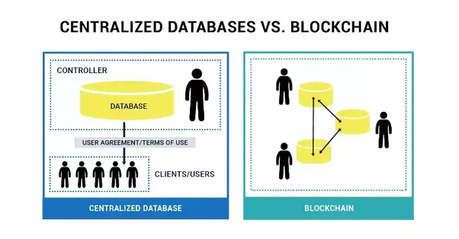
2.2.2 Distributed ledger Technology / Blockchain
Figure 4 : Centralized databases and Blockchain

The trend of internet has been developed to internet 2.0 which marked fundamental change in how we use Internet. The rapid advance of blockchain technology and the Internet of Things (IoT) are felt throughout our daily lives. IoT allows devices to send data to private blockchain ledgers for inclusion in shared transactions with tamper-resistant records. Blockchain enables the business partners to access and supply IoT data without the need for central control and management. Each transaction can be verified to prevent disputes and can ensure that each partner is held accountable for their individual roles. A blockchain is a peer-to-peer distributed ledger forged by concessive, combined with a system for “smart contracts” and other assertive technologies There are two type of blockchain, open public blockchain and permissioned enterprise blockchain. There is difference between database and blockchain. Database running on World Wide Web most often using client-server network architecture. Control of the database remains with administrators, allowing for access and permissions to be maintained by the centralized servers. They authenticate a client’s credentials before providing them with access to the database. The data can be altered or deleted by administrators as per their convenience. While blockchain is well-suited as a system of record for certain function. A blockchain is basically a glorified linked list (data structure). It consists of several nodes and each node participates in administration to verify data that recorded in blockchain and capable of recording new data. The distributed architecture of blockchain can help solve many of these security and trust challenges:
- Blockchain used to track the sensor data measurements and prevent duplication with any another malicious data.
- Deployments of IoT devices can be complex, and a distributed ledger is well suited to provide IoT device identification, authentication and seamless secure data transfer.
- IoT devices are directly addressable with blockchain, providing a history of connected devices for troubleshooting purposes.

2.2.3 Strength, Weaknesses, Opportunity and Threat

According to blockchain strength, weakness, opportunities and threats (SWOT) analysis, the technology is at a nascent stage of development, the potential gains is fueling massive research and investment.

Strengths | Weaknesses
- decentralized network  - open source  - distributed resilience and control  - security and modern cryptography  - asset provenance  - native asset creation  - dynamic and fluid value exchange | - Lack of ledger interoperability  - Customer unfamiliarity and poor experience  - Lack of trust in new technology  - Immature scalability  - Skills scarcity and cost  - Wallet and key management  - Poor tooling and poor developer user experience
Opportunity | Threats
- Reduced transaction cost  - Reduce fraud  - Reduce systemic risk  - Monetary democratization  - New business-model enablement  - Application rationalization and redundancy | - Legal junsdictional barriers  - Technology failures  - Institytional adaption barriers  - Poor government  - Ledger conficts  - Divergent blockchain

Table 1 : Blockchain strength, weakness, opportunity and threat analysis

2.2.4 Use Case
In the aspect of supply chain logistic, blockchain technology improves transparency, facilities better tracking of orders, eliminate errors in payment processing, and tracks real-time feedback from customers. For instance, smart contracts and smart payments are recorded using blockchain technology.
In the aspect of smart manufacturing, connected living and IoT, blockchain technology follows a decentralized approach facilitating a standardized peer-to-peer communication. Blockchain technology processes billions of transactions and reduce the associated cost, as it eliminates the setting up of large centralized data centers.
In the aspect of mobility solution, blockchain facilitates ride sharing service to be completely decentralized and enable the real sharing economy. For instance, La’Zooz, an Israeli start-up, is one of the first blockchain ride-sharing companies.
In the aspect of sales and leasing, the DocuSign’s Digital Transaction Management (DTM) platform, eSignature solution and Visa’s secured payment also use Blockchain technology. Customer use DocuSign platform to sign a smart contract. Leasing, insurance and services such as parking and tolls are activated and payment is made using Visa
In the aspect of connected insurance, OBD device is used by insurance provider to track and collect vehicle data on over speeding, location, engine diagnostics and use the data for premium calculation. This will reduce the number of insurance claims by decreasing the risk of accidents and diminishes fraudulent claims.

SUMMARY
This IoT carnival provide a greater chance for UTM students to gain extra knowledge and skills in the field of computer and technology. The activity Hackathon, workshop and hands on training prepare students the skill that they require such as design thinking skill and programming skill. While the industrial talk and project showcase provide an opportunity to students to know more about how technology and computing could make our life better. The project such as artificial intelligence (AI) based lightweight interference mitigation scheme for wireless sensor network (WSN) , smart home energy monitoring system, Iot based temperature control for smart mosques projects are successfully making our life more better.
The predictive maintenance talks, providing us the information of how the trend of world will going. Based on the predictions of IDC Agenda, we could know that how important the field of computing and IT are, because both the fields could develop the country moreover changing the world. In the past century, the development in the field of computing and IT changing the old style of water and steam industry to now the cyber-physical systems in industry. This revolution is all about the knowledge and development of computer and IT.
Next, the transaction-based networking talk provide a greater understanding about how wide the internet are. Since 1945, internet is facing rapid development from mathematic theory to computer network envision, hypertext, Arpanet, TCP/IP and world wide web. Then the internet began widely use in most of the field. Although internet is very useful to us, we also have to concert about the impact of internet. This same goes to blockchain, blockchain SWOT analysis are the better fact to show that all of the things have good and bad. We have to widely use the IT product the minimize the impact of the given product on us.

BIBLIOGRAPHY

(n.d.). Retrieved from What is the Difference Between a Blockchain and a Database?: https://www.coindesk.com/information/what-is-the-difference-blockchain-and-database
(n.d.). Retrieved from Why blockchain and IoT are best friends: https://www.ibm.com/blogs/blockchain/2018/01/why-blockchain-and-iot-are-best-friends/
(n.d.). Retrieved from swot of blockchain: https://rml-marketing.com/wp-content/uploads/2017/11/Blockchain-SWOT-Analysis.png

