
Title: Design Thinking

Group Members: TOK KAI XIAN (A18CS0267)
TAN ZHI QUAN (A18CS0260)
CHENG SHIN WEI (A18CS0046)
TAN WEI KOK (A18CS0258)
LEE CHEN HONG(A18CS0094)
Course: Technology and Information System
Lecturer: Dr. Aryati Binti Bakri
Section: 9
Table of Contents
1 Introduction 3
2 Detailed Description in Design Thinking 3
2.1 Empathy 3
2.2 Define 3
2.3 Ideate 5
2.4 Prototype 6
2.5 Test 8
3 Detailed Description Include Problem, Solution and Team Working 8
4 Assessment 9
5 Reflection 9

Table of Figures
Figure 1: Discussion the problem that obtain from respondents 5
Figure 2: The model and the frame creation of phototype 7
Figure 3: Application page design 7
Figure 4: Prototype 7

Table of Tables
Table 1: The problem of respondents 4
Table 2: List of idea 5

Introduction
Design thinking is a design methodology that provides a solution approach to solving the problems of somebody or a community. In order to identify the problems facing by school of computing (SC) students, we interviewed three respondents to study the problems facing by them during their study. Based on the problems obtain from the respondents, we discussed the major problem and the appropriated solution for the respondents. After the interview section, we get the fact that they are mostly facing the same problem. After our discussion, we identify limited reading resources as the major problem facing by school of computing students because without deeply understanding about a chapter, we cannot manage to answer our test or tutorial. Lastly, we decided to create an app which gathers all the past year tests for SC students. The way that we embodied the platform was through development of application.

Detailed Description in Design Thinking

Empathy
Empathy is the first stage of the design thinking and it is an important step because it should immerse ourselves to the user’s problem. In this way, we can solve their problem in more appropriate ways which produces the best solution. The stage of empathy began with the interview session. In the interview session, we can obtain the personal information of respondent and what the problems they faced. We have prepared a set of question, for example, we ask the respondent to introduce themselves and ask for the problems they faced in their learning. We interviewed three respondents with different background to study their problem in studying and we figure out that three of them facing the similar problem on studying.

Define
In the stage of define, we record all the problems faced by the respondent and arrange it into a table.
Respondent 1  Background:  20 years old, 1SCSJ | Respondent 2  Background:  20 years old,1SCSP | Respondent 3  Background:  20 years old,1SCSV
Problem 1  Insufficient time  -Due to a lot of assignment  -Different lifestyle from secondary lifestyle  -Active in a lot of events  Problem 2  Hard to understand  -Impropriate language  Problem 3  Entertainment affects study  -Play games and does not do revision for exam | Problem 1  Insufficient time  -Course are completely packed  -Exam preparation time too short  Problem 2  Limited reading source  -Resources given in point form  -Not enough example  Problem 3  Electronic affects my study  -Entertainment  -Cannot focus when phone beside  -Always take phone to chat or play game | Problem 1  Insufficient time  -Spend time with friends  -Lack of time to study  Problem 2  Limited reading source  -Not enough exercise and answer  -No good reference book  Problem 3  Entertainment affects  -Unable to reject phone and friends
Table 1: The problem of respondents
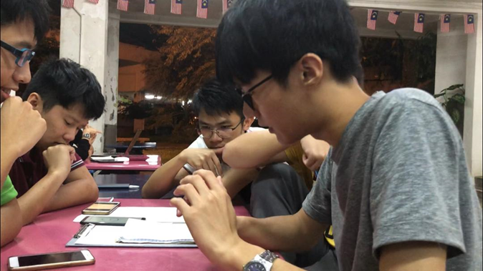
According to table, we think that limited reading source is the major problem faced by the SC students as the slide on e-learning is the only one way for SC students to get reading resource. Only less number of students have the reference books and the library are too far away from SC student. In addition limited exercise causing students can’t further understanding about the chapters as we just prepare a maximum of four past year question. Somehow, lecturer prepare only one past year exercise to us. Practice make perfect, as a student we required more practice to get a better result. Hence in our group discussion, we set limited reading resource are the major problem face by the respondent.
Figure 1: Discussion the problem that obtain from respondents

Ideate
In this stage, we have a detail discussion which is ideate (brainstorming session) about the major problem gained from the previous step. We have a discussion and come out with some idea, the best idea will be chosen to solve this problem.
Problem:
Limited Reading Source
Idea:
- Open WhatsApp discussion group 7. More learning programs
- More study room and reading materials 8. Point checking
- Exchange material with other university 9. Create an application
- Create a website that contain reading source 10. Virtual Reality (VR)
- Create Artificial Robot to teach 11. Direct mentor session
- User update question system 12. educational games

Table 2: List of idea
The problem that we decided to solve is limited reading sources among students. After deep discuss about the idea to solve the problem, we decided to create a software which could provide user update question system, a software library where students could share the reading materials and a point reward system as appreciation to the contributer.
Firstly, we discussed about the sources of reading resources. We plan to create a software that students can update the new question papers each year. By doing so, students manage to know the format of questioning and can get more past year test paper. Students also can do self-assessment as answers are prepared.
Point Reward system also embodied in this software. The aim of this system is to encourage students to share the reading material and new test exercise. Students who had contributed on uploading reading resources will be given the points as a reward, so that others user can appreciate their effort on sharing reading materials.
Next, we plan to create a software library to collect all the lecturer slide, reading materials or notes that share by the users. This could provide extra reading material to SC students. The uploaded materials will be delay as it need to get approve by the administrator of the software and the admin the determines the points should be given.

Prototype
Prototype is a model created from the best idea chosen from the ideate session. We decide to create a software which could solve the problem of limited reading source by using the electronic gadgets. We make a box and cut out a rectangle shape to make the screen of smartphone. A paper slide was made to present our prototype to our respondents. The slide includes the front page, user profile page, library and exercises.

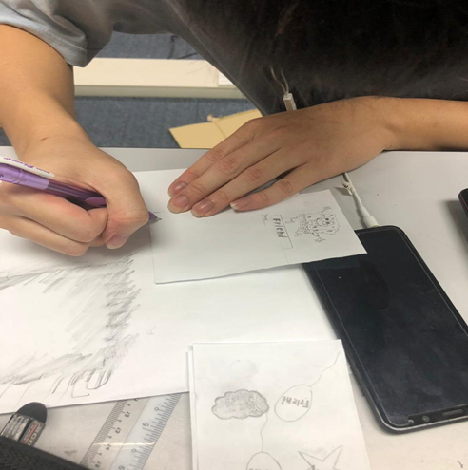
Figure 2: The model and the frame creation of phototype

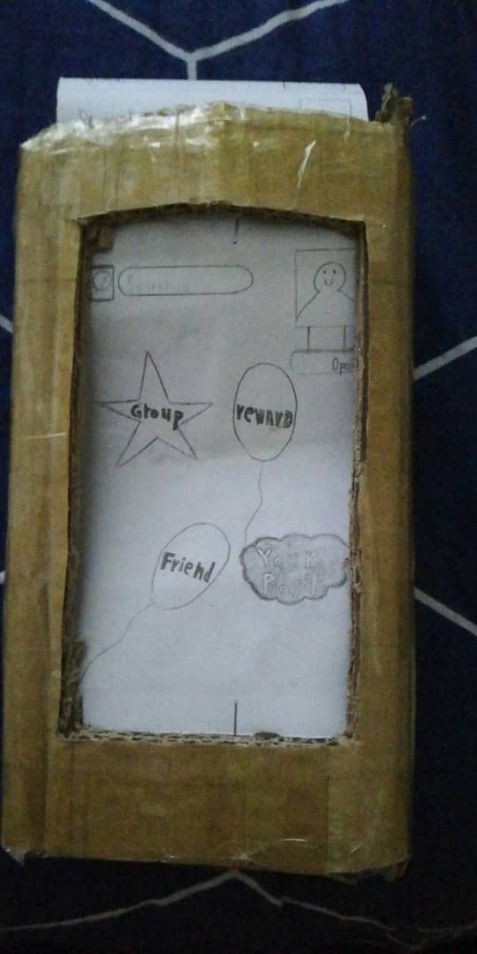
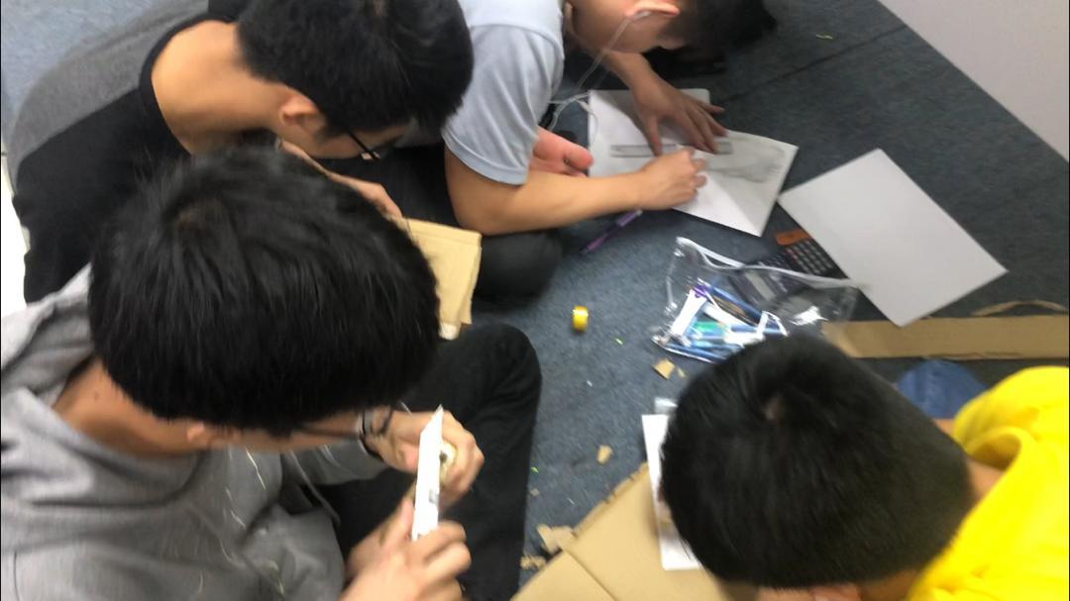
Figure 3: Application page design

Figure 4: Prototype

Test
In this stage, we will test our prototype with the respondent to get the feedback from the respondent and keep on innovate until we get a perfect prototype for the user. In our first test, one of the respondents give comment about our prototype less feature and incomplete. After several innovate, the respondent praises our product as it’s very useful and successfully solve his problem because this software could provide more exercises and reading material rather than slide given by lecturer. He hopes that we could make a real one in future. So that all the SC students could get the beneficial of it.

Detailed Description Include Problem, Solution and Team Working
There are many problems we faced during making this assignment. Our first problem is the group member always busy in other assignments causing group meeting have to cancel. This affect in facing difficulty in adjusting the time for group meeting. This factor causing us have to settle all the interview and group discussion in a short period so that we can finish ours project on time. Others than that, some of our group member have to help their club to conduct the event as they are members of the club, this causing our meeting delay many times. Next, the other problems is we always rejected by other to get interview. This is because they feel shy and don’t want to share their problems faced in their study. The next problem is the background sound when taking the video. We found out that it is very hard to take a good video because there are many background sound which will affect our quality of video. We need to consider the place of interview to minimise the background sound affect. In the aspect of teamworking, we divide every group member with different tasks likes Kai Xian interview the respondents, Shin wei take the video and Zhi Quan record the sound. We also do the prototype together to show the cooperation and creativeness of our group members. Another problem we faced is we have to fulfil the needs of the respondent. This is because different respondent have different point of views, that why we have to keep on innovate our prototype until the respondent satisfied.

Assessment
All our group members have a good cooperation during the project, and during the end of the project demonstration, we had done the best of ourselves to promote our problem solution to our respondent and our work had got a good feedback from our respondents. Although some of us are lacking of the skill of interpretation but we still manage to get and present our idea to our respondents.
During the transition between design thinking phases, the detail plan of our team is fortunately run smoothly. For instance, we manage to finish our interview with three respondents in one day even though some of us busy in club events. Due to cooperation of the team, we had performed well in all the phases of design thinking and consequently shorten the time span on this project.

Reflection
There are different reasons for people in choosing their course. For our group, we share the same goal by taking this SCSV courses which is become the game designer in our future. This is because most of the teenager nowadays are interesting in video games and we are also one of them. It is a fact that entertainment will influence study of students but their major problem is limited reading resource. So, our group design a prototype where it can help the student to increase their sources of study to help them in their study. This software app could increase the effectiveness in study as extra reading material and exercises are prepared and they could check the answer by themselves. This assignment let us learned about how important of teamwork and manage time wisely in making a project. Without these two things, we are unable to carry our job (game designer) properly. After making this assignment, we also found that what is our weak point that we must be improve so that it can improve our potential in the industry. Our weak point was altitude with others group member, poor speaking skill and also poor creative mind. To overcome these, we must spend more time to speak in language that we weak for, always be nice with others people and also learn extra information that cannot be found in the schoolwork. After solving our weak point, there will be better future waiting for us.

.

