

REPORT ON INDUSTRIAL VISIT

SEMESTER 1

SESSION 2018/2019

NAME: 1. MOHAMMAD AMIRUN HAZIQ BIN MOHAMMAD FADZLI (A18CS0109)
2. AHMAD AZHAR ADILAN BIN INDRA (A18CS0012)
3. AIMAN HAZIM BIN MOHD ARSYAT (A18CS0020)
4. MUHAMMAD AYMAN BIN MOHYEDIN (A18CS0128)
5. KALAI ARASIH A/P RAMACHANDIRAN (A18CS0088)
REPORT’S TITLE: DESIGN THINKING
LECTURER’S NAME: DR ARYATI BINTI BAKRI
SUBJECT: TECHNOLOGY AND INFORMATION SYSTEMS (SCSP1513)
SECTION: 02

TABLE OF CONTENTS

1.0 INTRODUCTION 3
2.0 DESIGN THINKING PROCESS 4
2.1 Empathize 4
2.2 Define 4
2.3 Ideate 4
2.4 Prototype 5
2.5 Test 5
3.0 PROBLEM, SOLUTION AND TEAM WORKING 5
4.0 DESIGN THINKING PROCESS EVIDENCE 6
4.1 INTERVIEW QUESTIONAIRE 7
4.2 ACTIVITY RECORDS 9
5.0 REFLECTION 10

1.0 INTRODUCTION

In this era, industries will look at the student that have soft skills. Nowadays, student is lack of soft skills that is why many fresh graduate cannot have a job. With design thinking, will help the student to develop skills such as teamwork, problem solving, communication, analysis, creativity and the ability to influence. Design thinking is an iterative process in which we seek to understand the user, challenge assumptions, and redefine problems in an attempt to identify alternative strategies and solutions that might not be instantly apparent with our initial level of understanding. Design thinking have five phases which is empathy, define, ideate, prototype and test. These phase are important to produce a product that can benefits others.
Thus Department of Information System, School of Computing, Faculty of Engineering, Universiti Teknologi Malaysia (UTM) is called to ensure that student in UTM could have the skills in order to help them to get the job after they are graduate. On 19/11/2018, Dr. Aryati Bakri gave us briefing to the design thinking at the seminar hall on N28A building. In the briefing, Dr. Aryati explained us about what is design thinking and the phases in design thinking. At the end of the talk, we have been given a task in which we must a project based on design thinking. The theme given is about learning style.
Learning style is about the way that we study. As we know, there is many type of learning style such as visual, auditory, kinaesthetic, solitary, social, logical, and verbal. Everyone in this world have their own learning style. Thus, with the energy of five students, my friend and I are called to resolve the problem of visual students to study in English language. Hence, this report is written to tell about our project. This is included the introduction, detail steps of our project, detail descriptions in design thinking and our reflection towards this project.
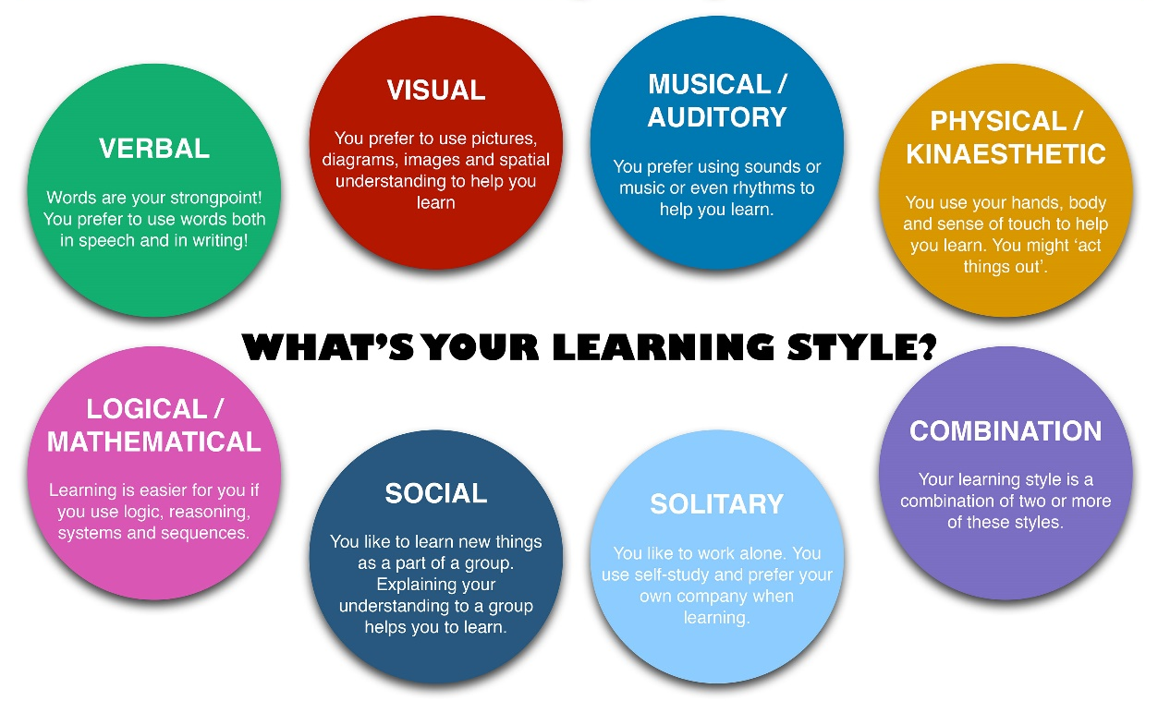

Figure 1:Type of learning styles

DESIGN THINKING PROCESS

Empathize
We do observation among UTM students to look on how their studies. From the observation, we do some survey to look out the learning style of UTM students. From the observation also, we saw that there’s some students that lack of English skills and they cannot understand English well during class especially the visual learner students. After we analysed our survey’s data, we found that the visual leaner got the highest percentage with 57.6% which is equal to 34 students from 59 responses. Thus, we decided we want to focus on the visual learner students only. After that, we engaged one of the target people with conducted an interview. We asked the question regarding the problem that they have faced during learning and studying using English language. From the interview, we found that our target people really faced hard time while studying and learning in English language.

Define
Based on the interview conducted, we analyse some problem that will be our bench mark to do the prototype and for our project itself. The problem that we listed is shown below:
  - What is the best way we learn English through digitally or physically?
  - Can we improve our English skills through reading novel or books?
  - What is the interactive way to learn English for visual learner?
  - Does visual learner like to move during study?
  - Did video learning style help the visual learner to study English?

Ideate
We do brainstorming on what we want to do for our prototype and to solve the target people problems. There are many ideas that we got from the brainstorming such as monopoly, interactive flash cards and Let’s Learn English learning tool. We listened to the explanation of each ideas and we took a vote on deciding the idea that will be chosen to make it our prototype. After thinking about the benefits, the way the idea brings user to use it and the implementation of user to the real life, we agreed that the English learning tool is the one that will be our prototype for this project.

Prototype
We started to do our prototype using Microsoft PowerPoint. Our guideline in working on this prototype is by looking back at the problem statement. To make it beneficial to the user, we put some grammar question, a tutorial video in learning English and some more feature to make it interactively teaching the user because our target user is the visual learner students. We also coded some games and question using C++ programming so that user can learn English digitally.

Test
After we finish worked on our prototype, we give it a try to our target people to test it. After the user test it, we asked them do give some feedback to look out is that our prototype give benefit and solve the problem of the target user. After heard on the feedback, we found that our prototype having some problem such as the coding that we coded doesn’t worked well. The user also said our prototype need some navigation button to navigate from one feature to another feature so that user can easily navigate our prototype. Thus, we do maintenance on our prototype to fix the problem in our prototype and to make it more beneficial to the target user. We hope that user enjoy while using our prototype.

PROBLEM, SOLUTION AND TEAM WORKING

One of the problems that occurred to us is the difficulty for all of the members to meet up in terms of time and place. This happened because of the commitment and the participation of the members in other tasks and events such as Programming Technique Project, Digital Logic Lab Exercise and Dance Competition. This problem had been solved by our use of technology application such as WhatsApp for gathering the ideas and decision for to ease all of us to commit to the project.
Next, we have difficulties to create and finish the prototype in the given period of time. This caused by the lack of commitment and skill between the members to assign the tasks and works to all the members. This problem had been solved by the efforts of the members to agree by the words of the leader and having a pros and cons discussion together in the WhatsApp application in the process to satisfy all members’ feelings. This discussion is very much needed as it solved the majority of our problem involving the assignation of the tasks such as to solve prototype with lacks of resources, lack of skills to finish the prototype, disagreement to present in certain forms of presentation, and assignation of person creating and managing the tasks.
Lastly, the problem is we have some inefficient communication process between us. The reason why it happened because some of the members didn’t want cooperate to give any idea as they have other commitment and just follow the flow. There are also mistrust feeling, and blaming each other. Fortunately, good leadership skills from one of us make the situation become better and our teamwork getting better.

DESIGN THINKING PROCESS EVIDENCE



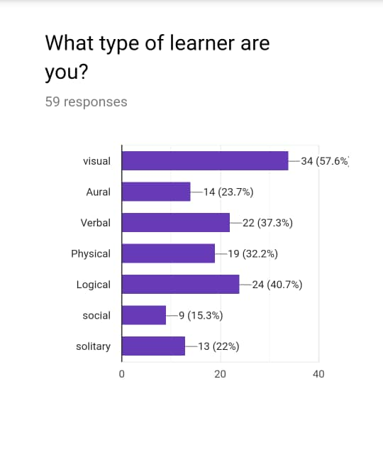

Pcture 3
Picture 1
Picture 3 shows our survey on learning for UTM students.
Picture 1 and Picture 2 shows that we having an interview with one of the students that having problems in learning English.
Picture 2

4.1 INTERVIEW QUESTIONAIRE
Age: 19 year’s old
Background: Students
Courses: Data Engineering
Year: 1

Question:
What type of learner you are?
Answer:
I’m a visual learner.

Question:
Do you feel hard to study in English, because here in UTM we conducted the class using English language?
Answer:
Yes, I feel hard to understand what my lecturer’s said during class. I can’t easily understand verbally talk because I need time to understand the word.

Question:
Did you make or jot down some note before or after or during class?
Answer:
Yes, I do make a note in order to help me understand the topic that I learned in the lecture.

Question:
Have you ever thought that, why your English vocabulary are not very well even though you have studied it for so long?
Answer:
I do think about it because my first language which Malay language is the most dominant language that I used in daily live. Thus, my English skills is not much improving.

Question:
Is there any application that you use to help you improve your English skills?
Answer:
Sadly, I didn’t use any application to help me improve my English language skills.

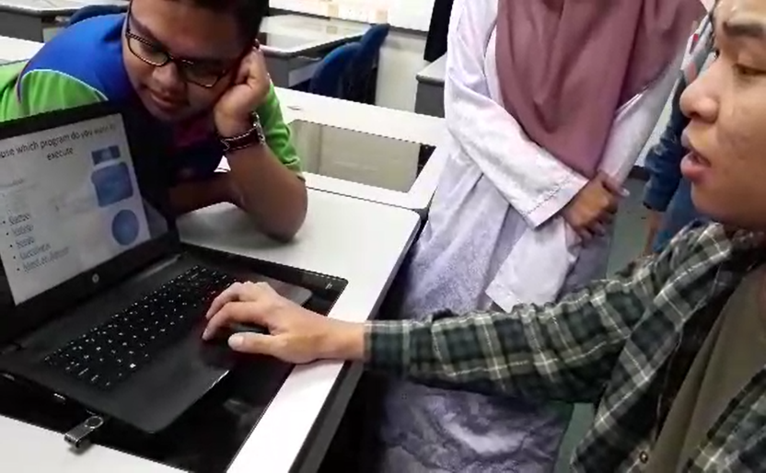
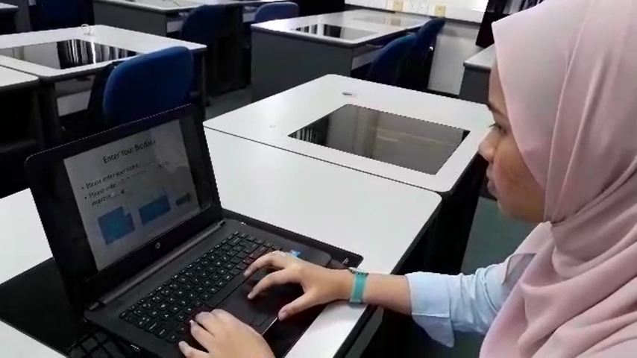
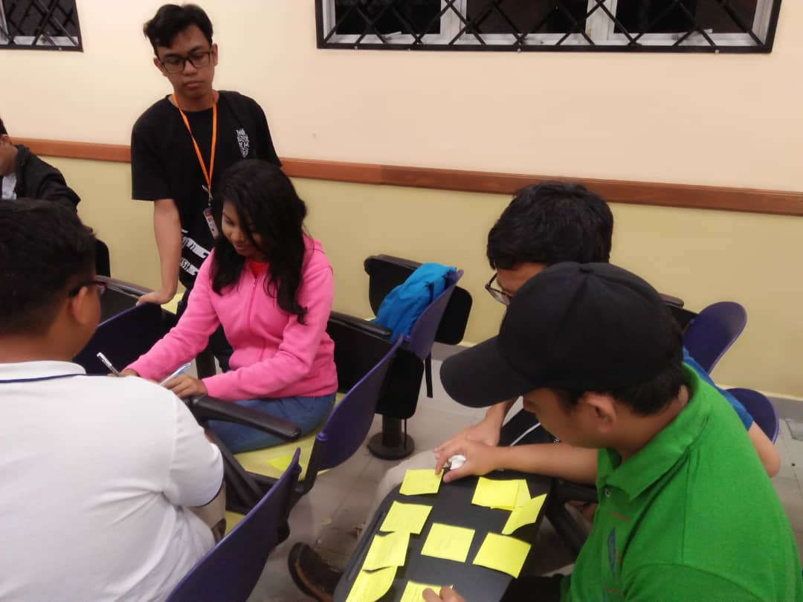
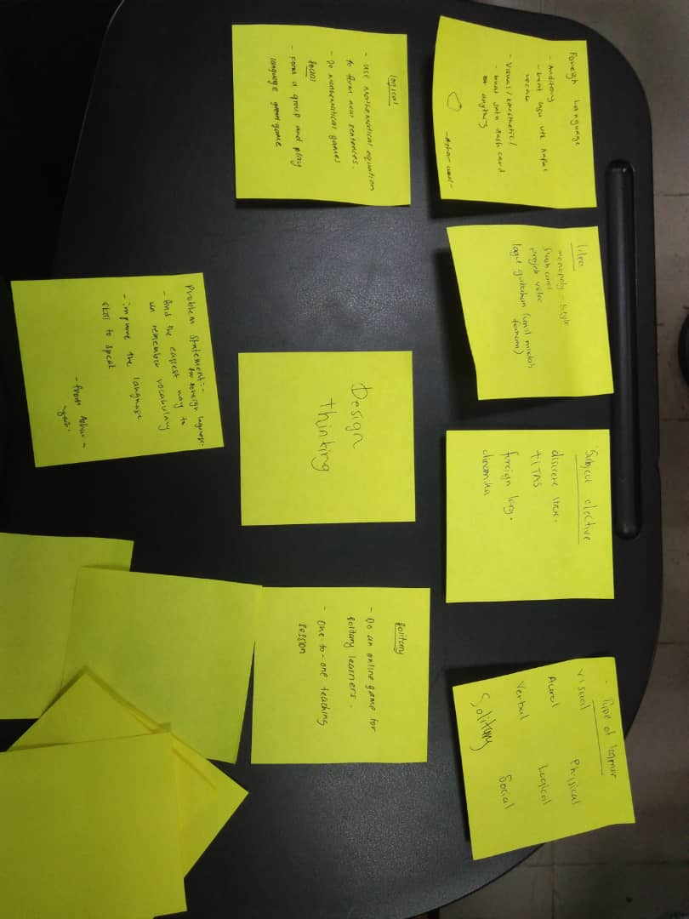
Picture 6 and picture 7 shows our test process which we give our prototype to the user to test it.
Picture 4 and picture 5 shows our brainstorming process which under ideate phase.
Picture 7
Picture 6
Picture 5
Picture 4
No. | Date | Activity
1. | 25/11/2018 | We start planning our design thinking project via WhatsApp group application.
2. | 26/11/2018 | We met up at Arked Angkasa KTDI for start making some survey for our project.
3. | 27 - 28/11/2018 | We conducted our interview with the target user. We also do some analysation on our survey and the interview that we have conducted.
4. | 30 – 31 /11/2018 | We having our brainstorming process which is we want to choose the best idea to make our prototype and we started worked on our prototype.
5. | 2/12/2018 | We give our prototype to the target user to test it.
6. | 3/12/2018 | We presented our design thinking project in the class.
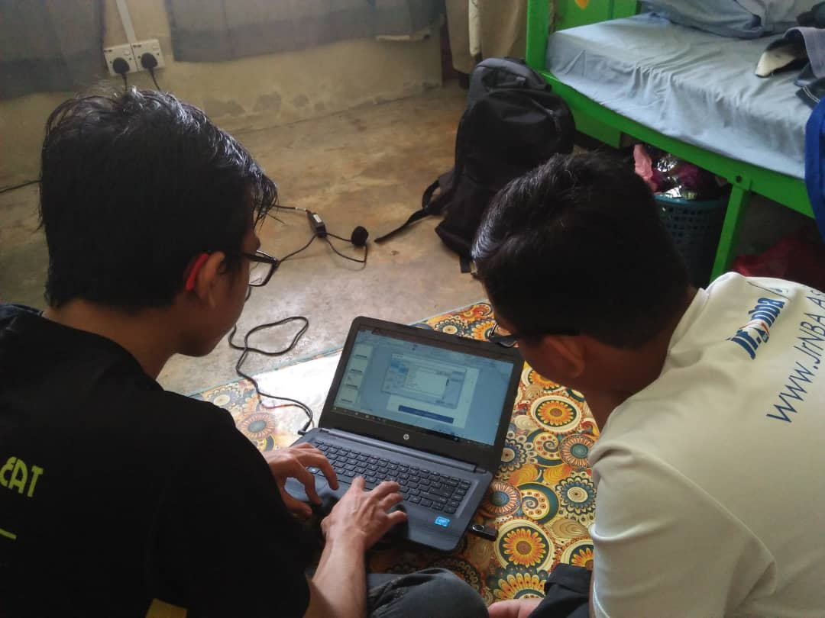
Picture 7

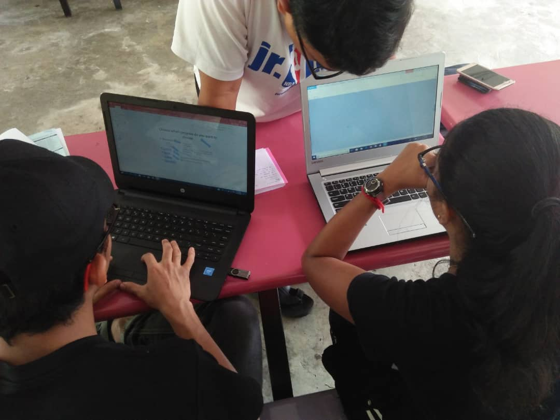

Picture 7 and picture 8 shows that we worked on our project prototype.

Picture 8

4.2 ACTIVITY RECORDS

5.0 REFLECTION

Our goal or dream with regard to our course/program is to be the best data engineer or programmer once we graduate. The goal is to be an employed graduate by a well-known industry in a very short period of time. The goal is also to be an employee with a high English proficiency. Nowadays, there are more than enough programmers, data engineers or other computer based professions. Hence, one should be unique enough to be employed by certain company especially the famous ones. Thus, having a goal as an employed digital worker is much more important.
Design thinking refers to the cognitive, strategic and practical processes by which design concepts are developed by designers or design teams. This has a very high effect on our goal which is to be a programmer. This is because design thinking is also associated with prescriptions for the innovation of products and services within business and social contexts where programmers play a major role in programming in innovating products. Design thinking is a creative design-based thinking process that helps you first define a problem and then develops solutions with the end user in mind. The main premise of design thinking is to create and test ideas in order to learn and improve on these ideas.
In order to improve our potential in the industry, basically we need to work hard. We need more practice in terms of solving IT based problems. Other than that, having more knowledge besides the field we are in is better in order to achieve our goals and dreams in this industry. Next, we need to be able to think out of the box in order to survive in this industry. New problems each day and every day. Hence, we must be capable enough to solve all those problems. Thus, we need to work in terms of solving problems more frequently. Trying to find solutions to problems that being discussed in the internet in this field will be much helpful.

