

REPORT OF INDUSTRIAL VISIT 3

SEMESTER 1

SESSION 2018/2019

NAME: 1. AHMAD AZHAR ADILAN BIN INDRA (A18CS0012)
2. CHAN JUN YAO (A18CS0043)
3. ANIS HUMAIRA BINTI MOHAMMAD HAIZAM (A18CS0034)
REPORT’S TITLE: CIMB
LECTURER’S NAME: DR ARYATI BINTI BAKRI
SUBJECT: TECHNOLOGY AND INFORMATION SYSTEMS (SCSP1513)
SECTION: 02

On 26/10/2018, a total of 64 students from School of Computing, Faculty of Engineering, University Teknologi Malaysia (UTM) campus Johor Bahru have participated an industrial visit to CIMB that based on Bangsar, Kuala Lumpur. From the 64 students, 54 of them are from Data Engineering courses and 10 of them are from Software Engineering courses. This industrial visit is one of the courses outline for subject Technology and Information System (SCSP 1513). In which at the end of the visit, students are able to write a report based on the visit. This report will be considered as their carry mark for this subject. This industrial visit has been proposed by Dr. Aryati Binti Bakri, the coordinator for subject SCSP 1513. She is assisted by Dr. Sharin Hazlin Binti Huspi.
The visit to CIMB started at about 2.45 p.m. and it’s ended at 4.30 p.m. During the visit the staff at CIMB take us a tour on their building at level 17 and 15. They served us a beautiful scenery of Kuala Lumpur from their building. After the tour ended, they served us a late lunch before the talk begin. The first speaker which is Mr. Qasmal Noor briefed us about the graduate opportunities to join internship with CIMB and the second speaker introduced us about IT infrastructure in CIMB. Thus, in this report we will give you a simple brief about CIMB. This is included the organization structure, their service and the achievement. Next, we will story to you about the graduate opportunities and the IT infrastructure in CIMB. At the end of this report we will tell you our reflection towards this industrial visit.
CIMB Group Holding Berhad is a local ASEAN investment bank in which their primary business is mainly focus on areas such as consumer banking, wholesale banking, comprising investment banking, a cooperate banking treasury and markets as well as group strategy and strategic. CIMB’s headquarter is located in the city that never sleeps, Kuala Lumpur. Their vision is to be the leading ASEAN company and some of their care values are customer centric, enabling people, high performance, integrity, and strength in diversity. They also implement corporate cultures into their organizations to be a better CIMB such as “We go the extra mile for our customers.”, “We engage openly and respect one another.”, and “We recognise our people and back them up.”. CIMB is considered as a leading regional universal bank that offers consumer banking, investment banking, and Islamic banking. Based on the recent data acquired, there are up to more than 900 branches of CIMB Groups in 18 different countries, 9 of which are non-ASEAN countries. CIMB Group is recognised as the 5th largest bank in ASEAN with over more than 12 million active customers and 38 000 working employees. In the ASEAN region, they recently opened up a new branch in Philippines which total up into 10 ASEAN countries under CIMB Group. Other ASEAN countries that CIMB have covered are Malaysia, Indonesia, Thailand, Singapore, Laos, Brunei, Myanmar, Cambodia, and Vietnam. The services that they have to offer are Wholesale Banking (corporate finance, equity capital markets, and institutional broking), Treasury (dept capital markets and syndicate, cross markets trading, and derivatives and government bond market making), Asset Management (retail and institutional funds (islamic and conventional), real estate funds, and private equity funds), Retail and Commercial Banking (deposits, private banking, and loan and financing), and last but not least Islamic Banking (wadiah, mudharabah, and sukuk).

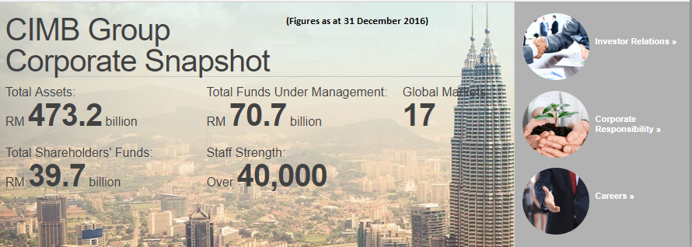
Figure 1: Snapshot about CIMB.

Not to forget, CIMB Group have also provided a pathway for undergraduate students and graduate students the opportunity to work with then and give first-hand experience of what it's like to work for the CIMB Groups. For undergraduates, they offer an Internship for 2 to 6 months with qualifications for year 1 to year 3 students with minimum CGPA of 3.00 and are active with their extracurricular activities. This programme is a huge opportunity for undergraduates as interns can gain practical skills and a ‘real world’ perspective on an occupation, interns get to meet with directors and interns from other departments, interns get to decide whether this is the right career for them as well as a big career opportunity for top performing interns because they will be offered a place in CIMB. In order to participate in this exciting internship, students must first submit their interest through the CIMB Career website then wait until you are called for an interview with CIMB, if a department is in need of extras hand then students will be placed in their respective specialties. For graduate students, CIMB has 2 offers which are The Complete Banker programme and CIMB FUSION programme. The qualifications for both The Complete Banker programme and CIMB FUSION programme are graduates must have strong results from various fields (based on stream), must be active in extracurricular activities including sports, have strong desire to learn and succeed, graduate must have energy and versatile, have good interpersonal skills, and are able to work independently. The Complete Banker programme is a 2 year programme where they will learn individual development planning and periodical check-points, career coaching and corporate
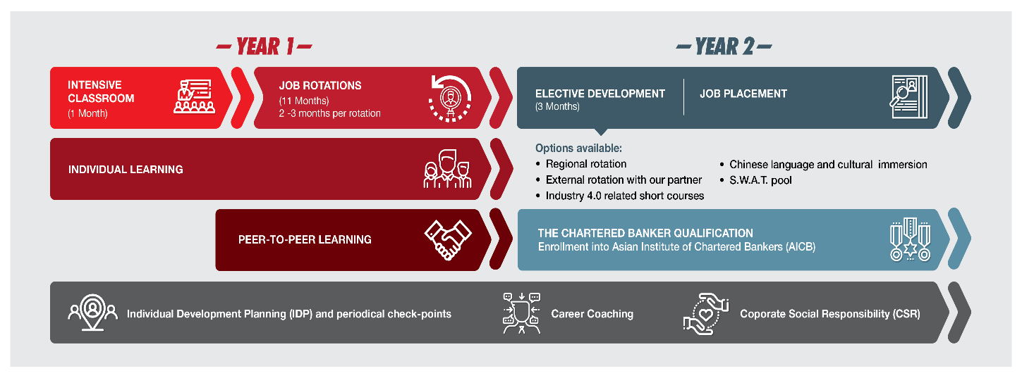

Figure 2: The Complete Banker Program

Next, Mr. Ahmad Affzan Bin Mokhtar Anuar has introduced us to the IT infrastructure in CIMB. He is the Director, Head of Production Support and Director, Head of MY IT infrastructure explained to us about six group IT which is applications, infrastructure, service management, IT security, risk and compliance and financial and administration. Our kind speaker said all type of business bank such as consumer and Islamic bank, commercial and transaction bank, wholesale bank, business enablers and digital use the same method to maintain business application in each type of bank. The first step is engagement and project management. The second step is delivery and last step is support. For example, CIMB has developed their own business application which is CIMB Clicks. This application allow user to check and manage their CIMB accounts, transfer money to accounts within CIMB and other banks, pay bills and many more.
Besides that, he also mentioned about IT security in CIMB. IT security in CIMB is split into five units which is parameter security, IT policy management and enforcement, vulnerability assessments and penetration testing, security operation control and cyber security. CIMB also take many action to protect all customer’s data as it is private and confidential. For example, in the CIMB Clicks application, they introduced the Transaction Authorisation Code (TAC) that is a unique 6-digit code sent via SMS to our mobile phone or via Messengers in CIMB Clicks mobile phone app for transaction authentication use.
Lastly, Mr. Affzan also explained to us on how they manage and operate IT infrastructure. CIMB’s infrastructure is split by technology domains. It is functions to operate and manage IT infrastructure which includes hardware, software and IT environments. The IT infrastructure of CIMB has six categories which is data centre operations, platforms, network and communications, storage, end user computing and lastly disaster recovery. All of these is manage and operate by three methods. The first one is engagement, next is through project and integrations and the last one is perform the operation.
Growing up as a Malaysia citizen, CIMB has long been a familiar name for us. And for the first time, to be able to set foot inside the headquarter of CIMB: Menara CIMB, let us feel so close to the company.
After our kind speaker introduced us about the internship programmes and competition CIMB organized, we definitely feel motivated. These programmes which demand the cream of the generation, motivates us to be the best of the best, through lifelong learning and expanding our skillset. This encourage us to step out our comfort zone, to learn, to explore and evolve. Nevertheless, this reclaims that the importance in excel in our academic studies, and yet developing extra potential in ourselves.
Despite CIMB bank originates as a bank company, CIMB gave significant attention and effort in developing and discovering talents. Those competitions, those internship programmes, provided a platform for potential developing: by preparing the required conditions for cultivation of future leaders. Hence, we would like to put forward our gratitude and express our appreciation towards CIMB for organizing these programme.
In a nutshell, every journey begins with a single step. In order to increase our potential in the industry, some of the practical approach include actively participate in national state activities such as hackathons and internship programmes. As these will widen our horizon and give us different perspectives in inspecting topic, and add experience of operation. Furthermore, participation in these events also expand our network of connection: get to know more peers in the industry, and concurrently gain more exposure to industrial companies.
At last, we would like to express our appreciation once again to every party who made this visit a reality, which brought us positive impact which would last a lifetime.
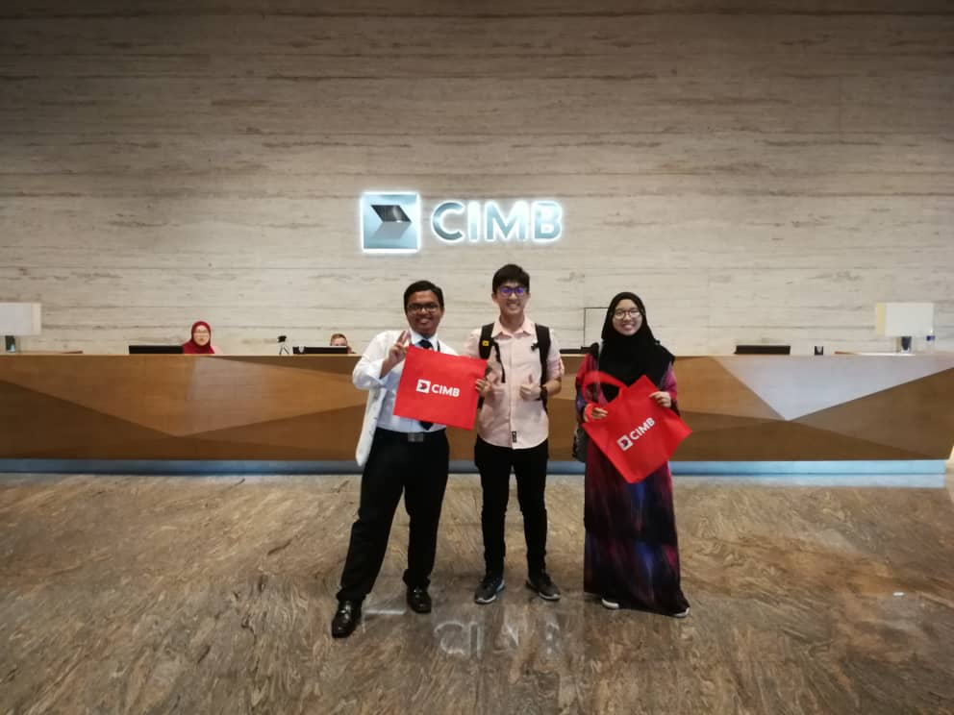
Figure 3: We at CIMB.

CITATION
- https://www.cimbbank.com.my/en/personal/banking-with-us/ways-to-bank/online-banking.html
- https://www.cimbbank.com.my/en/personal/support/security-and-fraud/tac.html
- https://www.cimb.com/en/careers/graduates-interns/malaysia/the-complete-banker-experience.html

