

REPORT OF INDUSTRIAL VISIT 2

SEMESTER 1

SESSION 2018/2019

NAME: 1. AHMAD AZHAR ADILAN BIN INDRA (A18CS0012)
2. CHAN JUN YAO (A18CS0043)
3. ANIS HUMAIRA BINTI MOHAMMAD HAIZAM (A18CS0034)
REPORT’S TITLE: ADAX
LECTURER’S NAME: DR ARYATI BINTI BAKRI
SUBJECT: TECHNOLOGY AND INFORMATION SYSTEMS (SCSP1513)
SECTION: 02

On 26/10/2018, a total of 64 students from School of Computing, Faculty of Engineering, University Teknologi Malaysia (UTM) campus Johor Bahru have participated an industrial visit to ASEAN Data Analytic eXchange (ADAX) that based on Bangsar, Kuala Lumpur. From the 64 students, 54 of them are from Data Engineering courses and 10 of them are from Software Engineering courses. This industrial visit is one of the courses outline for subject Technology and Information System (SCSP 1513). In which at the end of the visit, students are able to write a report based on the visit. This report will be considered as their carry mark for this subject. This industrial visit has been proposed by Dr. Aryati Binti Bakri, the coordinator for subject SCSP 1513. She is assisted by Dr. Sharin Hazlin Binti Huspi.
The industrial visit started with the talk given by Mr. Mohamad Nazir Bin Ismail and followed by Ms. Josephine Ong, Mr. Gan Chun How and Dr. Mark Chia.
Thus, in this report we will describe ADAX in term of organization structure, services that they provide to community, the achievements that they achieved, and programs and events that they have done to the community. At the end of this report we will tell you our reflection towards this industrial visit.
ASEAN Data Analytics eXchange, or simply ADAX, is an initiative by MDEC, the government owned agency. In acknowledgement of incoming of Big Data era, ADAX understands the practical application of Data Analytic tools, as well as the benefits it brings to the user: to grant capability of better decision making, accurate prediction, increasing cost effectiveness and much more. These abilities weren’t magic but science: a professional discipline which require training and practice. Hence, ADAX is being established in order to help governments, business, academia and professionals to adapt and adopt Data Analytics tool. Back in its establishment in year 2016, ADAX had been focusing on data professional development and Big Data Analytics(BDA) advocacy and awareness. During this phase, only Internet of Things and Big Data Analytics are being emphasised. However, in July 2018 ADAX marked the end of the first phase and moving on to the next phase, namely ADAX 2.0. In this phase, ecosystem development is in the spotlight: ADAX plans to focus on advanced analytics and artificial intelligent(AI). Our speaker then further explains, in this current phase, ADAX’s mission is to serve as a hub to catalyse Data Technology Ecosystem, via 3 steps: development of talent, promotion of technology and proliferation of adoption.
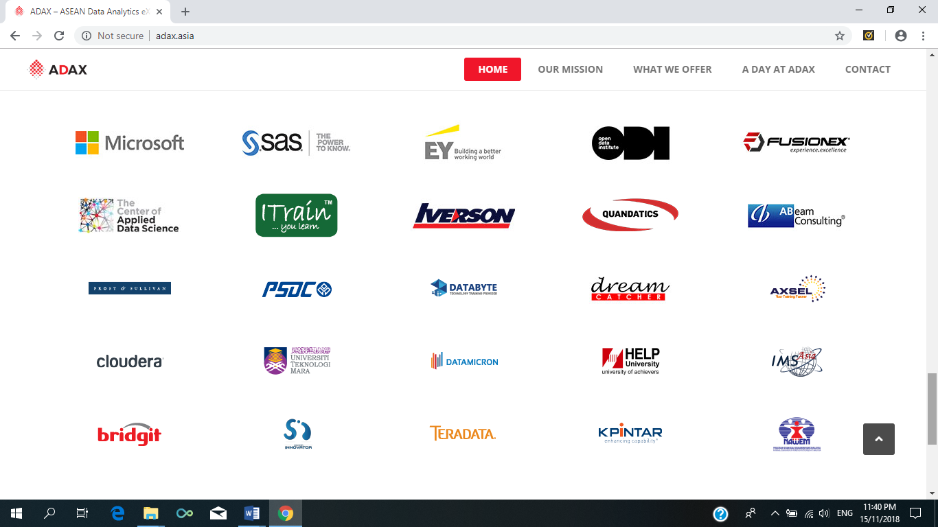
Figure 1: The collaborative partners of ADAX.

Speaking of developing talents, ADAX collaborate closely with training partners and universities. However, ADAX did not provide training, but instead is delivered by training partners which is selected through a selection committee. In other words, ADAX serves as a platform for both trainee and trainers, which appointment can be made via a governance process. Furthermore, ADAX did not provide any consultancy services. While putting forward the effort of developing talent, ADAX also plays its part as the focal point for Data Science and Artificial Intelligent community events. By hosting events like hackathon, ADAX achieved developing talent, promote and raise awareness of the topic at the same time. By doing so, ADAX also provides a soft-landing place for global Data Science and Artificial Intelligent company into our local market. Meanwhile, for proliferate adoption, ADAX which has strong understanding on the topic, and have vast connection with industrial peers, ADAX became a go-to place for data technology adoption journey, a one-stop hub to pull the data technology ecosystem together.
In the talk, our kind speaker also introduced DataCamp, an online learning platform which offers interactive R, Python, Sheets, SQL and shell courses. DataCamp conduct lessons in small portion, across all devices, which shortens the learning curve for students. The programs also give accreditation to students who completed the course, which in fact suggest the course is being recognised globally in the field of data science.
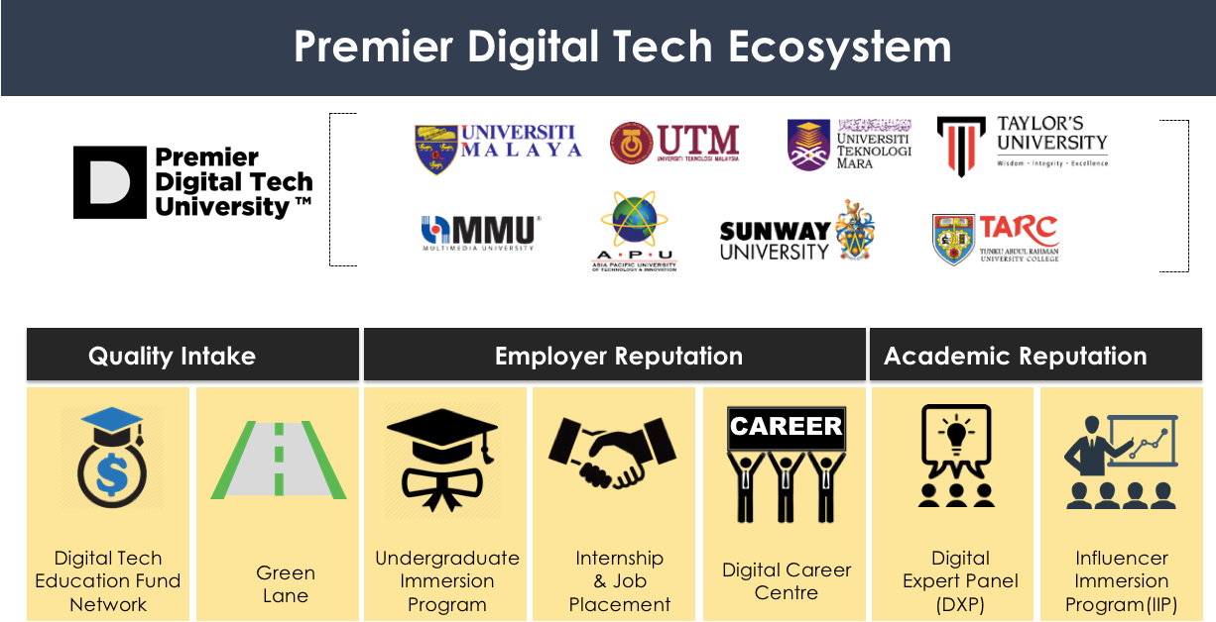
On the next talk, Ms. Josephine Ong introduced us the Premier Digital Tech University. Premier Digital Tech Universities which stands as top institutions of higher learning that can deliver first class theoretical and practical training. Among the eight universities are Universiti Malaya, Universiti Teknologi Malaysia, Universiti Teknologi Mara, Taylor’s University, Multimedia University, Asia Pacific University, Sunway University and Tunku Abdul Rahman University College, which give us a sense of pride to become a student of UTM. The motive of MDEC awarding Premier Digital Tech University is to catalyse adoption of digital economy across industry sector in Malaysia: to promote adoption of Internet of Things, Cloud Computing, Big Data Analytics, E-commerce, platform and sharing economy. These shift require higher volume of intake, higher quality and quantity of professional in the field. Hence MDEC had rolled out a programme named Undergraduate Immersion Programme. This programme aims to enhance and strengthen undergraduate’s competencies and improve their knowledge and skills through real-life industry projects with support from industry experts. Whereas mydigitalmaker offers a different approach. Via mydigitalmaker journey, MDEC suggest a development pathway all the way from secondary school to undergraduate to even placement of job. This comprehensive pathway is aligned with MDEC’s objective of increase in intake, quality, and quantity.
Figure 2: Premier Digital Tech Programs

The following talk is conducted by our speaker, Mr. Gan Chun How from the company, Fusionex. The topic began with a question: What is Data Hero? The speaker justifies frankly that the current world had wrong perspectives on data scientist: a misconception that data scientist can solve every single problem. He clarifies that data scientist is just an individual which possess statistical knowledge, skill of R programming and Python, and ability to deploy Big Data Tools. Data Science is a discipline built on the foundation of artificial intelligence, business intelligence and applications like machine learning, in order to solve big data problems: and Data Scientist is the operatives in the operation. Data scientist work with data sources: which can be tapped internally and externally. Internal data sources come from the company like sales figures, human resources records and much more. While external data sources including Forex, Stock Price and social platform. Then, the process extract, transform and load (abbreviated ETL), is carried out by Data Scientist to produce useful result and statistic.
Mr. Gan also quoted some practical application of big data and artificial intelligent in solving problem. Big data and AI helped companies to better understand the consumer: the characteristic of the population and their demand. Examples includes smart searches, smart advertisement placement to match relative product to relative consumer. Another case is that Big Data Tools and Machine Learning helped produced excellent and accurate forecast upon stock ordering based on historical sales and other influencing parameters such as advertising campaigns and store-opening times. The prediction is much more sensitive when compared to other standard systems: retailers can inspect effect of each parameter on each product, on a daily basis. The impacts are rather astonishing: reduction of up to 80 percent in out-of-stock rates, declines of more than 10 percent in write-off and days of inventory in hand, and gross-margin increases of up to 9 percent.
On the last talk, Dr. Mark Chia introduced us his company which is SAS. SAS is the leader in analytics. Through innovative software and services, SAS empowers and inspires customers around the world to transform data into intelligence. SAS realized that the world become demand on digital fusion as it is industrial revolution 4.0. Thus, SAS take action as an analytical leader to overcome this problem in industry. SAS has provided solutions by using Internet of Think (IoT). IoT solutions from SAS cover the full analytics life cycle – from data to discovery to deployment – incorporating data visualization, machine learning and streaming analytics in the data center or at the edge. SAS also used Artificial Intelligence (AI) to provide solution the industry. SAS embeds AI capabilities in their software to deliver more intelligent, automated solutions that help us boost productivity and unlock new possibilities. Nowadays many industries got many advantages from AI solutions provided by SAS. For instant, in banking industries; AI helped them by automate manually intensive, highly repetitive tasks, quickly identify fraudulent transactions and adopt fast, accurate credit scoring policies.
It’s truly an honour to be able to participate in this eye-opening industrial visit. With kind guidance brought by the technology frontiers, we are blessed to take a glance at the current trends in the field of technology: what to expect and what not to. Indeed, the current market has high and wrong expectation on data scientist: data scientist is just an individual which has capabilities to deploy big data tools in solving big data problems to aid better decision making.
With that being said, we as a Data Engineering students get a better picture of our own career development: the realistic picture of what a data scientist does, a realistic call from the dream. Hence, the exposure on practical application of data science stressed the importance of fundamental knowledge: what we are learning now, is the fundamental basic building blocks of data science, and success is only guaranteed with a strong foundation. Hence, regardless how basic what we are leaning now, we finally understand how important it is since every sophisticated project will still always back to basic at some point.
Furthermore, speaking in plans of self-improvement for increment of self-potential, we understand that the current market demands multi-talented employees. Datacamp is one of the best way to expand our practical skillset: online courses which teaches R and Python programming, Data Science courses which can add extra value to ourselves. However, it wasn’t the hard skills are important, instead, soft skills are also being taken into accounts. We shall develop our soft skills like presentation skills, team management skills, time management and much more.
Although the qualities that make a good data engineer nowadays are seemingly high, MDEC help us to cut out the panic: MDEC rolled out multiple programmes to assist us in development of these qualities. Hence, after the industrial visit, we are very interested to participate in programmes like Data Star initiative, soft skill development by MDEC and other potential developing programmes.
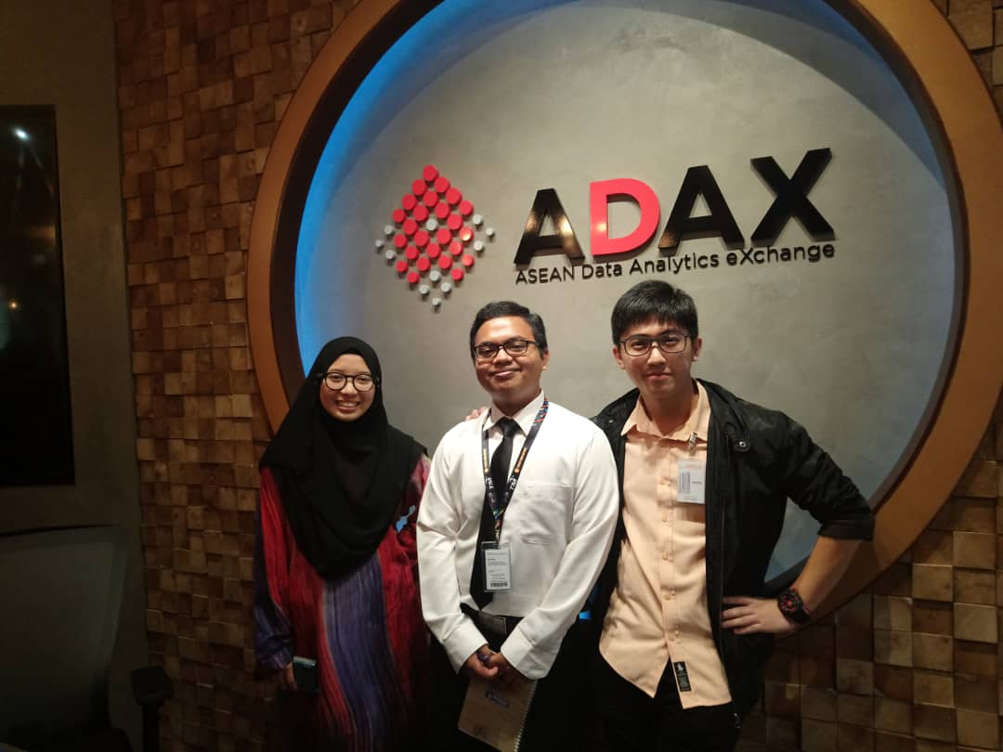
Last but not least, we would like to express our gratitude again to every party which made this visit a reality, which left a great, impactful experience for us.
Figure 3: We at ADAX.

CITATION
- https://www.sas.com/en_in/solutions/ai.html
- http://adax.asia/
- https://www.mydigitalmaker.com/programmes/premier-digital-tech-university

